Design Document

HandyHive

03/20/2025

Version 1

Austin Rehner, Fady Eskandr

1. Project Overview:

The goal of the Handy Hive web application is to connect homeowners with well-studied service providers for home maintenance and repair job assignments, such as plumbing works, electrical works, HVAC service works, and so forth.

Customers create a profile for themselves, search for services available, filtered by category or rating, and view service listings in full display. Once a suitable provider has been found, a customer may reach out to schedule an appointment. After receiving the service, customers may post reviews that assist future potential clients in making their own choices.

Service providers create and manage their own profiles, which enable them to display their business with descriptions, pricing, and availability. They may add new services, advertise promotions, and respond to customer feedback. Providers may also keep track of customer engagement and review trends via analytics dashboards to improve their business and also print an analytics report.

1. Use-Case Model

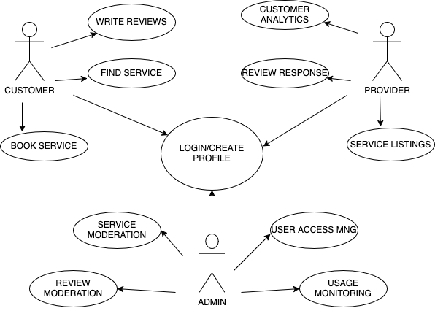

1. Database Schema

