Feb 11, 2025

Quality Metrics Report

**Introduction**

Thank you for participating in the xxxxxxxxxxxxxxxxxxxxxxxxxx of UK NEQAS Microbiology pilot External Quality Assessment (EQA) for xxxxxxxxxx.  
  
Samples for this EQA are distributed by UK NEQAS Microbiology as part of the xxxxxxxxxxxxxxxxxxxx and those with detectable virus are either sequenced inhouse or forwarded to the appropriate laboratory for sequencing according to routine practice. Distribution and sample numbering is consistent across both EQAs.  
  
A survey of sequencing technology is completed as part of the sequencing result upload process. FASTA files are assessed for sequencing sensitivity and precision which are combined to give an F-score (see Appendix 1 for definitions); a variant consensus report is then generated for each participant detailing true positives, false positives, and false negatives. The sequence data submitted is used by the EQA to generate a lineage using Nextclade.  
  
Your variant concordance report (xlsx format) and individual laboratory report (ILR) are available on the……… . If you have any problems accessing your reports then please contact …………   
  
The purpose of this EQA is to assess:  
 ➢ The accuracy of RSV sequencing.  
 ➢ Provide a measurement of the quality of viral sequencing.  
  
The summary of the EQA participation, variant call assessment, marking criteria applied and the scoring is provided as Appendix 1.

***CONFIDENTIAL. Copyright © UKNEQAS for Microbiology***

# Evaluation Report: WR099

## Table 1: RSV subtyping and clade assignment

|  |  |  |  |  |  |  |
| --- | --- | --- | --- | --- | --- | --- |
| **Indicator** | **Specimen ID** | **Your result** | **Intended Result** | **Reference Sample** | **Your score** | **Participant with intended results** |
| RSV Subtyping | 2525 | RSV-B | RSV-A | RSV-A | Fail | 3/3 (100%) |
| 2526 | RSV-B | RSV-B | RSV-B | Pass | 2/2 (100%) |
| 2524 | RSV-B | RSV-B | RSV-B | Pass | 2/2 (100%) |
| Clade | 2525 | A.3.1.1 | A.D.3 | A.D.3 | Fail | 3/3 (100%) |
| 2526 | B.D.E.1 | B.D.E.1 | B.D.E.1 | Pass | 2/2 (100%) |
| 2524 | B.D.4.1.1 | B.D.4.1.1 | B.D.4.1.1 | Pass | 2/2 (100%) |
| Legacy clade | 2525 | GA2.3.3 | GA2.3.5 | GA2.3.5 | Fail | 3/3 (100%) |
| 2526 | GB5.0.5a | GB5.0.5a | GB5.0.5a | Pass | 2/2 (100%) |
| 2524 | GB5.0.5a | GB5.0.5a | GB5.0.5a | Pass | 2/2 (100%) |

## Table 2: Sequencing Quality

|  |  |  |  |  |  |  |  |
| --- | --- | --- | --- | --- | --- | --- | --- |
| **Indicator** | **Specimen ID** | **Your result** | **Recommended Value\*** | **Reference Sample** | **Your score** | **Participant summary** | |
| Mean (IQR) | Participants meeting threshold |
| Genome Coverage (%) | 2525 | 95.6 | 90% or higher | 97.5 | Pass | 94 (91-99) | 2/3 (66%) |
| 2526 | 99.8 | 90% or higher | 99.8 | Pass | 29 (22-35) | 0/2 (0%) |
| 2524 | 99.7 | 90% or higher | 95.7 | Pass | 48 (33-64) | 0/2 (0%) |
| Ns in Sequence (%) | 2525 | 1.7 | 2% or lower | 0.0 | Pass | 6 (1-9) | 2/3 (66%) |
| 2526 | 0.0 | 2% or lower | 0.0 | Pass | 71 (65-78) | 0/2 (0%) |
| 2524 | 0.1 | 2% or lower | 1.7 | Pass | 52 (36-67) | 0/2 (0%) |
| Similarity (%) | 2525 | 76.2 | 98% or higher | 96.1 | Fail | 92 (89-98) | 1/3 (33%) |
| 2526 | 98.9 | 98% or higher | 98.9 | Pass | 28 (21-34) | 0/2 (0%) |
| 2524 | 99.1 | 98% or higher | 95.0 | Pass | 47 (32-63) | 0/2 (0%) |
| Read Coverage (mean) | 2525 | 23378.0 | 50 or higher | 23378.0 | Pass | 2255 (2255-2255) | 1/3 (33%) |
| 2526 | 5903.0 | 50 or higher | 11912.0 | Pass | 43 (43-43) | 0/2 (0%) |
| 2524 | 2954.0 | 50 or higher | 355.0 | Pass | 118 (118-118) | 1/2 (50%) |

* Recommended Value

* Obtained sufficient genome coverage (90% or higher).
* Obtained sufficient Ns in Sequence (2% or lower).
* Obtained sufficient Similarity (98% or higher).
* Obtained sufficient Read Coverage (Mean depth of 50 or higher).

# Sample 2524

## Lineage assignment

* Your lab's clade assignment matches the reference lab's and the most frequently submitted by other participants.

|  |  |  |  |
| --- | --- | --- | --- |
| **Participant** | **RSV Subtype** | **Clade** | **Legacy clade** |
| *Others (2)* | RSV-B | B.D.4.1.1 | GB5.0.5a |
| *Reference* | RSV-B | B.D.4.1.1 | GB5.0.5a |
| *WR099* | RSV-B | B.D.4.1.1 | GB5.0.5a |

***Table 1. Clade assignments for sample 2524, including RSV subtype.***

## Sequencing quality

* Obtained sufficient genome coverage (90% or higher).
* Obtained sufficient Ns in Sequence (2% or lower).
* Obtained sufficient Similarity (98% or higher).
* Obtained sufficient Read Coverage (Mean depth of 50 or higher).

***Figure 1. Quality metrics for sample 2524 for participants that submitted appropriate data files***

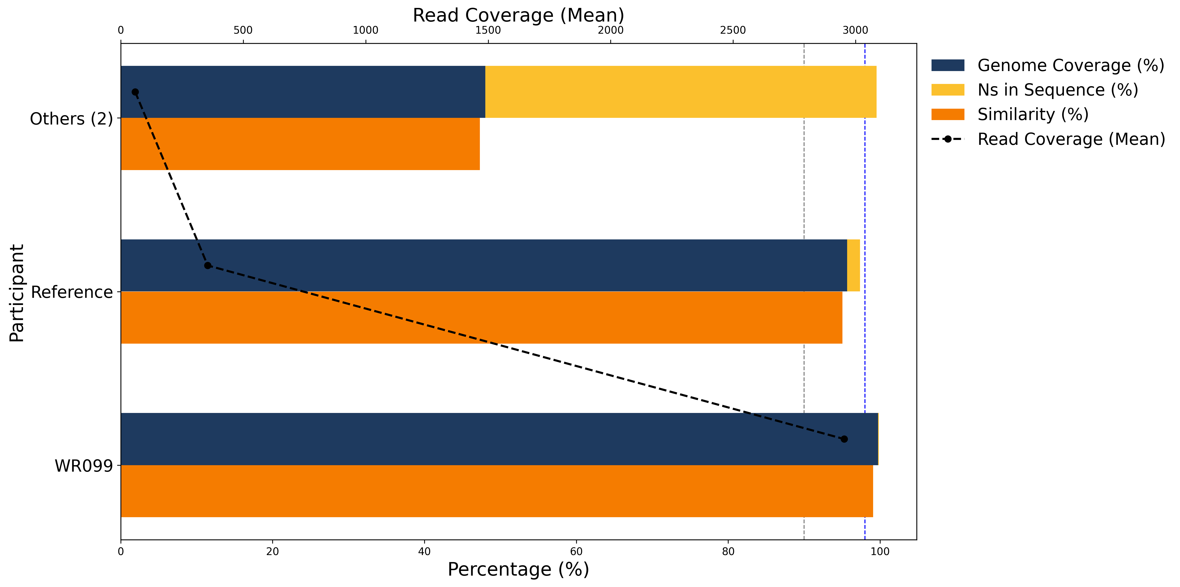

|  |  |  |  |  |
| --- | --- | --- | --- | --- |
| **Participant** | **Genome Coverage (%)** | **Ns in Sequence (%)** | **Similarity (%)** | **Read Coverage (Mean)** |
| *Others (2)* | 48.0 | 51.5 | 47.3 | 59.0 |
| *Reference* | 95.7 | 1.7 | 95.0 | 355.0 |
| *WR099* | 99.7 | 0.1 | 99.1 | 2953.7 |

***Table 2. Quality metrics data for sample 2524***

***Figure 2. Genomic visualisation of submitted sequence and reads.***

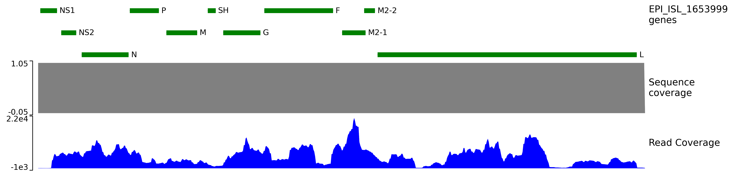

# Sample 2525

## Lineage assignment

* Your lab's clade assignment differs from the reference lab's and the most frequently submitted by other participants.

|  |  |  |  |
| --- | --- | --- | --- |
| **Participant** | **RSV Subtype** | **Clade** | **Legacy clade** |
| *Others (3)* | RSV-A | A.D.3 | GA2.3.5 |
| *Reference* | RSV-A | A.D.3 | GA2.3.5 |
| *WR099* | RSV-A | A.3.1.1 | GA2.3.3 |

***Table 3. Clade assignments for sample 2525, including RSV subtype.***

## Sequencing quality

* Obtained sufficient genome coverage (90% or higher).
* Obtained sufficient Ns in Sequence (2% or lower).
* Failed to satisfy the threshold for Similarity (98%).
* Obtained sufficient Read Coverage (Mean depth of 50 or higher).

***Figure 3. Quality metrics for sample 2525 for participants that submitted appropriate data files***

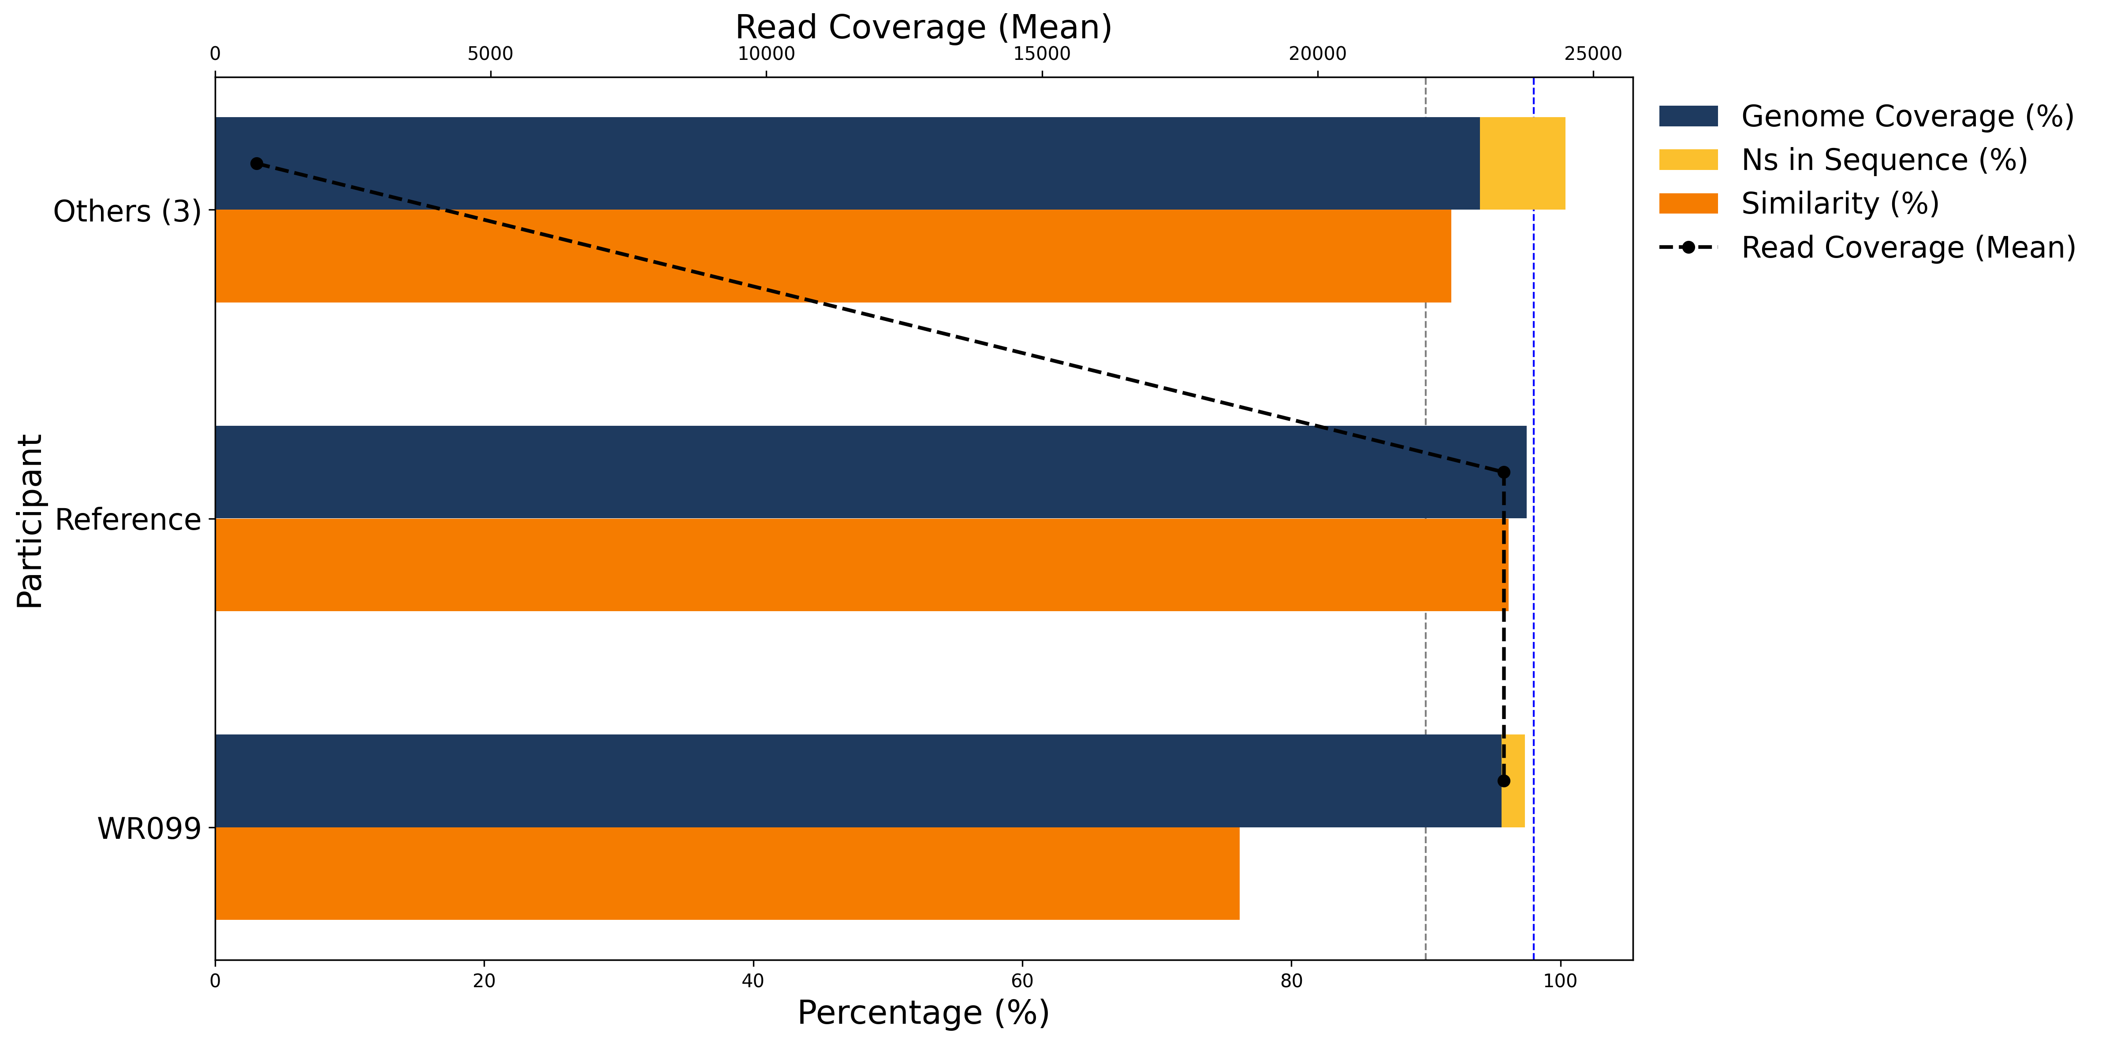

|  |  |  |  |  |
| --- | --- | --- | --- | --- |
| **Participant** | **Genome Coverage (%)** | **Ns in Sequence (%)** | **Similarity (%)** | **Read Coverage (Mean)** |
| *Others (3)* | 94.0 | 6.4 | 91.9 | 751.6 |
| *Reference* | 97.5 | 0.0 | 96.1 | 23378.1 |
| *WR099* | 95.6 | 1.7 | 76.2 | 23378.2 |

***Table 4. Quality metrics data for sample 2525***

***Figure 4. Genomic visualisation of submitted sequence and reads.***

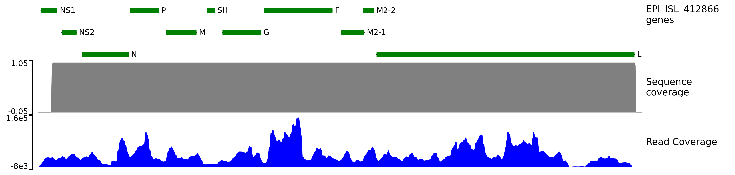

# Sample 2526

## Lineage assignment

* Your lab's clade assignment matches the reference lab's and the most frequently submitted by other participants.

|  |  |  |  |
| --- | --- | --- | --- |
| **Participant** | **RSV Subtype** | **Clade** | **Legacy clade** |
| *Others (2)* | RSV-B | B.D.E.1 | GB5.0.5a |
| *Reference* | RSV-B | B.D.E.1 | GB5.0.5a |
| *WR099* | RSV-B | B.D.E.1 | GB5.0.5a |

***Table 5. Clade assignments for sample 2526, including RSV subtype.***

## Sequencing quality

* Obtained sufficient genome coverage (90% or higher).
* Obtained sufficient Ns in Sequence (2% or lower).
* Obtained sufficient Similarity (98% or higher).
* Obtained sufficient Read Coverage (Mean depth of 50 or higher).

***Figure 5. Quality metrics for sample 2526 for participants that submitted appropriate data files***

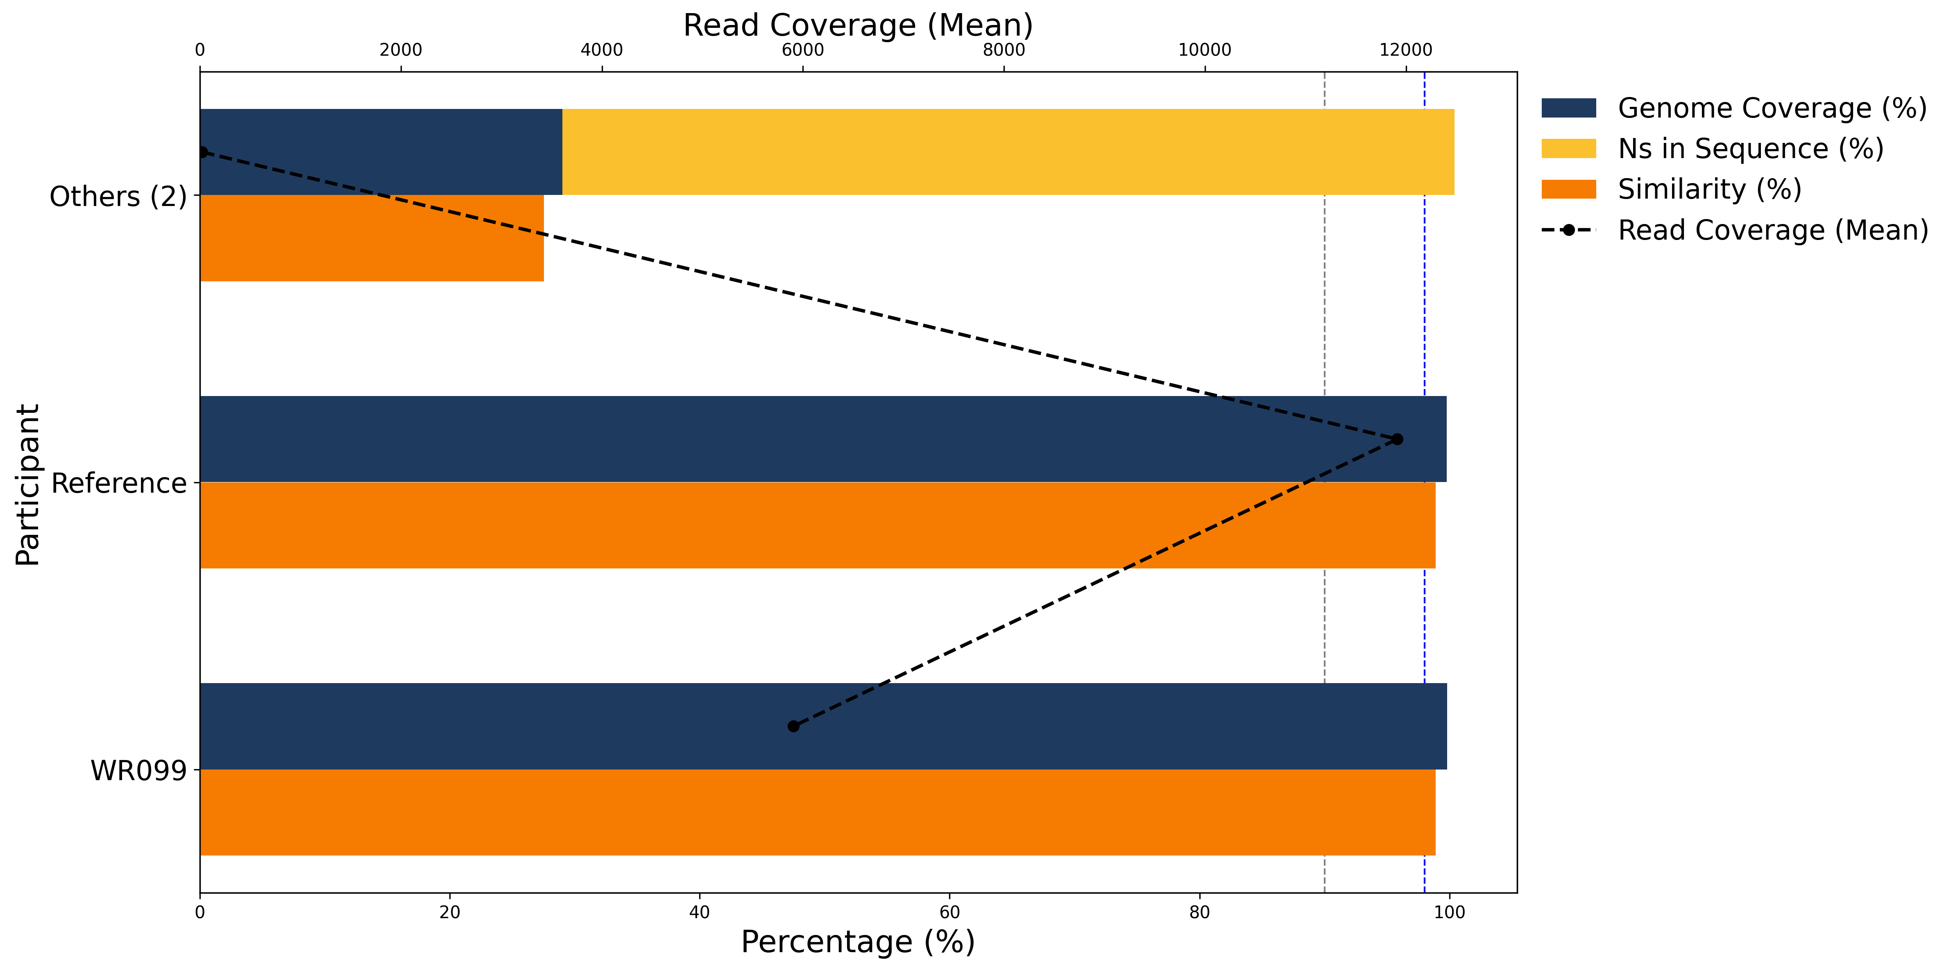

|  |  |  |  |  |
| --- | --- | --- | --- | --- |
| **Participant** | **Genome Coverage (%)** | **Ns in Sequence (%)** | **Similarity (%)** | **Read Coverage (Mean)** |
| *Others (2)* | 29.0 | 71.4 | 27.5 | 21.4 |
| *Reference* | 99.8 | 0.0 | 98.9 | 11912.1 |
| *WR099* | 99.8 | 0.0 | 98.9 | 5903.4 |

***Table 6. Quality metrics data for sample 2526***

***Figure 6. Genomic visualisation of submitted sequence and reads.***

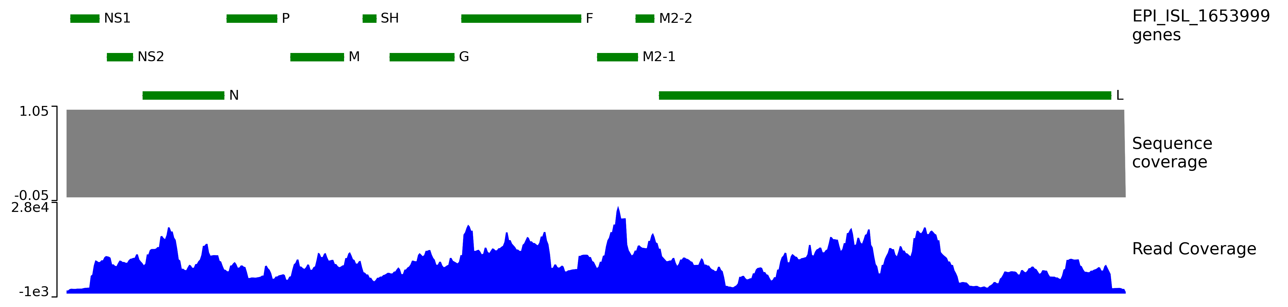

**Appendix 1: Additional Information  
  
*Samples provided and testing required***Original samples distributed by UK NEQAS Microbiology were freeze dried.  
 ➢ Sequencing-only laboratories received samples directly and were instructed to reconstitute with 0.5mL of  
molecular grade water prior to testing.  
 ➢ Samples processed by a primary testing laboratory were forwarded on as RNA / lysate and handled and  
stored according to local procedures / policies.  
Sequencing was carried out according to the laboratory's normal procedure.  
  
***Data submission and analysis***Data collection, quality control (QC), storage and analysis to WHO defined standards and requirements was carried out by University of Cranfield in collaborations with UK NEQAS for Microbiology and Micropathology ltd.  
Participants were required to submit a FASTA file as a minimum requirement. It is also possible to submit FASTQ and BED files which are used to assess quality metrics.  
  
***Validated results***The EQA cases were validated by a national RSV sequencing reference laboratory using Illumina sequencing with 99.9% of the genome covered at 20x. The quality of the reference laboratory sequences was classed as very high. Participants have only been assessed against regions successfully covered by the reference laboratory. Stated lineages were established using Nextclade and Nextstrain identifiers are reported. Participant submissions were compared against the reference sequences suggested by GISAID: EPI_ISL_412866 (RSV A) and EPI_ISL_1653999 (RSV B) for all regions successfully sequenced by the reference laboratory.  
  
***Quality Metrics***Where appropriate data files have been provided by the participant, the following quality metrics will be stated on the ‘gaps’ worksheet for each sample:  
➢ Genome Coverage (%) - The percentage of reference bases covered, with a threshold typically set at ≥90%. Computed using Nextclade.  
➢ Ns in Sequence (%) - The percentage of ambiguous bases (N's) in the sequence, with a threshold typically set at ≤2%. Computed using Nextclade.  
➢ Similarity (%) - The percentage of sequence similarity compared to the reference, with a threshold typically set at ≥98%. Computed using Nextclade.  
➢ Read Coverage (Mean Depth) - The average depth of sequencing reads, with a threshold typically set at ≥50. Computed using Qualimap2.  
  
***Participation and scoring submissions***xxxxxxxxxxxxxxxxxx  
  
***Scheme compliance***All participating laboratories complied with Scheme instructions.

***Automatically generated by xxx. All rights reserved © UKNEQAS for Microbiology; 2025***