

ITI AI PRO Graduation Project

New Feed Summarization and RecommendationReport

December 12th, 2021

1. **Initial design and flow of the web portal:**

* Concerning the recommender system, we will be dealing with 2 libraries: Matrix Factorization library and Surprise library.
* The user insert his id and then he will be redirected to the top n-recommended articles according to his preferences and history of interest.
* We will be dealing with 2 modes : recommending articles or sub-categories whereby he can show more articles under such sub-category. This will be achieved using a dropdown list.

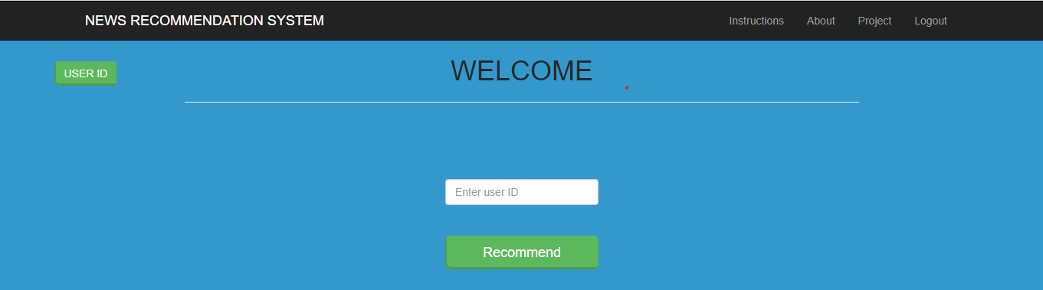

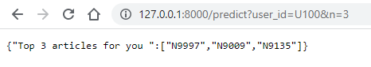

* The user can select any of these articles and will be directed to the article URL.

|  |  |  |
| --- | --- | --- |
| API | HTTP Request method | FUNCTION |
| IP:PORT_NO/ | GET | Welcoming Page |
| IP:PORT_NO/status | GET | Gives info about model |
| IP:PORT_NO/predict | GET | Get top n-recommended items |

1. GIT repository link : <https://github.com/karimhenry/New_feed_Summarization_Recommendation>
2. Presentation link : <https://docs.google.com/presentation/d/1536WLXjunobkA0Jt83VhAaOTKIWGRsUg/edit?usp=sharing&ouid=114999608387157692062&rtpof=true&sd=true>