
Design Documentation
CXS Bridge
Encryption & Data Management System


Supervised by En. Menna Samir
Prepared by Fady Samy
Internship Program Digital Design Internship

Table of Contents
Table of Contents 2
Table of Figures 3
1 Architecture 4
1.1 Purpose 4
2 System Overview 4
2.1 Functional Description 4
2.2 Data Flow Path 4
2.3 Control Flow Path 5
2.4 Main Functional Blocks 5
3 CXS Interface Wrapper (CXS_IF) 5
Purpose 6
3.1 RX Interface 7
3.1.1 Internal FLIT Format 7
3.2 FLIT FIFO 7
3.3 Credit Manager 8
3.3.1 Credit Counter Operation 9
3.4 Packet Formatter 10
3.5 Packet Encoder 10
4 Asynchronous FIFO (ASYNC_FIFO) 12
4.1 Write Pointer Handler 12
4.2 Read Pointer Handler 13
4.3 FIFO Memory 13
5 Control Unit 13
5.1 Finite State Machine (FSM) 15
5.2 tlp_data_payloads_received 15
5.3 tlp_config_counter 16
6 Transaction Layer Packets (TLP) 16
6.1 Overview 16
6.2 Configuration Transaction Layer Packet (Configuration TLP) 16
6.2.1 Field Descriptions (Configuration TLP Header) 16
6.3 Transfer Transaction Layer Packet (Transfer TLP) 17
6.3.1 Field Descriptions (Transfer TLP Payload) 17
7 Encryption Module 18
8 Parity Module 18
9 Address Translation Unit (ATU) 19
10 Central Data Memory (CDM) 21
10.1 Internal Organization 22
10.2 Write Source Selection 22

Table of Figures
Figure 1 - Architecture block diagram 4
Figure 2 - CXS Interface Wrapper (CXS_IF) architecture 6
Figure 3 - RX Interface block diagram 7
Figure 4 - FLIT FIFO block diagram 8
Figure 5 - Credit Manager block diagram 9
Figure 6 - Packet Formatter block diagram 10
Figure 7 - Packet Encoder block diagram 11
Figure 8 - Asynchronous FIFO block diagram 12
Figure 9 - Control Unit block diagram 14
Figure 10 - Control Unit FSM state diagram 15
Figure 11 - Encryption Module block diagram 18
Figure 12 - Parity Module block diagram 19
Figure 13 - Address Translation Unit (ATU) block diagram 19
Figure 14 - Central Data Memory (CDM) block diagram 21

1 Architecture

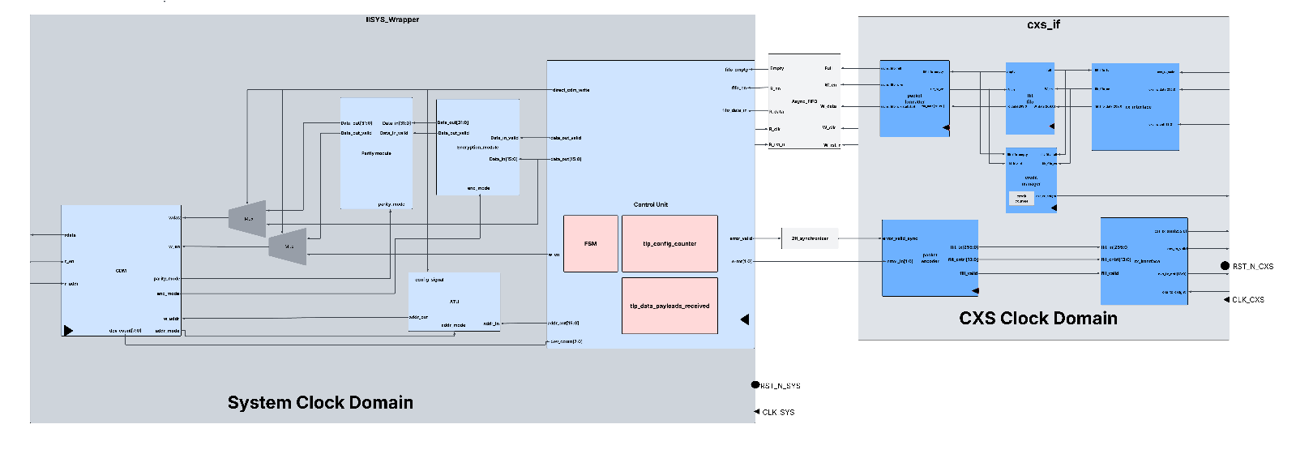
Figure 1 - Architecture block diagram

1.1 Purpose
This document defines the architecture of the CXS Bridge Encryption and Data Management System, a hardware module designed for secure data transfer between a CXS interface and multiple internal logic blocks. The bridge provides:
● Configurable data encryption.
● Parity generation for data integrity.
● Centralized data storage.
● Configuration management.
● Interface arbitration between software and internal hardware blocks.

The design targets a VLSI implementation and is intended to operate as an intermediate communication bridge between external software and internal processing modules.

2 System Overview
The CXS Bridge receives configuration packets and data packets from the CXS interface, encrypts incoming payloads using a configurable expansion algorithm, appends parity information, and stores the processed data inside the Central Data Memory (CDM). Multiple internal logic blocks access the CDM using dedicated address regions assigned during system configuration.
The Control Unit manages:
● System initialization and configuration registers.
● Phase transitions (Configuration, Link-Up, Data Transmission).
● Memory access arbitration and status reporting.

2.1 Functional Description

2.2 Data Flow Path
The data flow path is responsible for receiving, processing, and storing packet data transferred through the CXS interface.
- Flit Reception
The RX Interface receives incoming CXS flits, validates the receive interface signals, and stores accepted flits in the internal Flit FIFO.
- Packet Formatting
The Packet Formatter extracts valid 32-bit words from each flit and forwards them to the Asynchronous FIFO for clock-domain crossing.
- Packet Processing
The Control Unit interprets the received TLPs according to the current system state. During the Configuration phase, configuration information is extracted and written directly to the CDM. During the Transfer phase, payload data and logical addresses are separated for further processing.
- Data Processing
Payload data is encrypted according to the configured encryption mode, after which parity information is generated before storage.
- Address Translation
Logical addresses are translated into physical CDM addresses using the configured address translation mode and the device mapping information stored during configuration.
- Memory Storage
The processed payload, together with its parity information, is stored in the CDM at the translated address.

2.3 Control Flow Path
The control flow path coordinates the operation of all functional blocks and ensures correct sequencing of packet processing.
- System Initialization
The Control Unit initializes the system and enters the Configuration phase following reset.
- Configuration Management
Configuration TLPs update the CDM configuration registers, including device mappings, encryption mode, parity mode, and address translation mode.
- Packet Coordination
The Control Unit manages packet sequencing, monitors packet completion, and controls transitions between the Configuration and Transfer phases.
- Flow Control
The Credit Manager monitors the availability of receive buffering and generates credit grant signals to regulate incoming traffic on the CXS link.
- Clock Domain Coordination
The Asynchronous FIFO and synchronizers safely transfer data and control signals between the CXS and System clock domains.
- Status Reporting
Error conditions detected during processing are encoded into response packets and transmitted through the TX Interface.

2.4 Main Functional Blocks
CXS Interface: Interfaces with the CXS link to receive and transmit flits. It performs protocol handling, credit-based flow control, packet formatting, and clock-domain crossing between the CXS and System clock domains.
Control Unit: Coordinates the overall system operation by processing Transaction Layer Packets (TLPs), managing the Configuration and Transfer phases, controlling data movement, and generating control signals for the remaining functional blocks.
Encryption Block: Encrypts payload data during the Transfer phase according to the configured encryption mode before storage in the Central Data Memory (CDM).
Parity Unit: Generates parity information for encrypted payload data according to the selected parity configuration to support error detection.
Address Translation Unit (ATU): Translates logical addresses into physical CDM addresses using the configured address translation mode and the device configuration information stored in the CDM.
Central Data Memory (CDM): Stores system configuration information, including device address mappings and operating parameters, together with encrypted payload data and the corresponding parity information.

3 CXS Interface Wrapper (CXS_IF)

Purpose
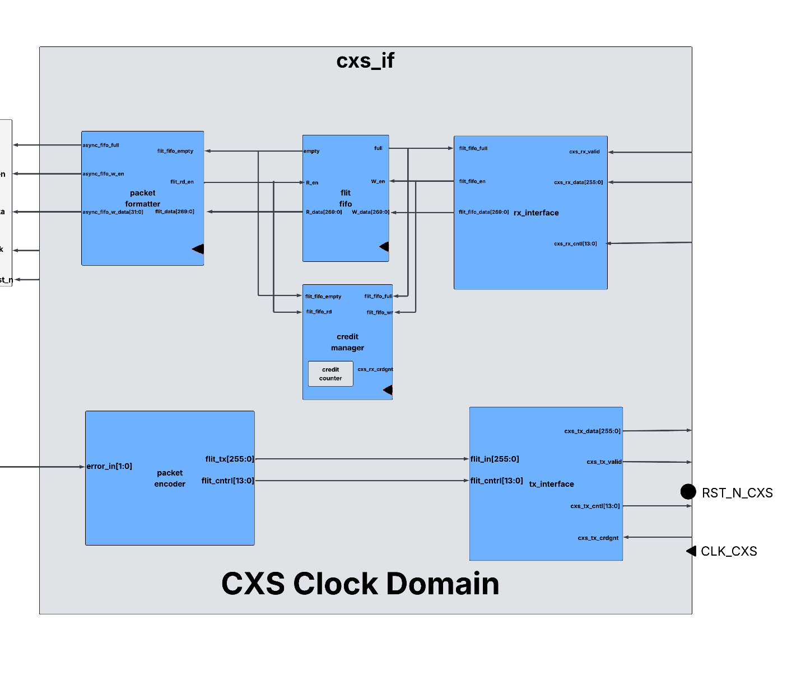
Figure 2 - CXS Interface Wrapper (CXS_IF) architecture
CXS Interface Wrapper: Top-level module operating in the CXS clock domain that integrates the receive path, transmit path, flow control, and FIFO buffering. It connects the external CXS interface to the internal asynchronous FIFO used for clock-domain crossing.
Name | Type | Size |  | Description
clk_cxs | Input | 1 bit |  | Clock for all logic operating in the CXS clock domain.
rst_n_cxs | Input | 1 bit |  | Active-low reset for all CXS interface submodules.
cxs_rx_valid | Input | 1 bit |  | Indicates that a valid receive flit is present on the CXS receive interface.
cxs_rx_data | Input | 256 bits |  | Receives incoming flit payload from the CXS link.
cxs_rx_cntl | Input | 14 bits |  | Receives CXS control information associated with the incoming flit.
cxs_rx_crdgnt | Output | 1 bit |  | Credit grant signal returned to the CXS transmitter indicating readiness to accept another flit.
cxs_tx_valid | Output | 1 bit |  | Indicates that a valid transmit flit is available on the CXS transmit interface.
cxs_tx_data | Output | 256 bits |  | Transmit flit payload sent to the CXS link.
cxs_tx_cntl | Output | 14 bits |  | CXS control information associated with the transmitted flit.
async_fifo_full | Input | 1 bit |  | Indicates that the downstream asynchronous FIFO is full and cannot accept additional words.
async_fifo_w_en | Output | 1 bit |  | Write enable signal for the asynchronous FIFO.
async_fifo_w_data | Output | 32 bits |  | Data word written into the asynchronous FIFO for transfer to the system clock domain.
flit_valid | Input | 1 bit |  | Indicates that a complete transmit flit is available from the system for transmission.
flit_data_in | Input | 270 bits |  | Complete transmit flit, including payload and control information, received from the system.
flit_ready | Output | 1 bit |  | Indicates that the CXS transmit path is ready to accept a new transmit flit.

3.1 RX Interface
Purpose
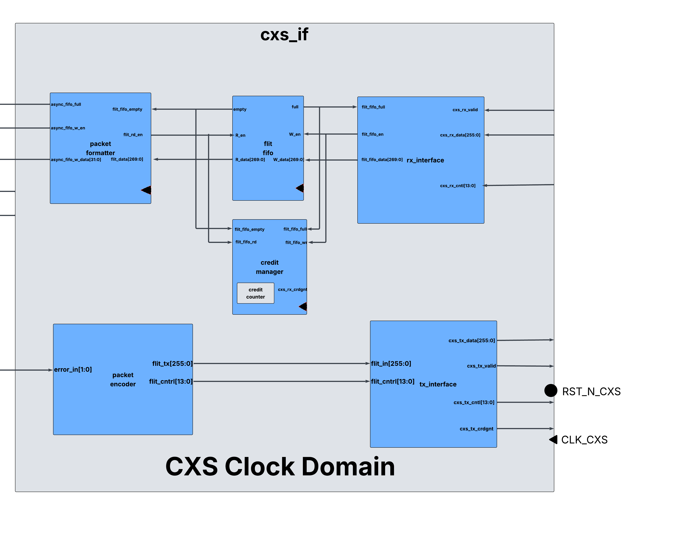
Figure 3 - RX Interface block diagram
The RX Interface receives incoming FLITs from the CXS receive interface and converts them into the internal FLIT format used by the bridge. It accepts valid CXS transactions, checks whether the receive FIFO can accept additional FLITs, and generates FIFO write transactions.

Ports
Name | Type | Size | Description
cxs_rx_valid | Input | 1 bit | Indicates a valid incoming FLIT
cxs_rx_data | Input | 256 bits | Incoming CXS payload
cxs_rx_cntl | Input | 14 bits | Incoming CXS control information
flit_fifo_full | Input | 1 bit | Indicates the FIFO cannot accept another FLIT
flit_fifo_wr | Output | 1 bit | FIFO write enable
flit_fifo_wdata | Output | 270 bits | FLIT written into the FIFO

3.1.1 Internal FLIT Format
The RX Interface combines the incoming control and data fields into a single 270-bit FLIT.
Bits |  | Description
[269:256] |  | CXS Control Field
[255:0] |  | CXS Data Field

Responsibilities
- Receives incoming CXS FLITs.
- Monitors cxs_rx_valid.
- Packs control and payload into the internal FLIT format.
- Prevents writes when the FIFO is full.
- Generates FIFO write requests.

3.2 FLIT FIFO
Purpose
Figure 4 - FLIT FIFO block diagram
The FLIT FIFO buffers received FLITs between the RX Interface and the Packet Formatter. It decouples the CXS receive interface from the internal packet processing logic, allowing each block to operate independently.

Parameters

Name | Default value | Description
DEPTH | 16 | How many locations are in fifo
DATA_WIDTH | 270 | Width of data stored in fifo

Ports

Name | Type | Size | Description
rst_n | Input | 1 bit | Active-low asynchronous reset
clk | Input | 1 bit | FIFO clock
flit_fifo_wr | Input | 1 bit | FIFO write request
flit_fifo_wdata | Input | 270 bits | FLIT to be written
flit_fifo_rd | Input | 1 bit | FIFO read request
flit_fifo_rdata | Output | 270 bits | FLIT read from FIFO
flit_fifo_full | Output | 1 bit | FIFO full indication
flit_fifo_empty | Output | 1 bit | FIFO empty indication

Responsibilities
- Stores incoming FLITs.
- Provides buffering between reception and packet processing.
- Supports independent read and write operations.
- Prevents FIFO overflow and underflow.
- Generates Full and Empty status signals.

3.3 Credit Manager
Purpose
The Credit Manager implements the receive-side credit-based flow control required by the CXS protocol. It maintains the number of available receive credits based on the occupancy of the FLIT FIFO.
Unlike the transmitted credit value, the credit counter is an internal register that tracks the number of available FIFO entries.
For a FIFO depth of 16 entries, the credit counter is 5 bits wide and is initialized to 16 after reset.

Figure 5 - Credit Manager block diagram

3.3.1 Credit Counter Operation
After reset:
credit_counter = 16
On every FIFO write:
credit_counter = credit_counter - 1
On every FIFO read:
credit_counter = credit_counter + 1
The counter therefore always represents the number of free FIFO locations available to receive additional FLITs.
A value of:
- 16 indicates the FIFO is completely empty.
- 0 indicates the FIFO is completely full.

Ports
Name | Type | Size | Description
rst_n | Input | 1 bit | Active-low asynchronous reset
clk | Input | 1 bit | Module clock
flit_fifo_wr | Input | 1 bit | FIFO write event
flit_fifo_rd | Input | 1 bit | FIFO read event
credit_counter | Output | 5 bits | Current available receive credits

Responsibilities
- Tracks available receive credits.
- Decrements the counter whenever a FLIT is written into the FIFO.
- Increments the counter whenever a FLIT is removed from the FIFO.
- Indicates the number of available FIFO entries.
- Prevents additional packet reception when no credits remain.

3.4 Packet Formatter
Purpose
Figure 6 - Packet Formatter block diagram
The Packet Formatter reads FLITs from the FLIT FIFO and reconstructs complete packets for the internal bridge logic. It first captures the flit from async fifo then streams the packets sized according to async fifo in many consecutive clock cycles while also using the captured control signal field from flit fifo so that it can determine what to send and when to stop.

Ports
Name | Type | Size | Description
rst_n | Input | 1 bit | Active-low asynchronous reset
clk | Input | 1 bit | Module clock
flit_fifo_empty | Input | 1 bit | Indicates no FLIT is available
flit_fifo_rdata | Input | 270 bits | FLIT read from FIFO
async_fifo_full | Input | 1 bit | Indicates async fifo is full
flit_fifo_rd | Output | 1 bit | FIFO read enable
async_fifo_w_en | Output | 1 bit | Async fifo write enable
async_fifo_w_data | Output | 32 bits | Streamed data to async fifo

Responsibilities
- Reads FLITs from the FIFO.
- Prevents reads when the FIFO is empty.
- Separates the payload and control fields.
- Reconstructs complete packets.
- Generates valid packet outputs for downstream processing.

Packet control fields
The CXSCNTL signal contains five fields. The widths of each field, and therefore the bit position of each field, vary with the properties of the interface.
Field Description
START Each bit in START indicates that a packet is starting in this flit.
The number of bits in START is CXSMAXPKTPERFLIT, which is the number of packets that can be
present in a flit of data. For example, when CXSMAXPKTPERFLIT = 4, then:
• START[0] = 1, at least one packet is starting in this flit.
• START[1] = 1, at least two packets are starting in this flit.
• START[2] = 1, at least three packets are starting in this flit.
• START[3] = 1, at least four packets are starting in this flit.
If any bit of START is 1, all lower bits of START must be 1.
START[N:0]PTR This field is an array of pointers to the starting location of each of the packets in this flit.
• There is one pointer for each bit in the START field, valid if that bit of START is set.
• If the corresponding START bit is 0, the pointer can have any value and should be ignored.
• All packet starts are 16-byte aligned.
• The width of each pointer is log2(CXSDATAFLITWIDTH/128) bits.
• The first byte of the Xth starting packet is (START[X]PTR << 4).
• Start pointers are defined to be monotonically increasing, for example START1PTR must be
greater than START0PTR.

4.2.2 Packet control field structure
Table 4-2 shows Packet control field widths and placement information for all combinations of
CXSMAXPKTPERFLIT and CXSDATAFLITWIDTH.
these structures are used.
END Each bit in END indicates that a packet is ending in this flit.
The number of bits in END is CXSMAXPKTPERFLIT, which is the number of packets that can be
present in a flit of data. For example, when CXSMAXPKTPERFLIT = 4, then:
• END[0] = 1, at least one packet is ending in this flit.
• END[1] = 1, at least two packets are ending in this flit.
• END[2] = 1, at least three packets are ending in this flit.
• END[3] = 1, at least four packets are ending in this flit.
If any bit of END is 1, all lower bits of END must be 1.
ENDERROR Each bit in ENDERROR indicates that a packet is ending with an error condition in this flit
• ENDERROR[0] = 1, the first packet ending this cycle has an error.
• ENDERROR[1] = 1, the second packet ending this cycle has an error.
• ENDERROR[2] = 1, the third packet ending this cycle has an error.
• ENDERROR[3] = 1, the fourth packet ending this cycle has an error.
The number of bits in ENDERROR is the number of bits in END.
If ENDERROR[N] is asserted, END[N] must be asserted.
END[N:0]PTR This field is an array of pointers to the last 4 bytes of packets ending in this flit.
• There is one pointer for each END bit, valid only if that END bit is set.
• If the corresponding END bit is 0, the pointer can have any value and should be ignored.
• All packet ends are 4-byte aligned.
• The width of each pointer is log2(CXSDATAFLITWIDTH/32) bits.
• Each end pointer points to the first byte of the last aligned 4 bytes of the packet.
• The last byte of the Xth ending packet is therefore ((END[X]PTR << 2)+3).
• Valid end pointers are defined to be monotonically increasing, for example if two packets end
in this flit then END1PTR must be greater than END0PTR.
Note
START[X]PTR and END[X]PTR might not point to the same packet, for example if a packet
started in a previous flit.

3.5 Packet Encoder
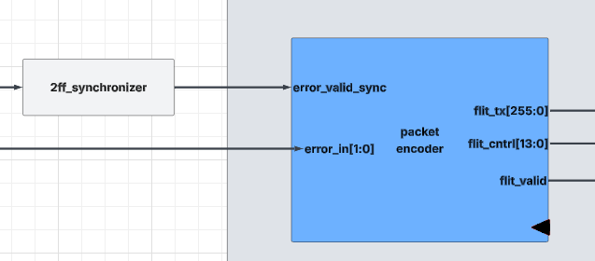
Figure 7 - Packet Encoder block diagram

Purpose:
Generates a CXS transmit flit in response to protocol or processing events detected by the Control Unit. The Packet Encoder monitors the synchronized error indication, constructs the appropriate response packet using the received error code, and outputs the encoded flit together with its associated control information for transmission through the TX Interface.
Name | Type | Size | Description
clk_cxs | Input | 1 bit | Clock for the Packet Encoder operating in the CXS clock domain.
rst_n_cxs | Input | 1 bit | Active-low reset.
error_valid_sync | Input | 1 bit | Synchronized error indication received from the system clock domain, initiating generation of a response packet.
error_in | Input | 2 bits | Encoded error type received from the Control Unit to be included in the response packet.
flit_tx | Output | 256 bits | Encoded transmit flit generated for transmission over the CXS interface.
flit_cntrl | Output | 14 bits | Control field associated with the generated transmit flit.
flit_valid | Output | 1 bit | Indicates that a valid transmit flit has been generated

Responsibilities
- Receives internal error or status information.
- Encodes the information into the CXS FLIT format.
- Generates the corresponding control field.
- Sends the generated FLIT to the TX Interface for transmission.

4 Asynchronous FIFO (ASYNC_FIFO)
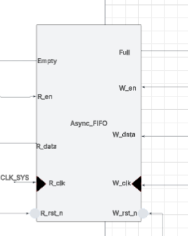
Figure 8 - Asynchronous FIFO block diagram

Purpose:
Safely transfers packet data between the CXS clock domain (CLK_CXS) and the System clock domain (CLK_SYS). It provides clock domain crossing (CDC), elastic buffering, rate matching between independent clock domains, and back-pressure handling while preventing metastability through synchronized read and write pointers.

Parameters:
Name | Default Value | Description
PKT_WIDTH | 24 bits | Packet total Width

Ports:
Name | Type | Size | Description
Full | Output | 1 bit | Wrap around and both pointers point to same location
W_en | Input | 1 bit | FIFO write enable
W_data | Input | PKT_WIDTH +1 | FIFO input data
W_clk | Input | 1 bit | Write clock
W_rst_n | Input | 1 bit | Write reset
Empty | Output | 1 bit | No Wrap around and both pointers point to same location
R_en | Input | 1 bit | FIFO read enable
R_data | Output | PKT_WIDTH +1 | FIFO input data
R_clk | Input | 1 bit | read clock
R_rst_n | Input | 1 bit | read reset
Purpose
The Asynchronous FIFO provides safe Clock Domain Crossing (CDC) between the CXS Interface (CLK_CXS) and the internal processing logic (CLK_SYS). It temporarily buffers packets while transferring them between independent clock domains, preventing metastability and accommodating differences in clock frequency. The FIFO also generates Full and Empty status flags, which are used by the CXS Interface and Credit Manager to implement flow control and prevent overflow or underflow.
One thing to make clear is that EOP signal (end of packet) bit which will be indicated by END signal that exists in CNTRL

Internal Architecture
The Asynchronous FIFO consists of three major functional blocks:
Write Pointer Handler
Read Pointer Handler
Dual-Port FIFO Memory

4.1 Write Pointer Handler
Purpose:
Operates in the write clock domain (CLK_CXS) and manages all write-side FIFO operations.
Responsibilities:
Maintains the binary write pointer.
Generates the Gray-coded write pointer for safe clock-domain synchronization.
Synchronizes the read pointer into the write clock domain using a two-stage synchronizer.
Detects the Full condition by comparing the synchronized read pointer with the next write pointer.
Updates the write pointer whenever a valid write request is accepted.

4.2 Read Pointer Handler
Purpose:
Operates in the read clock domain (CLK_SYS) and manages all read-side FIFO operations.
Responsibilities:
Maintains the binary read pointer.
Generates the Gray-coded read pointer.
Synchronizes the write pointer into the read clock domain using a two-stage synchronizer.
Detects the Empty condition by comparing the synchronized write pointer with the read pointer.
Updates the read pointer whenever a read transaction occurs.

4.3 FIFO Memory
Purpose:
Stores packets transferred between the two clock domains.
Responsibilities:
Accepts data using the write clock.
Provides data using the read clock.
Supports simultaneous read and write operations because the read and write ports operate independently.
Uses the write and read pointers to determine memory locations for incoming and outgoing packets.

5 Control Unit

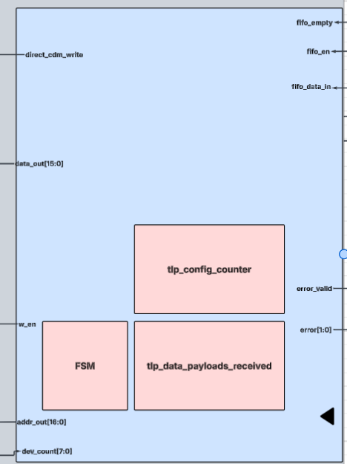
Figure 9 - Control Unit block diagram
Purpose:
Controls the overall system operation by interpreting incoming Transaction Layer Packets (TLPs) according to the current system state. It processes packet headers, extracts address and payload information, manages the configuration and data transfer phases, generates write requests for the Central Data Memory (CDM), controls the encryption bypass during configuration, coordinates data processing through the Encryption and Parity modules, and detects and reports protocol or packet format errors.

Parameters:
Name | Default Value | Description
ADDR_WIDTH | 8 bits | How many addresses
DATA_WIDTH | 16 bits | Data_WIDTH

Ports:

Name | Type | Size | Description
clk_sys | Input | 1 bit | System clock.
rst_n | Input | 1 bit | Active-low system reset.
fifo_empty | Input | 1 bit | Indicates that the asynchronous FIFO contains no data.
fifo_en | Output | 1 bit | Read enable for the asynchronous FIFO.
fifo_data_in | Input | 32 bits | Current word read from the asynchronous FIFO.
direct_cdm_write | Output | 1 bit | Bypasses the encryption path and writes configuration data directly to the CDM during the configuration phase.
w_en | Output | 1 bit | Write enable for the destination memory/register.
addr_out | Output | 16 bits | Address extracted from the received packet and forwarded to the Address Translation Unit (ATU).
data_out | Output | 16 bits | Data field extracted from the received packet for writing to the CDM or forwarding to the encryption path.
dev_count | Input | 8 bits | Number of configured devices extracted from the configuration register.
error_valid | Output | 1 bit | Indicates that a protocol or processing error has occurred.
error | Output | 2 bits | Encoded error type generated by the Control Unit.

5.1 Finite State Machine (FSM)

5.2 tlp_data_payloads_received
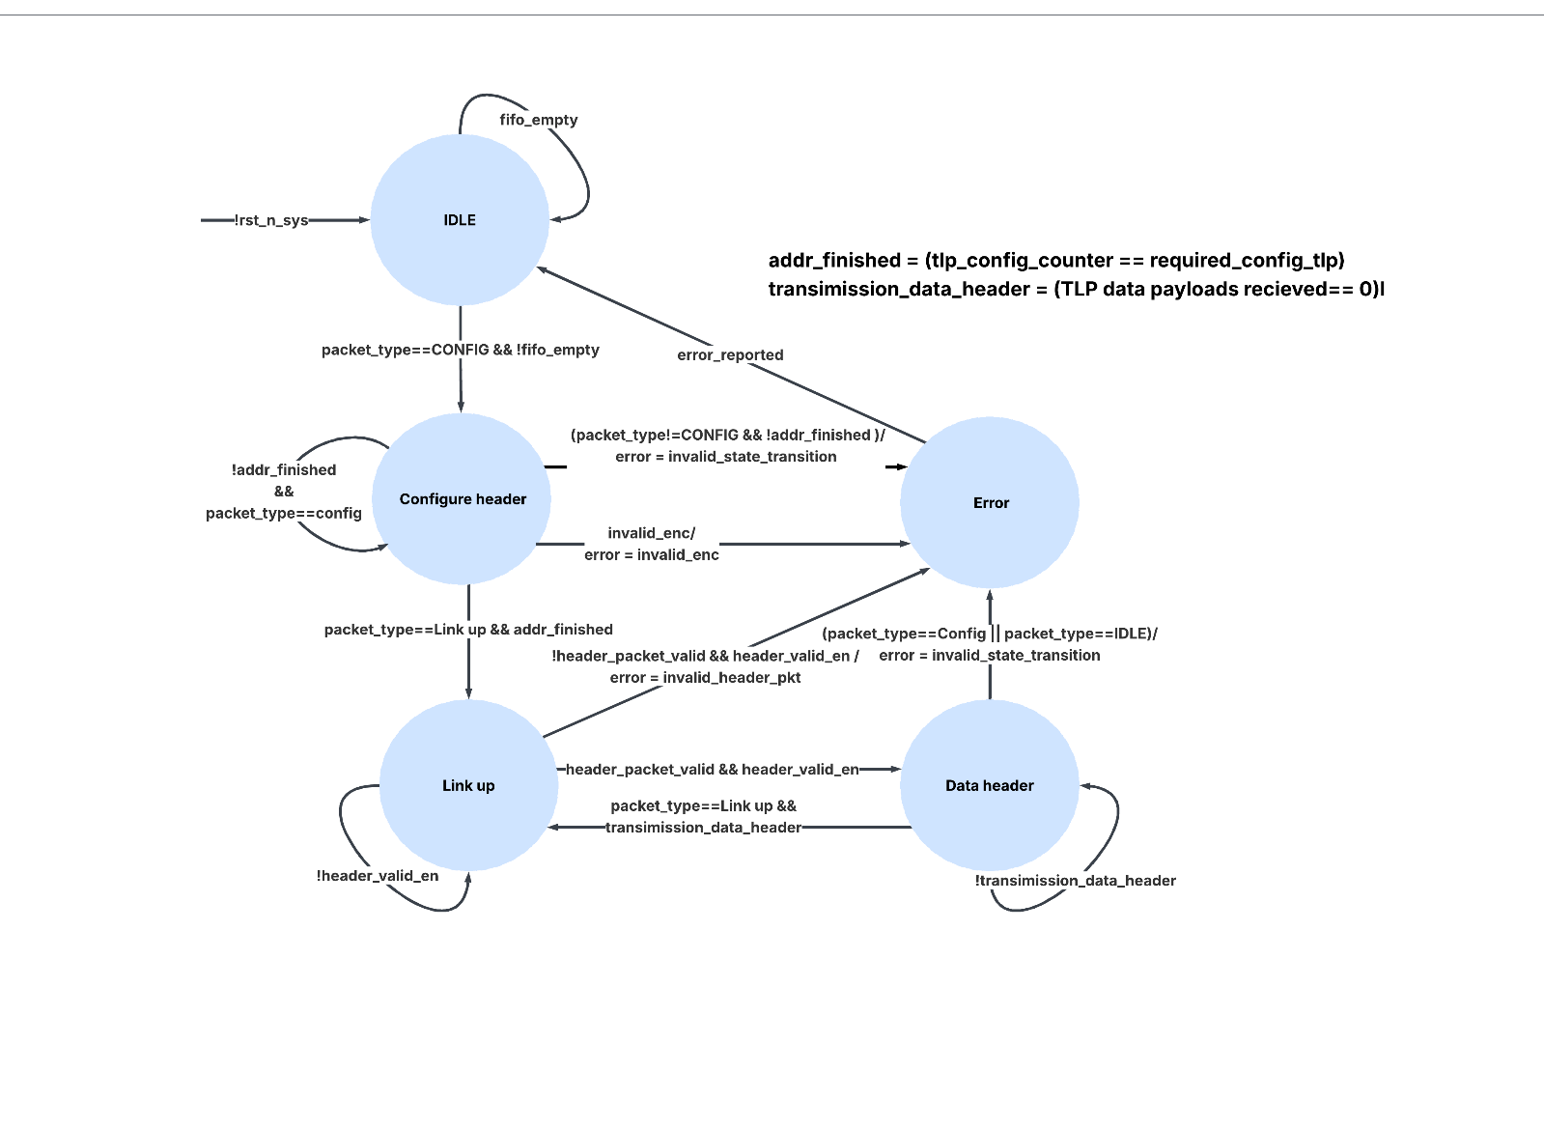
Figure 10 - Control Unit FSM state diagram
Purpose:
Counts the number of payload words received for the current Transaction Layer Packet (TLP), regardless of whether the packet is a Configuration TLP or a Data TLP. The counter is reset at the start of every new TLP and incremented for each payload word received after the header. It is used by the Control Unit to determine when the current TLP has been completely processed.
Since Configuration and Data TLPs may contain different numbers of payload words, the counter output is compared against a phase-dependent expected payload count. Separate comparators are used to determine packet completion according to the active packet type.
Responsibilities:
- Counts the payload words received for the current TLP, excluding the header word.
- Resets automatically at the beginning of each new TLP.
- Provides the current payload word count to the Control Unit.
- Supports both Configuration and Data TLP processing.
- Works with separate completion comparators to determine when the expected number of payload words has been received for the active TLP type.

5.3 tlp_config_counter
Size: DEV_COUNT + 1 bits (9 bits in the current implementation)
Purpose:
Tracks the number of device configuration entries successfully written during the Configuration phase and generates the corresponding CDM configuration address. Unlike the payload counter, this counter is specific to the configuration process and is used to sequentially populate the configuration registers stored in the CDM.
Responsibilities:
- Generates the configuration address used to write device configuration entries sequentially into the CDM, starting from Base Address 0x0001.
- Increments once for each successfully processed configuration payload word.
- Determines when all device configuration entries have been written by comparing the current count against the configured DEV_COUNT.
- Signals completion of the Configuration phase to allow the Control Unit to transition to the next operating state.

6 Transaction Layer Packets (TLP)

6.1 Overview
Communication between the CXS Interface and the Control Unit is performed using Transaction Layer Packets (TLPs). Two packet types are supported: Configuration TLPs and Data TLPs. The Configuration TLP initializes the system and device configuration, while the Data TLP carries payload data for processing and storage

6.2 Configuration Transaction Layer Packet (Configuration TLP)
The Configuration Transaction Layer Packet (Configuration TLP) is utilized to program system control settings, address range parameters, encryption modes, and parity checking policies across connected target devices. Word 0 serves as the global header, followed by N configuration words defined by DEV_COUNT.
Word | Description | Format
Word 0 | Header | BASE_ADDR [31:16], DEV_COUNT [15:8], ENC_MODE [7:4], ADDR_MODE [3], PARITY_MODE [2], SYS_STATE [1:0]
Word 1 | Device Configuration 0 | END_ADDR [31:16], START_ADDR [15:0]
Word 2 | Device Configuration 1 | END_ADDR [31:16], START_ADDR [15:0]
... | ... | ...
Word N | Device Configuration (DEV_COUNT−1) | END_ADDR [31:16], START_ADDR [15:0]

6.2.1 Field Descriptions (Configuration TLP Header)

Field Name | Bit Range | Description / Function
BASE_ADDR | 31:16 | Base address for CDM translation. Not hardcoded in the design: software supplies it in this header field during the Configuration phase, and the ATU latches it and adds it to every payload address during the Transfer phase.
DEV_COUNT | [15:8] | Device Count indicator (Specifies the number of attached configurable device words, up to 256).
ENC_MODE | [7:4] | Encryption Mode setting (Defines cipher mode: e.g., AES-128, AES-256, Bypass, Custom).
ADDR_MODE | [3] | Address Mode selector (0 = Direct 16-bit addressing, 1 = Extended / Paged addressing).
PARITY_MODE | [2] | Parity Mode selection (0 = Even Parity, 1 = Odd Parity).
SYS_STATE | [1:0] | System State configuration (00 = Idle, 01 = Operational, 10 = Maintenance, 11 = Reset).

6.3 Transfer Transaction Layer Packet (Transfer TLP)

The Transfer Transaction Layer Packet (Transfer TLP) carries execution data and write commands between functional modules. Like the Configuration TLP, Word 0 defines the header parameters. All subsequent words are designated as Payloads, where each 32-bit payload word contains 16 bits of Data and 16 bits of Target Address.

Word | Description | Format
Word 0 | Header | BASE_ADDR [31:16], DEV_COUNT [15:8], ENC_MODE [7:4], ADDR_MODE [3], PARITY_MODE [2], SYS_STATE [1:0]
Word 1 | Payload 0 | ADDR [31:16], DATA [15:0]
Word 2 | Payload 1 | ADDR [31:16], DATA [15:0]
... | ... | ...
Word N | Payload (N−1) | ADDR [31:16], DATA [15:0]

6.3.1 Field Descriptions (Transfer TLP Payload)

Field Name | Bit Range | Description / Function
DATA | [15:0] | 16-bit Payload Data payload payload transferred to the target destination address.
ADDR | [31:16] | 16-bit Destination Target Address specifying where the payload data is to be written.

7 Encryption Module
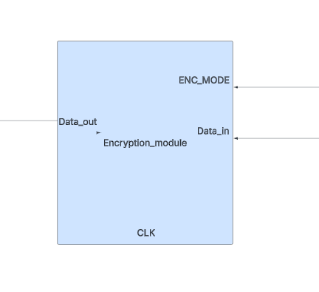
Figure 11 - Encryption Module block diagram
Purpose:
The Encryption Block encrypts the payload data extracted from incoming Data TLPs before it is stored in the Central Data Memory (CDM). The encryption operation is performed according to the configured encryption mode specified during the system configuration phase. During configuration packets, the encryption path is bypassed to allow configuration information to be written directly to the CDM without modification.

Parameters:
Name | Default Value | Description
DATA_WIDTH | 16 bits | Data_WIDTH

Ports:
Name | Type | Size | Description
CLK | Input | 1 bit | System clock (CLK_SYS). Encryption Module resides in the System Clock Domain (spec Section 9).
ENC_MODE | Input | 4 bits | Encryption mode selection, sourced directly from the Register File ENC_MODE field (Base Address 0x0000, bits [7:4], spec Section 5). 0000 = Even, 0001 = Odd.
Data_in | Input | DATA_WIDTH | Input data word to be encrypted, matching the payload width split out by the Control Unit (data_out).
Data_out | Output | DATA_WIDTH*2 | Bit-expanded (encrypted) output word. Per spec Section 4.3, each expansion mode doubles the input width, so Data_out is defined as DATA_WIDTH*2.

Encryption logic:
The Encryption Module performs a configurable bit-expansion algorithm based on the parity of the input word :
Step 1 -- Bit Counting: counts the number of logic '0' and '1' bits in the input word.
Step 2 -- Mode A (Even): 0 -> 00 1->01.
Step 3 -- Mode B (Odd): 0 -> 10 1->11.
Note: if the counts of 0s and 1s are equal, or both counts are even, the expansion maps '0' -> '01' and '1' -> '10' (e.g., input '10' becomes '1001').
ENC_MODE is configured once by software during the Configuration phase and held in the Register File.

8 Parity Module

Purpose:
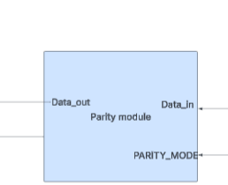
Figure 12 - Parity Module block diagram
The Parity Block is a combinational logic unit that generates a parity bit for encrypted payloads coming from the Encryption Block. Based on the configuration in the Register File (Even or Odd parity), the block immediately computes and attaches the parity bit to any valid payload before routing the final data to the Central Data Memory (CDM).
Parameters:
Name | Default Value | Description
ENC_DATA_WIDTH | 32 bits | Data_WIDTH

Ports:
Name | Type | Size | Description
PARITY_MODE | Input | 1 bit | Parity configuration, sourced directly from the Register File PARITY_MODE field (Base Address 0x0000, bits [3:2], spec Section 5).
Data_in | Input | ENC_DATA_WIDTH | Encrypted data word received from the Encryption Module, matching the Encryption Module's Data_out width.
Data_out | Output | ENC_DATA_WIDTH +1 | Encrypted data with the generated parity bit appended, forwarded to the CDM for storage (spec Section 4.4).

Description:
The Parity Module generates a parity bit (Even or Odd, selected by PARITY_MODE) which is appended to the encrypted data before it is written into the CDM, to ensure data integrity .
PARITY_MODE is configured once by software during the Configuration phase and held in the Register File. The field is a single bit: 0 = Even parity, 1 = Odd parity.

9 Address Translation Unit (ATU)
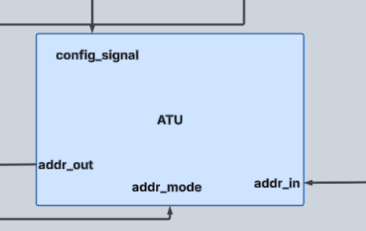
Figure 13 - Address Translation Unit (ATU) block diagram
Purpose:
The Address Translation Unit (ATU) translates logical addresses received from Data TLPs into valid CDM memory addresses according to the configured address translation mode. During address translation, the ATU compares the incoming address against the configured start and end address ranges stored in the configuration registers and determines the appropriate destination region within the CDM. The ATU supports both Address Range Mode and Region Mode and prevents accesses to invalid or unconfigured address regions.
Name | Default Value | Description
ADDR_WIDTH | 16 bits | How many addresses

Ports:
Name | Type | Size | Description
config_signal | input | 1 bit | If asserted at 1 it well be known that the system is in configuration phase
addr_mode | Input | 1 bit | Selects translation mode. Maps directly to Register File bit 3, ADDR_MODE (spec Section 5): 0 = Limit Address/Last Address mode, 1 = Region mode.
addr_in | Input | ADDR_WIDTH | Raw address received from a requesting logic block (Control Unit addr_out), to be translated/validated against the configured device address map (spec Section 4.6).
config_addr | Input | ADDR_WIDTH | Base address carried in the BASE_ADDR field of the Configuration TLP header. Latched during the Configuration phase and added to the incoming address during the Transfer phase, so the base address is programmed by software rather than hardcoded.
addr_out | Output | ADDR_WIDTH | Translated CDM address, generated from the region number + offset combination described in spec Section 4.6.
Description:
The Address Translation Unit (ATU) performs logical-to-physical address translation for memory accesses to the Central Data Memory (CDM). During the data transfer phase, the ATU receives the logical address extracted from the incoming Data TLP and translates it according to the selected address translation mode and the device address information stored in the CDM configuration registers.
The ATU supports two address translation modes:

- Address Range Mode – The incoming address is compared against the configured Start Address and
- End Address entries for each device to identify the corresponding address range.
Region Mode – The incoming address is interpreted as a region identifier, where each configured region corresponds to a predefined range of CDM addresses.
The address translation mode is selected by the ADDR_MODE configuration bit stored in the configuration register (Base Address 0x0000, bit 3). Device address information is obtained from the configuration entries stored in the CDM during the Configuration phase. The base address used for translation is not hardcoded in the design: it is supplied by software in the BASE_ADDR field [31:16] of the Configuration TLP header during the Configuration phase, and is latched by the ATU for use in the Transfer phase.
Upon a successful address match, the ATU generates the translated CDM address by combining the selected device or region identifier with the calculated address offset. If no valid address mapping is found, the ATU reports an address translation error to the Control Unit.

10 Central Data Memory (CDM)
Purpose:
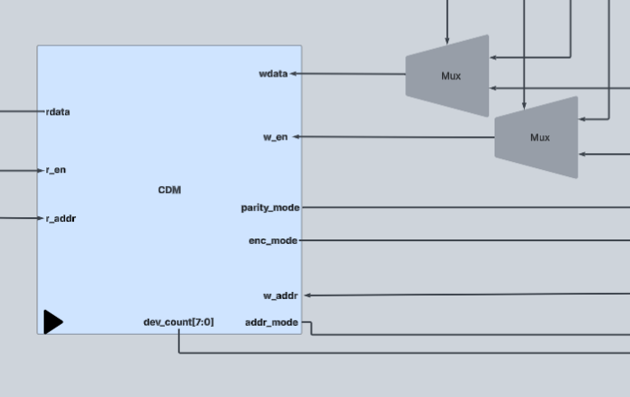
Figure 14 - Central Data Memory (CDM) block diagram
The Central Data Memory (CDM) stores both system configuration information and processed payload data. During the Configuration phase, the CDM stores global system parameters and device address information received from Configuration TLPs. During the Transfer phase, the CDM stores encrypted payload data together with associated parity information at translated memory locations generated by the Address Translation Unit (ATU). The CDM also provides configuration parameters such as address translation mode, encryption mode, parity mode, and device count to other system modules.

Parameters
Name | Default Value | Description
ADDR_WIDTH | 16 | Width of the CDM address bus, supporting a 16-bit address space.
DATA_WIDTH | 16 | Width of the payload data processed by the system.

Ports
Name | Type | Size | Description
clk_sys | Input | 1 bit | System clock (CLK_SYS). The CDM operates entirely within the System Clock Domain.
rst_n | Input | 1 bit | Active-low reset for the CDM. Initializes the configuration registers and memory contents.
r_en | Input | 1 bit | Enables a read operation from the CDM.
r_addr | Input | ADDR_WIDTH | Address of the CDM location to be read.
rdata | Output | (DATA_WIDTH*2)+1 | Data read from the selected CDM location. Returns configuration register contents or stored encrypted payload with parity depending on the addressed location.
w_en | Input | 1 bit | Enables a write operation to the CDM.
w_addr | Input | ADDR_WIDTH | Address of the CDM location to be written. During configuration, this selects a configuration register. During transfer, this is the translated address produced by the ATU.
wdata | Input | (DATA_WIDTH*2)+1 | Data written to the CDM. Configuration data is written directly from the Control Unit during the Configuration phase, while encrypted payload and parity are written during the Transfer phase.
dev_count | Output | 8 bits | Number of configured devices stored in the configuration register (Base Address 0x0000).
addr_mode | Output | 1 bit | Address translation mode stored in the configuration register.
enc_mode | Output | 4 bits | Encryption mode extracted from the configuration register for the Encryption Block.
parity_mode | Output | 1 bit | Parity mode extracted from the configuration register for the Parity Unit.

10.1 Internal Organization
Address Range | Description
0x0000 | Global configuration register (SYS_STATE, PARITY_MODE, ENC_MODE, DEV_COUNT, ADDR_MODE)
0x0001 – 0x00FF | Device configuration entries (START_ADDR, END_ADDR)
Remaining Addresses | Data memory used to store encrypted payloads and parity information

10.2 Write Source Selection
The CDM write interface receives data from two possible sources:
direct_cdm_write | Write Source
1 | Control Unit (Configuration phase)
0 | Encryption and Parity path (Transfer phase)
The multiplexers preceding the CDM select the appropriate write data and control signals according to the value of direct_cdm_write. This allows configuration information to bypass the encryption path while ensuring that payload data is processed before storage.

