Structure Finance:
- This is a financing technique. A deal structuring technique focused on asset cash flows. Cash flows from assets are engineered to fund something.
Typical features SF:
- Uses special purpose vehicles SPVs
- Tranches with different risk levels
- Assets generate cash flows that repay investors
- Focus on risk isolation and credit enhancement
Who uses SF:
- Banks, corporates, governments
Structure Fund:
- An investment fund with engineered payoffs.
- It is a fund that whose returns, risk or cash flows are engineered using a predefined structure. Structure sists inside the fund.
Typical features:
- Capital protection, yield enhancement, downside buffers
- Predefined payoff formulas e.g. capped upside, protected principal
- Often linked to indices, baskets or assets
- Investors buy fund units
Who uses it
- Private banking, wealth management
- Investors wanting tailored risk-return profiles
Fund Finance:
- This a financing provided to a fund. Borrowing at fund level to manage cash flows and boost return. (not an investment strategy and not a fund)
Typical features SF:
- It is a pooled investment vehicle that i. raises capital from multiple investors ii. Invests according to a defined strategy.
Who uses SF:
- Private credit funds, banks. GP facilities, NAV-based load

Alternative Investment Fund:
- This is a legal, regulatory category. A legal classification. How the fund is regulated and not how its financed or structured internally.
Typical features SF:
- It is a pooled investment vehicle that i. raises capital from multiple investors ii. Invests according to a defined strategy.
- Who can invest, reporting rules, risk management, leverage limits.
Who uses SF:
- Private Equity, Venture capital, Hedge funds, Real estate.
Structure Finance = how assets are financed
Structured Fund = how investor returns are engineered
Fund finance = how the fund borrows
AIF = how the fund is regulated. how the vehicle is legally classified.
Overlaps:
- A structured fund can also be an AIF
- A Structured finance vehicle can be wrapped inside an AIF
- An AIF may invest in structured finance instruments
Overlaps example:
A Luxembourg AIF invests in renewable energy SPVs (structured finance), uses a NAV facility (fund finance) and offers downside protection vis a structured payoff (structured fund).

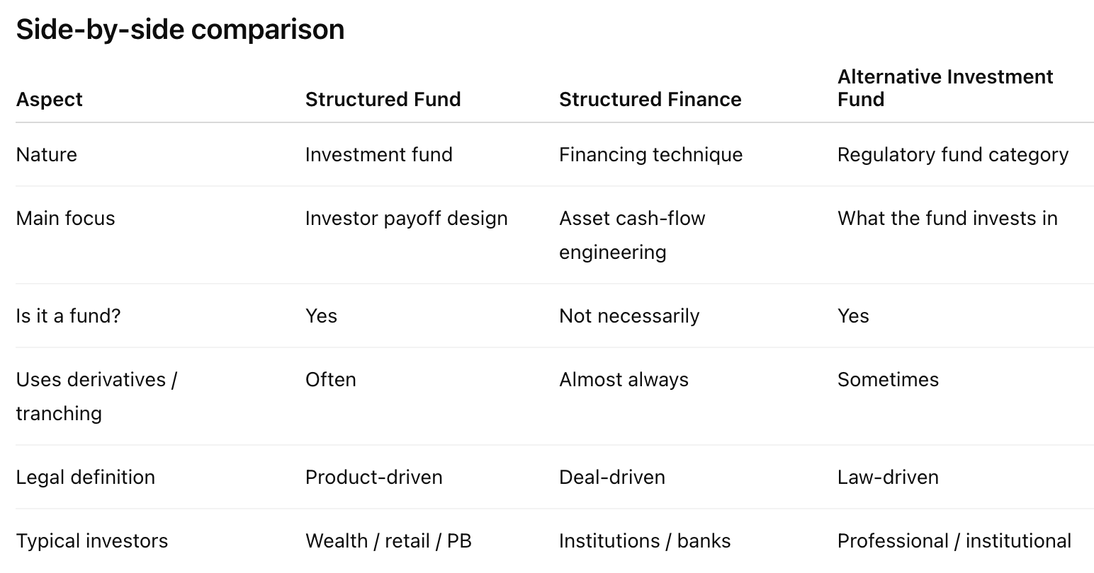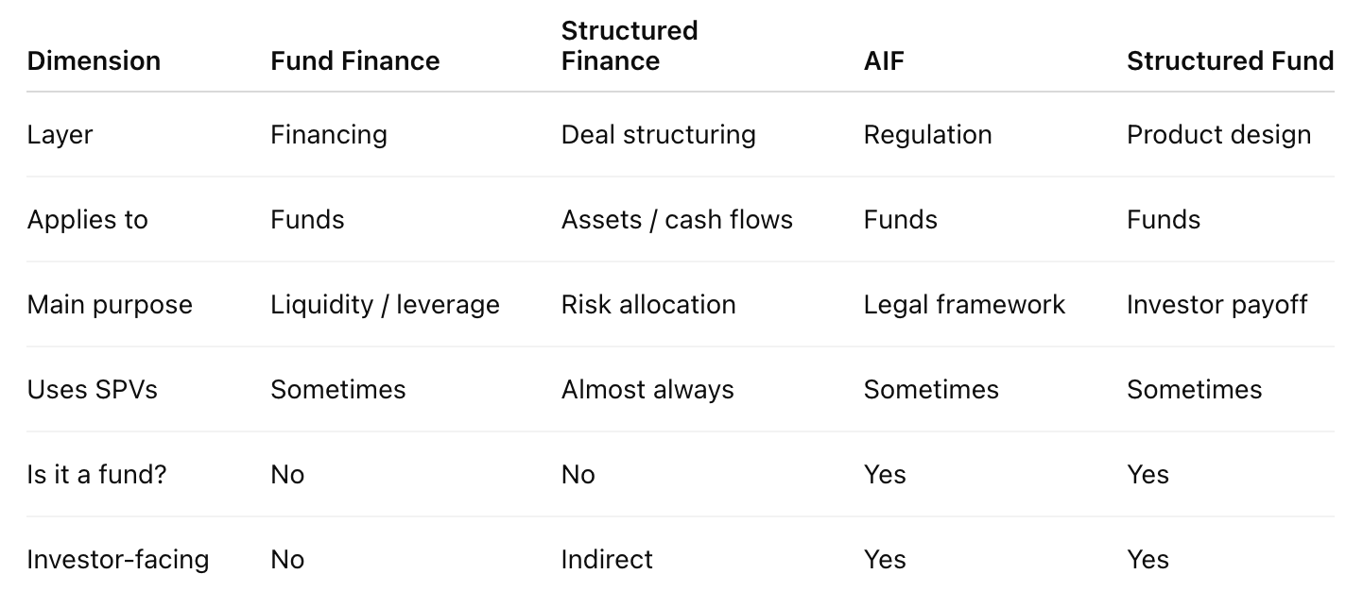
Examples of each
Overlap example of each

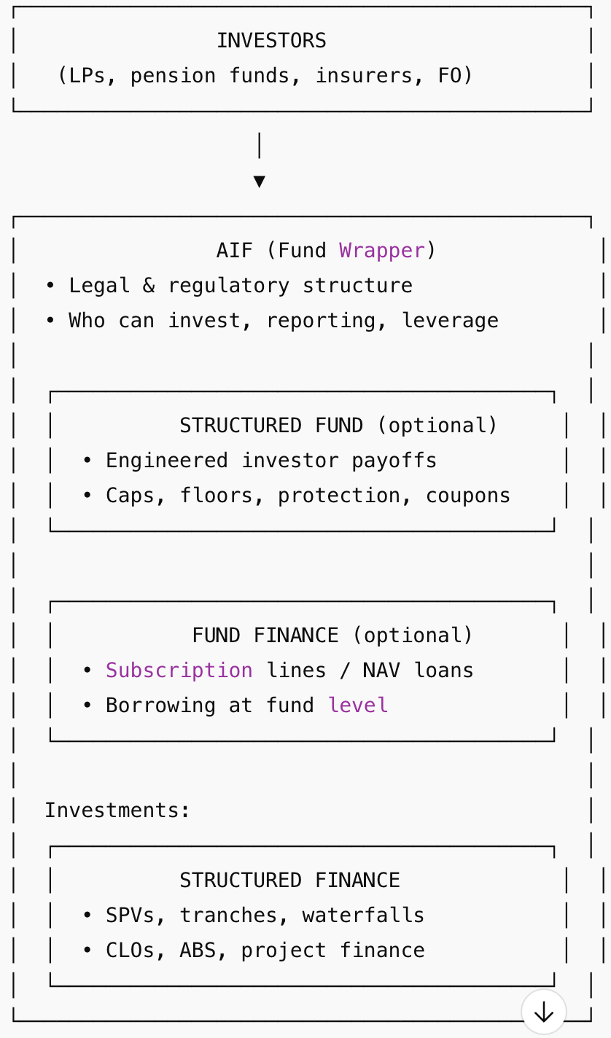
Infrastructure Debt fund example:
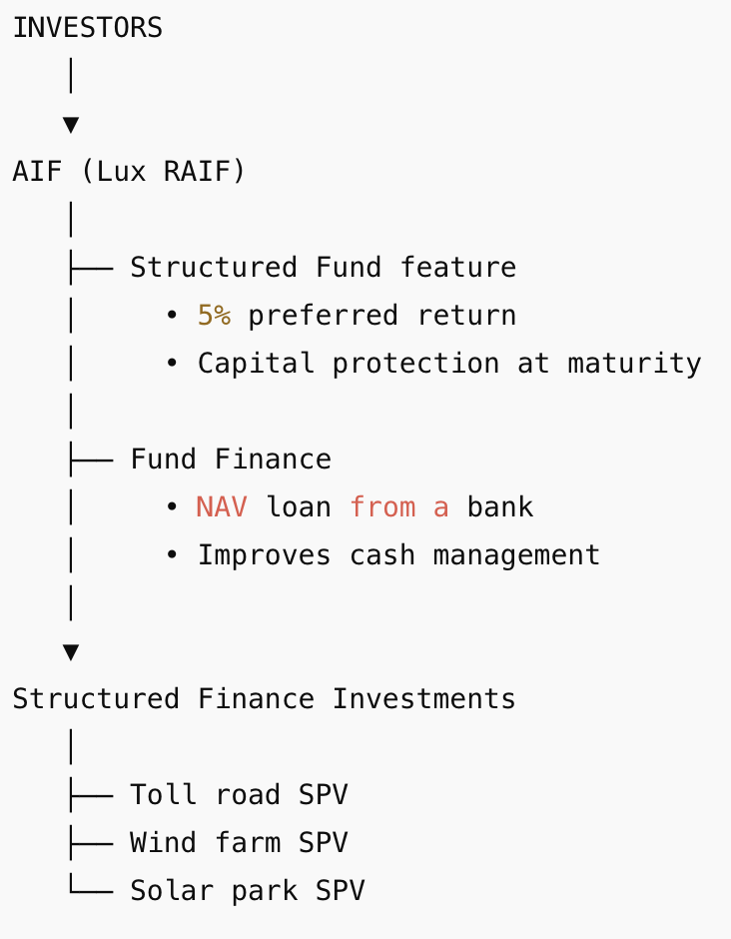

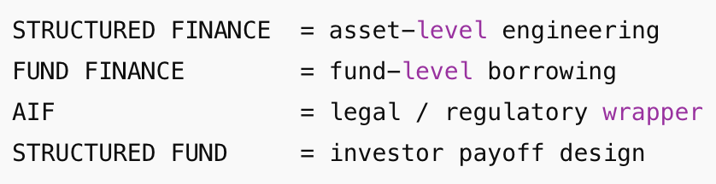
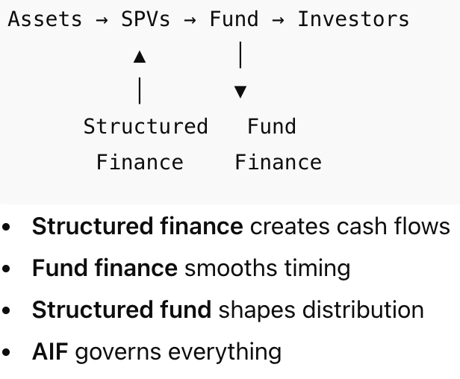

Full description and steps in securitization:

Failures in securitization:
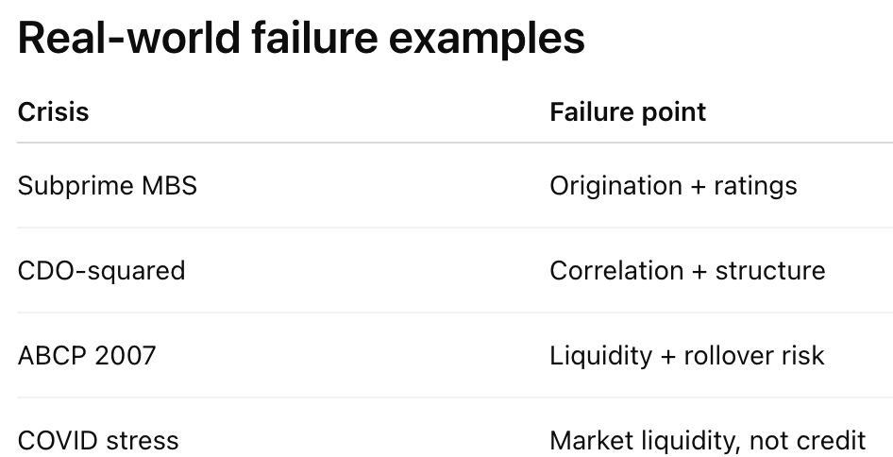
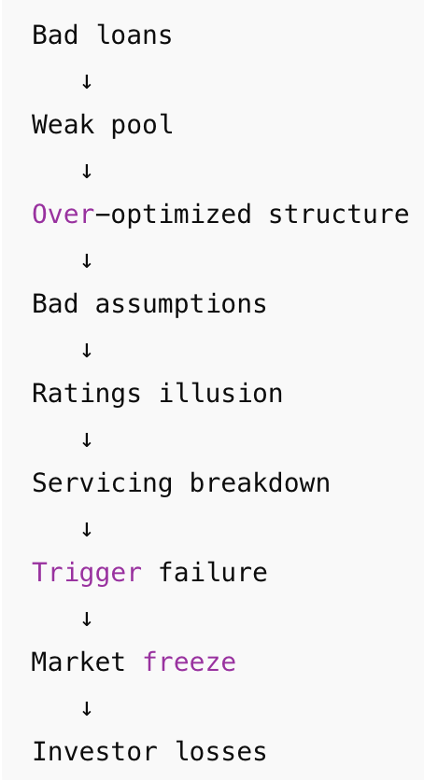
- SPV vs Fund. SPV is an entity designed for a single serving to isolate financial risks. It limits liability if the investment fails, the parent company and its assets are protected. A fund pools capital from multiple investors to diversify investments across a portfolio of companies.
- A structure fund’s cashflow framework is a securitization mindset applied at fund level, designed to absorb shocks by controlling timing, priority and behaviour across the fund’s life.
- A structured fund can be designed by
  - defining the investor payoff first
  - then reverse-engineering a structured finance style cashflow engine to support it
  - only through an iterative feasibility loop, not a one-way design.
- The flow is:
  - Payoff constraint defined
  - Cash-flow feasibility tested
  - Asset chosen to fit behaviour
  - Structure enforces discipline
- Conceptually:
  - Capital-protected funds
  - Yield-targeted credit funds
  - Principle-preserving income strategies are built
  - Its an iterative loop.
- Where you cannot reverse-engineer:
  - Liquidity where none exists
  - Correlation way
  - Behavioural risk
  - Tail events beyond economic reality
Structure Finance = asset cash flow engineering
Structured Fund = investor payoff engineering
Fund finance = how the fund borrows
Questions
- The idea is how we can soften structure-finance (asset cashflow engineering) thinking when applied to fund finance, because funds sit between structured finance and structured funds.
- (1) We borrow tool from structured finance like waterfall, stress timing (2) we cannot treat the fund cash flows like securitization cash flows (3) because manager discretion and flexibility dominate outcomes
- Structure finance cash flow is engineered at asset level
- Structure fund: payoffs are engineered at investor level.
- Fund finance cash flows are behaviour-dependent
- Cashflow analysis outputs must be illustrative of risk profiles and not prescriptive set of exactly modelled scenarios given rating level.
- Meaning: we cannot hard-code ratings to mechanical pass/fail test similar to securitization

- We do not have OC test pass/fail
- We have multiple possible paths: for example NAV down 15% the manager may:
  - Stop investing
  - Sell assets
  - Inject liquidity
  - Delay exists
- So, the cash flow framework outputs must answer
  - How bad could this get
  - How sensitive repayment to behaviour
  - Where are the weak points?
- The qualitative overlay comes from funs structures involve behavioural discretion. Whereas structure finance models assume mechanical enforcement.
- In short cashflow analysis model uncertainly because the manager is part of the cashflow engine.
- Structured finance cash flow modelling is softened and supplemented with qualitative judgment when applied to fund finance because funds sit between asset-level cash flow engineering and investor level payoff engineering and are dominated by manager discretion

This is what “illustrative, not prescriptive” really means:
- CLO: must pass Scenario X
- CAF: shows how bad it could get

