In the second file, we want to take a closer look at the dataset.

As seen in the first file, the dataset was recorded over a month, but over time some customers may change their behavior for some reasons. The main purpose of the second file is to determine this issue.

One way to implement this view is to ignore older records.

This means that a customer may be found who has refrained from visiting and using the application over time, or vice versa, it may be found that the closer we get to the present time, the greater the satisfaction of the application is seen in his behavior.

The data set can be considered in four weeks and the first week with all the recorded information left out. We are facing a new data set now. So, we have to recalculate the F and M values.

**Frequency and Monetary**

To get new frequency and monetary, we set the values of these two variables to zero instead of the values recorded in the first week.

A new F, M is now built by counting the frequency and aggregating the monetary.

**Note**: The recency column does not change anything.

**Conclusion**

By comparing the labels of this data set with the previous file, we can see the changes in customer behavior in each cluster separately.

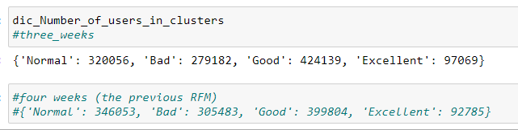

As can be seen, the number of customers in the excellent and good clusters has increased and the number of customers in the bad and normal clusters has decreased.

This means that if the customer gets a ‘Excellent’ label in three weeks, he will probably be in ‘Excellent’ cluster in four weeks.

This means that this customer can be trusted in the long time.

On the other hand, depending on the organizational strategy, it may be considered that as we get closer to the present time, in which cluster the customer is located.

That is, what behavior does the customer show in the short time?

**Note:** the number of inactive customers is 168952. It means that They just used the application in the first week and then stopped using it.