**ESR12 Report 1**

**Faezeh Shalchy**

The project is a part of EU funded Marie-Curie Fellowship programme (HyMedPoly) in the area of medical polymers for potential applications to biomedical implants such as cardiovascular stents or synthetic bone materials and structures. The project will look into the role of surface roughness and topography on the response of cell adhesion, proliferation and growth. There could be two possible applications in the longer terms – to maximise anti-microbial response and to enhance cell adhesion and growth for biomedical scaffolds. These could have important implications to healthcare in aging populations throughout the world.

The methodology envisaged would be theoretical and computational primarily, but some experiments are also planned. The use of computational elasticity and molecular modelling for multi-scale understanding of the structure-property relationship is proposed. The role of the elasticity of the solid surface on which cells grow will also be studied. Novel modelling techniques such as Dissipative Particle Dynamics are proposed for the understanding of the behaviour of matter at intermediate length scales. Collaborations with clinicians within the EU consortium will also be considered, as long as the scope is restricted to the main theme of the project, which is at the interface of mechanics and biology within the context of biomedical implants and antimicrobial materials

In this report, I try to summarize my efforts in the first three months working on this project. Different parts of this report can be sectioned as: (a) 3d printing of scaffolds, (b) contact mechanics, (c) cell mechanics.

1. **3D printing of Scaffolds**

***(a).1: Literature Review***

Osseous tissue, known as bone, is made of two different structures; cancellous and cortical bone. Cancellous, or the inner part of bone, is spongy in nature having 50–90 vol% porosity. However, cortical bone is the dense outer layer of bone with less than 10 vol% porosity. Both types of bone undergo dynamic remodeling, maturation, differentiation, and resorption that are controlled via interactions among osteocyte, osteoblast, and osteoclast cells [1].

In the literature, biodegradable polymers and bioactive ceramics are being combined in a variety of composite materials for tissue engineering scaffolds. Materials and fabrication routes for three-dimensional (3D) scaffolds with interconnected high porosities suitable for bone tissue engineering are investigated in various studies. One of the challenges in the field is the mechanical properties of today's available porous scaffolds, revealing insufficient elastic stiffness and compressive strength compared to human bone. One of the other challenges are surface functionalization and 3D scaffold characterizations [2].

Since higher porosity increases surface area per unit volume [1], finding solutions to design and make scaffolds with systematically controlled microstructure is vital. Arise of additive manufacturing technologies in 1980s enabled researchers in many fields to make materials with complex structures for various applications. This technology grows in a slower pace in biomedical application due to the complexity of the field and specific properties that are needed for biomaterials. However, the use of additive manufacturing technologies in bone tissue engineering has been growing in recent years. Three dimensional printing (3DP) is becoming popular due to the ability to directly print porous scaffolds with designed accurate shape, controlled chemistry and interconnected porosity. Some of these inorganic scaffolds are biodegradable and have proven ideal for bone tissue engineering.

The recent advances in 3D printed bone tissue engineering scaffolds along with current challenges and future directions are summarized in this paragraph[1].

{ADD A PARAGRAPH on 3d PRINTING}

***(a).2: 3d printed samples***

In our study samples with different structures were made using 3d printing. There are different parameters such as: diameter of each cylinder, distance between the cylinder and printing speed that were investigated and their effect is going to be considered in our study. Some SEM image of samples is presented here:

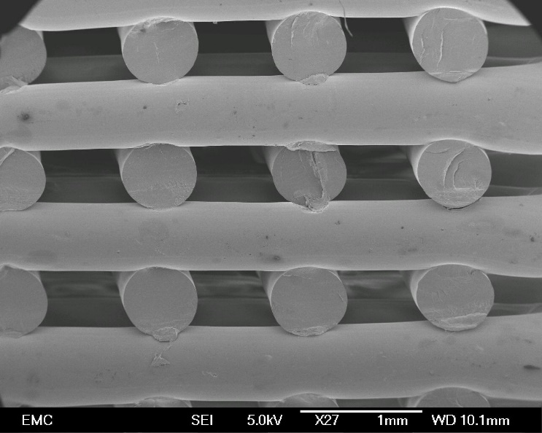

However, one of the most interesting results of our study is to make samples with a different nuzzle. This nuzzles results in samples whose rows and columns are cylinders with flower-like cross-section.

SEM pictures of samples produced with this technic is presented here:

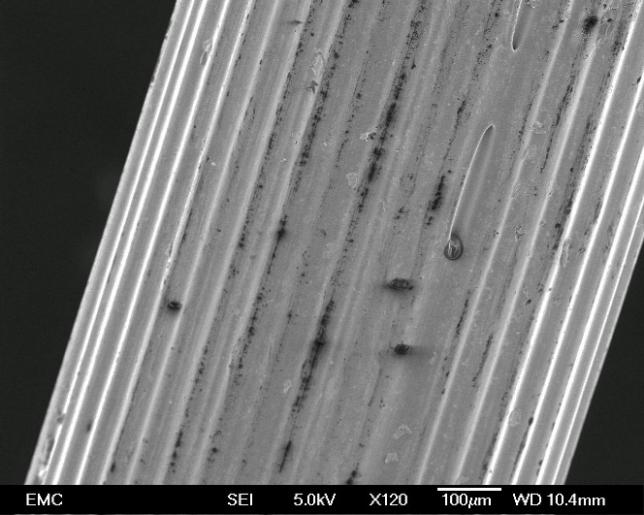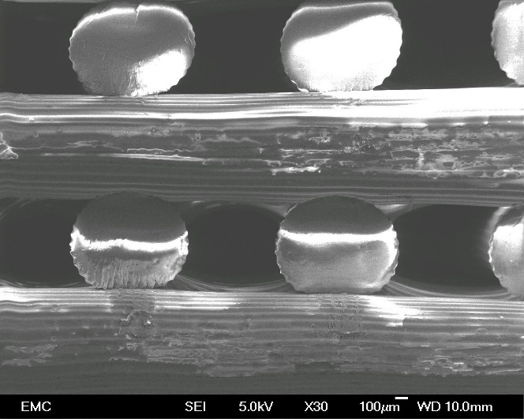

1. **Contact mechanics**

***(b). 1: Literature Review:***

Contact mechanics is the study of the [deformation](https://en.wikipedia.org/wiki/Deformation_(mechanics)) of [solids](https://en.wikipedia.org/wiki/Solids) that touch each other at one or more points.[[1]](https://en.wikipedia.org/wiki/Contact_mechanics#cite_note-Johnson-1)[[2]](https://en.wikipedia.org/wiki/Contact_mechanics#cite_note-Popov-2) The physical and mathematical formulation of the subject is built upon the [mechanics of materials](https://en.wikipedia.org/wiki/Mechanics_of_materials) an [continuum mechanics](https://en.wikipedia.org/wiki/Continuum_mechanics) and focuses on computations involving [elastic](https://en.wikipedia.org/wiki/Elasticity_(physics)), and [plastic](https://en.wikipedia.org/wiki/Plastic_Deformation) bodies in [static](https://en.wikipedia.org/wiki/Statics) or [dynamic](https://en.wikipedia.org/wiki/Dynamics_(physics)) contact. Central aspects in contact mechanics are the [pressures](https://en.wikipedia.org/wiki/Pressure) and [adhesion](https://en.wikipedia.org/wiki/Adhesion) acting [perpendicular](https://en.wikipedia.org/wiki/Perpendicular) to the contacting bodies' surfaces (known as the [normal direction](https://en.wikipedia.org/wiki/Normal_vector)) and the [frictional](https://en.wikipedia.org/wiki/Friction) [stresses](https://en.wikipedia.org/wiki/Stress_(mechanics)) acting [tangentially](https://en.wikipedia.org/wiki/Tangential_and_normal_components) between the surfaces. This page focuses mainly on the normal direction, i.e. on frictionless contact mechanics. [Frictional contact mechanics](https://en.wikipedia.org/wiki/Frictional_contact_mechanics) is discussed separately.

Contact mechanics is part of Mechanical [engineering](https://en.wikipedia.org/wiki/Engineering); it provides necessary information for the safe and energy efficient design of technical systems and for the study of [tribology](https://en.wikipedia.org/wiki/Tribology) and [indentation hardness](https://en.wikipedia.org/wiki/Indentation_hardness). Principles of contacts mechanics can be applied in areas such as locomotive wheel-rail contact, [coupling](https://en.wikipedia.org/wiki/Coupling) devices, [braking](https://en.wikipedia.org/wiki/Brake) systems, [tires](https://en.wikipedia.org/wiki/Tire), [bearings](https://en.wikipedia.org/wiki/Bearing_(mechanical)), [combustion engines](https://en.wikipedia.org/wiki/Internal_combustion_engine), [mechanical linkages](https://en.wikipedia.org/wiki/Linkage_(mechanical)), [gasket](https://en.wikipedia.org/wiki/Gasket) seals, [metalworking](https://en.wikipedia.org/wiki/Metalworking), metal forming, [ultrasonic welding](https://en.wikipedia.org/wiki/Ultrasonic_welding), [electrical contacts](https://en.wikipedia.org/wiki/Electrical_connector), and many others. Current challenges faced in the field may include [stress analysis](https://en.wikipedia.org/wiki/Stress_analysis) of contact and coupling members and the influence of [lubrication](https://en.wikipedia.org/wiki/Lubrication) and material [design](https://en.wikipedia.org/wiki/Design) on [friction](https://en.wikipedia.org/wiki/Friction) and [wear](https://en.wikipedia.org/wiki/Wear). Applications of contact mechanics further extend into the [micro](https://en.wikipedia.org/wiki/Microtechnology)- and [nanotechnological](https://en.wikipedia.org/wiki/Nanotechnology) realm [3].

General theory of large elastic deformations of a rubber sphere in simple compression is found and presented in the literature. Different assumptions can be employed in order to drive the equations. In one of the studies, a set of five equations associated with approach was derived, radii of contact surface without and with lateral extension of free surface, the lateral extensive displacement on the contact surface and the position of the contact surface in a very large range of applied forces, on the basis of the Hertz theory (half-space elastic body model) with an extensive term, in consideration of the rubber-elastic nonlinear elasticity, the lateral extension and the symmetry of the deformed shape of the rubber sphere. In Part 2 of that study, it is shown that results calculated by the set of the equations fit experimental data for a rubber sphere [4].

While Classical Mechanics deals solely with bulk material properties Contact Mechanics deals with bulk properties that consider surface and geometrical constraints. For instance, a probe in the form of a pin in a pin-on-disk tester is brought into contact with the material of interest, measuring properties such as hardness, wear rates, etc.

1. Geometrical effects on local elastic deformation properties have been considered as early as 1880 with the Hertzian Theory of Elastic Deformatio.1 This theory relates the circular contact area of a sphere with a plane (or more general between two spheres) to the elastic deformation properties of the materials. In the theory any surface interactions such as near contact Van der Waals interactions, or contact Adhesive interactions are neglected.
2. An improvement over the Hertzian theory was provided by Johnson et al. (around 1970) with the JKR (Johnson, Kendall, Roberts) Theory.1 In the JKR-Theory the contact is considered to be adhesive. Hence the theory correlates the contact area to the elastic material properties plus the interfacial interaction strength. Due to the adhesive contact, contacts can be formed during the unloading cycle also in the negative loading (pulling) regime. Such as the Hertzian theory, the JKR solution is also restricted to elastic spheresphere contacts.
3. A more involved theory (the DMT theory) also considers Van der Waals interactions outside the elastic contact regime, which give rise to an additional load. The theory simplifies to Bradley's Van der Waals model if the two surfaces are separated and significantly appart. In Bradley's model any elastic material deformations due to the effect of attractive interaction forces are neglected. Bradley's non-contact model and the JKR contact model are very special limits explained by the Tabor coefficient [].

In general, these three approaches can determine the contact behaviour of most of the materials. For our application, JKR seems to be more accurate and precise formulation. However, some modifications is needed due to the non-elastic behaviour and large deformation of cell and the high adhesion force that is usually appear between cell and the substrates.

(b).2: Future work

In this section, we are going to derive contact mechanics equations for large deformation assuming the presence of adhesion energy. Contact mechanics of cell is usually in large deformation with high amount of adhesion between cell and the substrate. Deriving these equations will help us to have a better understanding of cell contact mechanics and stress distribution in cell attached to a specific substrate.

(c). Cell Mechanics

In order to have a better understanding of mechanical response of cell, a UStretch Machine (a versatile uniaxial benchtop mechanical tester for biomaterials) was purchased. The training on this machine is being done and I will be able to do experiments on actual cell soon.

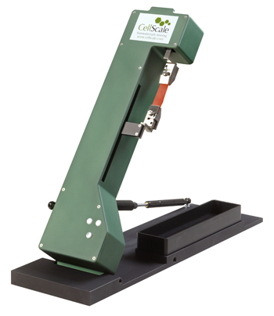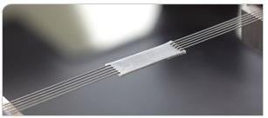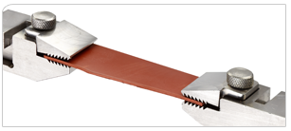

The UStretch is not limited to dry, vertical testing with bulky specimen grips. It is capable of both vertical and horizontal testing in or out of a temperature-controlled media bath. They system also has a wide range of specimen attachments including screw-driven clamps, spring-loaded clamps, and multi-point puncture grips.

Key Features

* High-performance actuator with inline load cell
* High-resolution CCD imaging with image-based strain measurement tools
* Several attachment options including patented BioRakes for fast and reliable specimen mounting
* Integrated temperature-controlled media bath
* Fully featured user interface software for simple, cyclic, relaxation, and multi-modal testing with real-time feedback []

**Reference**

1. Bose, Susmita, Sahar Vahabzadeh, and Amit Bandyopadhyay. "Bone tissue engineering using 3D printing." *Materials Today* 16.12 (2013): 496-504.
2. Rezwan, Kurosh, et al. "Biodegradable and bioactive porous polymer/inorganic composite scaffolds for bone tissue engineering." *Biomaterials* 27.18 (2006): 3413-3431.
3. https://en.wikipedia.org/wiki/**Contact**_**mechanics**
4. Tatara, Y. "On compression of rubber elastic sphere over a large range of displacements—part 1: theoretical study." *J. Eng. Mater. Technol* 113.3 (1991): 285-291.