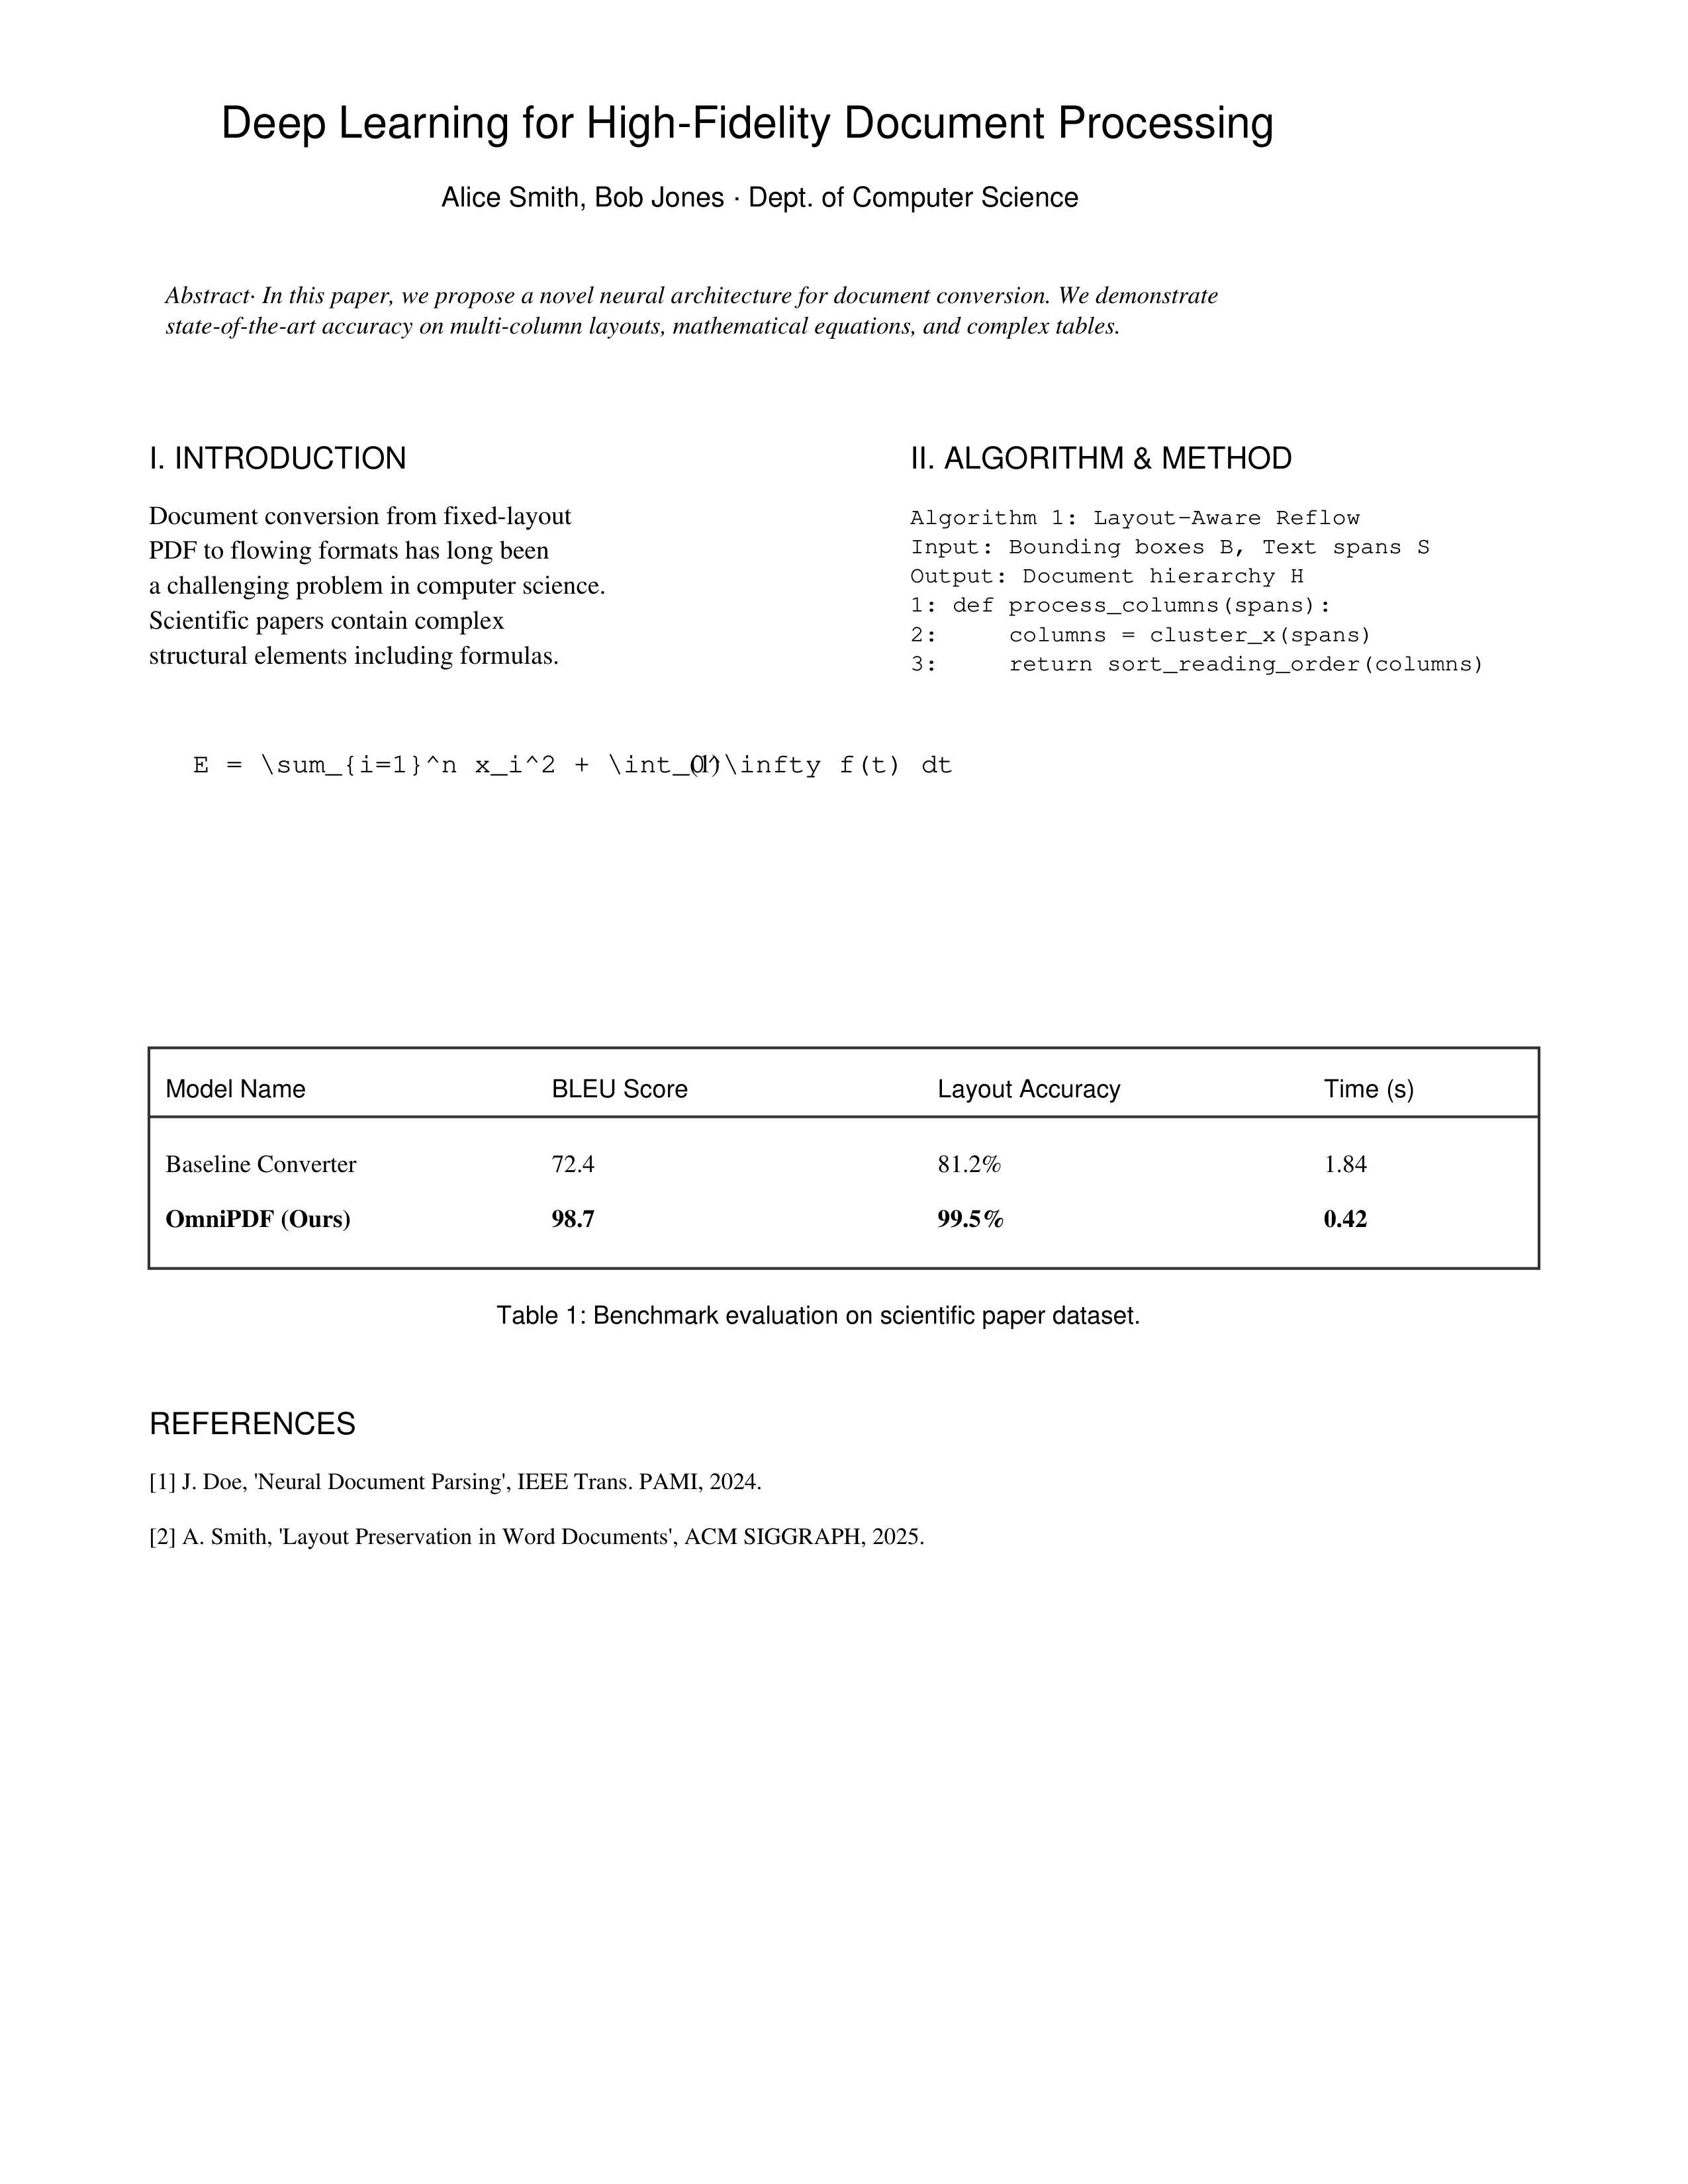
Deep Learning for High-Fidelity Document Processing
Alice Smith, Bob Jones · Dept. of Computer Science
Abstract· In this paper, we propose a novel neural architecture for document conversion. We demonstrate
state-of-the-art accuracy on multi-column layouts, mathematical equations, and complex tables.
I. INTRODUCTION
Document conversion from fixed-layout
PDF to flowing formats has long been
a challenging problem in computer science.
Scientific papers contain complex
structural elements including formulas.
E = \sum_{i=1}^n x_i^2 + \int_0^\infty f(t) dt
(1)
II. ALGORITHM & METHOD
Algorithm 1: Layout-Aware Reflow
Input: Bounding boxes B, Text spans S
Output: Document hierarchy H
1: def process_columns(spans):
2: columns = cluster_x(spans)
3: return sort_reading_order(columns)
Model Name
BLEU Score
Layout Accuracy
Time (s)
Baseline Converter
72.4
81.2%
1.84
OmniPDF (Ours)
98.7
99.5%
0.42
Table 1: Benchmark evaluation on scientific paper dataset.
REFERENCES
[1] J. Doe, 'Neural Document Parsing', IEEE Trans. PAMI, 2024.
[2] A. Smith, 'Layout Preservation in Word Documents', ACM SIGGRAPH, 2025.

