What is Kubernetes (k8s)?

Kubernetes is container orchestration engine. Kubernetes is an open-source system for automating deployment, scaling, and management of containerized applications.

How to setup local dev Kubernetes on windows machine?

* Install kubectl

[kubectl](https://kubernetes.io/docs/user-guide/kubectl/), is a Kubernetes command-line tool, and it is used to deploy and manage applications on Kubernetes. kubectl provides features to inspect cluster resources, create, delete, and update components, get status of k8s cluster, and deploy and run applications in k8s.

Following are the steps to setup a kubectl on windows:

1. Download the kubectl.exe using a link <https://kubernetes.io/docs/tasks/tools/install-kubectl/> and save the file in any folder on windows file system.
2. Add the kubectl.exe folder location in path variable - “Advanced System Settings -> Advanced -> Environment Variables -> Path”. For example, if you have saved file to C:/kube then add this folder path to the path variable.
3. Open a command prompt and type kubectl and you should see all commands supported by kubectl.

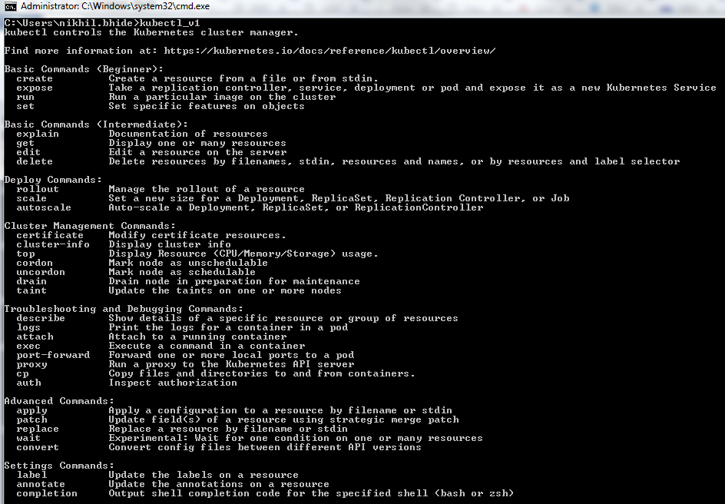

* Install minikube

1. VT-x or AMD-v virtualization must be enabled in your computer’s BIOS.
2. Install the virtualization platform such as Virtualbox or KVM. You are not really required to configure the image.
3. Download the minikube-windows-amd64 file from <https://github.com/kubernetes/minikube/releases>.

Current version of minikube is v0.29.0.

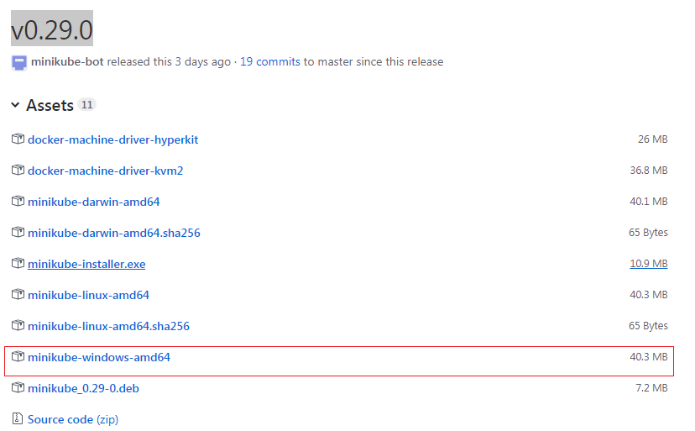

1. Rename the file to minikube.exe. Note the extension “exe” added.
2. Add this folder path location in path variable - “Advanced System Settings -> Advanced -> Environment Variables -> Path”. For example, if you have saved file to C:/kube then add this folder path to the path variable.
3. Open command prompt and fire a command minikube and you should see all commands supported by minikube.

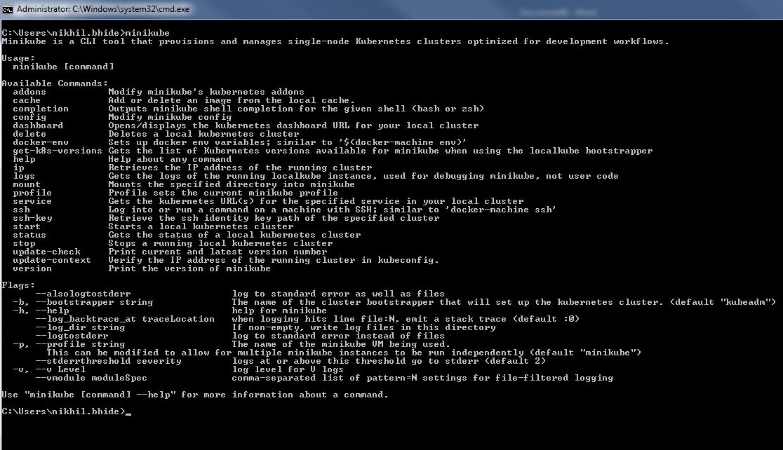

* Install Cygwin

Command prompt of windows really sucks when it comes to using k8s. Linux terminal provides fantastic user experience while running docker commands or k8s commands. On windows, you can get similar kind of user experience with Cygwin. Install Cygwin by following the steps listed on <https://cygwin.com/install.html>.

* Start MiniKube

Now, its time to start k8s local cluster. Open Cygwin terminal and run a command minikube start.

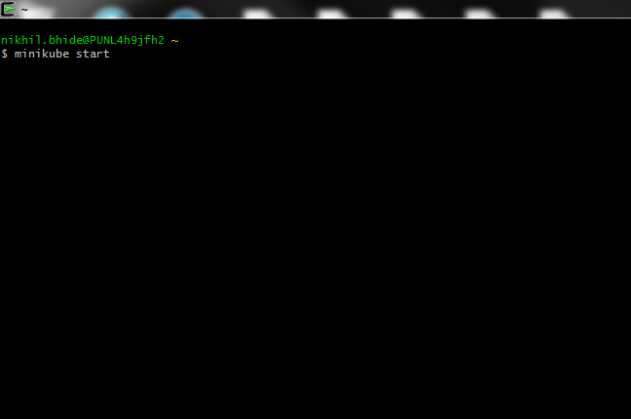

At this stage, what we are hoping is successful start-up of k8s cluster. Terminal should not hang or freeze. In the first time, it will take some time to start the cluster as in the background k8s downloads kubelet, kubeadm and minikube iso file of around 150 mb. Depending upon your network speed, after few seconds/minutes you should see following output on terminal.

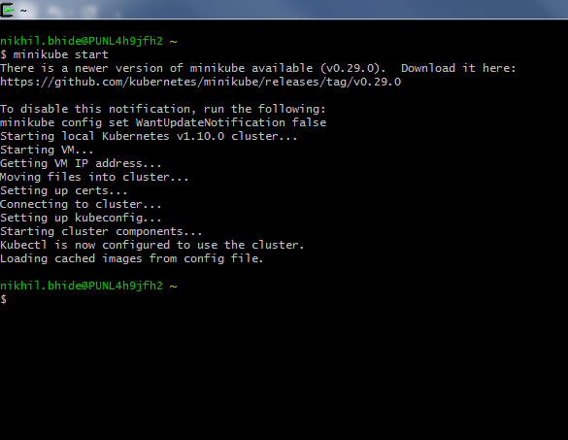

* Check the client of k8s

Run command kubectl version to confirm the working of minikube. You should get details of client version and server version.

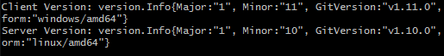

* Check the client of k8s

What is really happening?

Even though we really did not setup any image in VirtualBox, how the things are working? Whether k8s cluster is running on host OS – windows? Not exactly, if you just open virtual box then you will see something like follows –

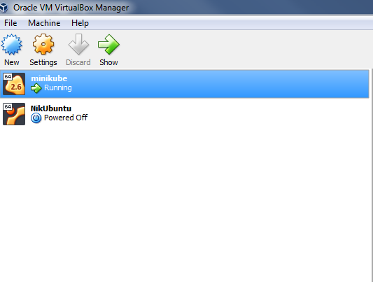

It clearly shows that minikube is running inside virtual box.

* Check k8s master

Execute kubectl cluster-info to check details of k8s master. If you have any other daemon deployed in k8s then details of those processes will also be highlighted.

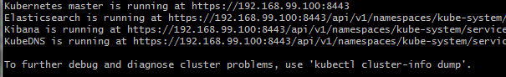

That’s it! Now you can start playing with k8s cluster installed locally.