COMP2322
Multi-thread Web Server Project Report
Chan Ching Hei
24087517d

Summary
This project is a multi-threaded web server program that is capable of handling HTTP request implemented with python. The project is separated into 3 modules, request, server and logger. The request is called by each client threads to handle the client request. The server is used to create a socket to receive the client HTTP request and to spawn client threads. The logger is simply to log every client request. In terms of multi-thread, the program utilize the threading class and for each client request, a new thread will be spawned.
The main module request is designed in the order of parsing the request, identify the user request and retrieve the resources, formulate a corresponding response and send the encoded message with the data file if needed. If the parameter is not enough, then the server will respond with 400 Bad Request. To handle GET and HEAD command, the program will parse the command and take the first split string to check if the command is correct, if not the program will go to the 400 Bad Request. Then the program will check whether If-Modified-Since is in the command, if yes, then the program will compare the client requested date and the file mtime. If the file is not modified, then 304 Not Modified will be send to the client. If the client did not request for If-Modified-Since, then the server will respond with 200 OK and the actual content if the request is GET. If a FileNotFoundError is raised then the server will respond with 404 Not Found. If a PermissionError is raised then the server will respond with 403 Forbidden. To handle the connection status, the server will check if Connection: keep-alive is in the request. If not, the flag will set to be false, and the connection will be closed. On each server respond, the logger will also record the client IP address, the access time, requested file and the response type.
The server module is where the server is running, it will first create a server socket, and listen to the server port. On any client try to connect to the server, a new client thread will be spawned, and start immediately, allowing the server to receive multiple request concurrently.

Demonstration
This section is the demonstration of how the server handles a variety of HTTP request with the output in the client side.
Starting the server
Server side response message of non-persistent connection
Response of type 200 OK with a text file
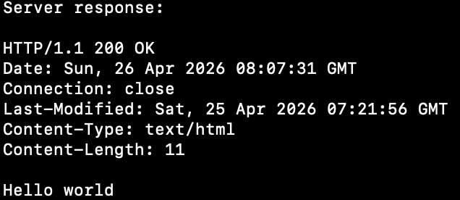
Response of type 200 OK with HEAD request, the content is excluded
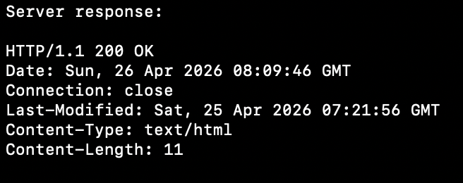
Response of a modified file
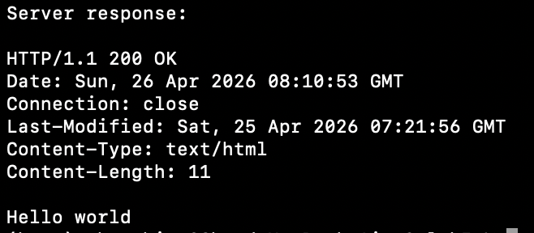
Response of a not modified file
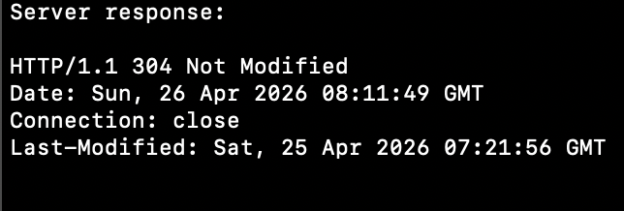
Response of type 404 Not Found accessing a file that does not exist
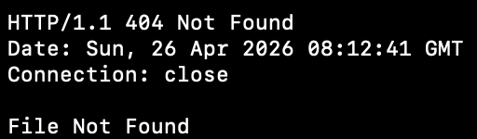
Response of type 403 Forbidden accessing a file with no read permission, e.g. sudo chmod 000 [file name]
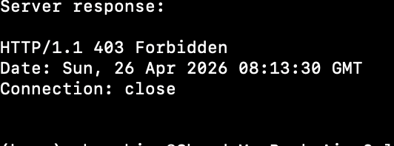
Persistent Connection
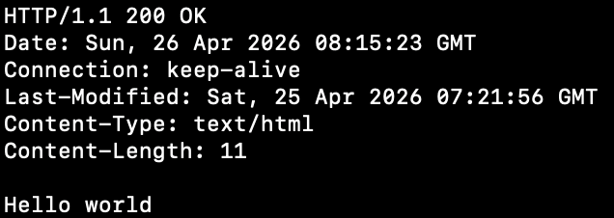
In the server side, the connection of 52985 is not closed, allowing the client to keep sending request
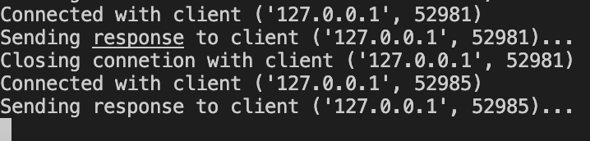

Here is another request from the same client
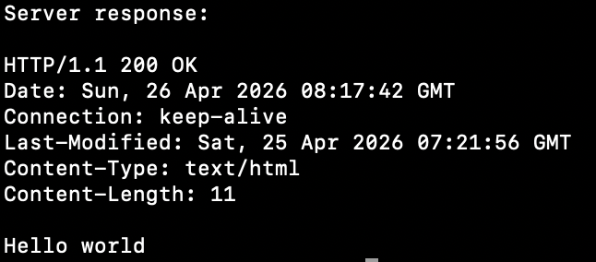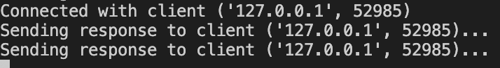
Response of requesting a image file. Extra code in client side could be implemented to handle the recieved image.
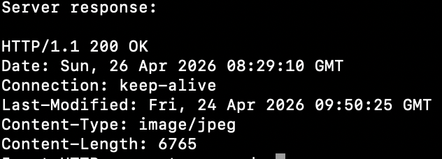

Log file
This log file contains the request sent in the demonstration section.
Client IP address: ('127.0.0.1', 52939), Access time: Sun, 26 Apr 2026 08:07:31 GMT, Access file: /text.txt, Response type: 200 OK
Client IP address: ('127.0.0.1', 52955), Access time: Sun, 26 Apr 2026 08:09:46 GMT, Access file: /text.txt, Response type: 200 OK
Client IP address: ('127.0.0.1', 52958), Access time: Sun, 26 Apr 2026 08:10:53 GMT, Access file: /text.txt, Response type: 200 OK
Client IP address: ('127.0.0.1', 52962), Access time: Sun, 26 Apr 2026 08:11:49 GMT, Access file: /text.txt, Response type: 304 Not Modified
Client IP address: ('127.0.0.1', 52962), Access time: Sun, 26 Apr 2026 08:11:49 GMT, Access file: /text.txt, Response type: 200 OK
Client IP address: ('127.0.0.1', 52967), Access time: Sun, 26 Apr 2026 08:12:41 GMT, Access file: /missing.txt, Response type: 404 Not Found
Client IP address: ('127.0.0.1', 52981), Access time: Sun, 26 Apr 2026 08:13:30 GMT, Access file: /denied.txt, Response type: 403 Forbidden
Client IP address: ('127.0.0.1', 52985), Access time: Sun, 26 Apr 2026 08:15:23 GMT, Access file: /text.txt, Response type: 200 OK
Client IP address: ('127.0.0.1', 52985), Access time: Sun, 26 Apr 2026 08:17:42 GMT, Access file: /text.txt, Response type: 200 OK
Client IP address: ('127.0.0.1', 53275), Access time: Sun, 26 Apr 2026 08:29:10 GMT, Access file: /1227835.jpg, Response type: 200 OK

