**Vision stream**

**1. Customer Behavior Analysis for Sales Optimization**

* **Foot Traffic Analysis**: Track and analyze the number of customers entering the store and peak traffic hours. This helps in determining when to allocate more staff and where to position high-demand items.

**1: ScreenShot of Foot Tracking Analysis:**

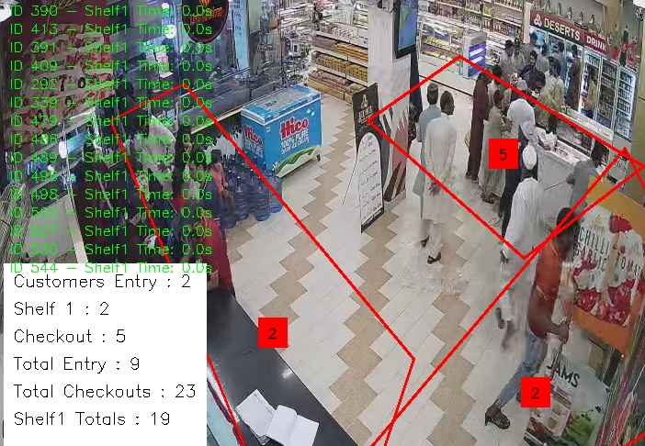

**2: Screenshot of peak hours Analysis**

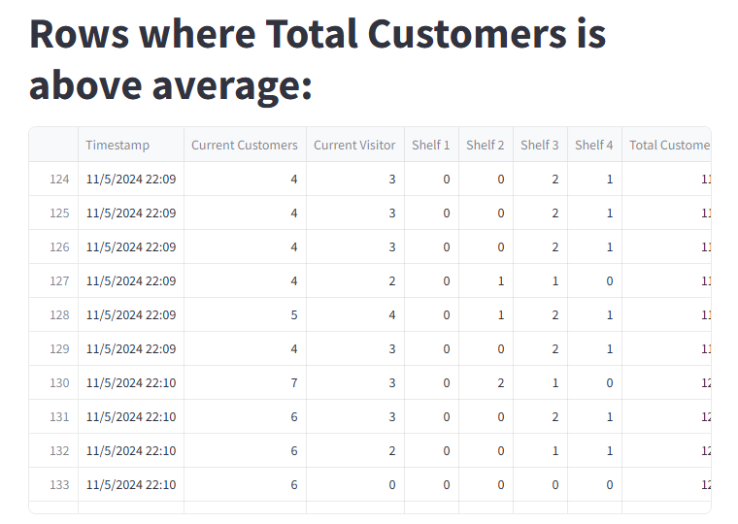

* **Shelf Monitoring**: Track when certain shelves are frequently visited. Use this information to rearrange products so that bestsellers are more visible.

**3**: Screenshot of Shelf Tracking:

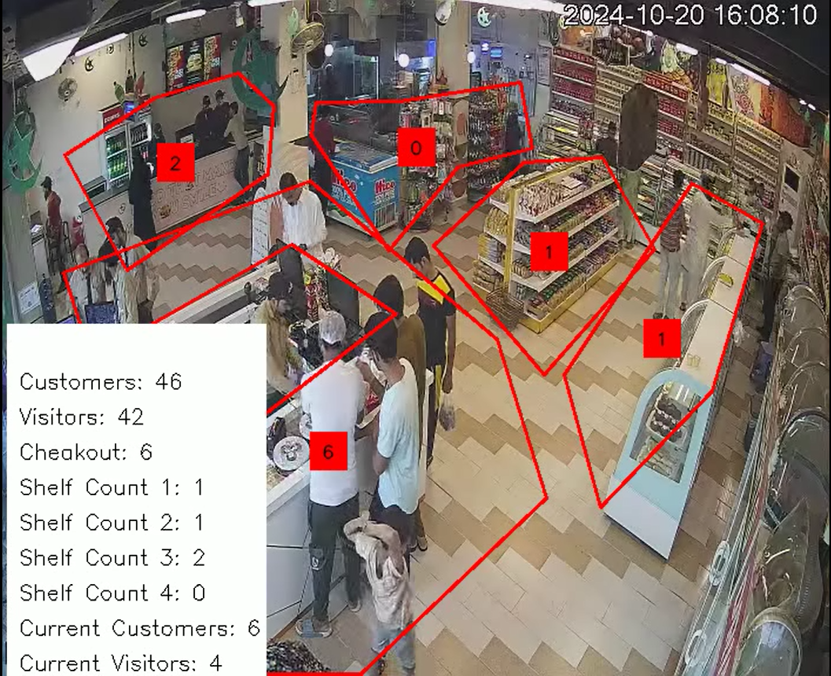

**2. Employee Activity Monitoring for Cost Efficiency**

* **Checkout Efficiency**: Use video feeds to monitor checkout lanes and analyze queue lengths. This data can help determine the number of employees needed at the checkout during peak times, improving customer service and reducing labor waste.

Screenshot of Checkout analysis:



* **Loss Prevention**: Detect potential theft or unauthorized access to restricted areas. Real-time alerts for suspicious behavior can reduce inventory loss and minimize costs related to shrinkage.

**3. Inventory and Stock Management**

* **Out-of-Stock Detection**: Use camera feeds to detect empty shelves in real-time. Notify staff to restock, ensuring popular items remain available and reducing lost sales due to stockouts.

Point of Sale Stream

**1. Sales by Product Category Visualization**

* **Visualization Type**: Bar Chart or Pie Chart
* **Details**: Show sales and profit per product category.
* **Benefit**: The owner can identify high-profit items and categories. Low-profit items can be removed or repositioned, while high-profit items can be promoted to maximize profit.

**2. Daily & Hourly Sales Trend**

* **Visualization Type**: Line Chart or Heatmap
* **Details**: Display sales trends by day and hour.
* **Benefit**: This helps identify rush hours, allowing the owner to allocate staff and stock efficiently. More staff during peak times can improve customer service, while reducing staff during off-peak hours lowers labor costs.

**4. Inventory Turnover Rate (ITR)**

* **Visualization Type**: Gauge Chart or Line Chart
* **Details**: Track inventory turnover for each product.
* **Benefit**: This helps identify slow-moving and fast-moving products. The owner can better manage stock for fast-moving items and discount or promote slow-moving items to reduce holding costs.

**6. Profit Margin by Product and Category**

* **Visualization Type**: Bar Chart or Matrix Table
* **Details**: Display profit margin per product and category.
* **Benefit**: Helps the owner understand each product's profit potential, so they can focus promotions on high-margin products to improve overall profitability.

**8. Discount Effectiveness Analysis**

* **Visualization Type**: Line Chart or Scatter Plot
* **Details**: Show the impact of discounts and promotions on sales and profit.
* **Benefit**: Helps the owner understand which discounts drive the most sales and profit, allowing for more strategic decisions on future promotions.