**Home Task 4  
  
Task1**

#include <iostream>

using namespace std;

int main() {

int nums;

for (nums=1;nums<=150;nums++) {

if(nums%10==0){

continue;

}

cout<<nums<<endl;

}

return 0;

}

**Explanation:** This code output first 150 numbers without multiple of 10

**Task 2**

#include<iostream>

using namespace std;

int main(){

int number, sum ,extra, x;

cout<<"Enter your Number!"<<endl;

cin>>number;

extra=number;

while (number>0)

{

x = number%10;

sum += x;

number /= 10;

}

cout<<"Sum of the digits of the "<<extra<<" is " <<sum<<endl;

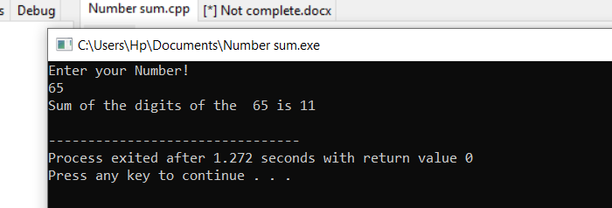 return 0;}

**Explanation:** This code represents the sum of digits of given number

**Task 3**

#include <iostream>

using namespace std;

int main (){

int number;

bool prime = false;

cout<<"Enter any number kindly!"<<endl;

cin>>number;

for(int i=2;i<number;i++)

{

if(number%i == 0)

{

prime = false;

break;

}

else {

prime= true;

continue;

}

}

if (prime==true)

cout<<"Given number is a prime number"<<endl;

else if(prime==false)

cout<<"Given number is NOT a prime Number"<<endl;

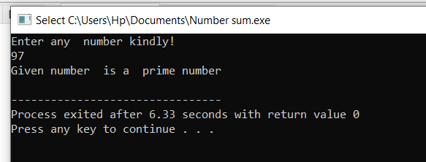 return 0;}

**Explanation:**

This code tells that the given input number is prime number or not