**Task 1**

//TASK 1 code to find sum of first 10 natural numbers

#include <iostream>

using namespace std;

int main(){

int sum,k;

// using for loop

for (int k=1;k<=10;k++){

sum+=k;

}

cout<<"Sum of first 10 natural numbers is " << sum << endl;

return 0;

}

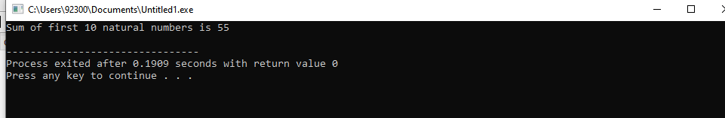

**Explanation:** In this code, sum of first 10 natural numbers is displayed..

**Task 2**

#include <iostream>

using namespace std;

int main (){

int table,num, answer;

cout<<"Kindly enter any Number!"<<endl;

cin>>num;

for (table=1;table<=20;table++)

{ answer= num * table ;

cout<<num<<"x"<<table<<"="<<answer<< endl;

}

return 0;

}

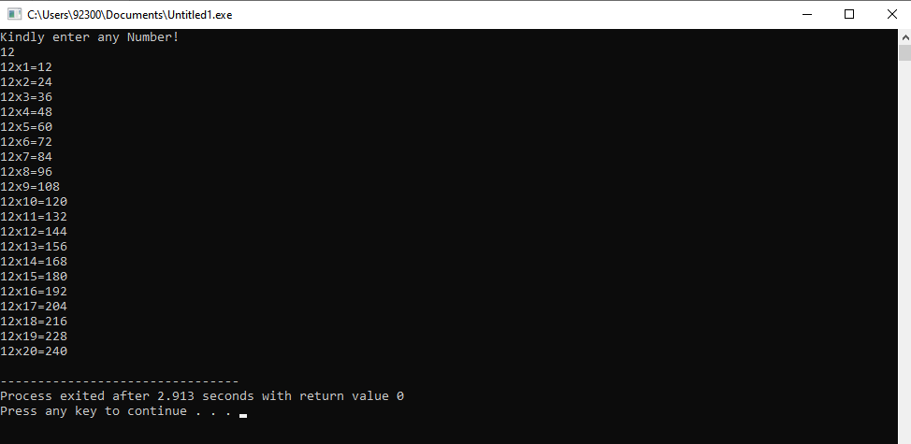

**Explanation:** In this code, table of given input is displayed.

**Task 3**

#include <iostream>

using namespace std;

int main()

{

double k,number;

cout<<"Enter any Number :"<<endl;

cin>>number;

for(k=number-1;k>=1;k--)

{number*=k;}

cout<<"The Factorial is :"<<number<<endl;

return 0;

}

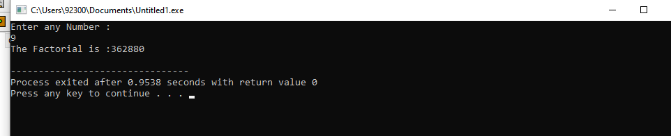

**Explanation:** In this code,factorial of given number is displayed.

**Task 4**

#include <iostream>

using namespace std;

int main() {

int sequence, first = 0,second = 1;

int number;

cout<<"Enter a number for sequence values:"<<endl;

cin>>number;

cout<<"The fibonacci sequence for "<<number<<" values is:";

//using for loop

for (int i = 1; i<number; i++)

if (i<=0) {

sequence = i;

} else {

sequence = first + second;

first = second;

second = sequence;

cout<<sequence<<endl;

}

return 0;

}

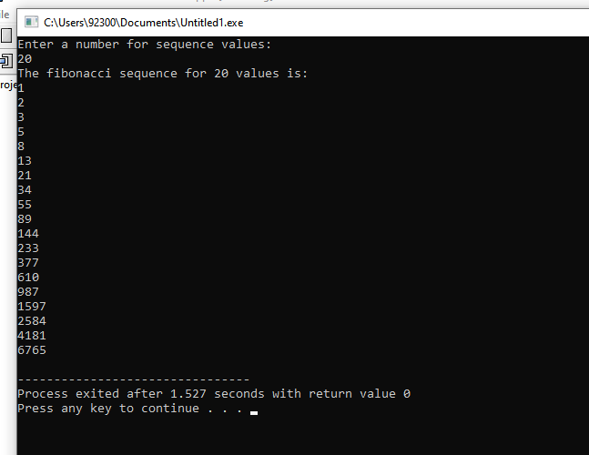

**Explanation:** In this code, number of fibonnaci sequence are displayed based on given input number.