Lab Task 5

**Name:** Fahad Asif

**Cms Id:** 462895

Task 1

#include <iostream>

using namespace std;

int main(){

//task 1

int x;

x=1;

do {

cout<<"Enter a number please!"<<endl;

cin>>x;

}

while(x>0);

return 0;

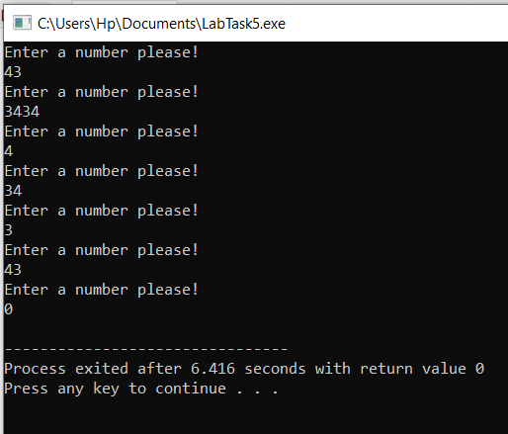}

Task 2

#include <iostream>

#include<math.h>

using namespace std;

int main() {

int c;

float a,b,answer;

char operation;

do {

cout<<"Kindly enter your first number!"<<endl;

cin>>a;

cout<<"Kindly enter the second number!"<<endl;

cin>>b;

cout<<"Enter the operation youn want to perform"<<endl;

cin>>operation;

switch (operation) {

case '+':

answer=a+b;

break;

case '-':

answer=a-b;

break;

case '*':

answer=a*b;

break;

case '/':

if (b==0) {

cout<<"Denominator can not be zero, invalid denominator, Kindly add valid value for denominator"<<endl;

}

answer=a/b;

break;

case '^':

answer=pow(a,b);

default:

cout<<"Invalid operation, kindly add valid operation!"<<endl;

}

cout<<"The answer for "<< a << operation << b <<" is " <<answer <<endl;

cout<<" "<<endl; //did this to add a line spacing

cout<<"press 1 to continue and 0 for termination"<<endl;

cin>>c;

}

while (c==1);

return 0;

}

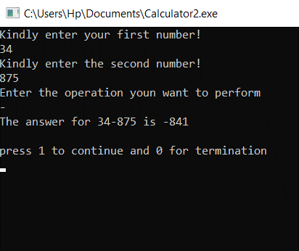

Task 3 (a)

#include <iostream>

using namespace std;

int main()

{

int a,sum;

a=2,sum=0;

while (a<=100) {

if (a%2==0) {

sum =sum+a;

}

a++;

}

cout<<"The sum of all even numbers from 2 to 100 is "<<sum<<endl;

return 0;

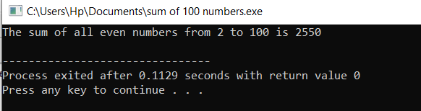}

**Task 3(b)**

#include <iostream>

#include<math.h>

using namespace std;

int main() {

int a,sum;

a=1,sum=0;

while (a<=100) {

sum=sum + a*a;

a++;

}

cout<<"The sum of square of first 100 numbers is "<<sum<<endl;

return 0;

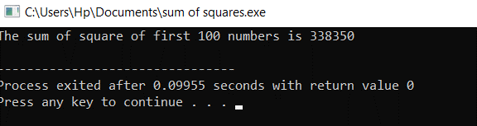}

**Task 4(a)**

#include <iostream>

#include<math.h>

using namespace std;

int main() {

int k=0;

while (k<=20) {

cout<<"Answer of 2^"<<k<<" is "<<pow(2,k)<<endl;

k++;

}

return 0;

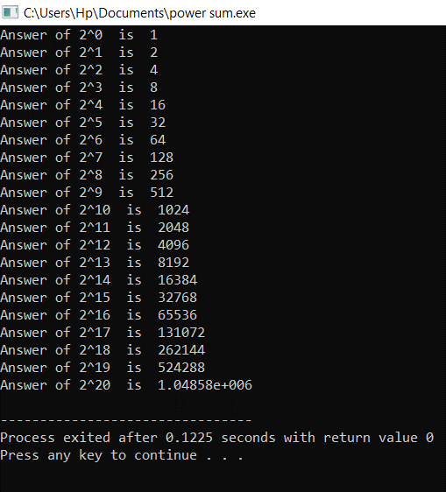}

**Task 4 (b)**

#include <iostream>

#include<math.h>

using namespace std;

int main() {

int a,b,c,sum;

sum=0;

c=a;

cout<<"Kindly enter 1st number"<<endl;

cin>>a;

cout<<"Kindly enter 2nd number"<<endl;

cin>>b;

while (a<=b ) {

if (a%2==1 ) {

sum=sum+a;

}

a++;

}

cout<<" "<<endl;

cout<<"The sum of odd numbers between "<<c<<" and "<<b<<" is "<<sum<<endl;

return 0;

