**Name: Fahad Asif**

**Cms id: 462895  
FOP Home task:5  
  
TASK 1  
#include<iostream>**

**#include<bitset>**

**using namespace std;**

**int main(){**

**int number1,number2,k,LCM,HCF;**

**cout<<" Kindly enter value of 1st number : "<<endl;**

**cin>>number1;**

**cout<<"Kindly enter value of 2nd Number : "<<endl;**

**cin>>number2;**

**for(k=1;k<=number1/2;k++)**

**{**

**if( number1%k==0 && number2%k==0 ){**

**HCF= k ;**

**}**

**}**

**LCM = number1*number2/HCF;**

**cout<<LCM<<" is the least common multiple (LCM) of "<<number1 << " and "<<number2<<endl;**

**return 0;**

**}**

**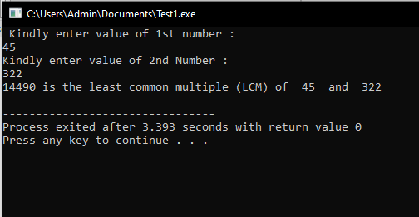  
  
Task 2  
  
  
#include <iostream>**

**using namespace std;**

**int main(){**

**int a1,a2,d,n;**

**cout<<" Enter 1st number "<<endl;**

**cin>>a1;**

**cout<<" Enter 2nd number "<<endl;**

**cin>>a2;**

**cout<<" Now, how many numbers you want to find sum of :"<<endl;**

**cin>>n;**

**d = a2 - a1;**

**int sum= (n*(2*a1+(n-1)*d))/2;**

**cout<<sum<<" is the sum of given A.P."<<endl;**

**return 0;**

**}**

**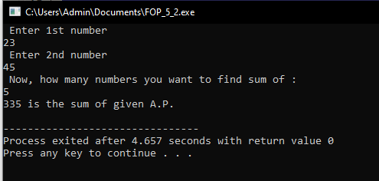  
  
  
TASK 3  
  
  
#include <iostream>**

**using namespace std;**

**int main(){**

**int a,b,c,d,e,f;**

**for(a=1;a<=6;a++) // upper triangle.**

**{for(b=6;b>=a;b--)**

**{cout<<" ";}**

**for(b=1;b<=a;b++)**

**{cout<<" *";}**

**cout<<endl;**

**}**

**for(c=1;c<=5;c++) // lower triangle**

**{for(d=0;d<=c;d++)**

**{cout<<" ";}**

**for(e=5;e>=c;e--)**

**{cout<<" *";}**

**cout<<endl;**

**}**

**return 0;**

**}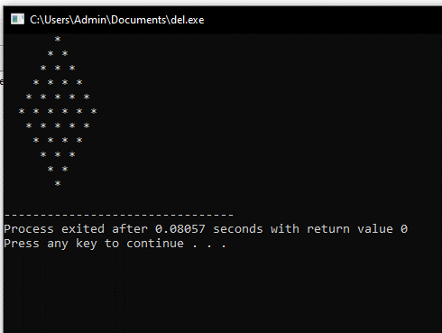 TASK 4  
  
  
#include<iostream>**

**using namespace std;**

**int main()**

**{**

**int num,count,bin[100];**

**cout<<"Enter a number"<<endl;**

**cin>>num;**

**for(int a=0;num>0;a++)**

**{**

**bin[a]=num%2;**

**num=num/2;**

**count++;**

**}**

**cout<<"\nBinary Equivalent is ";**

**for(int k=count-1;k>=0;k--)**

**{**

**cout<<bin[k];**

**}**

**}**

