Name: Fahad Asif  
Lab Assignment no.1  
  
Task no 1:  
#include <iostream>

using namespace std;

int main(){

int num;

cout << "PLEASE ENTER THE NUMBER ";

cin>>num;

cout<<"The Factors of the number "<<num<<" are "<<endl;

for (int i = 1; i <= num; i++) {

if (num%i==0) {

cout<<i<<"\n";

}

}return 0;

}

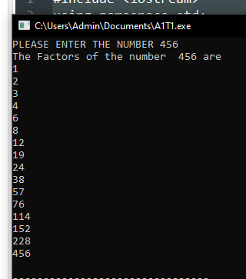Output:

**Task 2:**int main() {

int x = 5;

int y = 10;

if (x == 5)

if (y == 10)

std::cout << "x is 5 and y is 10" << std::endl;

else

std::cout << "x is not 5" << std::endl;

return 0;

}

**Output: x is 5 and y is 10  
  
  
Task 3:**#include <iostream>

using namespace std;

int main() {

int num;

cout<<"PLEASE ENTER THE NUMBER: ";

cin>>num;

if (num > 10 && num <=20) {

cout<<"1";

}

else {

cout<<"0";

}

return 0;

}  
  
  
Output:  
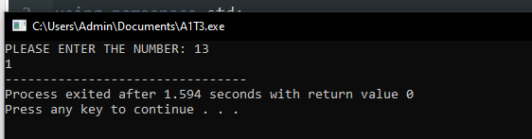

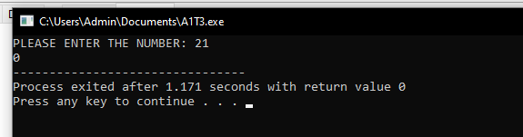  
  
Task 4:  
#include <iostream>

using namespace std;

int main() {

int n, i, factor, j ;

cout<<"Please enter any number ";

cin>>n;

i = n;

while (i >= 2) {

factor = 0;

j = 1;

while (j <= i) {

if (i%j==0) {

factor++; }

j++; }

if (factor==2) {

cout<<"The highest prime number just below the given number "<<n<<" is "<<i;

break; }

i--; }

return 0;

}  
  
Output:  
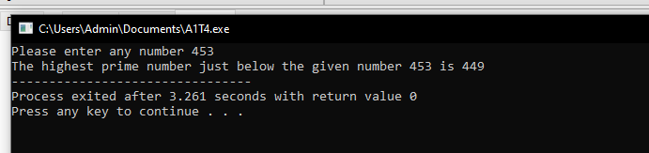  
  
  
Task no 5:  
#include <iostream>

#include <string>

using namespace std;

int main()

{

string s1, s2, rotated;

rotated= "";

cout<<"ENTER YOUR FIRST STRING "<<endl;

cin>>s1;

cout<<"ENTER YOUR SECOND STRING: "<<endl;

cin>>s2;

if (s1==s2) {

for (int i=0; i < s1.length(); i++) {

rotated = s1[i] + rotated;

}

cout<<"Both inputed strings are equal , rotated string is given as "<<endl;

cout<<rotated;

}

else {

cout<<"Both the strings are unequal";

}

return 0;}  
  
**Output:**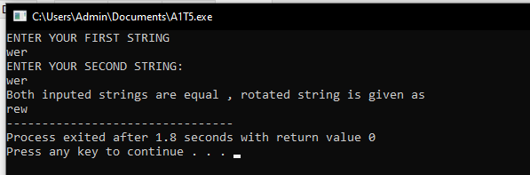

**Task 6:**#include <iostream>

using namespace std;

int main() {

int dividend, divisor, remainder, quotient;

cout<<"Enter your dividend kindly! "<<endl;

cin>>dividend;

cout<<"Enter your Divisor please "<<endl;

cin>>divisor;

if (dividend < divisor) {

cout<<"Enter values again and make sure that dividend is greater than divisor"; }

remainder = dividend;

for (int i = 1; i <= dividend; i++) {

remainder -= divisor;

if (remainder < divisor) {

quotient = i;

break; }

}

cout<< dividend <<"/"<<divisor<<"="<<quotient<<endl;

return 0;

}  
  
**Output :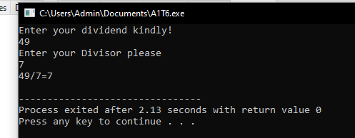 Task 7:**

#include <iostream>

#include <string>

using namespace std;

int main() {

string s, result;

bool found;

cout<<"Enter String: ";

cin>>s;

result = "";

for (int i = 0; i < s.length(); i++) {

found = false;

for (int j = 0; j < result.length(); j++) {

if ( s[i] == result[j] ) {

found = true; }

}

if (found == false) {

result += s[i];

}

}

cout<<"RESULT "<<result;

return 0;

}  
  
**Output: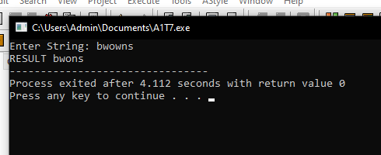 Task 8:**#include <iostream>

using namespace std;

int main(){

int x,new_array[5+x], array[5] = {1,2,3,4,5} ;

cout<<"ARRAY {";

for (int i = 0; i<5; i++) {

cout<<array[i];

cout<<" , ";

}

cout<<"}"<<endl;

cout<<"Enter the number of elements you want to add to the array:"<<endl;

cin>>x;

for (int i = 0;i<5;i++) {

new_array[i] = array[i];

}

cout<<"Enter the " << x << " new integers to be added to the array "<<endl;

for (int i =5;i<5+x;i++)

cin>>new_array[i];

cout<<"New array after adding the additional new element is given by"<<endl;

cout<<"NEW ARRAY = {";

for (int i = 0; i<5+x; i++) {

cout<<new_array[i]<<" ";

cout<<" , ";

}

cout<<"}"<<endl;

return 0;

}  
  
  
**Output:**