Name : Fahad Asif

Cms Id: 462895  
  
  
Task1 :

#include <iostream>

using namespace std;

int main(){

int array[9]={};

for(int i=0;i<10;i++){

cout<<"Enter the array value:";

cin>>array[i];

}

for(int i=0;i<10;i++){

cout<<array[i]<<" ";

}

return 0;

}  
  
**OUTPUT:**

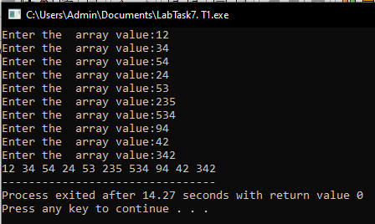

**Task 2**

#include <iostream>

using namespace std;

int main(){

int array[5];

int s=0,p=1,x;

cout<<"Enter 5 integers:"<<endl;

for(int i=0;i<5;i++){

cin>>array[i];

}

for(int i=0;i<5;i++){

x=array[i];

p*=x;

s+=x;

}

cout<<"Sum of array is equal to "<<s<<endl;

cout<<"Product of array is equal to "<<p<<endl;

return 0;

}  
  
  
Output:  
  
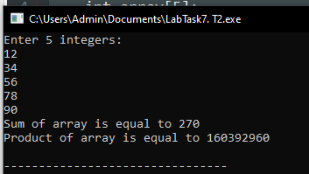  
  
task 3:  
#include <iostream>

using namespace std;

int main(){

int size;

cout<<"Enter size of diamond: "<<endl;

cin>>size;

int half=size/2;

char shape[size];

for (int i=0;i<=size-1;i++) {

shape[i]=' ';

}

for (int i=0; i<=half; i++) {

for (int j=0; j<=size;j++) {

shape[half-i]='*';

shape[half+i]='*';

cout<<shape[j];

}

cout<<endl;

}

for (int i=half;i>=0;i--) {

for (int j=0;j<size;j++) {

shape[half-i]=' ';

shape[half+i]=' ';

cout<<shape[j];

}

cout<<endl;

}

return 0;

}

Output:

