

**Submitted by:**

Fahad Asif

**Referred to:**

Sir. Muhammad Affan

**Roll no:**

462895

Fundamentals of Programming

Lab Manual

Task 1

#include <iostream>

using namespace std;

int main(){

int arr[10];

int sum,avg=0;

for(int i=0;i<10;++i){

cout<<"Enter the " <<(i+1) <<" element of the array"<<endl;

cin>>arr[i];

}

cout<<"Entered elements of the array are: ";

for (int i=0;i<10;++i){

cout<<arr[i]<<" ";

sum=sum+arr[i];

}

avg=sum/10;

cout<<endl;

cout<<"Average of the elements of the array is : "<<avg;

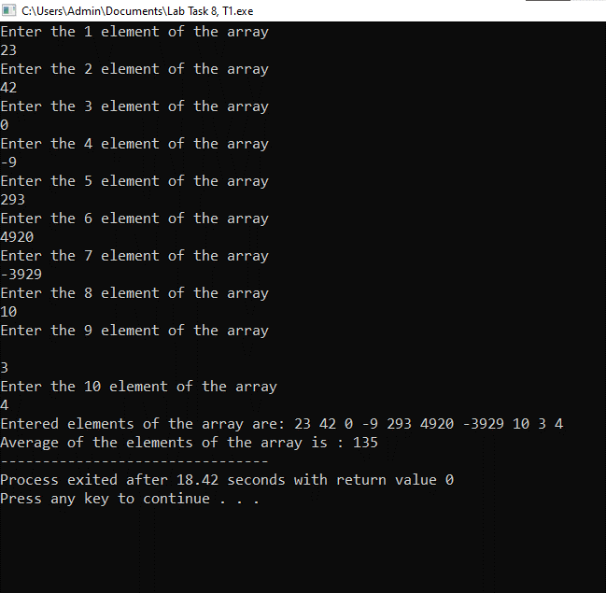}

Task 2

#include <iostream>

using namespace std;

int main(){

int arr[5];

for(int i=0;i<5;i++){

cout<<"Enter the "<<(i+1) << " element of the Array : ";

cin>>arr[i];

}

cout<<"Elements of the array in unsorted form (raw form) are :"<<endl;

for (int i=0;i<5;++i){

cout<<arr[i]<<" ";

}

cout<<endl;

for(int i=0;i<5-1;++i){

for(int j=0;j<5-i-1;++j){

if(arr[j]>arr[j+1]){

int k=arr[j];

arr[j]=arr[j+1];

arr[j+1]=k;

}

}

}

cout<<"Elements of array after sorting are : ";

for(int i=0;i<5;++i){

cout<<arr[i]<<" ";

}

return 0;

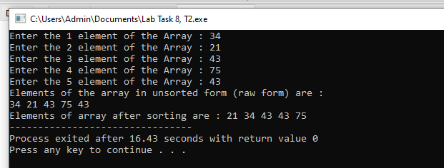}

Task 3

#include<iostream>

using namespace std;

int main () {

int size=5;

int midv=0,array[size] ;

cout<<"Enter 5 elements of the array "<<endl;

for (int m=0;m<5;m++) {

cin>>array[m];

}

for (int i=0;i<size;i++) {

midv=array[i];

for (int j=i;j<size;j++) {

if (midv>array[j]) {

midv=array[j];

array[j]=array[i];

array[i]=midv;

}

}

cout<<array[i]<<" ";

}

return 0;

}

