Removed FPS:

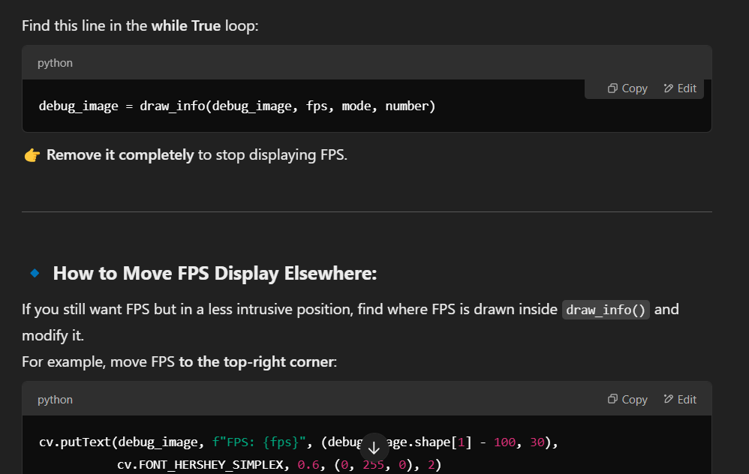

# Draw the additional information like fps  
debug_image = draw_info(debug_image, fps, mode, number)

**Current State:**

* Detects and Classify Gestures.
* Create Words and Sentences and TTS Added.
* O after O is not possible yet.

To Add:

* Make timing better of alphabet registration.
* Add a sign to show end of sentence and to speak it out loud.
* Ask gpt to remove unnecessary comments and modify code to make it look different.
* Create Paper.

Paper: