**Project Name:**

Smart Home Security & Monitoring System

**Iteration-0: Planning Phase**

**Course Section:** CS B

**Group Members:**

* Fahad Jameel i210394
* Shaffin Imam i212963
* Ahmed Javeed i221067

**Course**: Software Engineering



**1. Introduction**

We’re a small team of students working on a **Smart Home Security & Monitoring System** project. In this document, we’ll outline our initial planning including our problem statement, envisioned features, user stories, team roles, working agreements

**2. Problem Statement**

| **The problem of** | **an increase in crime rates in large cities** |
| --- | --- |
| **affects** | middle-income homeowners |
| **the impact of which is** | uncertainty in the safety and security of homeowners and their belongings |
| **a successful solution would be** | a flexible, cost-effective home security system that’s easy to set up, integrates well with existing alarm monitoring, and provides real-time alerts and controls |

**3. Envisioned Features**

1. **User Registration & Login**
2. **Profile Management**
3. **Sensor Setup & Configuration** (motion sensors, door/window sensors, cameras)
4. **Real-Time Alerts & Notifications**
5. **Activity Logs** (system events, sensor triggers)
6. **Remote Arm/Disarm**
7. **Live Video Feed**
8. **Scheduling Lights & Devices**
9. **Zone Management**
10. **Integration with Third-Party Alarm Services**
11. **Energy Usage Monitoring** (optional)
12. **Guest Access / Temporary Codes**
13. **Emergency Services Integration**
14. **System Health Dashboard**
15. **Automated Alerts for System Failures** (sensor offline, low battery)

**4. Product Backlog (User Stories)**

We brainstormed and came up with **25 user stories** that capture the core needs.

1. **User Registration**
   * *As a new homeowner, I want to create a secure account so that I can access my home security dashboard.*
2. **User Login**
   * *As a returning user, I want to log in with my credentials so that I can manage my home security features.*
3. **Edit Profile**
   * *As a homeowner, I want to update my personal details so that I can keep my contact information current.*
4. **Add Motion Sensor**
   * *As a homeowner, I want to add a motion sensor to my system so that I can detect any movement when I’m away.*
5. **Add Door Sensor**
   * *As a homeowner, I want to install a door sensor so that I can be alerted when the door opens unexpectedly.*
6. **Remote Arm/Disarm**
   * *As a homeowner, I want to arm or disarm my security system from anywhere so that I can control access to my house.*
7. **Push Notifications**
   * *As a homeowner, I want to receive push notifications on my phone so that I’m immediately alerted if something unusual happens.*
8. **Email/SMS Alerts**
   * *As a homeowner, I want to get email or SMS alerts so that I can stay informed even if I’m not using the app.*
9. **View Activity Log**
   * *As a homeowner, I want to see a history of all sensor triggers and system actions so that I can review any suspicious events.*
10. **Live Camera Feed**

* *As a homeowner, I want to watch a live feed from my cameras so that I can check on my property in real time.*

1. **Playback Recorded Footage**

* *As a homeowner, I want to review recorded clips so that I can investigate what happened when I wasn’t looking.*

1. **Schedule Lights**

* *As a homeowner, I want to set schedules for my lights so that I can simulate someone being home while I’m away.*

1. **Zone Management**

* *As a homeowner, I want to group sensors by zones so that I can easily monitor specific areas (like upstairs vs. downstairs).*

1. **Third-Party Alarm Service**

* *As a homeowner, I want to connect my system to a professional alarm service so that the police or security company are notified in a real emergency.*

1. **System Status Overview**

* *As a homeowner, I want a dashboard that shows me which sensors are active or offline so that I can quickly see if anything needs attention.*

1. **Low-Battery Alerts**

* *As a homeowner, I want to be notified when a sensor’s battery is low so that I can replace it before it fails.*

1. **Add/Remove Users**

* *As a homeowner, I want to manage additional users (family, friends) so that they can access or monitor my system.*

1. **Guest Access Code**

* *As a homeowner, I want to create a temporary code for guests or maintenance people so that they can enter my house without triggering alarms.*

1. **Smart Lock Integration**

* *As a homeowner, I want my smart locks to integrate with the security system so that the doors automatically lock when I arm the system.*

1. **Mobile App Interface**

* *As a homeowner, I want a dedicated mobile app so that I can quickly check on my home from my phone.*

1. **Voice Assistant Support**

* *As a tech-savvy user, I want to control my security system through voice commands (e.g., Alexa, Google Home) so that I can arm/disarm hands-free.*

1. **Multi-Language Support**

* *As a bilingual user, I want the interface to support multiple languages so that I can comfortably navigate the system.*

1. **Emergency Services Button**

* *As a homeowner, I want a panic/emergency button in the app so that I can immediately call for help.*

1. **Night Mode**

* *As a homeowner, I want a “night mode” that only monitors doors and windows so that I don’t trigger the alarm by moving around inside.*

1. **Monthly Activity Report**

* *As a homeowner, I want a monthly summary of system activity so that I can spot any unusual patterns.*

**5. Roles and Responsibilities**

We decided on these roles for our group:

1. **Product Owner (PO)** – *Ahmad Javeed*
   * Communicates with stakeholders and clarifies requirements.
   * Maintains and prioritizes the product backlog.
2. **Scrum Master (SM)** – *Fahad* 
   * Facilitates meetings (daily stand-ups, sprint planning, retros).
   * Removes any blockers and ensures the team follows the agreed-upon process.
3. **Development Team**
   * *Fahad (Front-End)*: Focuses on UI design, responsive layout, and user experience.
   * *Shaffin Imam (Back-End)*: Sets up the server, database, and core system logic.
   * *Ahmad Javeed (QA & Integration)*: Oversees testing, bug tracking, and ensures everything integrates smoothly.

**6. Team Agreement**

1. **Communication Methods**
   * We’ll use a WhatsApp group for quick updates.
   * Trello is our main tool for tracking tasks and progress.
2. **Response Times**
   * We’ll do our best to respond to team messages within 6 hours.
   * On weekends, responses might be slower, but we’ll still check in at least once a day.
3. **Meeting Attendance**
   * We’ll hold a virtual meeting on google meet every Monday at 10 PM.
   * Everyone should join unless they have an urgent reason not to.
   * If someone can’t attend, they must read the meeting notes afterward.
4. **Meeting Format**
   * Fahad (Scrum Master) will lead the meeting.
   * One person will take notes and post them on Trello so we have a written record.
   * Everyone is expected to share progress, roadblocks, and next steps.
5. **Preparation**
   * Before each meeting, we review the Trello board and update our tasks.
   * If we’re stuck, we mention it in the group chat so we can address it during the meeting.
6. **Version Control**
   * We’re using GitHub.
   * Each new feature or bug fix will be developed on a separate branch.
   * We’ll merge into main only after at least one team member reviews the code.
7. **Division of Work**
   * The PO (Ahmed Javeed) will prioritize stories.
   * Each dev team member chooses stories based on their skill set and interest, with an eye on balancing the workload.
8. **Assignment Submission**
   * Final check is done at least 24 hours before the deadline.
   * Fahad (Scrum Master) will handle the upload to Google Classroom.
   * We’ll do a quick internal review to confirm the document or code is correct.
9. **Contingency Planning**
   * If someone drops out or becomes inactive, we’ll redistribute tasks and notify the instructor if needed.
   * Repeated no-shows will be handled by a one-on-one conversation, and if it persists, we’ll escalate.
   * We all agree to maintain academic integrity no plagiarism or copying code from unauthorized sources.

**7. GitHub Repository**

* **Repository Link**: <https://github.com/Fahad-Jameel/SmartHomeSecurity>
* **Screenshot**:  
  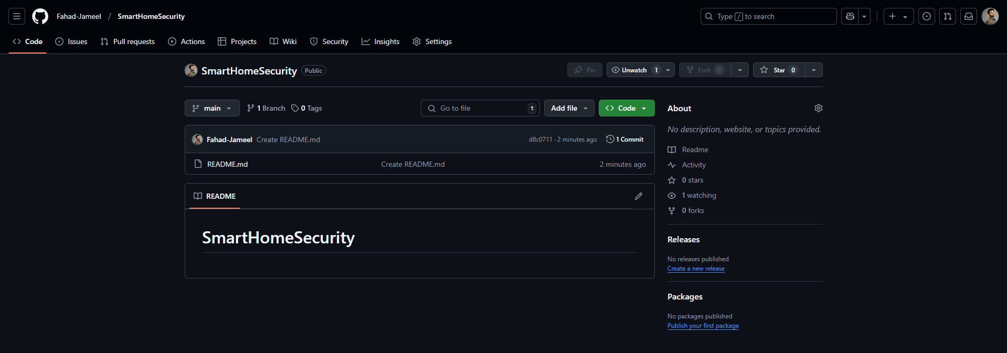

**8. Trello Board Snapshots**

1. **Snapshot #1**: **Product Backlog**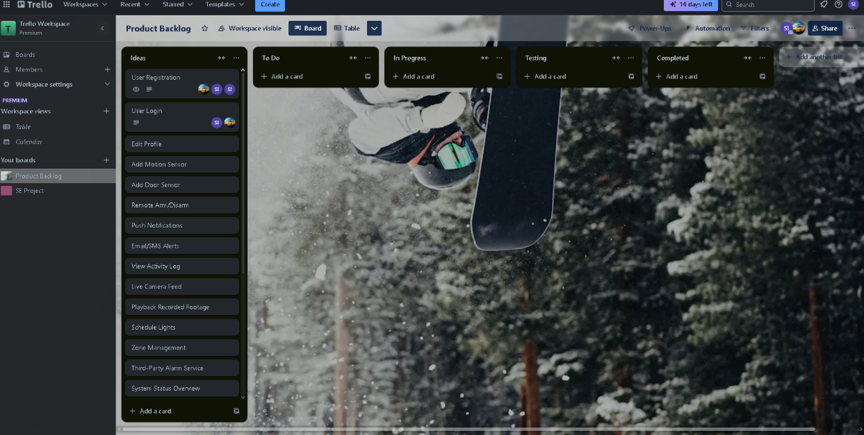
2. **Snapshot #2**: **Sprint Backlog**  
   