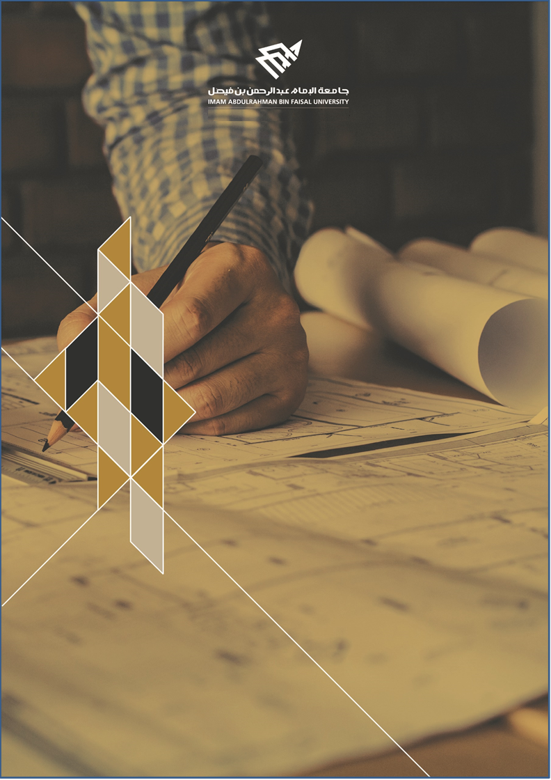
ARTI 404 – Image Processing

STUDENT PROCEDURAL MANUAL Lab 3

2025 - 2026
DEPARTMENT OF COMPUTER ENGINEERING

College of Computer Science and Information Technology
كلية علوم الحاسب وتقنية المعلومات

Lab 3 – Answers: Image Manipulations using OpenCV Library

Task 1: Geometric Transformations

1.1 Increase the size of the image (2×)
Original size: (512, 512, 3)
Resized size : (1024, 1024, 3)
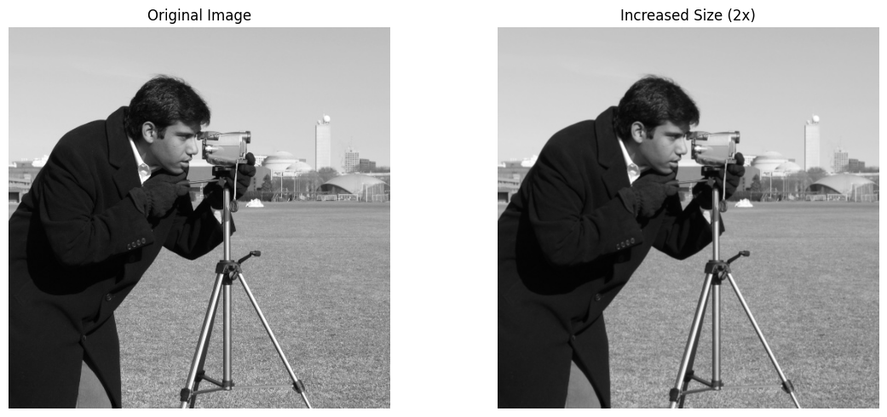

1.2 Rotate the image by 120 degrees
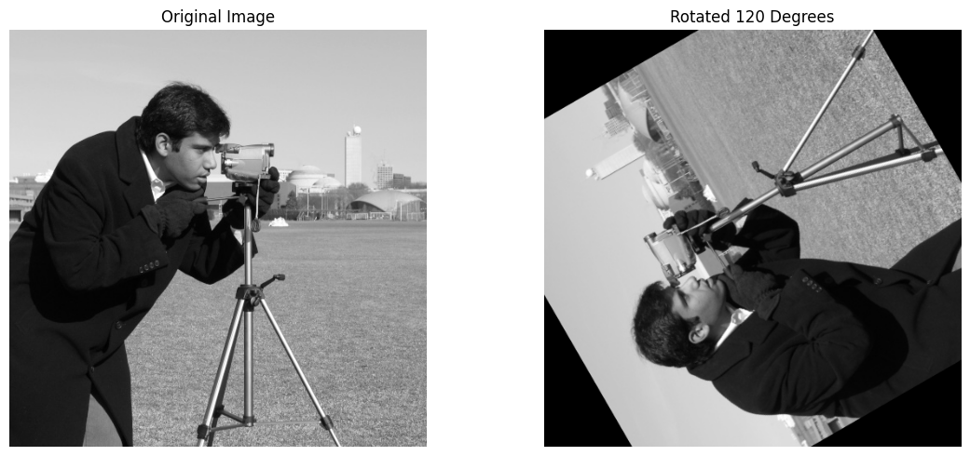

1.3 Shear operation (factor 0.3)
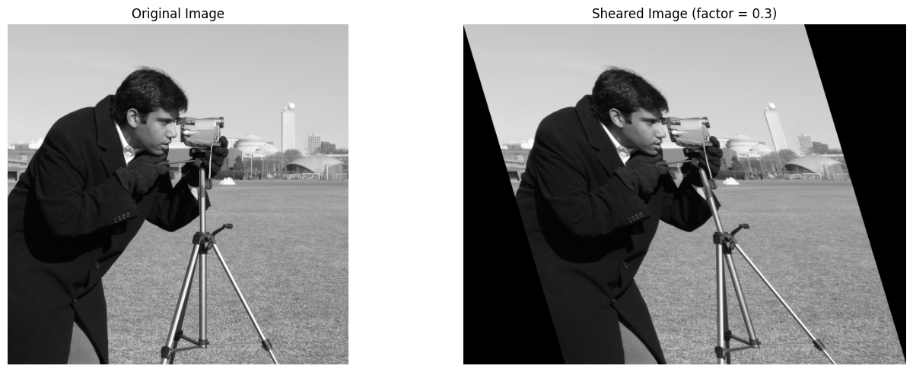

Task 2: Intensity Transformations

2.1 Negative image
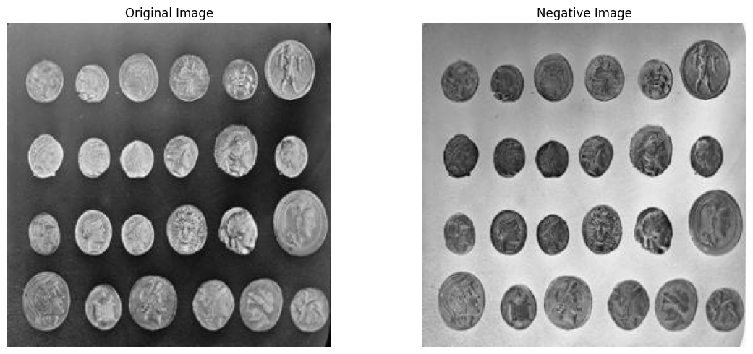

2.2 Log transformation
Constant c = 45.9859
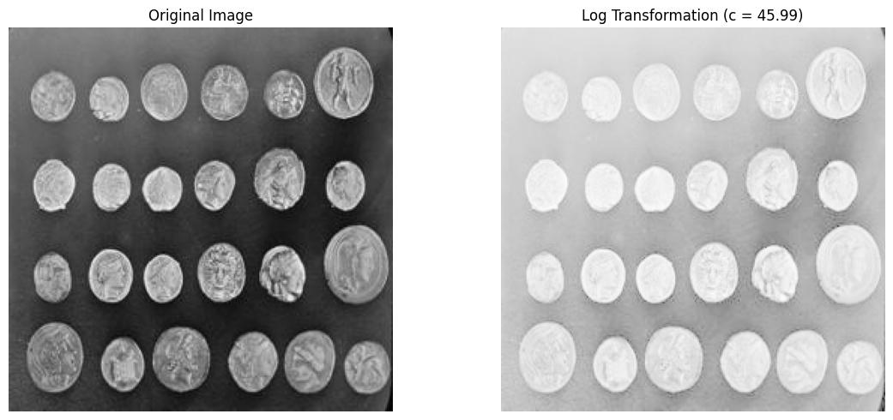

2.3 Power law (gamma = 0.4)
Gamma = 0.4
