

College of Computer Science and Information Technology
تامولعملا ةينقتو بساحلا مولع ةيلك

DEPARTMENT OF COMPUTER ENGINEERING

ARTI 404 – Image Processing

STUDENT PROCEDURAL MANUAL Lab 4

2025 - 2026

Lab 4 – Answers: Intensity Transformations and Filtering – Spatial Domain

Task 1: Contrast Stretching (3rd and 80th Percentiles)

1.1 Percentiles
3rd percentile: 87.0, 80th percentile: 118.0

1.2 Original image and histogram
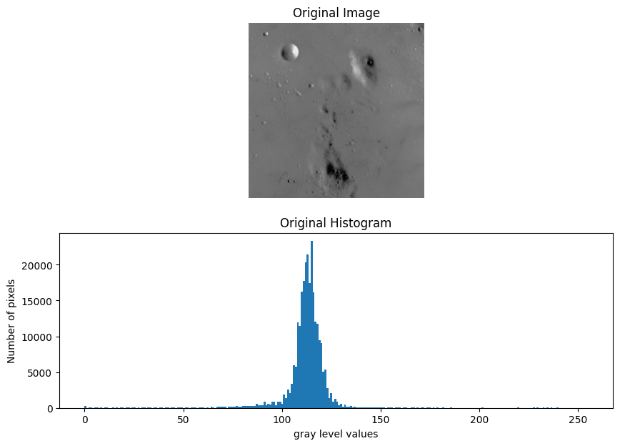

1.3 Contrast-stretched image and histogram
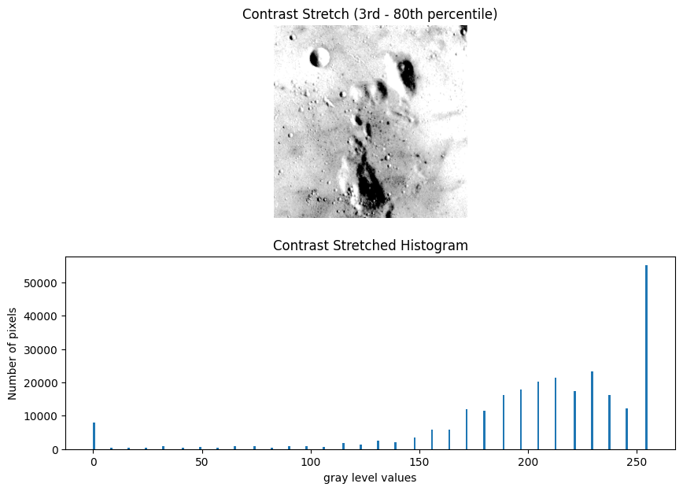

Task 2: Histogram Equalization
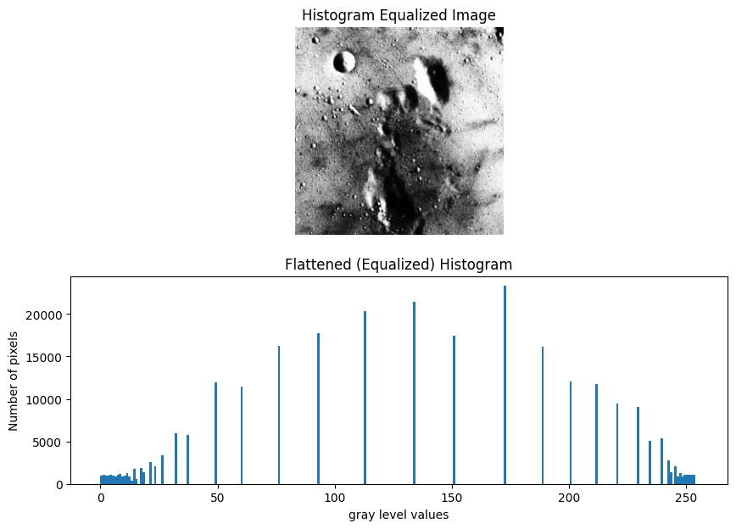

Task 3: Histogram Matching

3.1 Source, reference and matched images
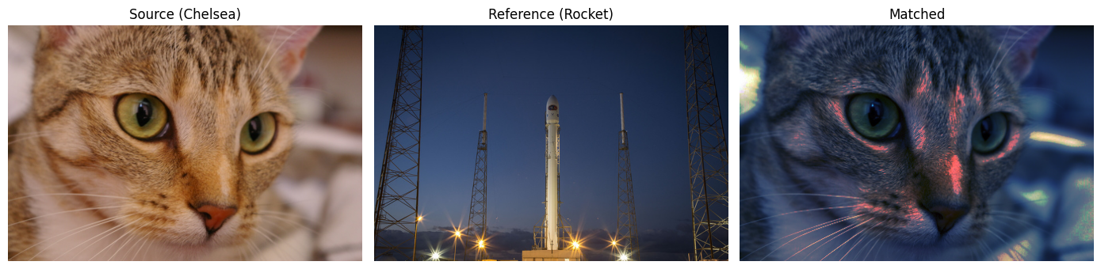

3.2 Histograms and cumulative distributions per color channel
