

College of Computer Science and Information Technology
تامولعملا ةينقتو بساحلا مولع ةيلك

DEPARTMENT OF COMPUTER ENGINEERING

ARTI 406 – Image Processing

STUDENT PROCEDURAL MANUAL Lab 5

2025 - 2026

Lab 5 – Answers: Spatial Filtering – Smoothing and Sharpening

Task 1: 7×7 Box Filter
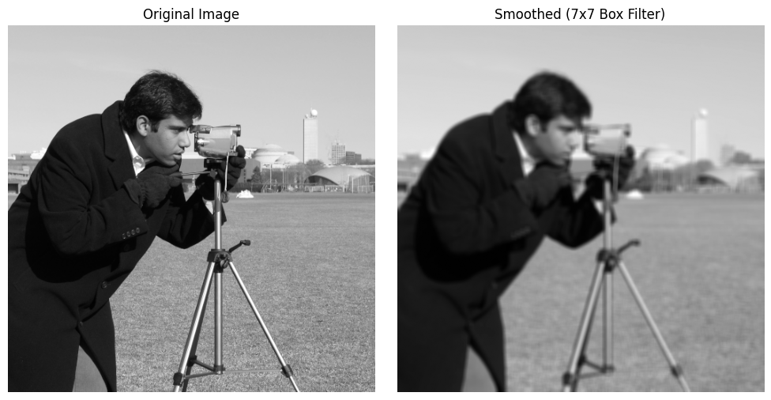

Task 2: 5×5 and 21×21 Gaussian Filters
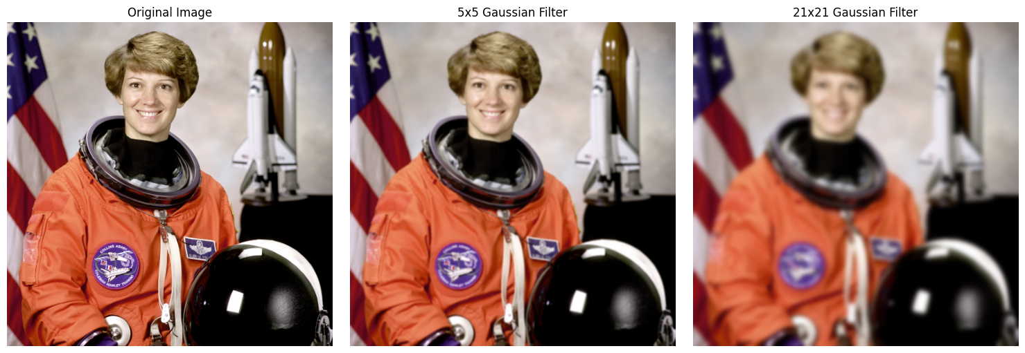

Task 3: 3×3 Laplacian Filter for Sharpening
