

College of Computer Science and Information Technology
تامولعملا ةينقتو بساحلا مولع ةيلك

DEPARTMENT OF COMPUTER ENGINEERING

ARTI403 – Image Processing

STUDENT PROCEDURAL MANUAL Lab 1

2026 - 2027

Lab 1 – Answers: Basics of Programming with Python

Task 1: Exercise with the Cheat Sheets (NumPy)

1.1 Creating arrays
[1 2 3]
[[1.5 2. 3. ]
[4. 5. 6. ]]
[[[1.5 2. 3. ]
[4. 5. 6. ]]
[[3. 2. 1. ]
[4. 5. 6. ]]]

1.2 Array of zeros
array([[0., 0., 0., 0.],
[0., 0., 0., 0.],
[0., 0., 0., 0.]])

1.3 Array of ones (int16)
array([[[1, 1, 1, 1],
[1, 1, 1, 1],
[1, 1, 1, 1]],
[[1, 1, 1, 1],
[1, 1, 1, 1],
[1, 1, 1, 1]]], dtype=int16)

1.4 np.arange(10, 25, 5)
[10 15 20]

1.5 np.linspace(0, 2, 9)
array([0. , 0.25, 0.5 , 0.75, 1. , 1.25, 1.5 , 1.75, 2. ])

1.6 Inspecting an array
(3,)
3
2
float64
float64
[[1 2 3]
[4 5 6]]

1.7 Arithmetic and math operations
[[-0.5 0. 0. ]
[-3. -3. -3. ]]
[[-0.5 0. 0. ]
[-3. -3. -3. ]]
[[2.5 4. 6. ]
[5. 7. 9. ]]
[[2.5 4. 6. ]
[5. 7. 9. ]]
[[0.66666667 1. 1. ]
[0.25 0.4 0.5 ]]
[[0.66666667 1. 1. ]
[0.25 0.4 0.5 ]]
[[ 1.5 4. 9. ]
[ 4. 10. 18. ]]
[[ 1.5 4. 9. ]
[ 4. 10. 18. ]]
[[ 4.48168907 7.3890561 20.08553692]
[ 54.59815003 148.4131591 403.42879349]]
[[1.22474487 1.41421356 1.73205081]
[2. 2.23606798 2.44948974]]
[0.84147098 0.90929743 0.14112001]
[[ 0.0707372 -0.41614684 -0.9899925 ]
[-0.65364362 0.28366219 0.96017029]]
[0. 0.69314718 1.09861229]

Task 2: Loading and Visualizing Images

2.1 Image loaded with OpenCV
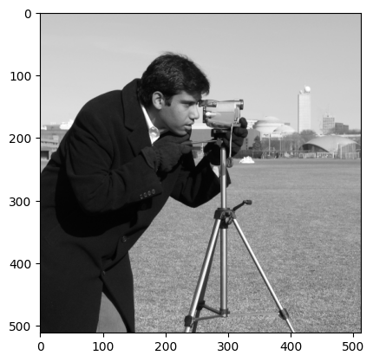

2.2 Image loaded with PIL
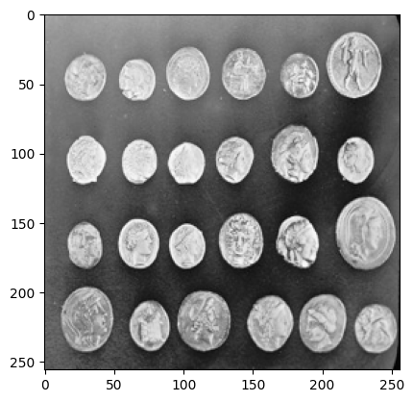

Task 3: Image Storing

3.1 cv2.imwrite('new_image.jpg', img)
True

Task 4: Display Image as an Array

4.1 OpenCV image as an array
(512, 512, 3)
[[[200 200 200]
[200 200 200]
[200 200 200]
...
[189 189 189]
[190 190 190]
[190 190 190]]
[[200 200 200]
[199 199 199]
[199 199 199]
...
[190 190 190]
[190 190 190]
[190 190 190]]
[[199 199 199]
[199 199 199]
[199 199 199]
...
[190 190 190]
[190 190 190]
[190 190 190]]
...
[[ 25 25 25]
[ 25 25 25]
[ 27 27 27]
...
[139 139 139]
[122 122 122]
[147 147 147]]
[[ 25 25 25]
[ 25 25 25]
[ 26 26 26]
...
[158 158 158]
[141 141 141]
[168 168 168]]
[[ 25 25 25]
[ 25 25 25]
[ 27 27 27]
...
[151 151 151]
[152 152 152]
[149 149 149]]]

4.2 PIL image as a NumPy array
(256, 256)
[[ 77 134 134 ... 20 8 8]
[118 147 146 ... 40 7 7]
[134 140 143 ... 61 7 8]
...
[ 81 73 69 ... 8 6 6]
[ 84 76 72 ... 7 6 7]
[ 87 72 64 ... 6 6 8]]

