

College of Computer Science and Information Technology
تامولعملا ةينقتو بساحلا مولع ةيلك

DEPARTMENT OF COMPUTER ENGINEERING

ARTI 403 – Image Processing

STUDENT PROCEDURAL MANUAL Lab 2

2026 - 2027

Lab 2 – Answers: Digital Image Fundamentals

Task 1: Change the Sampling and Quantization Parameters

1.1 Different sampling factors (2, 4, 8, 16)
=== Different Sampling Factors ===
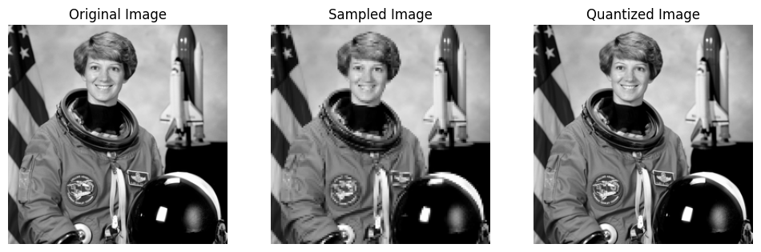
Sampling factor=2: image size reduced from (256, 256) to (128, 128)
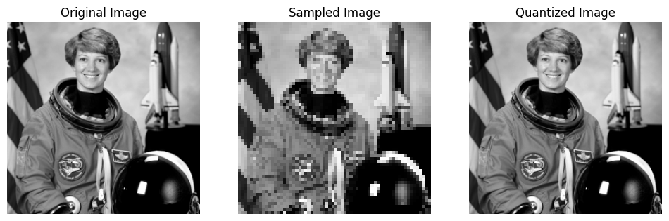
Sampling factor=4: image size reduced from (256, 256) to (64, 64)
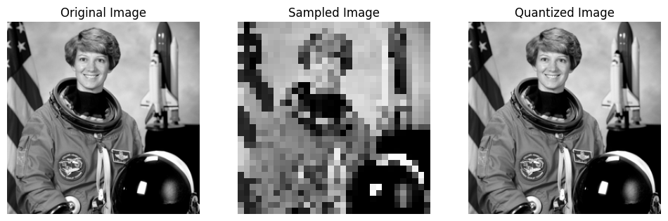
Sampling factor=8: image size reduced from (256, 256) to (32, 32)
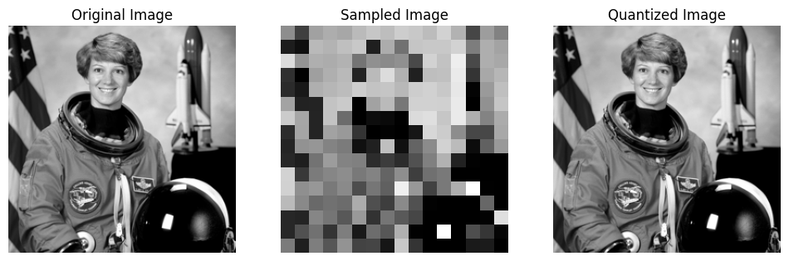
Sampling factor=16: image size reduced from (256, 256) to (16, 16)

1.2 Different quantization levels (128, 64, 16, 4, 2)
=== Different Quantization Levels ===
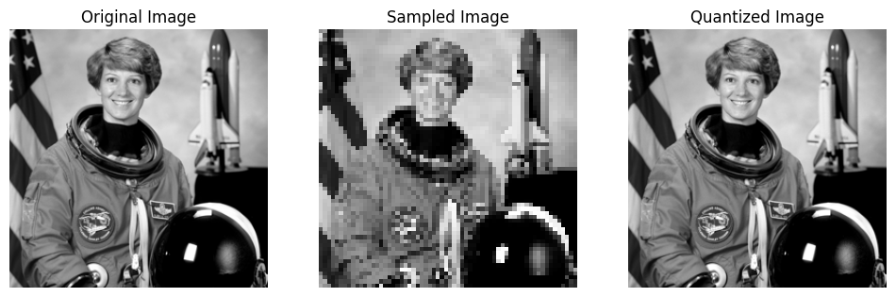
Quantization levels=128: fewer levels = more visible banding
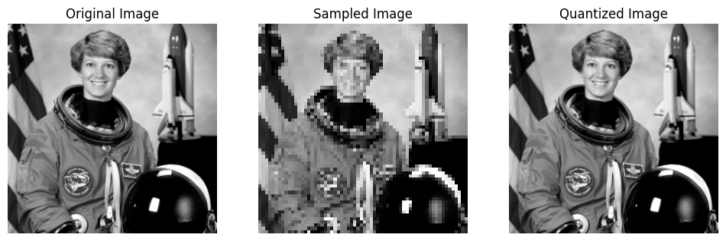
Quantization levels=64: fewer levels = more visible banding
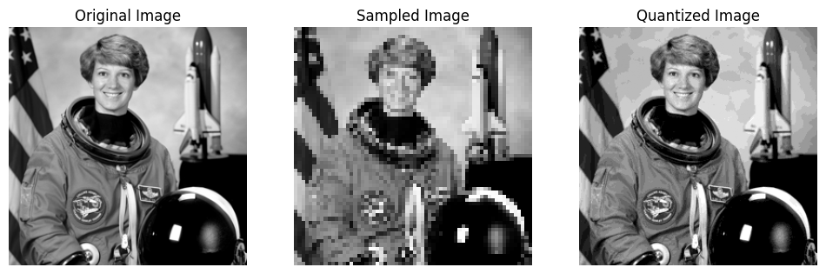
Quantization levels=16: fewer levels = more visible banding
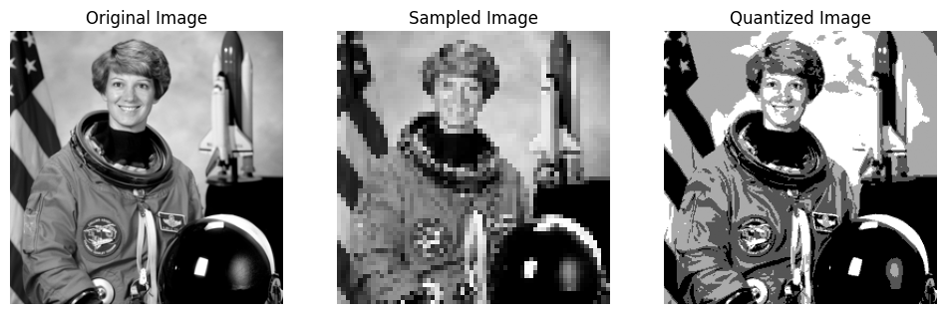
Quantization levels=4: fewer levels = more visible banding
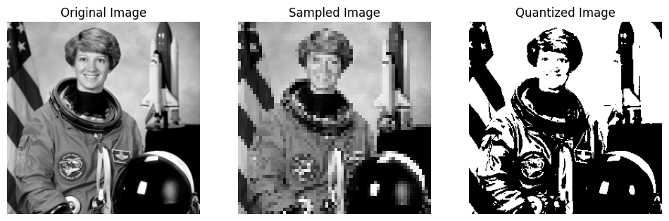
Quantization levels=2: fewer levels = more visible banding

Task 2: Arithmetic and Logical Operations on Two Images

2.1 Subtraction
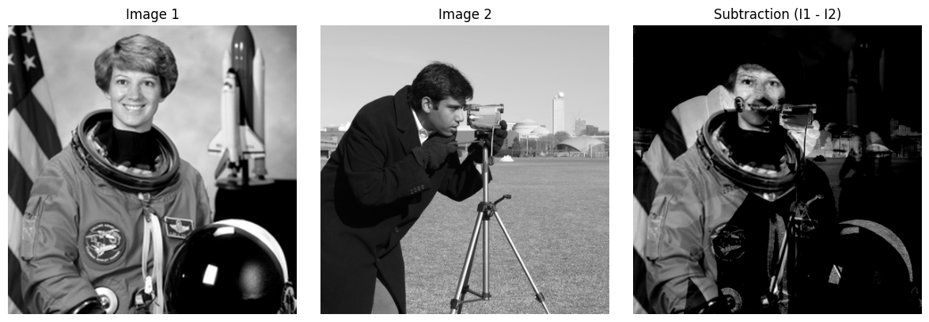

2.2 Image + 175
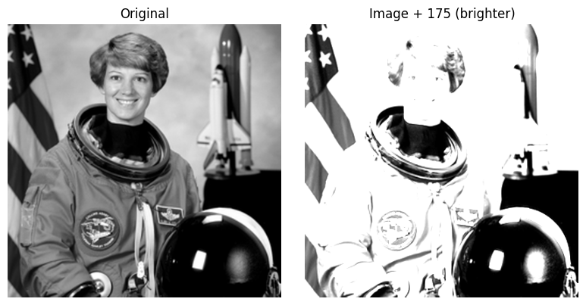

2.3 Set difference (A − B)
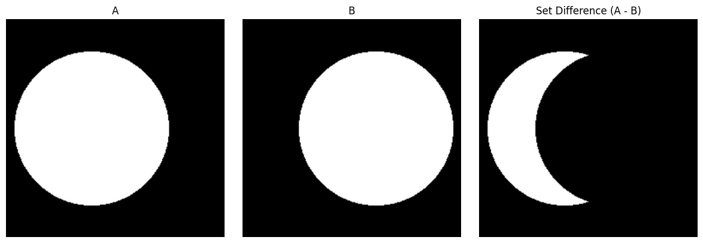

2.4 Symmetric difference (A XOR B)
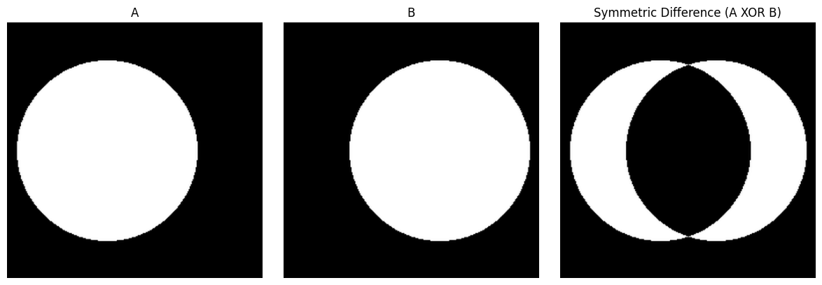

2.5 Intersection (A AND B)
