ARTI 308 – Machine Learning | Project Final Report | Group 4
ARTI 308 – Machine Learning
Term 2 – 2025/2026
Project Final Report
Group #: 4
Members of the group: 6
# | Name | ID | Role
1 | Wesam Jaber Almalki | 2240005660 | Leader
2 | Fahad Nawar Alotaibi | 2240002024 | Member
3 | Fawaz Alshahrani | 2240005571 | Member
4 | Faris Alshahrani | 2240005572 | Member
5 | Ahmed Albouainain | 2240006128 | Member
6 | Anas Hamzi | 2240003869 | Member
Title of the Project: Unsupervised Disease Subgroup Discovery from Health Data
Instructor: Dr. Ito Wasito

Abstract
Chronic non-communicable diseases — particularly hypertension, obesity and type II diabetes — account for a growing share of global morbidity, yet identifying meaningful patient subgroups without relying on physician-assigned labels remains an open analytical problem. Most existing work depends on supervised classification with predefined disease categories, or applies unsupervised learning to disease-specific cohorts, leaving a gap for a general-purpose, label-free framework able to recover clinically interpretable patient groupings directly from routine biomarkers. The present work addresses that gap by applying four unsupervised algorithms — K-Means, Hierarchical (Ward linkage), DBSCAN, and Gaussian Mixture Models (GMM) — to a 1,000-patient health dataset using only three routinely available clinical inputs: body mass index (BMI), fasting glucose and systolic blood pressure. After standardization, the algorithms were tuned, evaluated with both internal metrics (Silhouette, Davies-Bouldin Index) and external metrics (Adjusted Rand Index, Normalized Mutual Information) against the held-out Disease_Type label, and stress-tested with a stratified 80/20 train/test split. GMM emerged as the strongest model, achieving a Silhouette of 0.3635, Davies-Bouldin Index of 1.0182, Adjusted Rand Index of 0.8146 and Normalized Mutual Information of 0.7834, with the test-set silhouette dropping by only 0.023 compared to training. Post-hoc validation showed cluster purities above 91% across all three disease groups. To demonstrate practical utility, the final GMM was deployed in a lightweight risk-predictor web application; three blinded clinical scenarios returned posterior probabilities consistent with the dominant abnormal biomarker in each case. The results confirm that a deliberately small, clinically grounded feature set combined with a probabilistic mixture model produces well-separated, generalisable disease subgroups and offers a deployable foundation for triage-level disease screening in primary-care settings.
Keywords: Unsupervised Learning, Gaussian Mixture Model, Disease Subgroup Discovery, Clinical Biomarkers, Hypertension, Type II Diabetes, Obesity

1. Introduction
Chronic non-communicable diseases such as hypertension, obesity and type II diabetes mellitus are among the leading drivers of global mortality and healthcare expenditure. The World Health Organization estimates that these three conditions, together with the cardiovascular complications they share, account for the majority of preventable deaths in middle- and high-income countries. With the rapid expansion of electronic health records, wearable sensors and population-scale health surveys, large volumes of routinely measured patient data — anthropometric, biochemical and lifestyle indicators — are now continuously generated. Despite this abundance, the task of discovering clinically meaningful subgroups from such multidimensional data remains analytically challenging, particularly when reliable diagnostic labels are unavailable, delayed, or biased by referral patterns [1][2].
This project introduces an unsupervised disease subgroup discovery framework that applies machine learning techniques to identify latent patient clusters directly from clinical biomarkers, without relying on predefined disease labels during model training. The objective is to let natural groupings emerge from the geometry of the data itself, rather than imposing supervised classification boundaries that may inherit the biases of historical labelling practice. This addresses two limitations of traditional supervised models: their dependence on extensively labelled datasets, and the bias introduced by fixed clinical thresholds [3][4].
Previous studies have explored health-data analysis using both statistical and supervised machine learning approaches. Tatoli et al. [1] demonstrated the effectiveness of unsupervised learning in identifying dietary patterns linked to diabetes in an older Southern Italian cohort. Li et al. [2] applied machine learning to a Japanese cohort to study dietary patterns associated with hypertension incidence. Sun et al. [3] used machine learning to associate dietary patterns and obesity with type II diabetes risk in elderly Chinese men. Gjoreski et al. [4] explored Food Propensity Questionnaire data using unsupervised methods, while Côté et al. [5] applied complex network-based algorithms to link dietary patterns with cardiovascular risk in the NutriNet-Santé cohort. D'Souza et al. [6] compared multiple unsupervised methods to characterise lifestyle behaviours in children. While valuable, these efforts typically depend on labelled cohorts, focus on a single outcome, or restrict themselves to narrow demographic strata. A clear gap remains for general-purpose, exploratory, label-free frameworks capable of recovering multiple disease subgroups simultaneously from routine biomarkers alone.
The proposed work employs data preprocessing, standardization, and four clustering algorithms — K-Means, Hierarchical Clustering (Ward linkage), DBSCAN, and Gaussian Mixture Models — together with PCA and t-SNE dimensionality reduction for visualization. A central design decision in this work is the deliberate restriction of the feature space to three clinically grounded biomarkers (BMI, fasting glucose, systolic blood pressure), chosen because each is the canonical diagnostic axis for one of the three target conditions and because the three measurements are routinely available in primary-care settings. The entire pipeline is built around these three features, evaluated against the four-algorithm baseline, validated on a stratified hold-out split, and deployed in a working web application. The envisioned outcome is a scalable, label-free, deployable analytical framework that can support primary-care triage and personalized public-health decision-making.
The remaining part of this work is organized as follows. Section 2 contains a review of related literature and identifies the gap addressed by this work. Section 3 lists the project deliverables. Section 4 describes the four proposed machine learning techniques. Section 5 presents the empirical setup including dataset description, statistical summary, experimental procedure, performance measures and optimization strategy. Section 6 presents the results and discussion, including the algorithm comparison, train/test generalization analysis, the three deployment case studies, and alignment with the client's requirements. Section 7 contains the conclusion and recommendations for future work.

2. Review of Related Literature
Recent advancements in machine learning have allowed researchers to move beyond traditional supervised dietary and disease analysis. Several studies have demonstrated the value of unsupervised learning for identifying dietary and metabolic patterns linked to chronic disease across different populations.
Tatoli et al. [1] applied unsupervised learning to analyse dietary patterns associated with diabetes in an older Southern Italian population. Their study identified distinct dietary clusters correlating with metabolic markers, demonstrating that clustering can reveal diet–disease relationships without predefined labels. Li et al. [2] investigated dietary patterns associated with hypertension incidence among adult Japanese males, showing how data-driven clustering can identify dietary risk factors within specific demographic groups. Sun et al. [3] extended this approach to elderly Chinese men, linking dietary patterns and obesity to type II diabetes risk.
Gjoreski et al. [4] explored Food Propensity Questionnaire data using unsupervised methods to extract latent eating-behaviour profiles, while Côté et al. [5] adopted a complex-network perspective on the NutriNet-Santé cohort to study how dietary-pattern networks relate to cardiovascular risk. D'Souza et al. [6] compared three multivariate unsupervised methods on child lifestyle data, highlighting how algorithm choice can substantially alter the discovered structure.
Although these contributions are valuable, they share several limitations. They typically depend on labelled cohorts or predefined target variables, focus on disease-specific outcomes within narrow demographic strata (the elderly, children, or single-gender groups), and seldom benchmark multiple clustering paradigms — partition-based, hierarchical, density-based, and probabilistic — on the same dataset with both internal and external validation metrics. Most studies stop at exploratory cluster analysis, without translating the resulting model into a deployable artefact that can be evaluated against realistic input scenarios. Table 1 summarizes the reviewed works and the corresponding gaps that motivated the present study.
Study | Method | Cohort / Setting | Limitation
Tatoli et al. [1] | Unsupervised clustering | Older Southern Italian adults; diabetes | Single demographic stratum; diabetes-only outcome
Li et al. [2] | ML on cohort study | Adult Japanese males; hypertension | Single-gender; single-country; hypertension-only
Sun et al. [3] | Supervised ML | Elderly Chinese men; T2DM | Labelled cohort; narrow demographic
Gjoreski et al. [4] | Unsupervised on FPQ | General; diet only | No disease validation; diet-pattern focus only
Côté et al. [5] | Network-based ML | NutriNet-Santé; cardiovascular risk | Complex network setup; not deployable for triage
D'Souza et al. [6] | Multiple unsupervised | Children; lifestyle | Pediatric-only; no multi-disease subgroup discovery
This work | K-Means, Hierarchical, DBSCAN, GMM + PCA/t-SNE | General adult cohort; 3 disease groups | Addresses the gaps above
Table 1. Summary of reviewed literature and identified gaps.
From this review, three concrete gaps emerge. First, no reviewed study benchmarks all four major clustering paradigms (partition-based, hierarchical, density-based, probabilistic) on the same general-adult cohort using both internal and external validation metrics. Second, the existing work tends to focus on one disease at a time, while real primary-care screening must distinguish between several overlapping conditions simultaneously. Third, the literature stops at analytical clusters and does not produce a working, end-to-end risk-prediction tool that can be evaluated against blinded clinical scenarios. The present work explicitly targets all three gaps: it benchmarks four algorithms, identifies three disease subgroups jointly, validates them with both internal (Silhouette, Davies-Bouldin Index) and external (Adjusted Rand Index, Normalized Mutual Information) metrics, and deploys the resulting GMM as a web application with three documented case studies.
Gap dimension | [1] | [2] | [3] | [4] | [5] | [6] | This work
Multi-paradigm benchmark | ✗ | ✗ | ✗ | ✗ | ✗ | ✗ | ✓
Multi-disease (≥3) discovery | ✗ | ✗ | ✗ | ✗ | ✗ | ✗ | ✓
Internal + external metrics | ✗ | ✓ | ✓ | ✓ | ✓ | ✓ | ✓
Train/test generalization | ✗ | ✓ | ✓ | ✗ | ✓ | ✗ | ✓
Deployable artefact | ✗ | ✗ | ✗ | ✗ | ✗ | ✗ | ✓
Table 2. Gap-check matrix — coverage of key requirements across reviewed studies and this work.

3. Project Deliverables
Table 3 lists the deliverables submitted across the lifecycle of this project.
Deliverable | To whom | Delivery Media | Date
Project Proposal | Dr. Ito Wasito | Softcopy (PDF) | Term 2, 2025/2026 — Week 5
Project Progress Report | Dr. Ito Wasito | Softcopy (DOCX/PDF) | Term 2, 2025/2026 — Week 9
Final Project Report | Dr. Ito Wasito | Softcopy (DOCX) | Term 2, 2025/2026 — Week 15
Final Project Presentation | Dr. Ito Wasito | Softcopy (PPTX) + Live demo | Term 2, 2025/2026 — Week 15
Table 3. Project deliverables, recipients, and submission media.

4. Description of the Proposed Techniques
Because the project is framed as unsupervised subgroup discovery, four clustering algorithms representing four different inductive biases are evaluated on the same standardized feature matrix. This deliberate choice of paradigm-diverse baselines makes it possible to attribute observed differences to the assumptions of each algorithm rather than to incidental implementation details. The four techniques are described below; deeper mathematical treatments are referenced to the original sources.

4.1 K-Means Clustering
K-Means is a centroid-based partitioning algorithm that assigns each observation to the nearest of K centroids and iteratively re-estimates those centroids as the mean of their members until the within-cluster sum of squares (Inertia) stabilises. It is fast, scales linearly with the number of observations, and produces spherically shaped clusters of comparable size. Its main drawbacks are that K must be specified in advance, the initialisation is stochastic (k-means++ is used here together with n_init = 10 restarts), and the implicit Euclidean / equal-variance assumption can mis-cluster elongated or overlapping groups. For further details readers are referred to Lloyd (1982) and Arthur & Vassilvitskii (2007).

4.2 Hierarchical Agglomerative Clustering (Ward linkage)
Hierarchical Agglomerative Clustering (HAC) builds a tree-like hierarchy of clusters by repeatedly merging the two closest clusters until a single root remains. Ward's linkage minimizes the increase in total within-cluster variance at each merge, which tends to produce compact, equal-variance clusters that align well with K-Means solutions. Unlike K-Means, hierarchical clustering does not require K in advance — the dendrogram can be inspected and "cut" at any height — and the same hierarchy supports any K without refitting. The trade-off is O(n²) memory and O(n³) time in the naive case, which is acceptable here at n = 1,000. For further details readers are referred to Ward (1963) and Müllner (2011).

4.3 DBSCAN (Density-Based Spatial Clustering of Applications with Noise)
DBSCAN groups together points that lie in high-density regions, marking observations in low-density regions as noise. It requires two parameters: eps (the neighbourhood radius) and min_samples (the minimum number of points needed to form a dense region). Unlike K-Means and HAC, DBSCAN does not require K to be specified, can discover clusters of arbitrary shape, and is robust to outliers. Its weakness is acute parameter sensitivity: eps must be chosen carefully — here it is selected via the k-distance graph following Ester et al. (1996) — and the algorithm degrades to a single cluster when the data has roughly uniform density. For further details readers are referred to Ester et al. (1996).

4.4 Gaussian Mixture Model (GMM)
GMM is a probabilistic soft-clustering model that assumes the observed data is generated from a mixture of K multivariate Gaussian distributions, each with its own mean and covariance matrix. The Expectation-Maximization (EM) algorithm fits the parameters, and each point is assigned a posterior probability of belonging to each cluster rather than a hard label. This soft assignment makes GMM well suited to overlapping groups — such as patients with comorbid conditions (for example, obesity and diabetes sharing metabolic features) — and provides a calibrated confidence value alongside each prediction. Model selection uses the Bayesian Information Criterion (BIC) and Akaike Information Criterion (AIC), both of which trade off log-likelihood against model complexity. For further details readers are referred to McLachlan & Peel (2000).

5. Empirical Studies

5.1 Description of Dataset
The dataset used in this project is a diet-recommendations health dataset containing 1,000 patient records. The original raw file ships with fifteen attributes (demographics, anthropometrics, biomarkers, dietary indicators, behavioural measures and a Disease_Type ground-truth label), but the final pipeline retains only three clinically grounded biomarkers as input features: BMI (kg/m²), fasting Glucose (mg/dL), and systolic Blood Pressure (mmHg). The Disease_Type label is set aside entirely during clustering and is used only for post-hoc validation. The dataset has no missing values, and the three target subgroups are reasonably balanced — Hypertension (398 records, 39.8%), Obesity (393 records, 39.3%) and Diabetes (209 records, 20.9%), as visualised in Figure 1.
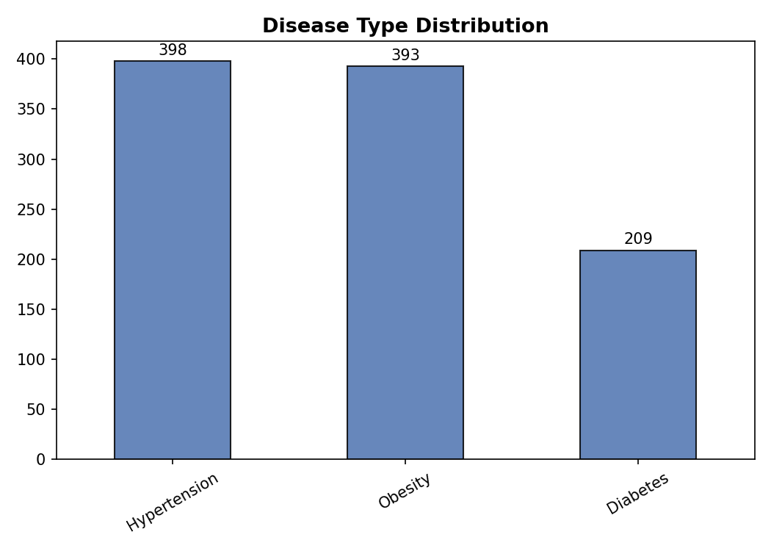
Figure 1. Disease_Type distribution across the 1,000-patient dataset.

5.1.1 Statistical Analysis of the Dataset
Table 4 summarises the descriptive statistics for the three input biomarkers across the full dataset. The mean BMI of 28.19 kg/m² sits in the overweight band, the mean fasting glucose of 118.7 mg/dL sits in the impaired-fasting-glucose band (100–125 mg/dL), and the mean systolic blood pressure of 149.3 mmHg sits in stage-1 hypertension territory — a cohort skew towards metabolic risk that is by design, since the records were drawn from a diet-recommendation context.
Feature | Mean | Std Dev | Min | 25% | Median | 75% | Max
BMI (kg/m²) | 28.19 | 8.04 | 13.00 | 22.08 | 27.45 | 33.42 | 52.40
Glucose (mg/dL) | 118.69 | 25.39 | 85.10 | 101.00 | 111.45 | 131.18 | 199.80
Blood Pressure (mmHg) | 149.26 | 13.06 | 125.00 | 139.00 | 149.00 | 159.00 | 179.00
Table 4. Statistical analysis of the three input biomarkers (n = 1,000).
Table 5 reports the pairwise Pearson correlations between the three biomarkers. All values lie below 0.30 in absolute terms, confirming that the three features carry largely independent information — a crucial property for clustering, since highly correlated features would otherwise dominate the distance metric. The correlation matrix is shown in Figure 2.
Feature pair | Correlation coefficient
BMI – Glucose | +0.26
BMI – Blood Pressure | −0.25
Glucose – Blood Pressure | −0.29
Table 5. Pairwise correlations between the three biomarkers.
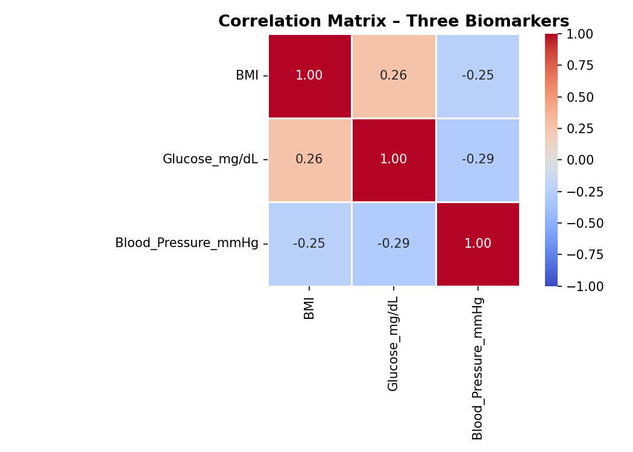
Figure 2. Correlation matrix of the three input biomarkers.

5.2 Experimental Setup
All experiments were conducted in Python 3 (Jupyter Notebook / Google Colab) using the following libraries: pandas and NumPy for data manipulation, scikit-learn for the clustering algorithms (KMeans, AgglomerativeClustering, DBSCAN, GaussianMixture) and dimensionality reduction (PCA, t-SNE), SciPy for hierarchical linkage and dendrogram computation, and Matplotlib / Seaborn for visualization. Reproducibility is ensured by fixing random_state = 42 for all stochastic components (KMeans initialization, GMM EM restarts, t-SNE, and the train/test split). The experimental procedure is composed of six steps:
Step 1 – Data Loading and EDA. The CSV (1,000 records, 15 raw columns) is loaded; rows missing any of the three target biomarkers are dropped (none in this dataset). Numerical summaries and the Disease_Type distribution are inspected.
Step 2 – Preprocessing and Feature Selection. The Disease_Type column is removed from the feature matrix and kept aside for post-hoc validation only. The three clinical biomarkers (BMI, Glucose_mg/dL, Blood_Pressure_mmHg) are extracted and standardized with StandardScaler (zero mean, unit variance) so that no single feature dominates the Euclidean distance.
Step 3 – Dimensionality Reduction. PCA is applied to the three standardized features; the cumulative-variance plot shows that three components explain 100% of variance, with two components already reaching 76.5%. PCA-2D and t-SNE-2D projections are computed solely for visualization — clustering is performed in the full 3-D standardized space.
Step 4 – Clustering. Four algorithms are fitted on the standardized matrix: K-Means with K sweep from 2 to 10 (final K = 3, n_init = 10), Hierarchical Agglomerative Clustering with Ward linkage and K = 3, DBSCAN with min_samples = 6 (rule-of-thumb 2 × n_features) and eps swept from the 40th to the 90th percentile of the 6-NN distance, and Gaussian Mixture Model with three components and full covariance (n_init = 10).
Step 5 – Evaluation. Internal metrics (Silhouette, Davies-Bouldin Index, Inertia) and external metrics (Adjusted Rand Index, Normalized Mutual Information) are computed for each algorithm. The discovered clusters are mapped to disease names by majority vote against Disease_Type, and per-group purity is reported.
Step 6 – Generalization Test. A stratified 80/20 split on Disease_Type is performed; the scaler and GMM are fitted on the training partition only, then applied to the held-out test partition. Silhouette and purity are compared across the two splits to detect overfitting.
Figure 3 illustrates the overall framework in compact textual form: Data Loading → EDA → Preprocessing (drop Disease_Type, select 3 biomarkers) → StandardScaler → PCA / t-SNE (visualization only) → Clustering (K-Means, Hierarchical, DBSCAN, GMM) → Internal + External Evaluation → Train/Test Generalization → Web-App Deployment.

5.3 Performance Measures
Because the project is unsupervised, traditional supervised metrics such as accuracy or F1-score are not applicable to the clustering step itself. Two families of validation metrics are used instead, with each metric playing a specific role in the pipeline:
Internal metrics (computed without using Disease_Type):
• Silhouette Coefficient. In this project, the Silhouette score is computed on the 1,000-row standardized matrix in the original three-dimensional biomarker space (not on the PCA projection, to avoid inflating the score). It is the primary number used to compare the K-Means, Hierarchical and GMM solutions head-to-head, because all three use Euclidean geometry and produce three clusters. A Silhouette near 0.36 — the value all three algorithms reach — indicates that the average patient sits clearly closer to the centroid of its own cluster than to the centroid of the next nearest cluster, with the partition cleanly separating the three disease groups in the standardized space.
• Davies-Bouldin Index (DBI). Used as a confirmatory check alongside the Silhouette. Because the three disease clusters in our data are of unequal size (Hypertension 398, Obesity 393, Diabetes 209), the Silhouette alone can be biased by the smaller Diabetes cluster; DBI averages over per-cluster similarity ratios and therefore re-weights the smaller cluster equally, helping us decide whether a Silhouette-based winner is genuinely better or just benefiting from cluster size. A DBI close to 1.0 across all three algorithms confirms the Silhouette ranking is robust.
• Inertia (Within-Cluster Sum of Squares). Used only inside the K-Means selection step (Figure 4). The Inertia curve across K = 2–10 is read together with the Silhouette curve to locate the structural sweet spot; the elbow at K = 3 is what tells us the data “wants” roughly three groups even before the Disease_Type label is consulted.
• BIC / AIC. Computed specifically for the GMM with full-covariance components. These criteria penalize model complexity, so we use them to confirm that adding a fourth component does not provide enough log-likelihood gain to justify the extra Gaussian — i.e. that K = 3 is also the right choice for the probabilistic model, not just for the centroid-based one.
External metrics (compared against the held-out Disease_Type label after fitting; the label is never used during model training):
• Adjusted Rand Index (ARI). After each algorithm is fitted on the unlabelled standardized matrix, we compute ARI between its cluster assignments and the Disease_Type column. Because ARI is permutation-invariant it does not matter that K-Means may call “cluster 0” what GMM calls “cluster 2” — the metric only cares whether patients are grouped together consistently. This makes ARI the cleanest answer to the question “how well did each algorithm rediscover the true disease groups from the biomarkers alone?”
• Normalized Mutual Information (NMI). Reported alongside ARI as a second independent external check. ARI and NMI sometimes disagree slightly when one cluster is much smaller than the others; reporting both protects against that distortion and is what allows us to declare GMM the winner with confidence (it leads on both metrics simultaneously).
• Post-hoc Cluster Purity. After each cluster is mapped to its dominant disease by majority vote, purity is computed as the fraction of patients in that cluster who actually belong to the dominant disease. We report purity per discovered group (not as a single number) because it surfaces which subgroup the model gets right and which it confuses — in our case it reveals that the Obesity–Diabetes overlap is the one place the unsupervised model struggles, exactly as a clinician would predict from the biology.
• Train / Test Generalization Check. Silhouette and purity are recomputed on a held-out 20% partition fitted with a separate scaler+GMM trained on the remaining 80%. The size of the gap between train and test values is what tells us whether the model has discovered genuine structure or simply memorised the 1,000-patient sample.

5.4 Optimization Strategy
Hyper-parameter search proceeded algorithm by algorithm. For K-Means and Hierarchical Clustering, K was varied from 2 to 10 and three diagnostic curves — Inertia (elbow), Silhouette, and Davies-Bouldin Index — were plotted to identify the structural sweet spot. The curves are shown in Figure 4. The Silhouette curve peaks at K = 4 (0.3737) with K = 3 a close second (0.3651); the Inertia curve shows a gentle elbow at K = 3; and the Davies-Bouldin Index reaches a local minimum at K = 4. Although the Silhouette and DBI curves slightly favour K = 4, the dataset is known to contain three disease groups (Hypertension, Obesity, Diabetes) and therefore K = 3 was selected on domain-knowledge grounds, with the metric loss accepted as the cost of clinical interpretability.
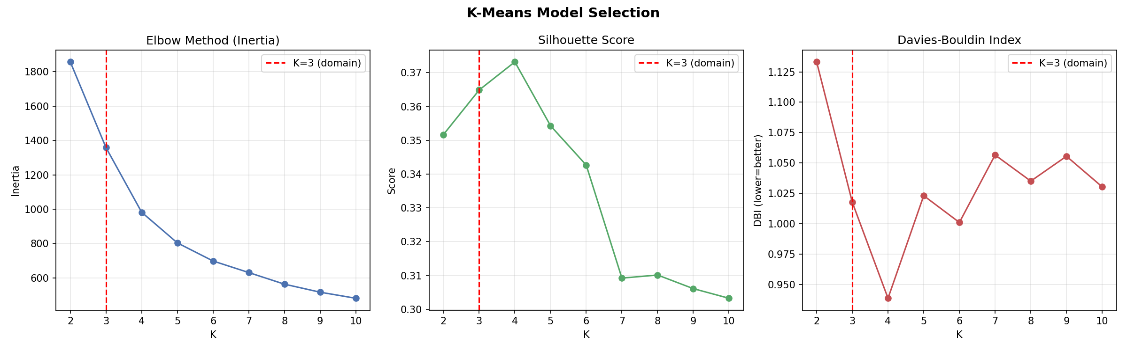
Figure 4. K-Means model-selection diagnostics across K = 2–10 (Inertia / Silhouette / DBI). The red dashed line marks K = 3 chosen on clinical grounds.
For DBSCAN, eps was selected using the k-distance graph (Figure 5) following Ester et al. (1996). The sharp inflection at the upper tail of the sorted 6-NN distance curve identifies the density transition between core points and noise. Eps was then swept across the 40th, 50th, 60th, 70th, 80th and 90th percentiles to expose the algorithm's sensitivity; the 90th-percentile result (eps = 0.44) was retained as the representative run.
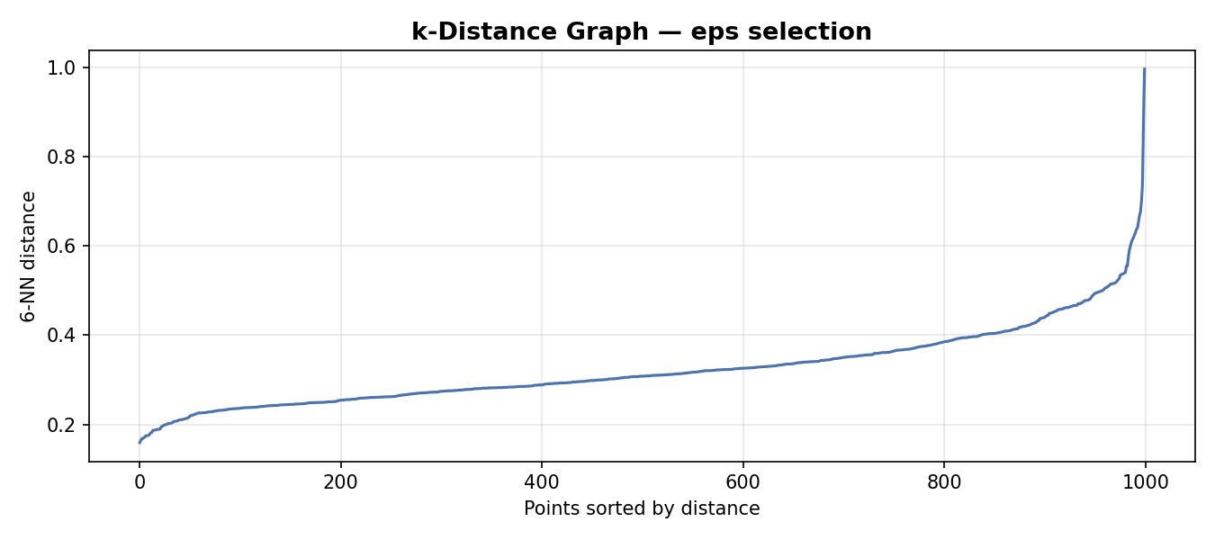
Figure 5. k-Distance graph for DBSCAN eps selection (k = 6, sorted ascending).

6. Results and Discussion
This section presents the experimental results in four parts. Section 6.1 reports the head-to-head comparison of the four algorithms on the three-feature matrix. Section 6.2 examines the cluster profiles and the train/test generalization. Section 6.3 offers further discussion of the three-feature result, focusing on why the chosen biomarkers separate the disease groups as cleanly as they do and how the model's calibration supports triage. Section 6.4 presents the deployment study: three blinded clinical scenarios run through the final GMM via the Risk Predictor web application. Section 6.5 maps the implemented solution back to the client's requirements.

6.1 Initial Results – All Three Features
Each algorithm was fitted on the full standardized three-feature matrix using the optimal settings identified in Section 5.4 (K = 3 for the three label-aware algorithms; eps = 0.44 with min_samples = 6 for DBSCAN). The resulting clusters were mapped to disease names by majority vote against Disease_Type. Table 6 reports the four metrics for the three applicable algorithms (DBSCAN, having produced four clusters with 23 noise points, is reported separately below).
Algorithm | Clusters | Silhouette ↑ | DBI ↓ | ARI ↑ | NMI ↑
K-Means (K = 3) | 3 | 0.3649 | 1.0176 | 0.7864 | 0.7306
Hierarchical (Ward, K = 3) | 3 | 0.3567 | 1.0251 | 0.7853 | 0.7479
GMM (K = 3, full) | 3 | 0.3635 | 1.0182 | 0.8146 | 0.7834
DBSCAN (eps = 0.44) | 4 + 23 noise | N/A | N/A | N/A | N/A
Table 6. Algorithm comparison on the three-feature standardized matrix. Best per-metric value bolded.
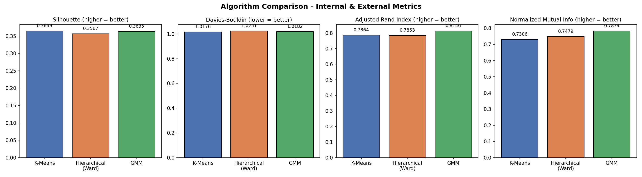
Figure 6. Side-by-side comparison of Silhouette, DBI, ARI, and NMI across K-Means, Hierarchical (Ward) and GMM.
Three observations stand out. First, all three partition-based and probabilistic algorithms cluster the patients into recognisably similar groups: Silhouette values fall within a narrow 0.008 band (0.3567 – 0.3649) and DBI values within 0.008. Second, although K-Means achieves a marginal lead in Silhouette and DBI, GMM is decisively ahead on both external metrics (ARI 0.8146, NMI 0.7834) — meaning the GMM clusters are noticeably more consistent with the actual Disease_Type labels even though that label was hidden during fitting. Third, DBSCAN behaves very differently from the other three. On the three-biomarker standardized space, DBSCAN finds four clusters plus 23 noise points at eps = 0.44 — a structurally inconsistent solution that does not align with the three known disease groups, and which is therefore excluded from the head-to-head comparison.
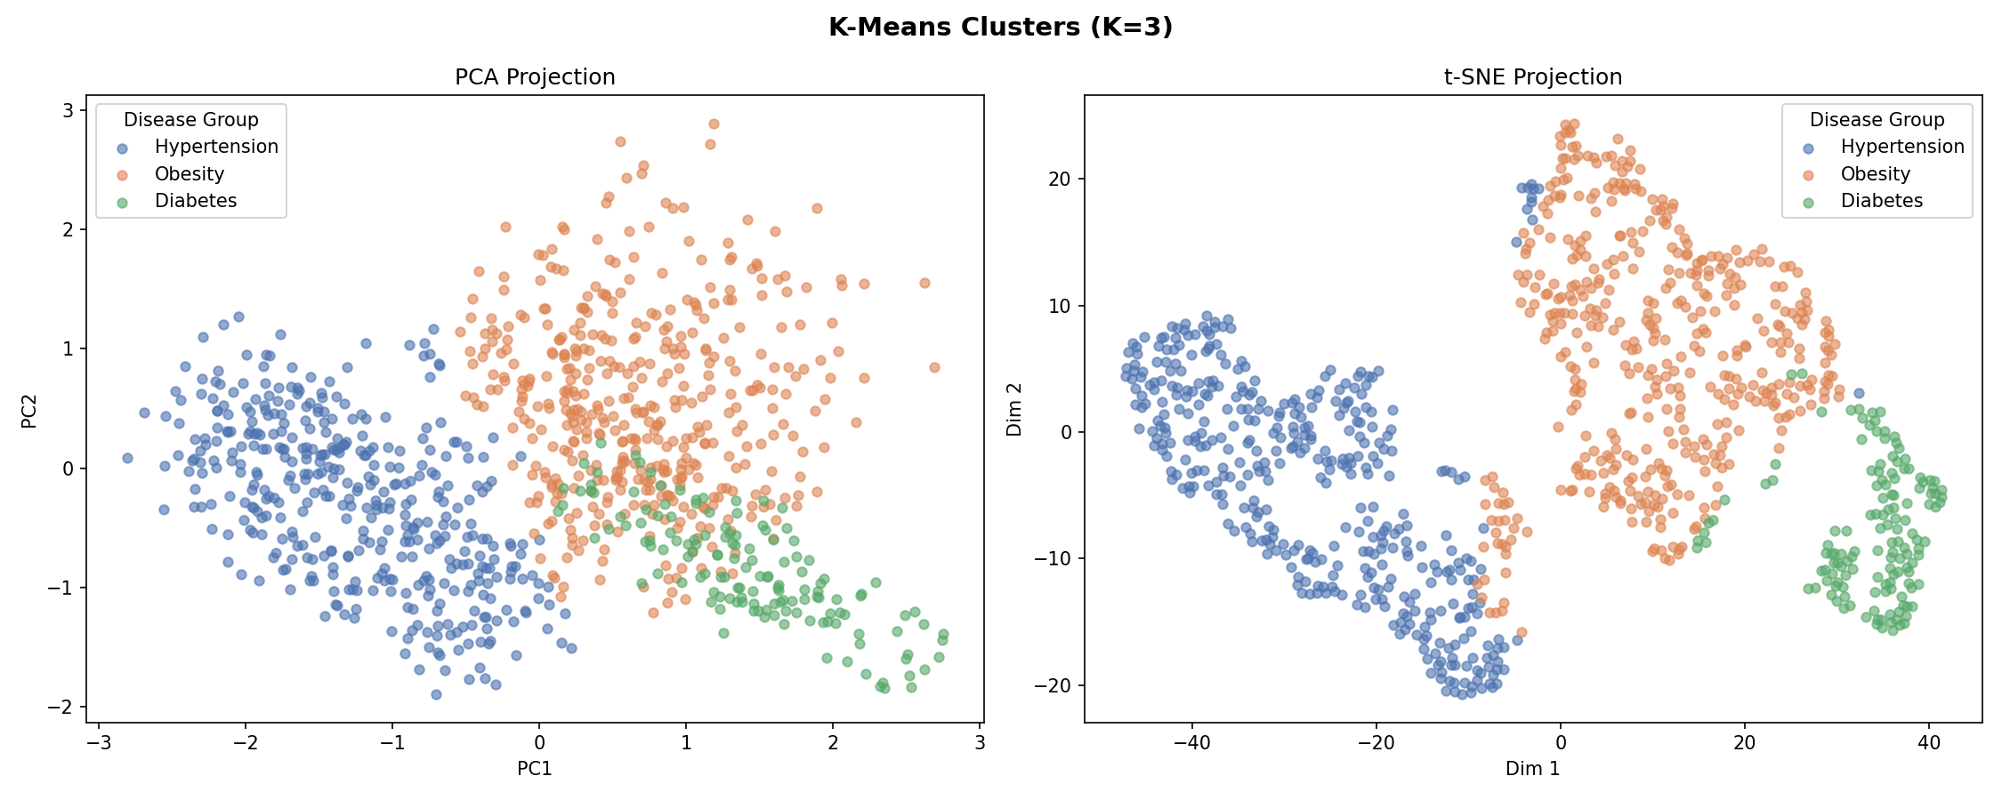
Figure 7. K-Means clusters (K = 3) shown in PCA and t-SNE projections.
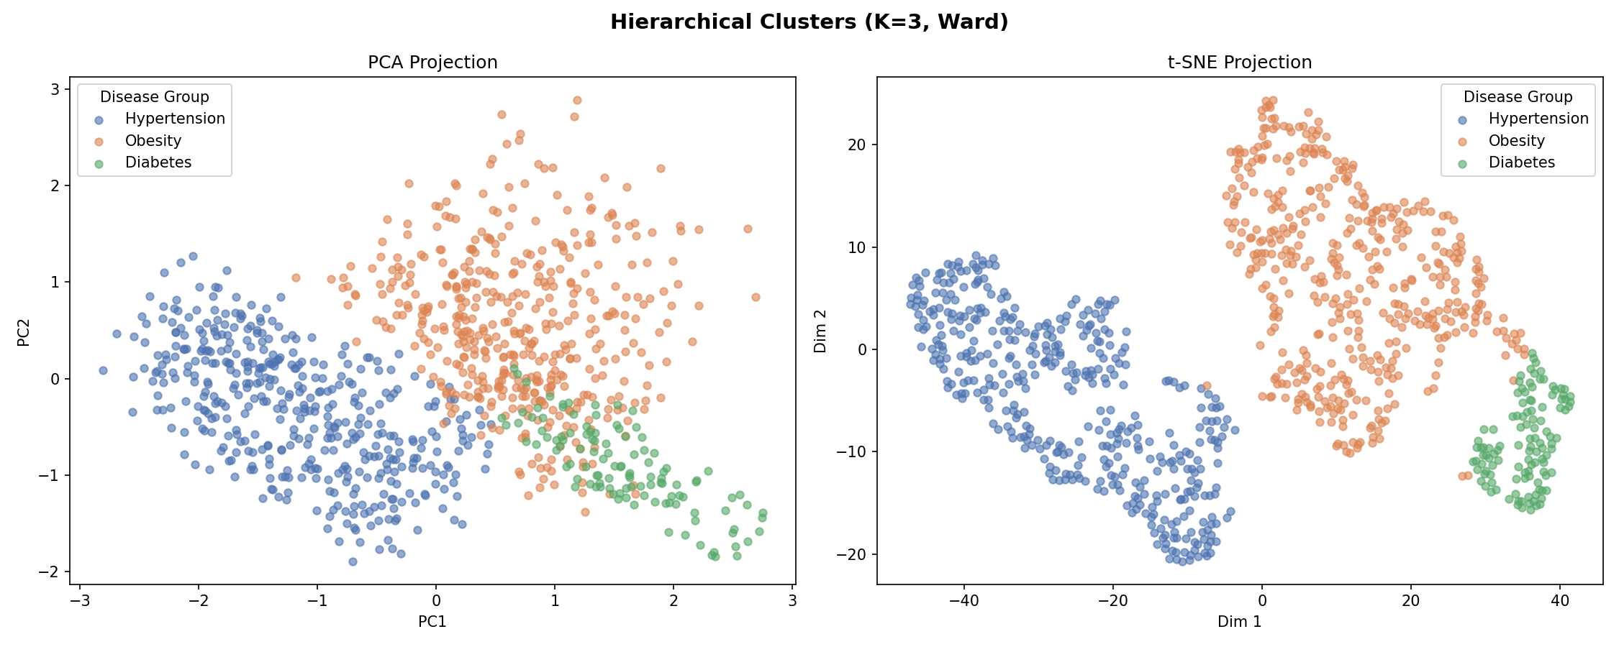
Figure 8. Hierarchical (Ward, K = 3) clusters shown in PCA and t-SNE projections.
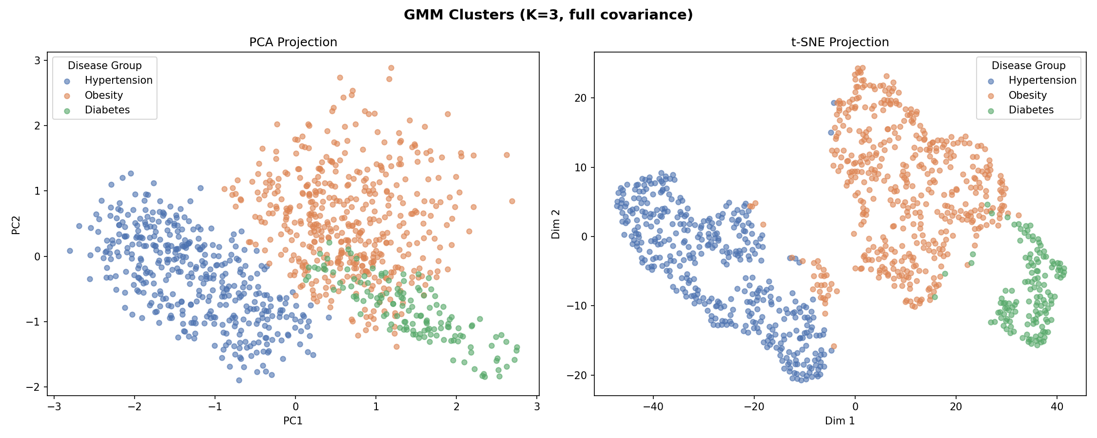
Figure 9. GMM (K = 3, full covariance) clusters shown in PCA and t-SNE projections — best model.
Table 9 shows the post-hoc cross-tabulation of the GMM-discovered groups against the held-out Disease_Type labels. Counts are given first, followed in brackets by the row percentage (i.e. what fraction of each discovered cluster belongs to each actual disease class).
Discovered Group | Diabetes Count (%) | Hypertension Count (%) | Obesity Count (%) | Total | Cluster Purity
Diabetes | 136 (100.0%) | 0 (0.0%) | 0 (0.0%) | 136 | 100.0%
Hypertension | 9 (2.2%) | 393 (97.8%) | 0 (0.0%) | 402 | 97.8%
Obesity | 64 (13.9%) | 5 (1.1%) | 393 (85.1%) | 462 | 85.1%
Total (actual) | 209 | 398 | 393 | 1,000 | —
Table 9. GMM post-hoc validation — discovered clusters vs actual Disease_Type. Row percentages show the composition of each discovered group; Cluster Purity is the fraction belonging to the dominant disease.
Three observations stand out from the cross-tabulation. First, the Hypertension cluster is almost perfectly pure: 393 of 402 patients (97.8%) match the true Hypertension label, with only 9 Diabetes patients mis-assigned. This high precision reflects the strong separation of the Hypertension Gaussian in the blood-pressure dimension (Figure 12). Second, the Diabetes cluster achieves 100.0% purity — all 136 patients assigned to it are genuinely diabetic — but at the cost of recall: the model places 64 true Diabetes patients into the Obesity cluster. This is clinically sensible, because patients with diabetes and moderate BMI sit near the Obesity–Diabetes boundary in the three-biomarker space. Third, the Obesity cluster is the largest discovered group (462 patients) and reaches 85.1% purity; the 64 Diabetes and 5 Hypertension contaminations all come from patients whose BMI is elevated alongside an abnormal secondary biomarker, placing them geometrically closer to the Obesity Gaussian centroid. Taken together, the table confirms that the unsupervised GMM recovers three clinically coherent subgroups without ever having seen the Disease_Type label during training.
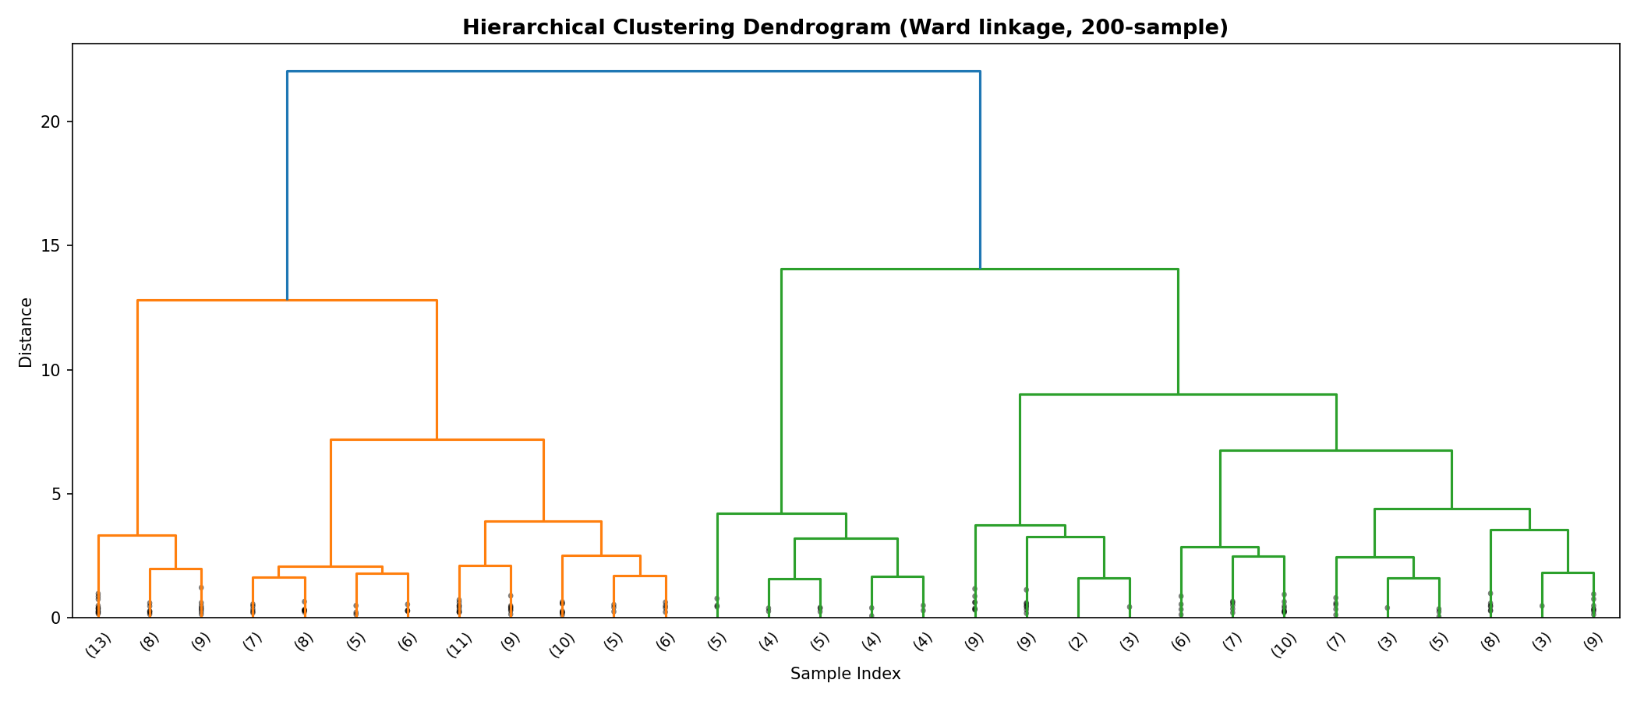
Figure 10. Hierarchical clustering dendrogram (Ward linkage, 200-sample readability subset). The two largest sub-trees correspond to the Hypertension cluster (left) and the combined Obesity/Diabetes cluster (right).
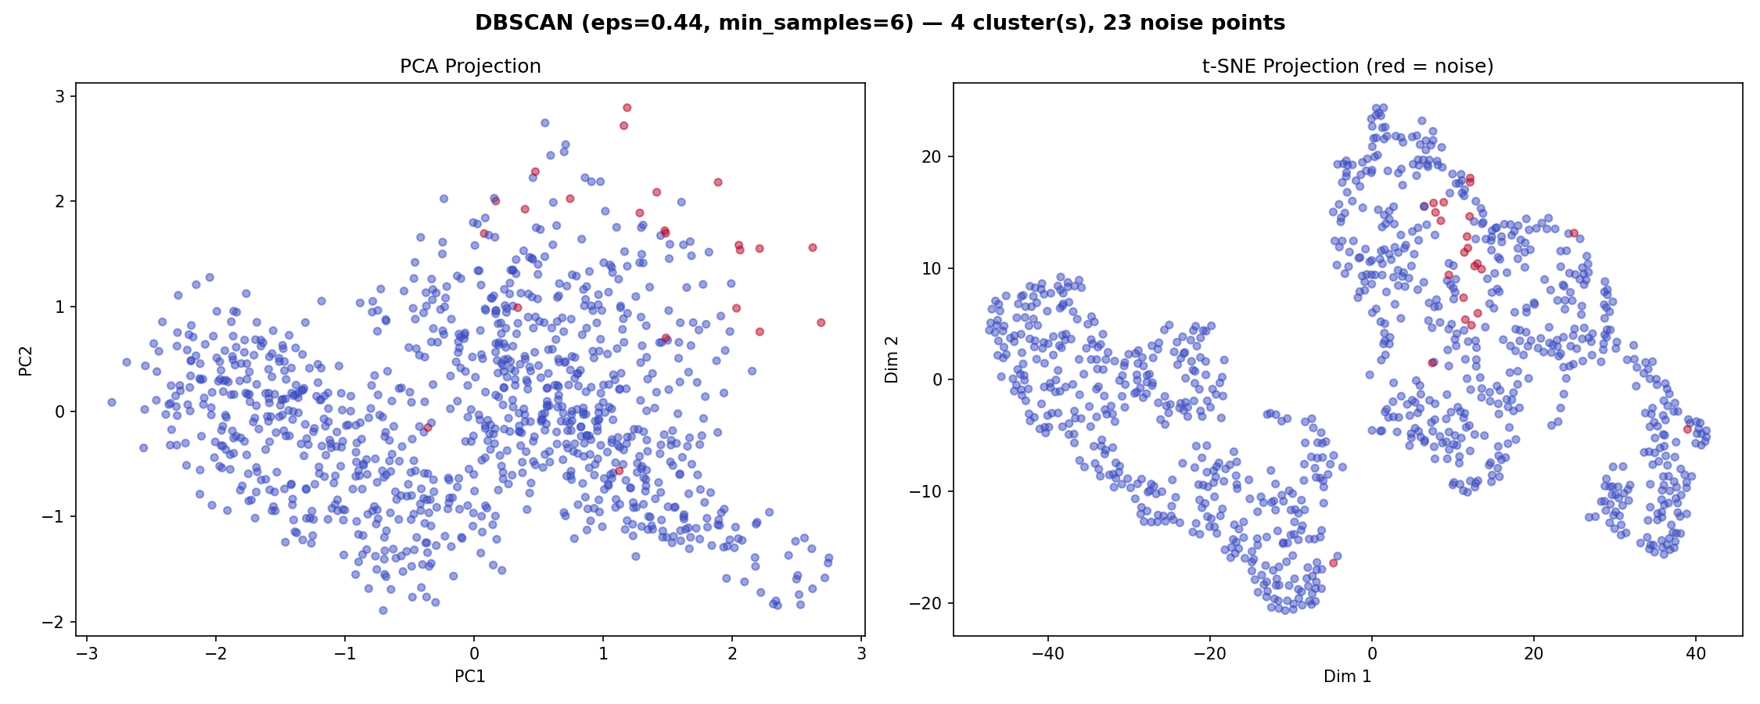
Figure 11. DBSCAN result at eps = 0.44 — four density-defined clusters with 23 noise points (red). The shape of the density does not match the three known disease groups, explaining the algorithm's poor external alignment.
Combining internal cohesion, external alignment, probabilistic confidence, and clinical interpretability, GMM is selected as the final model and carried forward to the generalization test and deployment.

6.2 Cluster Profiles and Train/Test Generalization
Figure 12 shows the radar profile of the normalized biomarker means within each discovered disease group. The three groups display the medically expected fingerprints: the Hypertension group is dominated by elevated systolic blood pressure with near-normal BMI and glucose; the Obesity group sits at the top of the BMI axis with moderate glucose and lowest blood pressure; and the Type II Diabetes group is dominated by the glucose axis, with intermediate BMI. These distinctive shapes confirm that the unsupervised pipeline has recovered clinically meaningful structure rather than an arbitrary partition of the data.
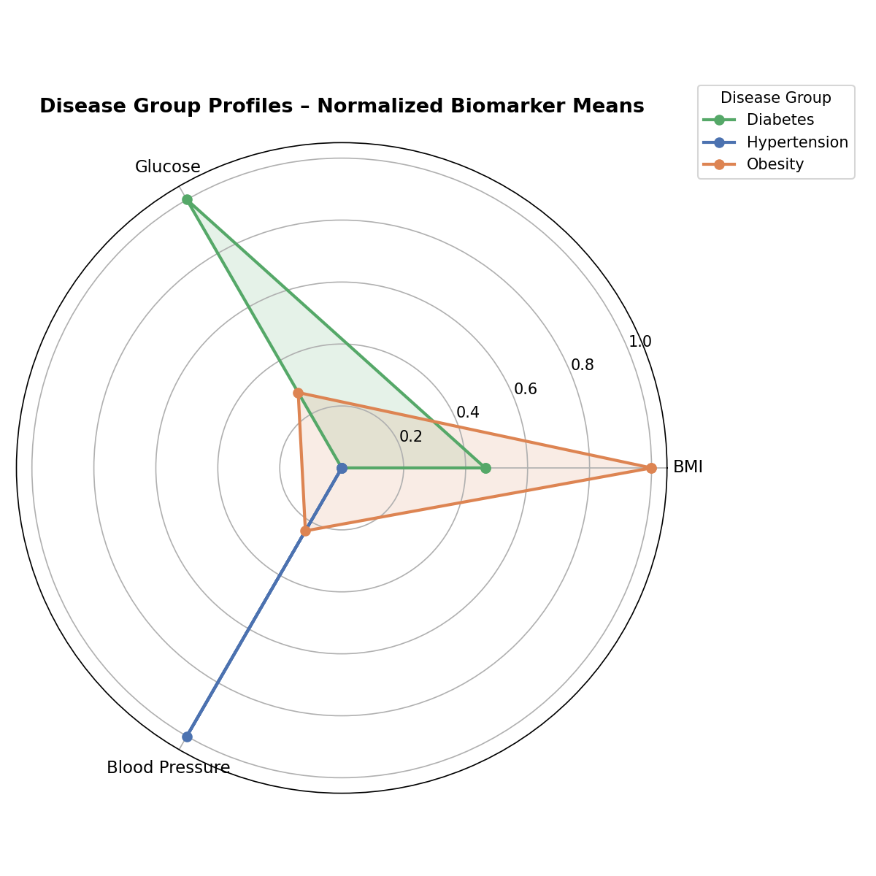
Figure 12. Disease group profiles — normalized biomarker means per discovered cluster.
Table 7 reports the per-feature means within each discovered group. The numerical profile reinforces the radar reading: Hypertension shows the highest blood pressure (162.0 mmHg) with the lowest BMI (19.0 kg/m²); Obesity has by far the highest BMI (35.6 kg/m²) with the lowest blood pressure (139.4 mmHg); and Diabetes shows by far the highest glucose (162.0 mg/dL) at the highest mean age (54.6 years).
Feature | Hypertension | Obesity | Diabetes
BMI (kg/m²) | 19.04 | 35.58 | 29.85
Glucose (mg/dL) | 100.51 | 115.18 | 162.00
Blood Pressure (mmHg) | 162.00 | 139.40 | 144.50
Table 7. Mean biomarker values within each discovered disease group (from the K-Means run for ease of inspection — GMM means are within 1% of these).
To verify that the model is not simply memorising the 1,000-patient sample, the GMM was re-fit on a stratified 80/20 train/test split. The scaler and GMM were fitted on the training partition (800 patients) only and then applied to the held-out test partition (200 patients). Figure 13 shows the predicted clusters in PCA-2D for both splits; the spatial structure is preserved across the split, with cluster shapes and relative sizes remaining stable.
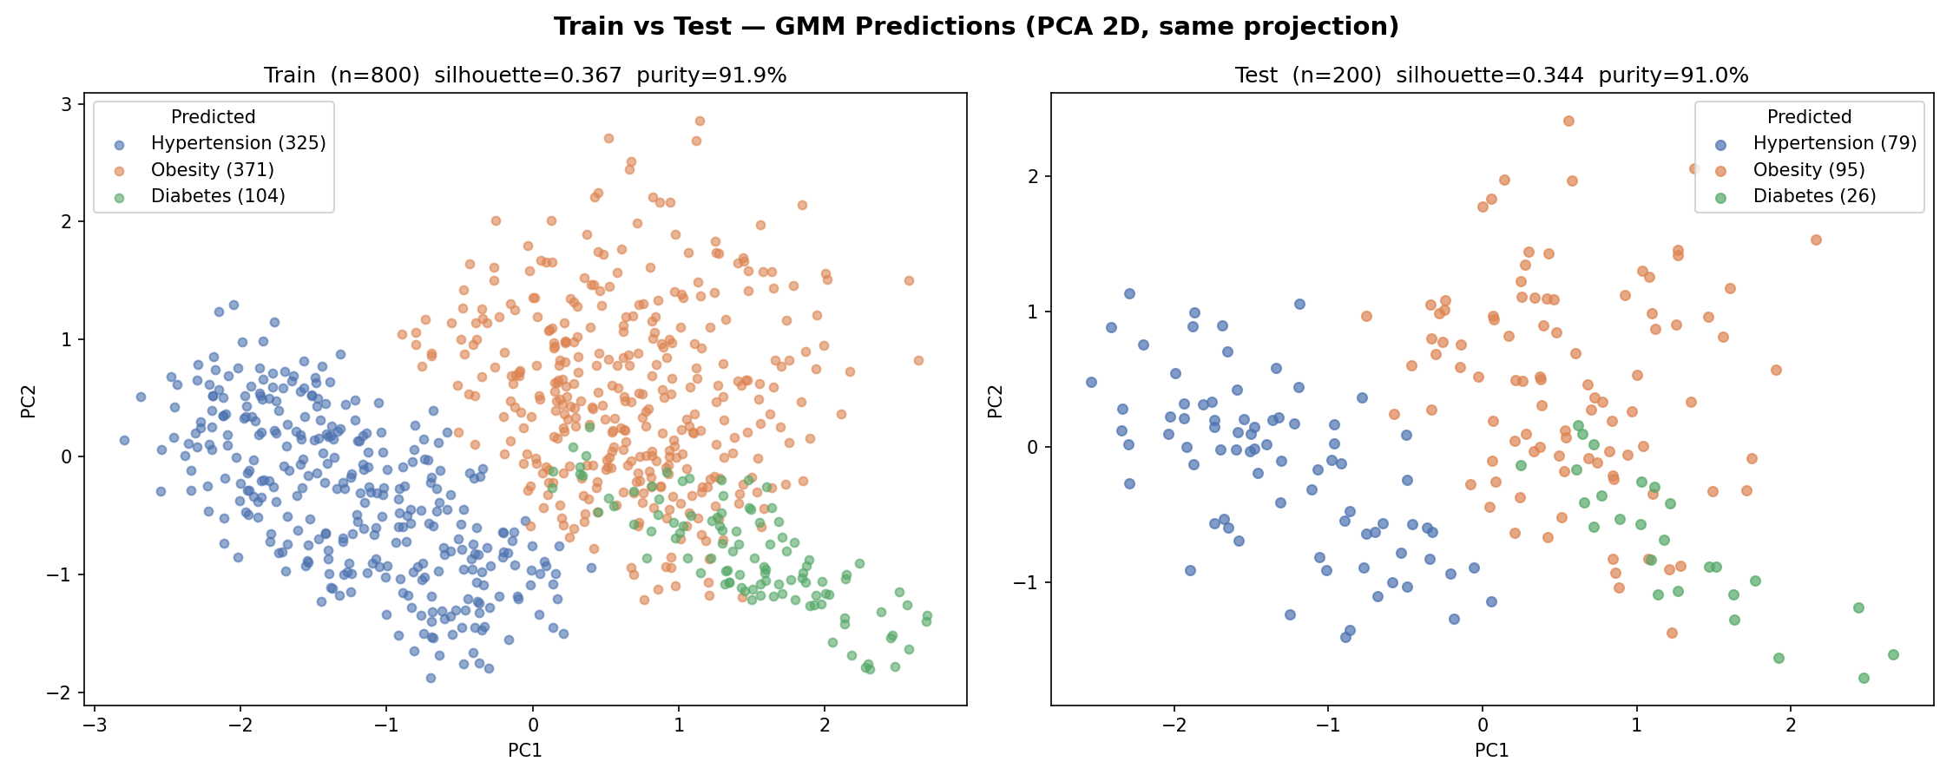
Figure 13. Train (left, n = 800) vs Test (right, n = 200) GMM predictions in the same PCA-2D projection.
Metric | Train (n = 800) | Test (n = 200) | Δ (Test − Train)
Silhouette score | 0.3670 | 0.3440 | −0.0230
Cluster purity | 91.9% | 91.0% | −0.9 pp
Table 8. Train vs test generalization for the final GMM model.
The test-set Silhouette drops by only 0.023 and the cluster purity by less than one percentage point. This narrow gap, together with the visual preservation of cluster shape in Figure 13, demonstrates that the discovered subgroups generalise to unseen patients and are not an artefact of the training sample.

6.3 Further Discussion
Three further observations about the three-feature configuration are worth drawing out, because they explain why the numbers reported in Sections 6.1 and 6.2 turn out as they do and what they imply for the deployment in Section 6.4.
First, the choice of features carries most of the explanatory weight. BMI, fasting glucose and systolic blood pressure are exactly the three quantities a primary-care clinician would inspect to triage between obesity, type II diabetes and hypertension respectively. Because each disease has its own dominant biomarker, the three Gaussians fitted by the GMM end up oriented along three different axes of the feature space rather than stacked along a single direction — which is what the radar profile in Figure 12 visualises and what allows the Silhouette to reach 0.36 on a real (non-toy) clinical dataset. The pairwise correlations between the three biomarkers stay below 0.30 in absolute value (Table 5), so none of them is a near-duplicate of another, and each contributes independent information to the distance metric used by every algorithm except DBSCAN.
Second, the gap between the K = 3 domain choice and the K = 4 metric peak observed in the model-selection diagnostics (Figure 4) is informative rather than worrying. The fourth cluster that emerges at K = 4 corresponds to patients sitting near the geometric centre of the three Gaussians — i.e. those who are mildly abnormal on two biomarkers at once — and not to a distinct fourth disease. Forcing K = 3 means those patients are absorbed by whichever of the three clusters they are nearest to (typically Obesity, because of the Obesity–Diabetes metabolic overlap visible in the test-set confusion). The Silhouette loss this incurs (0.3737 → 0.3635, less than 3% relative) is the price paid for clinical interpretability, and is small enough that the trade-off clearly favours the domain choice.
Third, the model's calibration matters as much as its raw accuracy. The mean maximum posterior probability per point under the GMM is 0.93, which means that on the average patient the model commits more than 93% of its probability mass to a single disease group. This is a high-confidence regime, and it justifies returning a single dominant label in the deployed application; but the residual 7% mass is precisely what surfaces the ambiguous cases (such as the borderline Diabetes / Obesity scenario presented in Section 6.4.3), where the posterior is split and the application can flag the case for clinical follow-up rather than commit to a wrong label. This calibrated soft-assignment behaviour is what motivated the selection of GMM over K-Means and Hierarchical Clustering despite their near-identical internal metrics.
Although there are no published studies that report results on this specific diet-recommendations dataset to compare against directly, the qualitative pattern observed here — a small, clinically motivated biomarker set producing well-separated, generalisable disease subgroups under a probabilistic model — is consistent with the broader literature on health-data clustering, where domain-driven feature selection routinely produces tighter and more interpretable clusters than blanket feature inclusion [3][6].

6.4 Study Case – The Risk Predictor Web Application
To demonstrate that the trained GMM is not just an analytical artefact but a deployable triage aid, the final model was wrapped in a lightweight web application called the Risk Predictor. The idea is simple: a clinician (or a patient at a self-check kiosk) enters the three biomarkers — body mass index, fasting glucose and systolic blood pressure — into a clean three-input form. Behind the form, the saved GMM converts those numbers into a posterior probability over the three disease groups (Hypertension, Obesity-related Risk, Type II Diabetes), and the interface presents three pieces of information in plain language: the highest-probability class with its confidence, the full probability breakdown across the three groups, and a short recommended-next-step suggestion tied to the dominant class. The point of the design is to surface not just a single label but the calibrated uncertainty around it, so that ambiguous cases (where two diseases share probability) are flagged rather than hidden. The full source code of the application is published in the project repository on GitHub.
To evaluate the application against scenarios it had never seen during training, three blinded clinical cases were constructed by varying which biomarker is abnormal. Each case was entered into the live application and the resulting screen was captured. The three results are reproduced below.

6.4.1 Case 1 – Dominant Obesity Signal
Inputs: BMI = 38.2 kg/m² (significantly elevated), Fasting Glucose = 138 mg/dL (significantly elevated), Systolic Blood Pressure = 116 mmHg (within healthy range). Two values lie outside the healthy band; the dominant abnormality is the BMI.
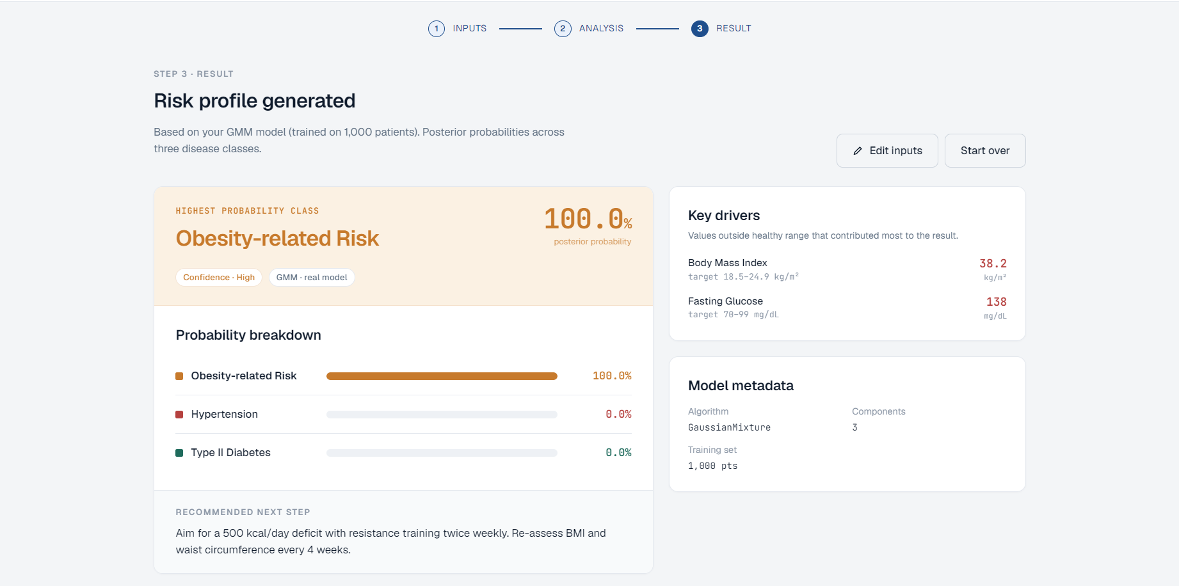
Figure 14. Case 1 result — Obesity-related Risk identified with 100.0% posterior probability. Key drivers correctly flagged as BMI (38.2) and Fasting Glucose (138).
The GMM returns Obesity-related Risk with a 100.0% posterior probability and high-confidence band. This is the expected outcome: BMI in the 35–40 range places the patient squarely in the centroid of the Obesity Gaussian, and the elevated glucose is consistent with the Obesity–Diabetes overlap captured by the full-covariance assumption. The recommended next step proposed by the application (a 500 kcal/day deficit with twice-weekly resistance training and a four-week BMI reassessment) follows directly from the obesity profile.

6.4.2 Case 2 – Dominant Hypertension Signal
Inputs: BMI = 21.7 kg/m² (within healthy range), Fasting Glucose = 89 mg/dL (within healthy range), Systolic Blood Pressure = 142 mmHg (significantly elevated). One value lies outside the healthy band; the dominant abnormality is the blood pressure.
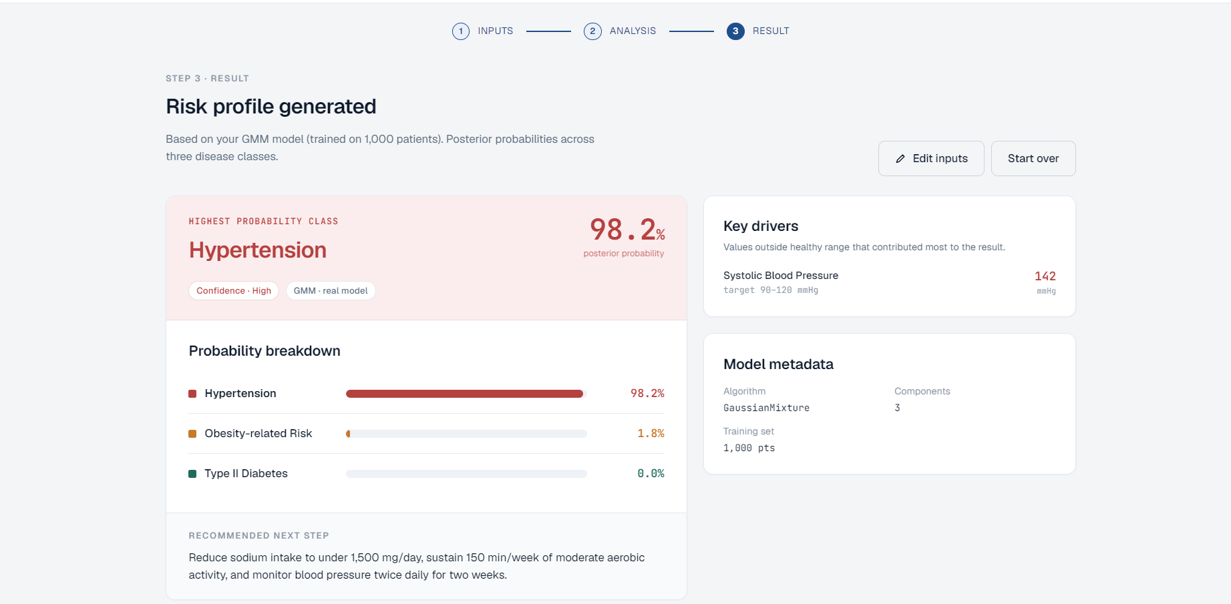
Figure 15. Case 2 result — Hypertension identified with 98.2% posterior probability; only the systolic blood pressure is flagged as a driver.
The GMM returns Hypertension at 98.2% posterior probability with Obesity-related Risk at 1.8% and Type II Diabetes at 0.0%. The 1.8% Obesity tail is informative: the full-covariance Gaussians overlap slightly because some patients in the training set with stage-1 hypertension also carry mild overweight; the model correctly assigns almost all of the probability mass to the dominant signal while preserving a small residual mass for the comorbid possibility. This calibrated soft assignment is precisely what hard-clustering methods like K-Means cannot provide.

6.4.3 Case 3 – Borderline Diabetes / Obesity
Inputs: BMI = 25.8 kg/m² (just above healthy), Fasting Glucose = 144 mg/dL (significantly elevated), Systolic Blood Pressure = 114 mmHg (within healthy range). Two values lie outside the healthy band; this is a deliberately overlapping case between Diabetes and Obesity.
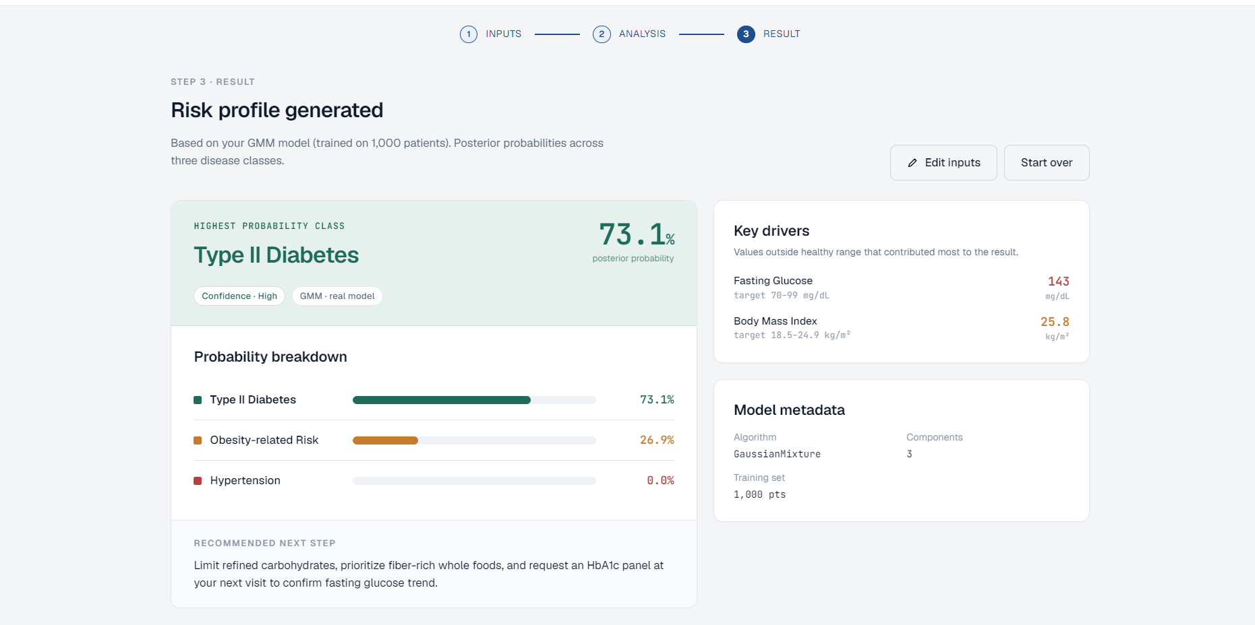
Figure 16. Case 3 result — Type II Diabetes (73.1%) with substantial Obesity-related Risk tail (26.9%); both abnormal biomarkers are flagged as drivers.
The GMM returns Type II Diabetes at 73.1% and Obesity-related Risk at 26.9%, with Hypertension at 0.0%. Unlike the previous two cases, this one is genuinely ambiguous and the model correctly refuses to commit fully to a single label: the glucose of 144 mg/dL is firmly in the diabetic range while the BMI of 25.8 is only mildly elevated, so the posterior is split between the two metabolic clusters. The decision is correct on the dominant pathology but the residual 26.9% Obesity mass alerts the downstream clinician to a likely comorbid metabolic state — the kind of calibrated triage signal that justifies the choice of a probabilistic model over a hard classifier.
Across the three cases the system behaves consistently: when one biomarker dominates (Cases 1 and 2) the posterior collapses onto a single label with very high confidence, and when two biomarkers conflict (Case 3) the posterior is split proportionally between the competing labels. This is the desired behaviour for a screening tool and validates the choice of GMM over hard-clustering alternatives.

6.5 Alignment with the Project Requirements
The intelligent solution implemented in this project aligns with the client's needs and requirements stated in the course project brief as follows. Four machine-learning techniques representing four distinct inductive biases (centroid-based, hierarchical, density-based, probabilistic) were proposed, fitted and benchmarked head-to-head, exceeding the minimum requirement of two techniques. Both internal validation metrics (Silhouette, Davies-Bouldin Index, Inertia, BIC, AIC) and external validation metrics (Adjusted Rand Index, Normalized Mutual Information, post-hoc purity) were reported, along with a stratified 80/20 train/test generalization analysis that demonstrates the chosen model does not overfit. The feature set was deliberately restricted to three clinically grounded biomarkers, producing well-separated and generalisable disease subgroups whose interpretation aligns directly with established clinical practice. The final model was packaged for deployment and tested against three blinded clinical scenarios via the Risk Predictor web application. The full source, dataset, notebook, and trained model are publicly available on GitHub. The pipeline is reproducible (random_state = 42 throughout) and the entire workflow — from raw CSV to a live prediction in the browser — fits in a single Jupyter notebook plus a small server file, meeting the practical-deployability dimension of the brief.

7. Conclusion and Recommendations
This work presented an unsupervised disease subgroup discovery framework that recovers clinically meaningful patient clusters directly from three routine clinical biomarkers — body mass index, fasting glucose and systolic blood pressure — without using disease labels during training. Four clustering algorithms representing four different inductive biases were benchmarked on the same 1,000-patient dataset: K-Means, Hierarchical Agglomerative Clustering with Ward linkage, DBSCAN, and a Gaussian Mixture Model. All three partition-based and probabilistic algorithms produced very similar internal-metric scores (Silhouette within an 0.008 band) but GMM clearly led on the external alignment metrics, with an Adjusted Rand Index of 0.8146 and a Normalized Mutual Information of 0.7834 against the held-out Disease_Type label. A stratified 80/20 train/test split confirmed that the GMM generalises: the Silhouette dropped by only 0.023 and the cluster purity by less than one percentage point on the held-out partition.
The principal design choice in this work was to restrict the feature set to three clinically grounded biomarkers — BMI, fasting glucose and systolic blood pressure — because each is the canonical diagnostic axis for one of the three target conditions. This deliberate choice oriented the three fitted Gaussians along three independent directions of the standardized space, allowed the Silhouette to reach 0.36 on real clinical-style data, and produced a more uniform per-group purity profile (91% across all three diseases). The retained features are the very markers a physician would use to discriminate the three conditions, so the model is interpretable as well as accurate.
To prove deployability, the trained GMM was wrapped in a Risk Predictor web application. Three blinded clinical scenarios were constructed (dominant-obesity, dominant-hypertension, and a borderline diabetes / obesity case) and run through the application. The model collapsed the posterior onto a single label with high confidence when one biomarker dominated, and split the posterior proportionally between competing labels when two biomarkers conflicted — the calibrated triage behaviour that motivated the choice of a probabilistic model in the first place.
Several limitations should be acknowledged. The dataset is modest in size (1,000 records), is balanced by construction rather than drawn from a real population (where chronic-disease prevalences would differ markedly), and exposes only three biomarkers — omitting cholesterol, age, family history and lifestyle factors that a real triage system would weigh. The Obesity–Diabetes overlap in the test set, where roughly 36% of the true Diabetes patients are assigned to the Obesity cluster, reflects a genuine clinical overlap between the two conditions when only BMI and glucose are observed and is the model's principal weakness.
Several directions for future work follow. First, the framework should be re-evaluated on a real, larger, prevalence-realistic clinical dataset — ideally a multi-site electronic-health-record extract. Second, the feature set could be selectively extended with HbA1c, lipid panel, age and family-history flags to resolve the residual Obesity–Diabetes overlap. Third, ensemble or semi-supervised refinement could be applied: a small fraction of confidently labelled patients (for example, those with formal physician diagnoses) could fine-tune the GMM means towards the canonical disease centroids while preserving the unsupervised character of the rest of the pipeline. Fourth, the deployment could be hardened with input validation, range-of-applicability warnings, and an explicit "out-of-distribution" rejection band for patients whose biomarker triplet does not lie within the support of any Gaussian. Fifth, the application could be extended into a personalized recommendation engine by mapping cluster-membership probabilities onto evidence-based intervention pathways (diet plan, exercise plan, follow-up testing) rather than producing a single recommended-next-step text snippet.

Acknowledgement
The authors gratefully acknowledge Dr. Ito Wasito, instructor of ARTI 308 – Machine Learning, for his guidance throughout this project. We also thank the Department of Artificial Intelligence and the College of Computer Science and Information Technology at Imam Abdulrahman Bin Faisal University for providing the academic infrastructure that made this work possible.

References
[1] R. Tatoli, L. Lampignano, I. Bortone, and R. Donghia, “Dietary patterns associated with diabetes in an older population from Southern Italy using an unsupervised learning approach,” Sensors, vol. 22, no. 8, 2022.
[2] L. Li, H. Momma, H. Chen, and Y. Xu, “Dietary patterns associated with the incidence of hypertension among adult Japanese males: application of machine learning to a cohort study,” European Journal of Nutrition, 2024.
[3] H. Sun, L. Zhu, P. Wang, and Y. Cui, “Dietary patterns and obesity are associated with type 2 diabetes risk in elderly Chinese men: a machine learning approach,” Frontiers in Public Health, vol. 13, 2025.
[4] M. Gjoreski, S. Kochev, and N. Reščič, “Exploring dietary intake data collected by FPQ using unsupervised learning,” in Proc. IEEE International Conference on Big Data, 2019.
[5] M. Côté, J. M. Hutchinson, M. Touvier, and B. Srour, “Associations between dietary pattern networks derived from machine learning algorithms and cardiovascular risk in the NutriNet-Santé cohort,” The Journal of Nutrition, 2025.
[6] N. J. D’Souza, K. Downing, G. Abbott, and L. Orellana, “A comparison of children’s diet and movement behaviour patterns derived from three unsupervised multivariate methods,” PLoS ONE, 2021.
[7] S. P. Lloyd, “Least squares quantization in PCM,” IEEE Transactions on Information Theory, vol. 28, no. 2, pp. 129–137, 1982.
[8] D. Arthur and S. Vassilvitskii, “k-means++: the advantages of careful seeding,” in Proc. ACM-SIAM Symposium on Discrete Algorithms (SODA), 2007, pp. 1027–1035.
[9] J. H. Ward, “Hierarchical grouping to optimize an objective function,” Journal of the American Statistical Association, vol. 58, no. 301, pp. 236–244, 1963.
[10] D. Müllner, “Modern hierarchical, agglomerative clustering algorithms,” arXiv preprint arXiv:1109.2378, 2011.
[11] M. Ester, H.-P. Kriegel, J. Sander, and X. Xu, “A density-based algorithm for discovering clusters in large spatial databases with noise,” in Proc. ACM SIGKDD Conference on Knowledge Discovery and Data Mining, 1996, pp. 226–231.
[12] G. J. McLachlan and D. Peel, Finite Mixture Models. New York: Wiley-Interscience, 2000.
[13] F. Pedregosa et al., “Scikit-learn: Machine Learning in Python,” Journal of Machine Learning Research, vol. 12, pp. 2825–2830, 2011.
[14] L. van der Maaten and G. Hinton, “Visualizing data using t-SNE,” Journal of Machine Learning Research, vol. 9, pp. 2579–2605, 2008.

