The first part of the task is to add SEVERAL images into blog articles, under every H2 tag. For example:

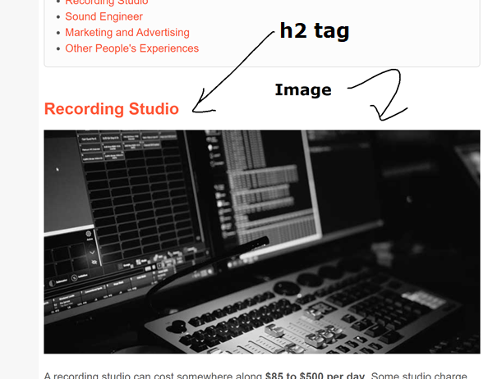  
The screenshot above is from: <https://www.gemtracks.com/guides/view.php?title=how-much-does-it-cost-to-record-an-album&id=47>

**Instructions**

1. Sign into FTP (the details will be provided to you later).
2. The FTP will let you upload to <https://www.gemtracks.com/img-temp/>
3. Go to <https://www.gemtracks.com/outsource2/> (login details will be provided to you later)
4. After logging in, you will see a list of links. These are the links to the pages that need the images

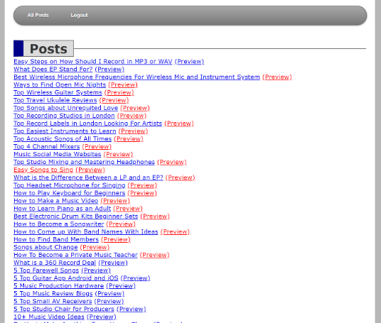

1. Click on a link, and you will be directed to the “edit” page
2. In the HTML of the “edit” page, look for every <h2> tag but NOT “Conclusion”

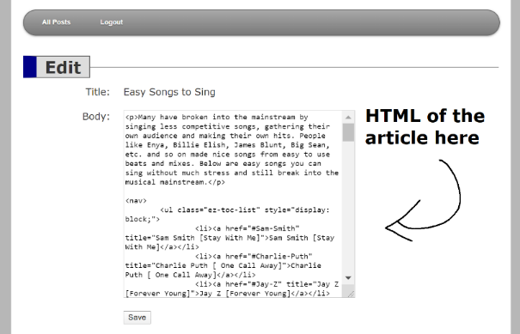

1. For every <h2> tag you see that is NOT <h2>Conclusion</h2>, add the following HTML under it:

<p><img src="[/img-temp/id-your-image.jpg](https://www.gemtracks.com/img/studio.jpg)" style="width:100%;" title="" alt=""></p>

1. Look for stock photos online based on the H2 tag. For example, if the H2 tag says <h2>Be Happy</h2> then look for a photo of a person smiling.
2. Crop the image to 803px width and 412px height. You can make it any color you want (color or black and white).

Save it as **id-name-separated-with-hyphens-lowercase.jpg** (the id is the ID of the article, which you can find in the URL of the page you are editing). After the ID is the name of the image, usually the h2 title in lowercase and separated with a hyphens. For example: Be Happy would be **100-be-happy.jpg**



1. Upload the image to /img-temp/ using the FTP, and then put in the HTML. In title=”” and alt=”” put the H2 text
2. Save and check

The second task is to add a HTML table of content

1. Copy the following “Table of Content” HTML into the article somewhere after the first paragraph and before the first H2 tag. It is usually before the first H2 tag.

<nav>

<ul class="ez-toc-list" style="display: block;">

<li><a href="#title-here" title="TITLE HERE">TITLE HERE</a></li>

<li><a href="#title-here" title="TITLE HERE">TITLE HERE</a></li>

<li><a href="#title-here" title="TITLE HERE">TITLE HERE</a></li>

</ul>

</nav>

This is a live and correct article: <https://www.gemtracks.com/guides/view.php?title=how-to-get-on-spotify-playlist&id=49>

See where the Table of Content is located.

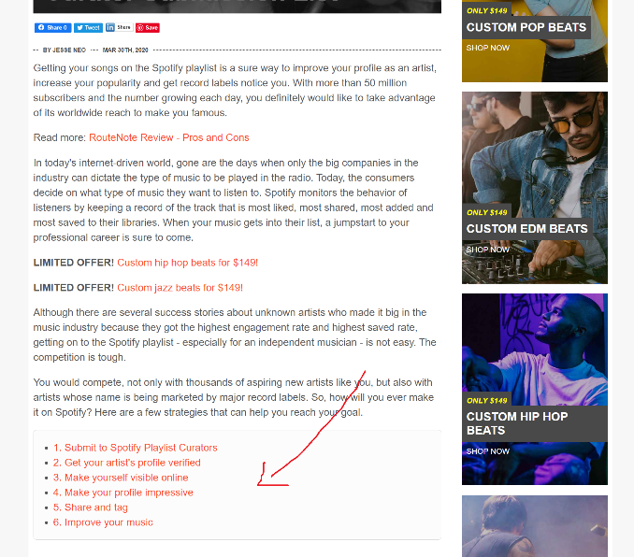

1. Look for all the **<h2></h2>** tags in the article but NOT "conclusion.” Get their name, and then add an ID to the H2 tag. The ID should be the title in lower case, no symbols, and dashes instead of spaces. For example

<h2>Connect With Friend’s Friends</h2>

should be

<h2 id="connect-with-friends-friends">Connect With Friend’s Friends</h2>

**Remember: Do NOT do this to <h2>Conclusion</h2>**

1. Edit the "Table of Content" HTML by changing **#title-here** to the H2 ID you did above, and the **TITLE HERE** with the name of the H2 tags. In this example, it will be:

<li><a href="#**connect-with-friends-friends**" title="**Connect With Friend’s Friends**">**Connect With Friend’s Friends**</a></li>

1. Save and view the live article to make sure it’s correct

The final task is to find YouTube videos.

1. For each blog post, look for all the <h2></h2> titles that could potentially have **YouTube** videos included to make them more understandable.

For example, if the title is about a song, you could find a video featuring that song.

Or if the title is about getting songwriting ideas, you could find a video featuring a tutorial on how to get song ideas.

Or if the title is about a review of a product, you could find a video reviewing the same product.

Here is an example with videos: <https://www.gemtracks.com/guides/view.php?title=top-7-ways-on-how-to-get-discovered-online-as-a-singer-&id=4>

1. Once you have decided that a video is useful, add the following HTML

<p><iframe width="100%" height="415" src="https://www.youtube.com/embed/**video-id-here**" frameborder="0" allow="accelerometer; autoplay; encrypted-media; gyroscope; picture-in-picture" allowfullscreen></iframe></p>

Replace **video-id-here** with the ID of the YouTube video.

Try to make sure every article has at least a few videos. The more the better because it will help with SEO.