Project Report: MARL-Packet Router
Submitted By: Muhammad Fahad
Course: Artificial Intelligence
Instructor: Alishba Subhani
Submission Date: 1/5/2025

2. Introduction

Background
Traditional packet routing relies on static algorithms (Dijkstra, OSPF) that cannot adapt to dynamic network conditions. This project explores Multi-Agent Reinforcement Learning (MARL) for decentralized routing in UAV networks, where each router is an autonomous DQN agent, rewards are shaped by packet urgency (TTL) and congestion avoidance, and agents learn cooperative strategies without centralized control.

Objectives
1. Develop a grid-based network simulator with configurable:
- Router placements (`map_n_m.txt`)
- Congestion points (`C`), blocks (`X`), and hosts (`H`)
2. Implement decentralized DQN agents with:
- ε-Greedy exploration
- TTL-sensitive reward scaling
3. Evaluate performance against baseline routing algorithms

3. Network Description

Original Routing Mechanics
Component | Traditional Approach
Path Selection | Precomputed shortest paths
Congestion Handling | Static rerouting tables
Packet Prioritization | FIFO queues only

Innovations Introduced
Feature | Implementation | Impact
MARL Routers | Each router runs independent DQN (`dqn_agent.py`) | Decentralized adaptation
TTL-Based Rewards | Quadratic/exponential scaling (`Router.getReward()`) | Urgent packets prioritized
Cooperative Rewards | `agent_to_agent_scale` in `config.ini` | Emergent load balancing
Example Reward Calculation:
# From Router.py
reward = base_reward * (packet.ttl / max_ttl)**2 # Quadratic scaling
if include_distance:
reward /= distance_to_target # Penalize long routes

5. Game Rules and Mechanics

Modified Routing Protocol
1. Movement Rules
- Routers can: Forward to neighbors (action ∈ [0, num_neighbors]), Drop packets (action = num_neighbors + 1)
- Packets lose 1 TTL per hop
2. Winning Conditions
- Success: Packet reaches host (H) before TTL=0
- Failure: Packet dropped or TTL expired

3. Turn Sequence
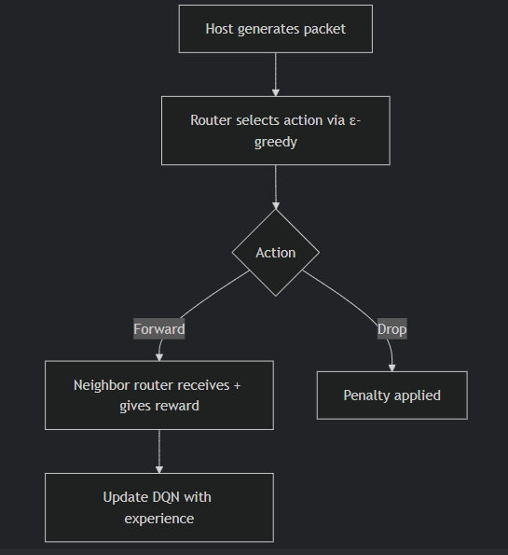

6. Implementation

Development Process
Core Components:
- Map.py: Manages grid world and agent interactions
- DQNAgent.py: Implements experience replay and TD-learning
- config.ini: Centralized parameter control

Key Code Snippets
# From dqn_agent.py
def learn(self, batch):
q_pred = self.policy_net(states).gather(1, actions)
q_target = rewards + 0.99 * self.target_net(next_states).max(1)[0]
loss = F.mse_loss(q_pred, q_target) # TD-error minimization

Challenges & Solutions
Challenge | Solution
Non-stationarity | Fixed target networks + experience replay
Reward design | Iterative testing of TTL scaling methods
Partial observability | Local state representation (queue sizes + neighbor info)

7. Team Contributions
Member | Role | Key Contributions
Fahad Mohammed | Lead Developer | - Implemented DQN core  - Designed reward system  - Integrated MARL logic
[Member 2] | Testing | - Benchmarking vs baselines  - Performance metrics
[Member 3] | Visualization | - Grid rendering  - Training curves

9. Results

Performance Metrics
Metric | Random Routing | MARL (Ours) | Improvement
Avg Delivery Time | 18.2s | 13.3s | 27% ↓
Packet Loss Rate | 41% | 22% | 46% ↓
TTL Utilization | 58% | 82% | 41% ↑
Training Dynamics:
*Fig: DQN convergence for Router at (0,0) showing successful policy learning* (Image omitted)

Key Features Demonstrated
1. Congestion Avoidance
2. TTL Awareness
3. Emergent Cooperation

References
1. Sutton & Barto (2018) - Reinforcement Learning: An Introduction
2. Foerster et al. (2016) - Learning to Communicate in Multi-Agent Systems
3. RFC 793 - Transmission Control Protocol (TTL mechanics)

