Digital Cash Register: Report

**Theory**:   
The main idea behind our *digital cash register* project is really simple. Our project circuit consists of four main parts. They are the *Card Identification System*, the *Memory Unit*, the *Counting System* and the *Display System*. The *Card Identification System* identifies the product that the buyer wants to buy using a specific **‘*Product Card*’** and *IR Emitters* & *IR Receivers*. The *Memory Unit* preserves the prices of all the goods offered. The *Counting System* consists of two types of counting systems ― *Binary Down-counting* and *BCD Up-counting System*. The *Binary* counter *down-counts* from the product’s price to zero one after another, effectively summing up the prices. Switches are used to control *data loading* and *counting*. Finally, the *Display System* shows the results of addition in *BCD* format.

**Instruments Used**:

* *Timer ICs*  ― IC **555**
* *Quad Op-Amps* ― IC LM**324**
* *16 to 1 Multiplexers* ― IC **74150**
* *4 Bit Binary Up/Down Counters* ― IC **74191**
* *BCD Up/Down Counters* ― IC **74190**
* *Logical OR Gate ICs* ― IC **7432**
* *NOT Gate ICs* ― IC **7404**
* ***Infrared Emitters*** & ***Infrared Receivers***
* *5 V Power Supply Regulator ICs* ― IC **7805** & corresponding **Heat Sink**
* *7 Segment Displays* & corresponding *Display Driver ICs* ― IC **7447**
* *Resistors, Potentiometers, Capacitors* & *LEDs*
* *12 V Adapter* & *SPDT Switches*
* *Breadboards* & *Connecting Wires*

**Operation**:   
The operation of our circuit is quite interesting. The *cash register* works by **identifying** the products & corresponding prices, **summing up** them as well as **displaying** it to both the seller and the buyer. The operation of the circuit can be divided into *four steps*. So, here’s the steps ―

***First*,** *Card Identification System*The identification of a product leads to finding out the price of that specific product. To implement this, we have used a *Card Identification System*. We have kept a **‘*Product Card*’** for ­each product holding a specific ID Number (in *Binary* format) of the corresponding product. To read this number, we have used a **Sensor/Reader Circuit** consisting of *Infrared Emitters* and *Infrared Receivers* placed *face-to-face*. The card is inserted between them. The circuit reads **1** when the infrared ray is received and **0** when it is blocked and so these cards have 4 **bars** for *4 Bit data* which are either *empty* (*read as* **1**) or *solid* (*read as* **0**).

***Second*,** *Memory Unit*   
We have implemented this unit using four *16 to 1 Multiplexer* ICs (*IC* **74150**). So, there is a highest of 16 products that can be identified. Also, the highest price that can be set is **15 units** *(in binary* 1111, *i.e.*, *highest number in 4 Bit data system. By adding more Bits, the number of products and the highest price can be extended up to the choice)*. The ID No. read in the *Reader* is sent to the *common selector* pins of the *MUXs*. This enables a special number of input pin in each *MUX* which holds the product’s price to send it to the output pin.

***Third*,** *Counting System*   
The *Counting System* for sums up the prices of all the products that a buyer buys to the total. The *Counting System* is consists of two types of counting ―

* *Binary Down-counting* ―  
  We have implemented this using one *IC* **74191** which is a *4 Bit Binary Up/Down Counter*. It is used as a *Down-Counter* only by making the *D/U* pin (pin 5) = **1**. The price of a product in *4 Bit data* from the *MUX* output pins is sent to the inputs of this counter. Then, the counter *down-counts* from that price to zero.

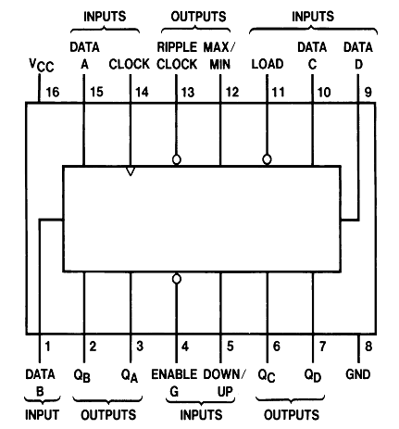   
Fig: Pin diagram of *IC* **74191**

* *BCD Up-counting* ―  
  We have implemented this using two *IC* **74190‘s** which are *BCD Up/Down Counters*. It is used as an *Up-Counter* only by making the *D/U* pin (pin 5) = **0**. When the *Binary* counter *down-counts*, the *BCD* counter block *up-counts* from zero to the product’s price simultaneously and stays there until it is manually cleared.

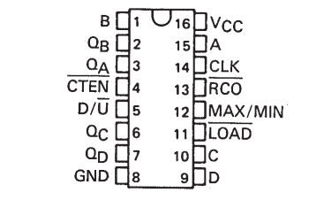  
Fig: Pin diagram of *IC* **74190**

If a second price comes to next, the *BCD* counter block counts from the previous point (1st product’s price) to the sum of the two prices, effectively *adding* the prices. Similarly, more prices can be added. Thus, the *Counting System* sums up the prices of all the products that a buyer buys.

The *Binary* counter is the core unit here, as price *data* is loaded into it for counting. There are several switches to control the *adding* process ―

* *Load/Count* Switch ―  
  This switch controls the *loading* of price to the *Counting System* and the counting. When *Load/Count =* **1**, the price *data* is loaded into the *Binary* counter and when *Load/Count =* **0**, the counters count.
* *Master Reset* Switch ―  
  This switch is needed when more than one buyer comes into account. After one buyer’s prices are summed up to total, pushing this switch starts counting from zero again. *Master Reset* Switch is implemented by simply connecting the *Load* pins (pin 11) to a switch.

When the *BCD* counter reaches to the price and *Binary* counter reaches to zero, the *MAX/MIN* pin of *Binary* counter (pin 12) changes to **1** from **0** which makes the *Common Enabler* of the *Counting System* 1. As the counter ICs are *active low*, they stop counting. By varying the *Clock frequency*, the counting can be made of certain speed.

**Fourth,** *Display System*   
The *Display System* shows the results of addition. We have implemented the *Display System* using *7 Segment Displays*. There is two *7 Segment Displays* for two *BCD* counter driven by two *Display Driver* ICs (*IC* **7447**). Here, the largest sum that can be displayed is **99**.

|  |
| --- |
| ***Digital Cash Register System Flow Chart*** |

**Circuit Diagram**:

|  |
| --- |
| ***Fig: Digital Cash Register System*** |

