***EEE 424: Numerical Methods Laboratory***

***Lab Group: A1***

|  |
| --- |
| “Monte-Carlo” Simulation of Magnetization in Ferromagnetic Material with Temperature Variation |
| *Submitted to-*  *Md. Imran Momtaz Soumitra Roy Joy*  Assistant Professor Lecturer  Dept. of EEE Dept. of EEE BUET BUET |
| *Submitted by-*  Abul Hasan Fahad Monjurul Feeroz Meem  Std. No.: 0806021 Std. No.: 0806028 |

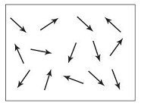

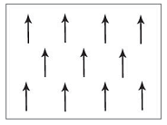

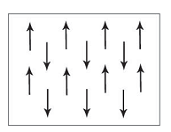

Project Proposal:



“Monte-Carlo” Simulation of Magnetization in Ferromagnetic Material with Temperature Variation:

* **Ising Model:** To simulate magnetic behavior of a Ferromagnetic Material subject to temperature variation, we resort to the “Ising” model, proposed by physicist Ernst Ising who did it in 1920s. It is a mathematical model in statistical mechanics. It has since been used to model diverse phenomena in which bits of information, interacting in pairs, produce collective effects. Serious applications include complicated models of ferromagnets, fluids, alloyds, interfaces, nuclei, subnuclear particles. Now-a-days, it is one of the pillars of Computational physics.
* **Test System:** In this project, we have used it to model the behavior of a 2D ferromagnetic domain. The domain can be conceived as a “Grid of Magnetic Dipoles”. This grid is of size 10-by-10, having 100 dipoles. We assume the dipoles either have “spin up” or “spin down”. For spin-up (↑) we have si= 1 and spin-down (↓) we have si =−1.

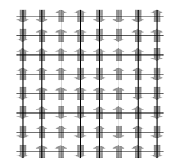

Figure: 2D Ising Grid

* **Interaction Energy:** Magnetism in the material depends on the interaction of adjacent dipoles. The energy due to interaction of adjacent dipoles: −J if parallel and +J if anti-parallel.

J is assigned a value “> 0” (greater than zero) for ferromagnets.

* **Energy of a configuration:** Energy of the dipole-arrangement is calculated by the following expression:

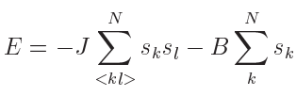

Where, N= Total no. of spins

<kl>= sum of nearest members (periodic boundary condition)

B= external Magnetic field

In our case, we have excluded external magnetic field. So, we employed the expression-



* **Magnetization of a configuration:** Magnetization is calculated as-

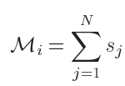

Where Mi= sum of all the spins in “i-th” configuration

“Metropolis Monte-Carlo Algorithm” to simulate Ising Model:

1. Calculate energy of the lattice at a given temperature.
2. Choose a random position in the lattice. Flip its spin and calculate the present energy of the system.
3. Take the difference between present and previous energy.
4. If the energy is positive then keep the spin flipped.
5. Otherwise, calculate- , where β = 1/KT, ΔE= energy difference. Assume K=1, so that T becomes dimensionless.
6. Compare w with a random number r. If r<=w, accept the spin-flip, otherwise keep the initial system.
7. Perform this Monte-Carlo Loop for, at least 100 times. Calculate energy and magnetization at each step.
8. After the looping is done, take the average of energy and magnetization. This is our result for a specific temperature.
9. Vary the temperature and find the value of energy and magnetization at each temperature.
10. Also vary interaction energy and plot the energy and magnetization

Results:

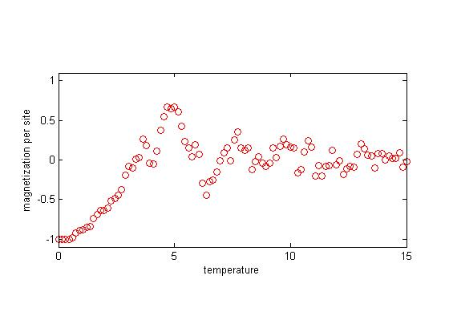

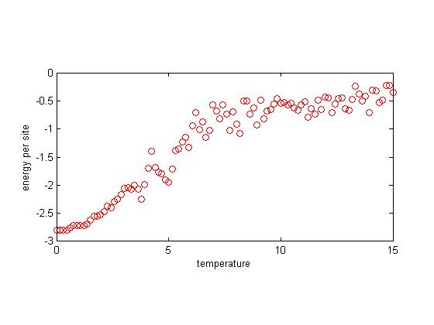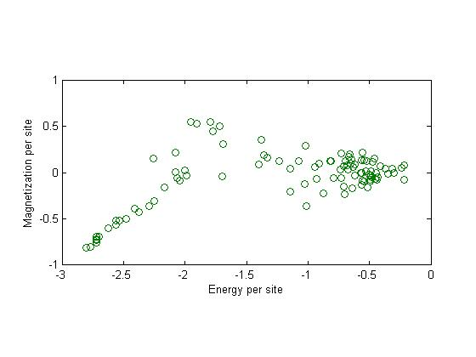

Figure: Results for Interaction Energy J=1







Figure: Results for Interaction Energy J=0.8

Figure: Results for Interaction Energy J=0.8







Figure: Results for interaction energy J=0.5

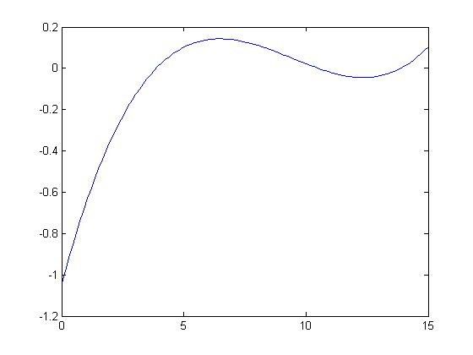

Magnetization

(Y axis)

Figure: Magnetization vs. Temperature fit for J=1.0



Temperature (X axis)

Figure: Magnetization vs. Temperature fit for J=0.8



Temperature (X axis)

Magnetization

(Y axis)

Figure: Magnetization vs. temperature 3rd order fit for J=0.5

Discussion:

1. Ising Model is a mathematical model, which employs statistical techniques to model the behavior of ferromagnetism. It is not a physical model. So it can’t predict real values of transition temperatures for different materials.
2. From the obtained Magnetization vs. Temperature curves, it is clear that there is a ferromagnetic to paramagnetic transition between T=0 to T=5.
3. System Energy increases with temperature, as expected.
4. As evident from our results, Magnetization increases as energy decreases.
5. As interaction energy decreases, the phase transition occurs earlier. It is expected as dipoles are weakly interacting.
6. If sufficient time is provided, we could have extended our work to 3D system.

Code:

clear all;

close all;

clc;

n = 10;

b = -ones(n,n);

b = b .^ round(rand(n,n));

save('A_load','b')

clc; close all;

n = 10;

K = 1;

% K=1.38e-23;

J = 1;

B = 0;

temp_point = 50;

monte_loop = 200;

% a = -ones(n,n);

% a = a .^ round(rand(n,n));

load('A_load','b');

a=b;

figure(1)

image((a+1)*128)

axis square; colormap bone;drawnow

T = linspace(15,0,temp_point);

for t = 1:length(T)

beta = 1/(K*T(t));

for g = 1:monte_loop

i = floor((n-1).*rand(1) + 1);

j = floor((n-1).*rand(1) + 1);

eb = -J*energy(a)-B*sum(sum(a));%(energy before change)

a(i,j) = -1*a(i,j);

et = -J*energy(a)-B*sum(sum(a));%(energy after change)

dele = (et-eb);

if dele > 0

w = exp(-beta*dele);

r = rand();

if r > w

a(i,j) = -1*a(i,j);

end

end

Mag(g) = sum(sum(a));

En(g) = -J*energy(a)-B*sum(sum(a));

figure(2)

image((a+1)*128)

xlabel(sprintf('T = %0.2f, M = %0.2f, E = %0.2f', T(t), Mag(g)/n^2, En(g)/n^2));

set(gca,'YTickLabel',[],'XTickLabel',[]);

axis square; colormap bone;drawnow

end

M(t) = mean(Mag)/(n*n);

E(t) = mean(En)/(n*n);

end

%magnetization

figure()

plot(T,M/max(abs(M)),'ro')

ylabel('magnetization per site');

xlabel('temperature');

ylim([-1.1 1.1]);

pbaspect([2 1 1]);

print(gcf, '-depsc2', 'ising-magnetization');

%energy

figure()

plot(T, E, 'ro');

ylabel('energy per site');

xlabel('temperature');

pbaspect([2 1 1]);

print(gcf, '-depsc2', 'ising-energy');

% Magnetization per site, versus Energy per site

figure()

plot(E, M, 'o', 'Color', [0 0.5 0]);

xlabel('Energy per site');

ylabel('Magnetization per site');

pbaspect([2 1 1]);

print(gcf, '-depsc2', 'ising-mvse');

p = polyfit(T,M,3);

O=polyval(p,T);

figure()

plot(T,O)

function e = energy(a);

n = length(a);

sum = 0;

for i = 1:n

for j = 1:n

if j-1 < 1

p = a(i,j) * a(i,n);

else

p = a(i,j) * a(i,j-1);

end

if j+1 > n

q = a(i,j) * a(i,1);

else

q = a(i,j) * a(i,j+1);

end

if i-1 < 1

r = a(i,j) * a(n,j);

else

r = a(i,j) * a(i-1,j);

end

if i+1 > n

s = a(i,j) * a(1,j);

else

s = a(i,j) * a(i+1,j);

end

sum = sum + p + q + r + s;

end

end

e = sum;

end

Representative Output:

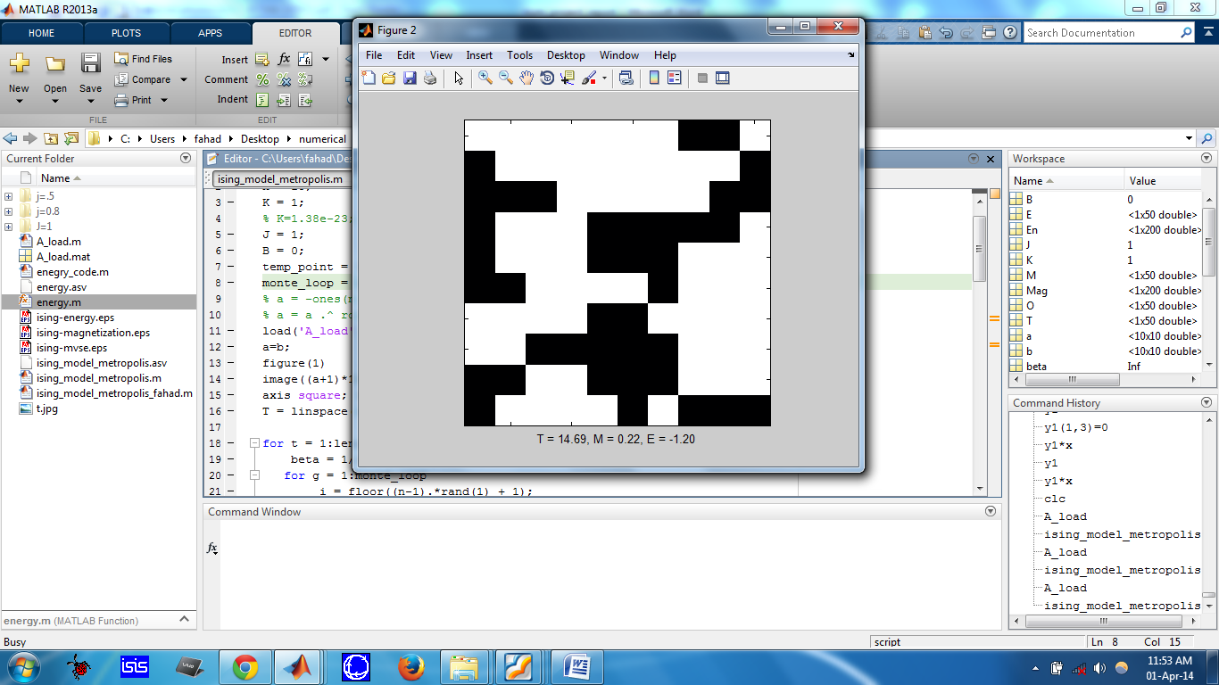

10-by-10 Grid

Black = spin down

White = spin up