**Assignment**

**Submitted by:**

**Fahad Iqbal**

**Submitted to:**

**Dr Usman Akthar**

**SAP ID: 34966**

***MS IT***

***Department of Computer* Science**

**IT Infrsturstrure**

**Q no: 01 what is the automation framework?**

Let's explain what an automated testing platform is before looking into the most presents a considerable of systems and their benefits. A screening framework is a set of principles or guidelines for designing and developing test cases. A framework and a set of procedures and technologies meant to enable data quality professionals test more reliably.

Codes, test-data handling methods, object libraries, procedures for storing test results, and advice on how to access recourses are all examples of instructions.

While these are not crucial elements, and testers can still program or record tests without them, utilizing an organized framework often gives additional benefits that would otherwise be ignored.

**Benefit Test Frame Work**

* Test performance has increased.
* Maintenance requirements are reduced.
* Manual interaction is minimal.
* Maximum coverage of assessments
* Software reusability

**Type Automation frame work**

There are different types of the automation frame work as follows.

* Data Driven frame work
* Frame of Linear Automation
* Framework for Modular-Based Testing
* Hybrid Testing frame work
* Library Architecture frame work

**Question .What is Selenium?**

Selenium is an open-source (free) automated software framework for evaluating web applications across multiple browsers and platforms. Selenium Test Scripts can be written in a variety of programming languages, including Java, C#, Python, and the others. Selenium Testing is the term for tests performed using the Firefox testing tool.

Selenium System is far more than a single tool; it's a suite of tools, each of which responds to a specific firm's Selenium QA test procedures. The includes a list of tools.

* Selenium Integrated Development Environment (IDE)
* Selenium Remote Control (RC)
* Web Driver
* Selenium Grid

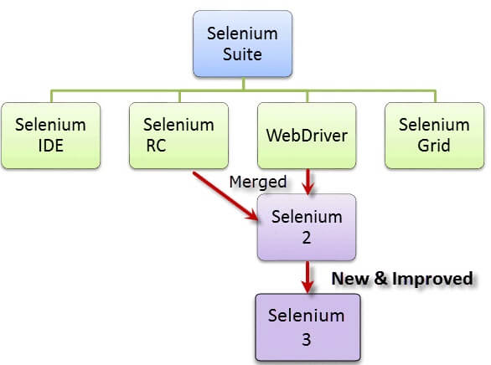

**Selenium how does it work**

Selenium RC is a Remotely Control that functions by intercepting the browser's remote and then inserting the automation code to also be tested through custom scripts. Selenium RC uses the Selenium RC Server to interface with browsers. When an user visits the website, it injects JavaScript capability into browsers.

A local end ('client') of the Employ different methods protocol communicates commands (testing scripts) to a computer driver. These commands are run by the driver on its browser instance. So, if the test script mentions Chrome and Firefox for processing, the Chromed River will run the test on Chrome, while the Gecko Driver should run the test on Firefox.

**Why do I need Selenium Automation Testing?**

The Selenium automated test approach has been widely used in the web development industry. Almost every company that operates online through a website or application uses the Selenium tool in their testing methods.

Regardless of the fact that Selenium is an automation test platform, it isn't just for testers. Selenium allows developers to streamline their unit testing efforts by being compliant with many programming languages. Even DevOps teams use Selenium in their CI/CD technologies to ensure that every moment a code change is committed through pipeline from one staging area to the another, a full round of browsers automated testing is done.

Check out the following scenario for a manual tester: confirming that the web app's signup page (www.example.com/signup) verifies input strings and properly registers a user in the current versions of Chrome and Firefox on Windows 7.

Assume the signup page includes the following fields: user, email address, and passwords. On the newest version of Firefox and Chrome, the tester will acquire Windows users desktop and do the following actions in order:

* In the address bar, type ([www.example.com/signup](http://www.example.com/signup)).
* In each input field, type an incorrect string (email, username, and password)
* Check to see whether the input words were checked it against database's regales as well as any pre-existing values.
* In each input, enter 'valid' strings; clicking Set up an account
* Check to see whether the page "Welcome, "username"" displayed.
* Check to see where a new eligible for registration for "user" was established in the database server.
* If the signup functionality worked, label the test as 'successful.' If something didn't, mark this as 'failed.'

**Q NO 2** **The most common tools that are used for configuration management are packer and ansible. You need to concisely compare both of them.**

**What is Ansible?**

Ansible is a tool for IT automation. It can configure networks, deploy applications, and handle more advanced IT activities like continual deployments and rolling updates with no downtime. The primary goals of Ansible are simple and greatest ease of use.

**What is Packer?**

Packer is a program me that automates the production of machine images of any form. It encourages you to use automated tools to configure and manage software within your Organization in order to ensure images, incorporating contemporary configuration management.

|  |  |
| --- | --- |
| **Packer**   * A person working in the packing profession, especially one who prepares food for extended storage (computing) A software application that compress code or data. * A ring of stuffing or a special device than seals the gap between the tubing and the head of an oil well, keeping it gastight and impermeable. * A buffer or shim is an object which is introduced to leave a space open for the function of alignment. * He is working as a hog packer. * a packer of household goods * When his shoulder problems stopped him from raising furniture, he continued their job as a packer. | **Ansible**   * A significantly quicker cellular modem is a hypothetical technology that allows users to communicate instantly over long distances. * You remembered the ansible, the device I showed you on the ship which can connect with other worlds quickly even without wasting years. * An ansible might theoretically be driven by subatomic that have experienced quantum physics, which uses Einstein’s ‘spooky action at a distance,' allowing one particle to change the characteristics of its partnered particle in timely manner. * The master’s ansible is on the scene, in connection for our whole invasion fleet; all of our warships are functional and ready to fight. * Key had provided 2 hours here, sufficient time to extricate the news from the ansible, discuss it, and even analyze it, but she didn't even mean for everyone to be cramped and vulnerable. |

References

https://www.sciencedirect.com/topics/computer-science/infrastructure-master