

***Documented by:***

* Aisha Afnan

***Certificate of Completion:***

This is to certify that we have completed our ACCP Semester E-Project.

Submitted to: **Aptech Computer Education** on

**2nd October, 2024**

***By:***

* Muhammad Muhiuddin Altaf
* Muhammad Fahad
* Aisha Afnan
* Farheen Najam
* Sumbul Ghayyaz
* Osama Abbas

***Acknowledgement:***

First of all, we would like to thank Almighty Allah for giving us the ability to complete the project.

And then, we would like to express our gratitude to our teacher **Sir Noman Hassan** who guided us on this project which in turn helped us learn new things. Whose guidance, encouragement, constant supervision, and unwavering support have been invaluable throughout this journey. Thank you for inspiring us to strive for excellence and for always being there as a mentor. Your belief in our potential has made it possible for us to complete this project.

***Project Synopsis:***

**Project Title:** Quick Metric

**Overview:** Quick Metric is a user-friendly web application that facilitates seamless conversions between metric and imperial units. The website aims to serve students, professionals, and anyone needing quick and accurate conversions in science, engineering, cooking, and more.

**Objectives:**

* Provide an intuitive interface for users to convert units effortlessly.
* Support a wide range of metric and imperial units, including length, weight, volume, temperature, and area.
* Ensure fast, reliable, and accurate conversion calculations.
* Incorporate educational resources to enhance users’ understanding of metric and imperial systems.

**Features:**

1. **User Interface:**
   * Clean, responsive design suitable for both desktop and mobile devices.
   * Simple input fields for easy entry of values and selection of units.
2. **Unit Conversion:**
   * Comprehensive list of metric and imperial units.
   * Instant conversion results with real-time calculations.
3. **Conversion History:**
   * Save and display recent conversions for user convenience.
4. **Educational Resources:**
   * Articles and tutorials explaining the metric system and its advantages.
   * Interactive quizzes to test users' knowledge of unit conversions.
5. **Accessibility:**
   * Features to support users with disabilities, including screen reader compatibility.

**Target Audience:**

* Students in science and math disciplines
* Professionals in engineering, healthcare, and cooking
* General public seeking to understand or convert units

**Expected Outcomes:**

* A fully functional website that meets user needs for unit conversions.
* Increased understanding and appreciation of metric measurements.
* Positive user feedback and ongoing engagement with the platform.

**Conclusion:** Metric Master seeks to bridge the gap between metric and imperial units, promoting ease of use and education in a globalized world. Through a commitment to accuracy and user experience, the website aims to become a go-to resource for conversions and learning about measurement systems.

***Customer Requirements and Specifications:***

Quick Metric includes the following key features:

**1. Supported Units & Categories:**

- Cover various measurements like length, temperature, volume, area, and currency conversion.

- Allow conversions between metric and imperial systems (e.g., meters to feet, kilograms to pounds).

**2. Real-Time Conversion:**

- Instant calculations as users input values or change units, with adjustable precision (decimal places).

**3. User Interface:**

- Simple, clean layouts with dropdown menus for quick unit selection.

- Mobile-friendly and accessible designs, supporting multiple languages.

**4. Advanced Features:**

- Batch conversion for multiple units at once.

- Custom unit definitions and historical units.

- Currency conversion with live rates.

These features make conversion websites user-friendly, accurate, and versatile for different use cases.

***Hardware and Software Requirements:***

**Hardware:**

* Pentium 166 or better
* 64 megabytes of RAM or better

**Software:**

* HTML Editor
* Bootstrap
* Figma
* Chrome/Firefox

***Website Features:***

Features of the Quick Metric website are:

**1. Intuitive User Interface:**

- Clean and responsive design for easy navigation on both desktop and mobile devices.

- Simple layout with clear input fields for entering values and selecting units.

**2. Comprehensive Unit Conversion:**

Support for a wide range of units including:

* + Length: meters, kilometers, inches, feet, miles
  + Weight: grams, kilograms, ounces, pounds
  + Volume: liters, milliliters, gallons, quarts
  + Temperature: Celsius, Fahrenheit, Kelvin
  + Area: square meters, acres, square feet

**3. Instant Conversion Results:**

- Real-time calculations that provide immediate conversion results as users input values.

**4. Conversion History:**

- A feature that saves recent conversions for quick access, allowing users to revisit frequently used conversions.

**5. Educational Resources:**

- Articles and guides explaining the metric system's benefits and practical applications.

**6. Customizable User Experience:**

- Options to set preferred units and display formats, enhancing user convenience.

**7. Accessibility Features:**

- Compatibility with screen readers and other assistive technologies to ensure inclusivity for all users.

- Options for larger text sizes and high-contrast modes.

**8. Feedback and Support:**

- Access to a help center with FAQs and troubleshooting tips.

**9. API Integration:**

- Potential integration with third-party APIs for enhanced features or additional data resources.

**10. Responsive Design:**

- Optimized layout for seamless use on various devices, including smartphones and tablets.

These features collectively aim to provide a comprehensive and enjoyable user experience, making the Metric Master website an essential tool for anyone needing unit conversions.

***User Guide:***

* Home

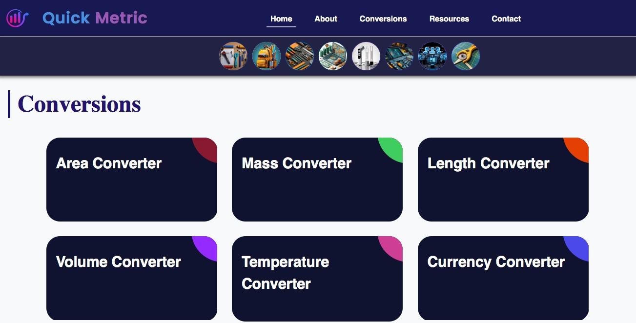

* Conversion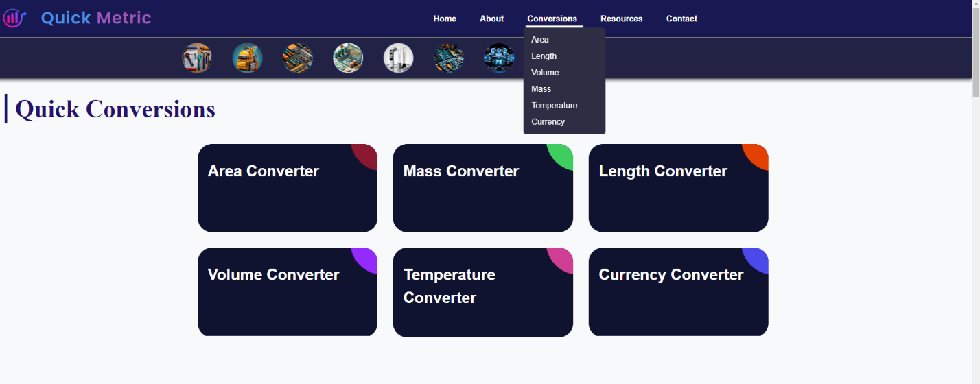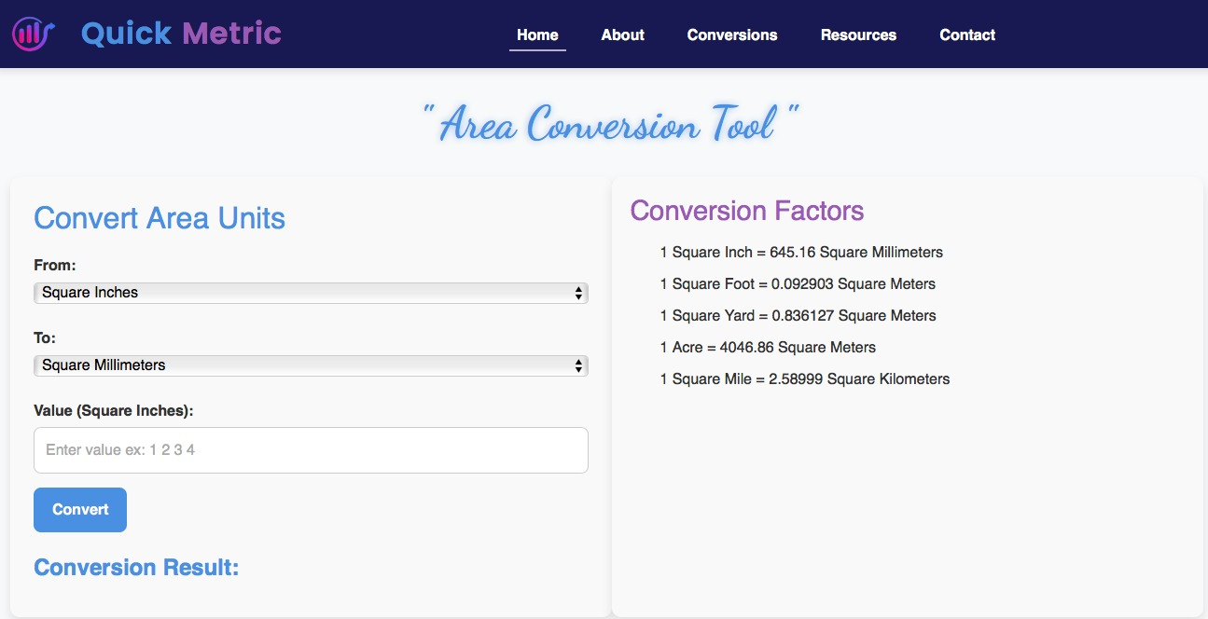

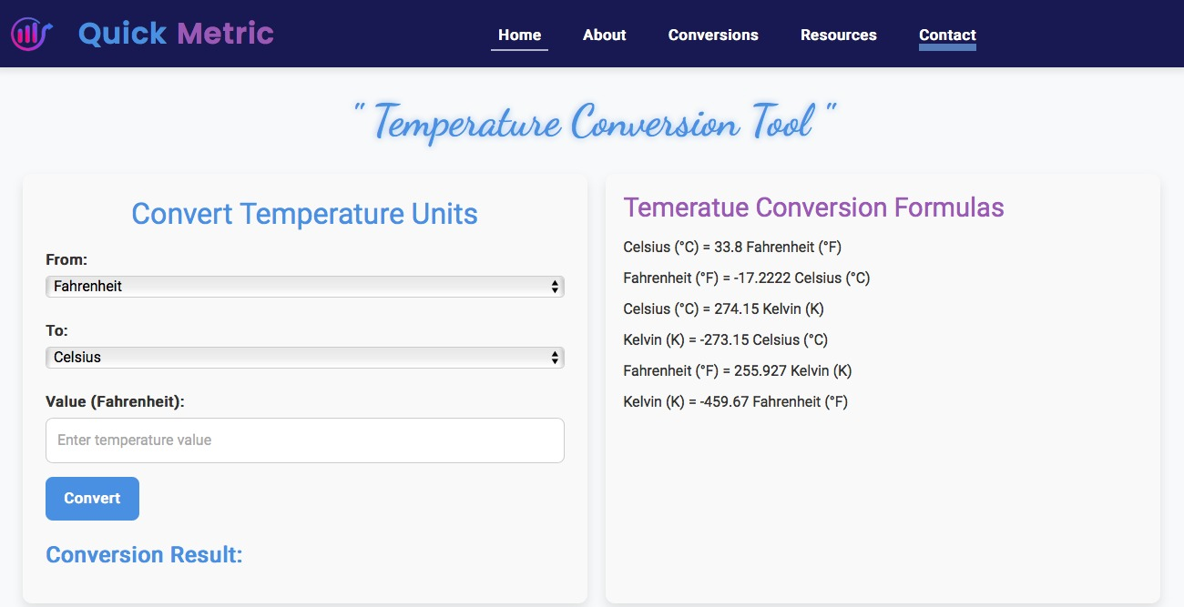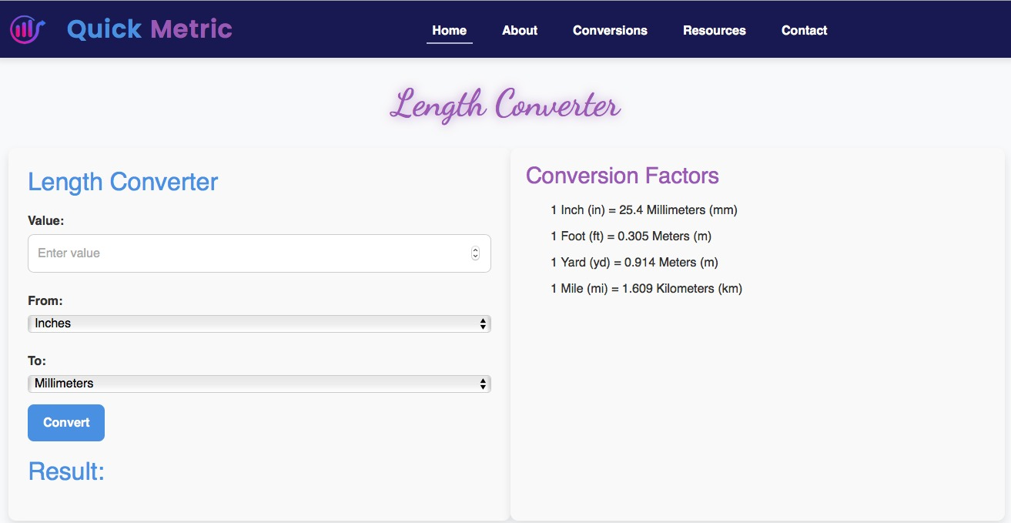

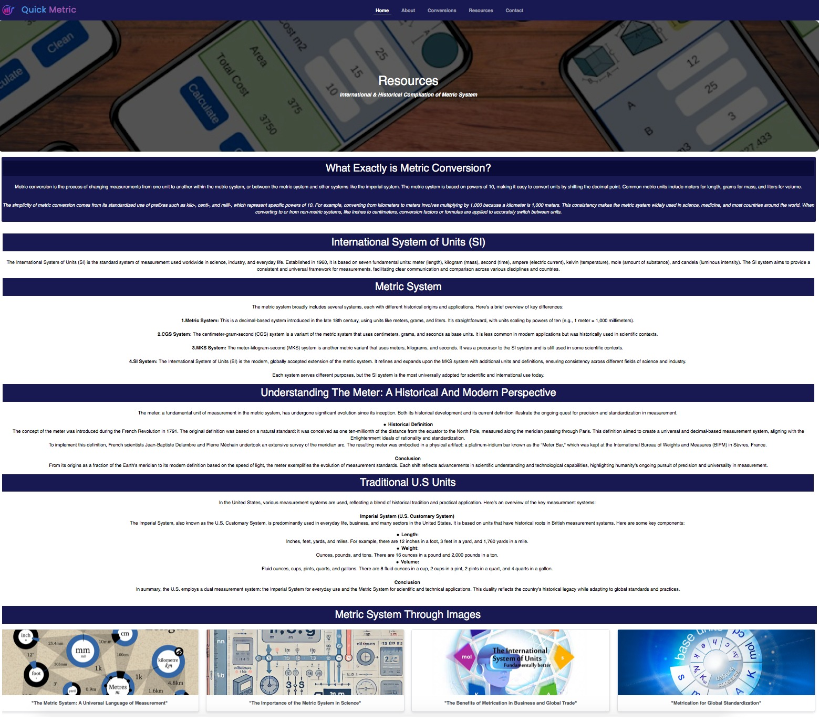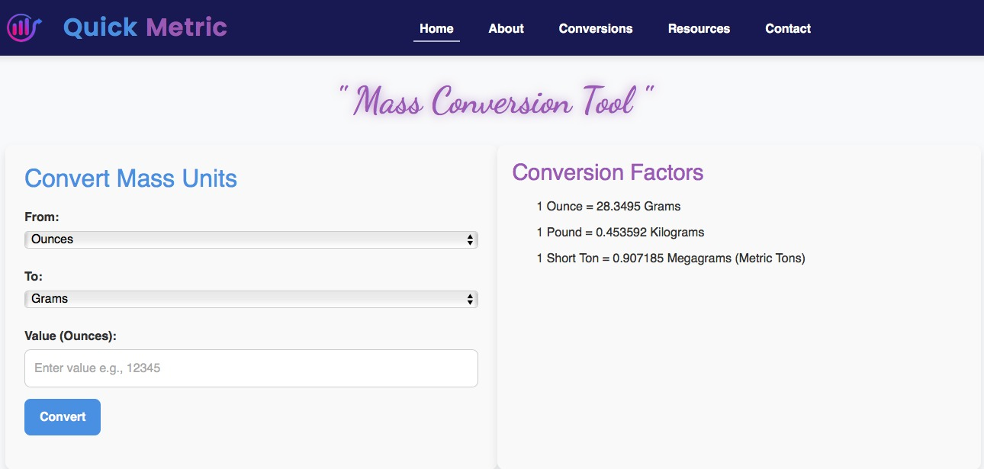

* Resources

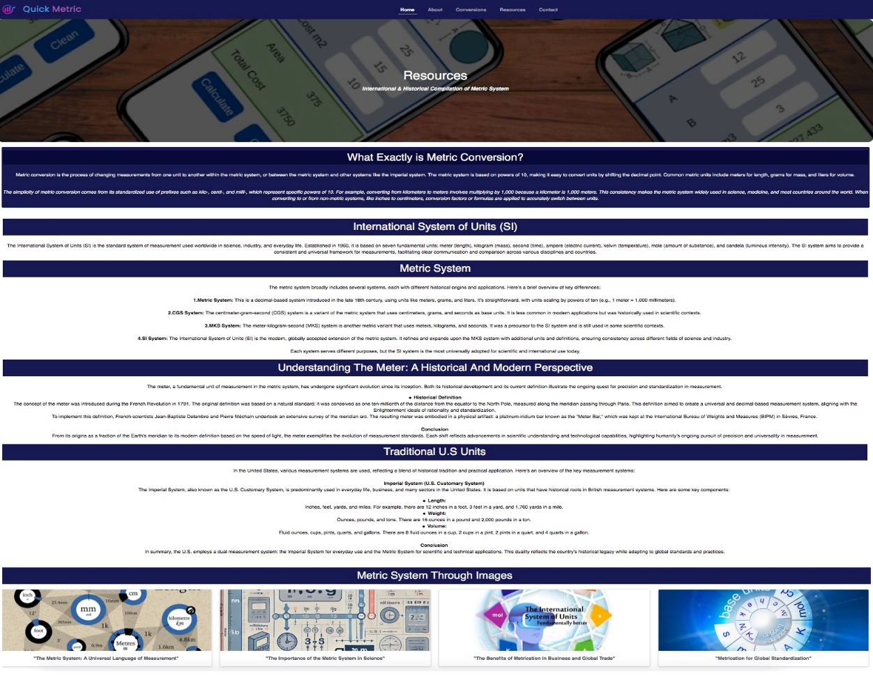

* About Us

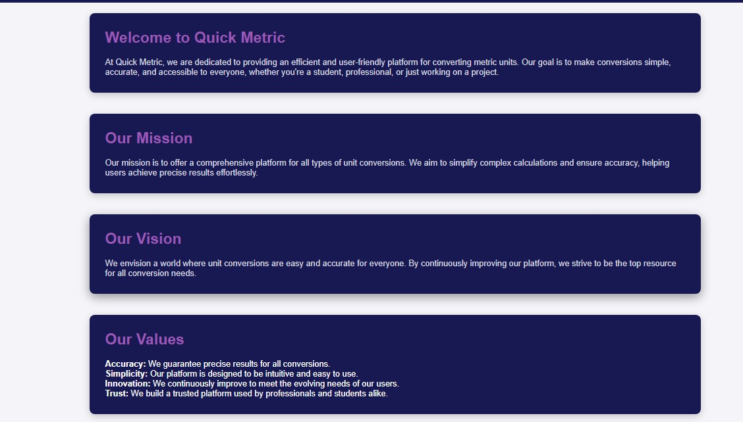



* Contact Us

