**NAME:FAHAD ALI**

**SAP ID:70174668**

**SECTION 1-O**

**SUBMITTED TO:SIR SALMAN IRFAN**

**Lab assignmet**

**Question 1:**

Step 1:start

Step 2:number 1=10,number 2=20

Step 3:answer=number 1+2

Step 4:print sum=30

Step 5:stop

#include <iostream>

using namespace std;

int main(){

    int number1=10;

    int number2=20;

    cout<<"number1+number2";//30

    cout<<"=30";

    return 0;

}

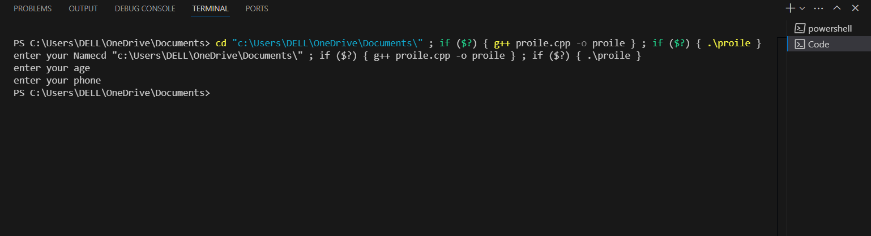

|  |  |  |  |  |
| --- | --- | --- | --- | --- |
|  | 1 | 2 | 3 | 4 |
| A |  |  |  |  |
| B |  |  |  |  |
| C |  |  |  |  |
| D |  |  |  |  |

**QUSETION 2: ALGORITHM STEPS:**

START

STEP 1:FIRST NUMBER

STEP 2:INPUT FIRST NUMBER

STEP 3:SECOND NUMBER

STEP 4:INPUT SECOND NUMBER

STEP 5:SUM TWO NUMBER

STEP 6:PRINT SUM

END

**Q 3:ALGORITHM STEPSTHREE MEMORY CELLS (**

START

STEP 1:Print(Enter value in usd)

STEP 2:Input value of usd

STEP 3:Convert (PKR=USD*170)

STEP 5:Print PKR

END

**Q 4:ALGORITHM STEPS**

START

STEP 1:THREE MEMORY CELLS(MA1+MA2+MA3)

STEP 2:INPUT THEIR VALUES

STEP 3:FIRST ADD(B+C)

STEP 4:MULTIPLY A WITH (B+C)

STEP 5:ADD(A+C)

STEP 6:MULTIPY C WITH (A+C)

STEP 7:Add step step 4 and step 6

Step 8:print result

END

**Q 5:ALGORITHM STEPS**

START

Step 1:length of rectangular fence in feet

Step 2:width of rectangular fence in feet

Step 3:multiply length and width

Step 4:print result in feet(square)

END

**Q 6:ALGORITHM STEPS**

START

Step 1:INPUT 1=initial velocity

Step 2:INPUT 2=final velocity

Step 3:INPUT 3=time taken

Step 4:acceleration=input 2-input 1

Step 5:divide step 4 by step 3

Step 6:print result

END

**Q 7:ALGORITHM STEPS**

START

Step 1:input student name

Step 2:input subject 1marks

Step 3:input subject 2 marks

Step 4:input subject 3 marks

Step 5:input subject 4 marks

Step 6:input subject 5 marks

Step 7:add step (1-5)

Step 8:divide step 7 by total subject marks*100=%

Step 9:result=step 1and step 8

END

**Q 8:ALGORITHM STEPS**

START

Step 1:input:size of fertilizer bag

Step 2:input:cost of bag

Step 3:area in square feet covered by bag

Step 4:result=output:cost of the fertilizer per pound

Step 5:output:cost of fertilizing the area per square

END

**Q 9:ALGORITHM STEPS**

START

Step 1:input number (1-15)

Step 2:add number(1-5)

Step 3:multiply number(6-10)

Step 4:subtract number(11-15)

Step 5:add step 2 and 3

Step 6:subtract step 4 from step 5

Step 7:print result

END

**Q 10:ALGORITHM STEPS**

START

Step 1:

Step 2

**Q 11:ALGORITHM STEP**

START

Step 1:input number

Step 2:print reverse of step 1

END