**LAB ASSIGNMENT**

**NAME:FAHAD ALI**

**SAP ID:70174668**

**SECTION(1-O)**

**SUBMIT TO:SIR SALMAN IRFAN**

**Example#1:**

**IF** the cost of the dress is less than 1500 **Then** you will buy that dress.

If (cost < 1500) {

Cout << “buy the dress”;

}

**IF-Else Statement**

Consider the previously defined scenarios, however, consider them with the following constraints.

**Example #2:**

**IF** the cost of the dress is less than 1500 **Then** you will buy that dress **Otherwise** you will not buy the dress.

If (cost < 1500) {

Cout << “buy the dress”;

}

If (cost >= 1500) {

Cout << “don’t buy”;

}

The same operation can be performed by using the **IF-Else Block.**

If (cost < 1500) {

Cout << “buy the dress”;

} else {

Cout << “don’t buy”;

}

**Tasks: -**

**Task 1: Write a program that checks whether an integer is even or odd.**

**Hint:** num % 2 will return either 0 or 1 against any number.

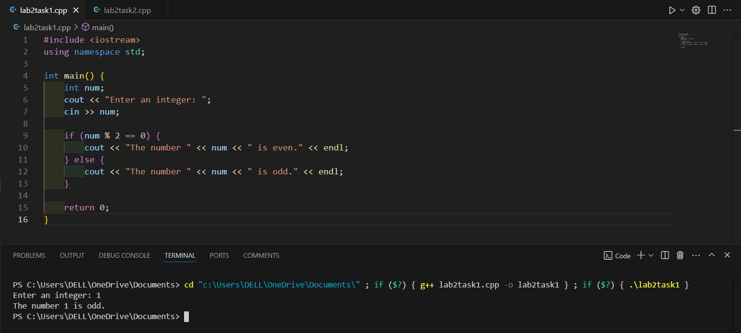

**Task 2:** Write a program that inputs two integers and prints the larger one.

**Hint:** Use comparison operator (< / >)

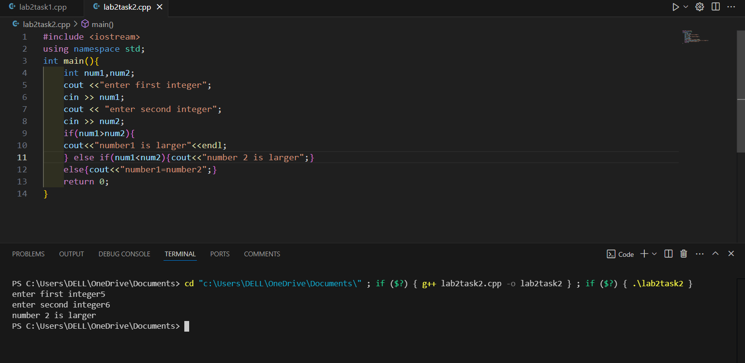

**Task 3:** Write a program that inputs two words and checks if they are the same. Make a difference between uppercase and lowercase letters (“Ali”, “ali”, “ALI” are different words). You have to print "yes, the words are the same" or "no, the words are different".

**Hint:** Use comparison operator (==)

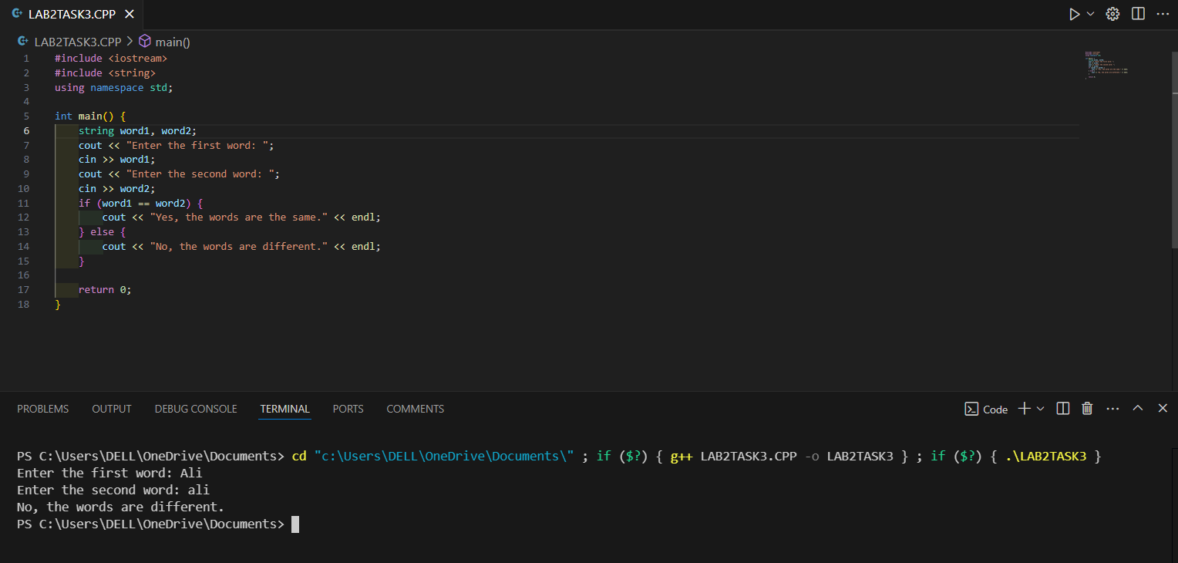

**Task 4:**

Mr. Aslam is running a medical store. He does not know how to calculate the discount for shopping. His business model only allows two types of discounts.

The two scenarios for discount include.

5% discount on Rs 5000 or less amount.

10% discount on greater than Rs 5,000.

Consider that you are a programmer. Write a program to solve this issue faced by Mr. Aslam.

**Hint:**

Actual price = 5000

Discount price = 5000 * 5/100

Net payable = actual – discount

**Task 5:**

Develop a calculator that performs basic arithmetic operations (+, -, *, /, %).

Program will take the first value from the user as input, then it will ask for the operator and then the 2nd number.

**Hint:** use comparison operator (==) with using string datatype for “+”, “-“, “*”, “/”, “%”