Assignment-01
The Changing Atmosphere: Natural Evolution and Human Impact
Course Name: Elements of Environmental Science
Course Code: ENV 103
Semester: Fall 2026
Submitted by:
Name:
Student ID:
Section: 1
Submission Date: 31 October 2026

The Changing Atmosphere: Natural Evolution and Human Impact
1. Introduction
The thin veil of gases that envelopes our planet Earth is known as atmosphere. It provides us oxygen, regulates our climate, drives weather and water cycle. It shields life from harmful UV radiation. Currently it is dominated by nitrogen (78%) and oxygen (21%) with rest made up of argon, carbon dioxide and other traces of gases. It is comprised of 5 layers: troposphere, stratosphere, mesosphere, thermosphere and exosphere (see Figure 1). It has naturally evolved over billions of years. But in the past two centuries, due to human impact, its change is getting accelerated.
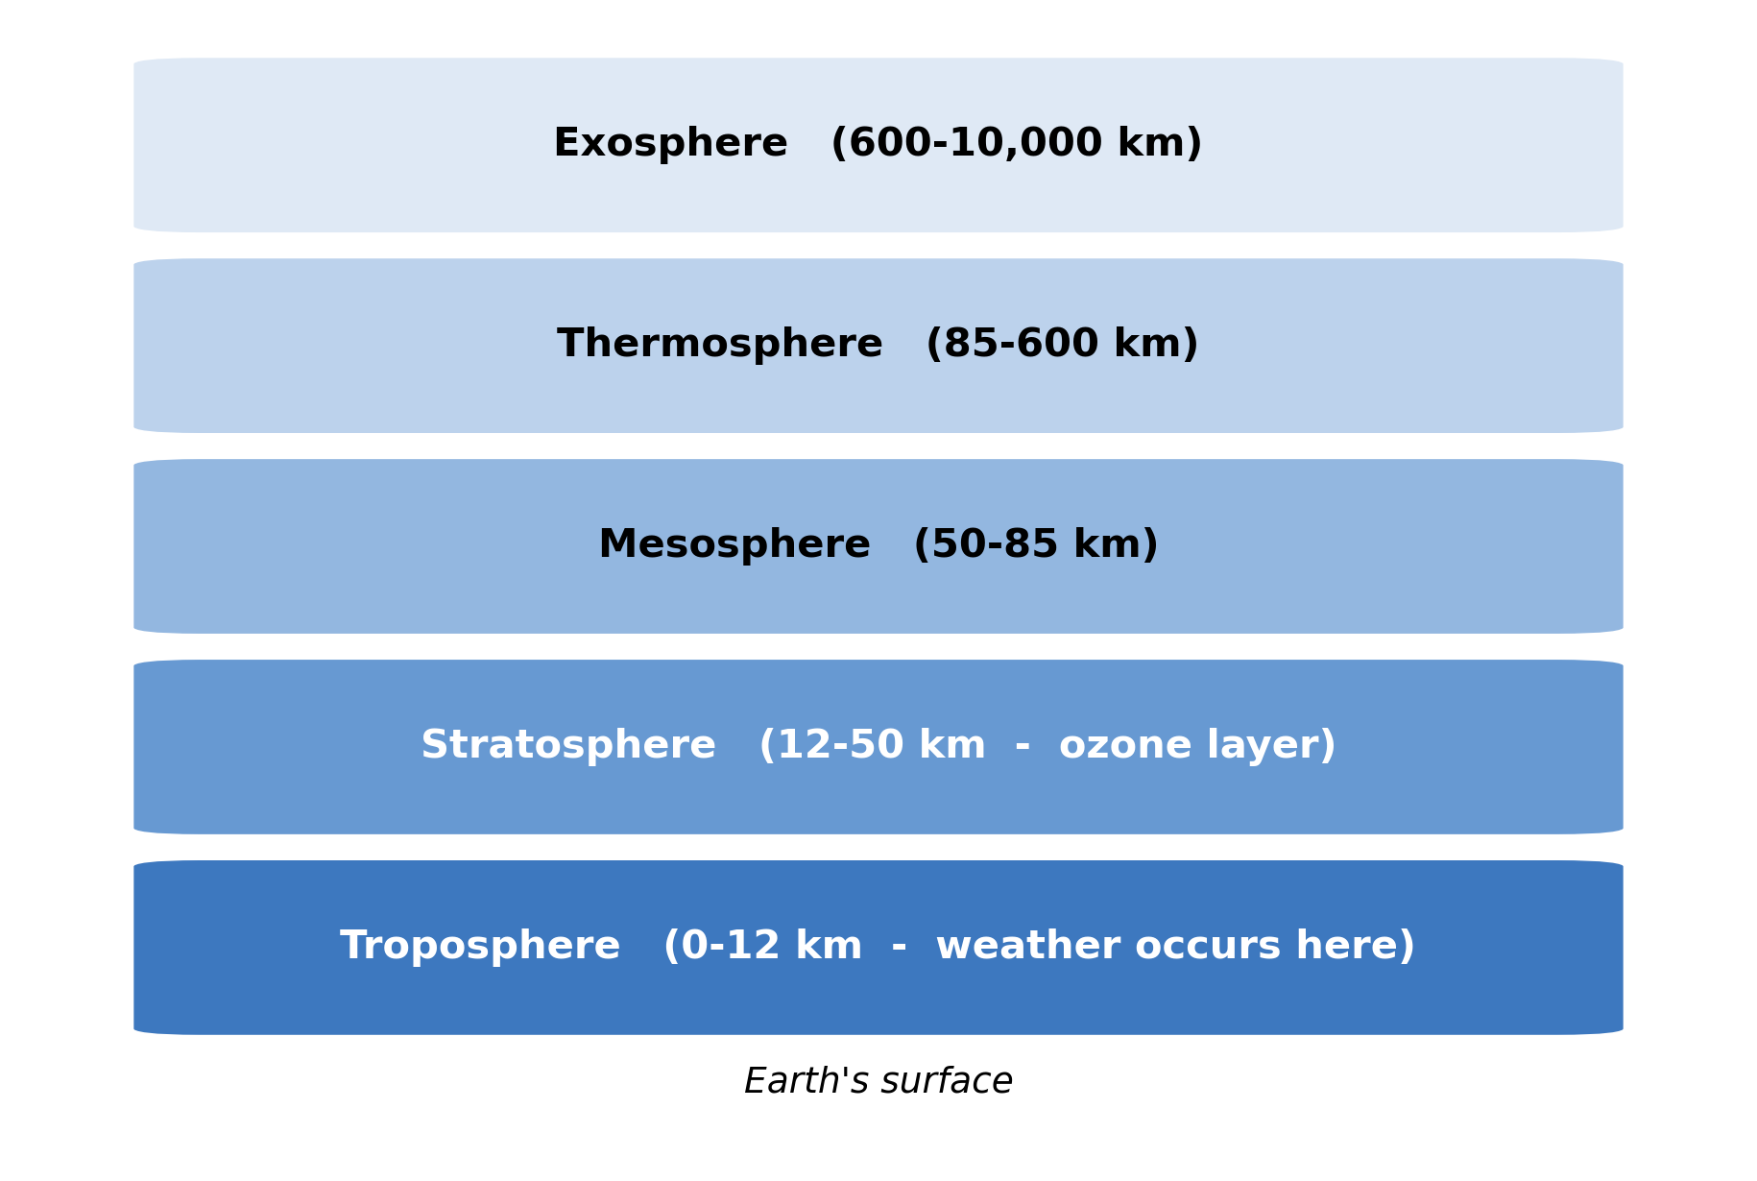
Figure 1. Five layers of atmosphere (not to scale)
Note: Original diagram design by the author. Approximate ranges for altitude are shown.
2. Natural Evolution of the Atmosphere
Although volcanoes released water vapour, carbon dioxide and nitrogen, but there was barely any free oxygen. So life, as we know it, was not possible. As Earth cooled down, water vapour condensed and created oceans. Most of the carbon dioxide got dissolved into oceans and became trapped in rocks.
Around 2.4 billion years ago, the cyanobacteria that lived in the oceans started to photosynthesize in a big way. They took in carbon dioxide and released oxygen. So we got "Great Oxidation Event" and oxygen level started to rise gradually. Some of oxygen reacted to form ozone in the stratosphere. So we got the ozone layer that absorbs most of UV rays. It helped life to inhabit in the land. Due to difference in temperature with altitude, air got layered. Thus we got weather in the troposphere. Protection from ozone in stratosphere. Meteors burning in mesosphere. Then thermosphere and exosphere fading into space. So naturally it has evolved over hundreds of millions of years (see Figure 2).
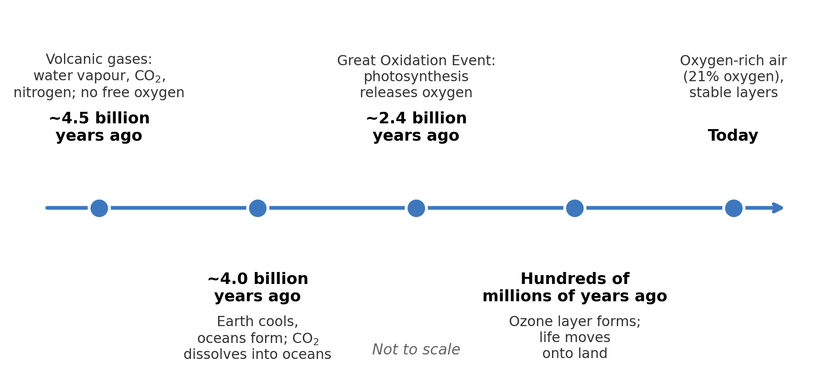
Figure 2. Timeline of evolution of atmosphere. Showing major stages (not to scale)
Note: Original diagram design by the author.
3. Human Impact on the Atmosphere
We are releasing carbon dioxide and other greenhouse gases with the burning of coal, oil, gas. With deforestation, we are having fewer trees available to absorb carbon dioxide. Livestock, rice paddy fields releasing methane. Nitrous oxide released from fertilizers. Also air pollution from factories and motor vehicles.
Carbon dioxide level has risen from ~280 parts per million (ppm) before industrial era to ~425 ppm in 2024. That is more than 50% rise (National Oceanic and Atmospheric Administration [NOAA], 2025; see Figure 3). Human influence has caused the planet to warm unequivocally, from around 1.1 degree Celsius, in the period of 2011-2020 relative to 1850-1900, according to Intergovernmental Panel on Climate Change (2023). We once had thinning ozone layer by use of chlorofluorocarbons in refrigerators. So we got seasonal ozone hole over Antarctica. But due to Montreal protocol it is slowing down and we are seeing a gradual recovery of ozone layer (World Meteorological Organization [WMO], 2023). Smoke dust traffic air pollution in South Asia, including Bangladesh, often becomes harmful. It causes millions of premature deaths (World Health Organization [WHO], 2024). Natural forces are still at work, but the pace of change is not anywhere close to human induced change.
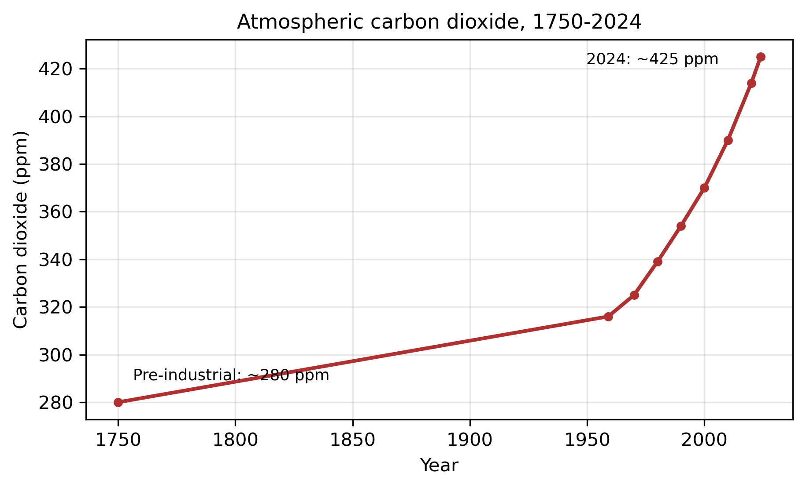
Figure 3. Atmospheric carbon dioxide concentration, 1750-2024
Note: Original graph plotted by the author. Data source: National Oceanic and Atmospheric Administration Global Monitoring Laboratory (2025). 1750 is ice core estimated value.
4. Conclusion
To conclude, atmosphere has naturally evolved over billions of years. But in a lifetime, humans are changing it. It is important to know these timelines because there is the possibility that it can be damaged rapidly due to something that took so long to build. We should use cleaner source of energy. Also we should keep cooperating like in ozone agreement to keep it supportive of life.
References
Intergovernmental Panel on Climate Change. (2023). Climate change 2023: Synthesis report. Contribution of Working Groups I, II and III to the Sixth Assessment Report of the Intergovernmental Panel on Climate Change. IPCC. https://doi.org/10.59327/IPCC/AR6-9789291691647
National Oceanic and Atmospheric Administration Global Monitoring Laboratory. (2025). Trends in atmospheric carbon dioxide. https://gml.noaa.gov/ccgg/trends/
World Health Organization. (2024). Ambient (outdoor) air pollution. https://www.who.int/news-room/fact-sheets/detail/ambient-(outdoor)-air-quality-and-health
World Meteorological Organization. (2023). Scientific assessment of ozone depletion: 2022 (Global Ozone Research and Monitoring Project - Report No. 62). World Meteorological Organization.

