Aror University of Art, Architecture, Design & Heritage Sukkur

|  |  |
| --- | --- |
| **Name :Fahad Hassan** | **BS : AI Section B** |
| **RollNo:Ari-F23-0078** | **Submitted to : Sir Abdul Ghafoor** |

1. <https://leetcode.com/problems/concatenation-of-array/>

**Task 1 Solved:**

|  |
| --- |
| task1 leetcode lb1.png |

* <https://leetcode.com/problems/find-words-containing-character>
* **Task 2 Solved:**

|  |
| --- |
| task2 leetcode lb1.png |

1. <https://leetcode.com/problems/maximum-number-of-words-found-in-sentences>
2. **Task 3 Solved:**

|  |
| --- |
| task3 leetcode lb1.png |

1. [https://leetcode.com/problems/count-number-of-pairs-with-absolute-di<erence-k](https://leetcode.com/problems/count-number-of-pairs-with-absolute-di%3cerence-k)

Unavailable : link..

1. <https://leetcode.com/problems/find-common-elements-between-two-arrays>

**Task 5 Solved:**

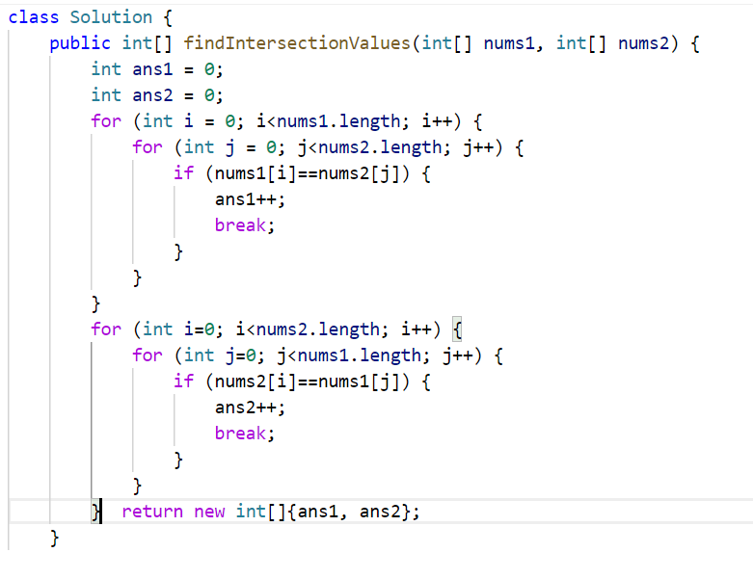

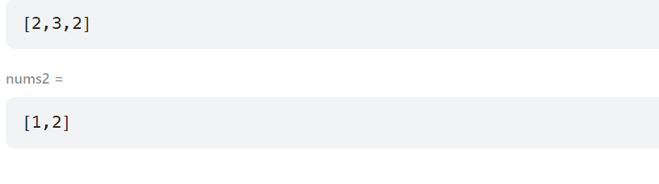

1. <https://leetcode.com/problems/count-primes/>

**Task 6 Solved:**

|  |  |
| --- | --- |
| **task6 leetcode lb1.png** | **output 6 1.png** |