|  |  |
| --- | --- |
| DSA LAB: 10 | Leet Code Tasks |
| Submitted to: Sir Abdul Ghafoor | Submitted By: Fahad Hassan |

Task 1

|  |  |
| --- | --- |
| IN 1.png |  |

Output:

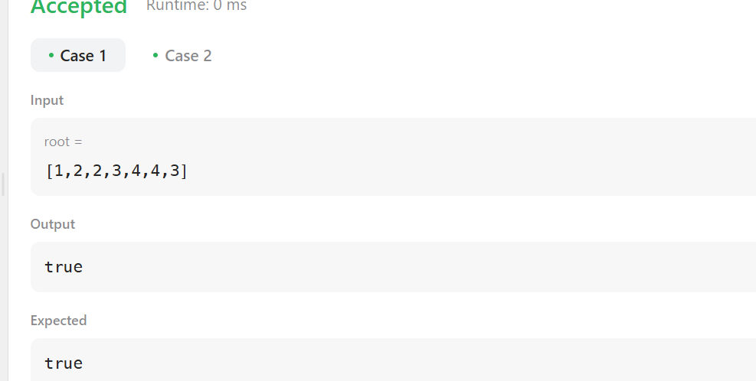  
  
Task 2

|  |
| --- |
| IN 2.png |
| Output:  OU 2.png |

Task 3:

|  |
| --- |
| Input: IN 3.png |
| IN 3 1 .png |

Output:  
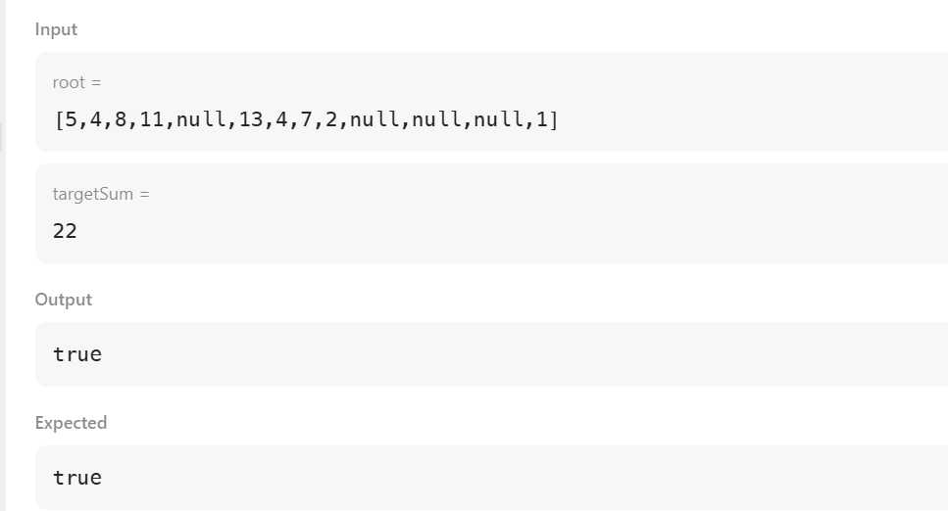

Task 4:  
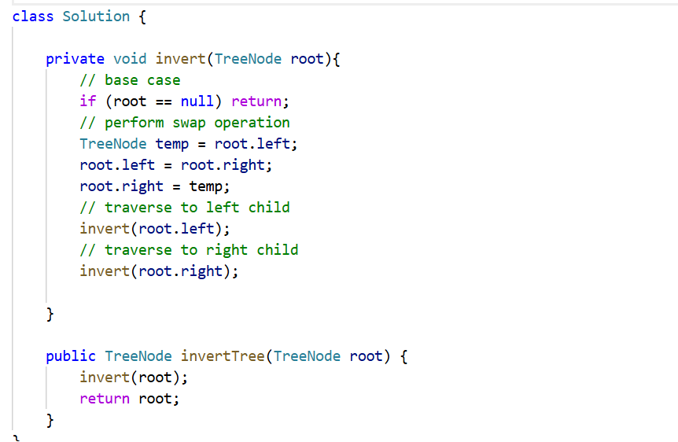

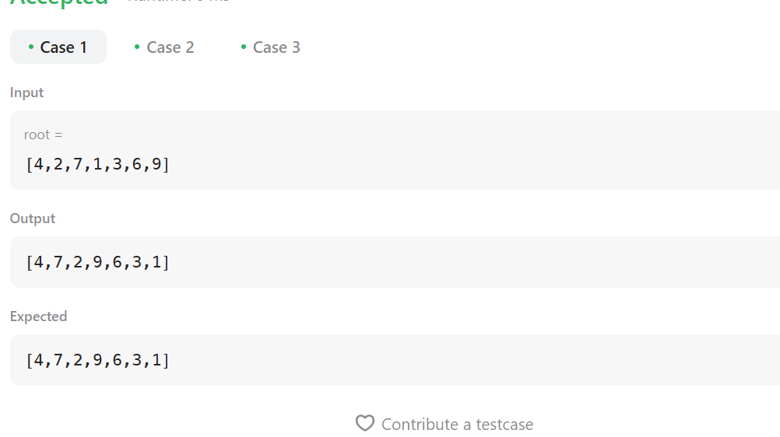  
  
Task 5:

|  |
| --- |
| IN 5.png |
| Output: OU 5.png |