Aror University of Art, Architecture, Design & Heritage Sukkur

Department of AI-Multimedia and Gaming

|  |  |
| --- | --- |
| Name: Fahad Hassan | LAB: DSA_03 |
| Roll No: Ari-f23-0078 | Sir Abdul Ghafoor |

**Lab Part 01**

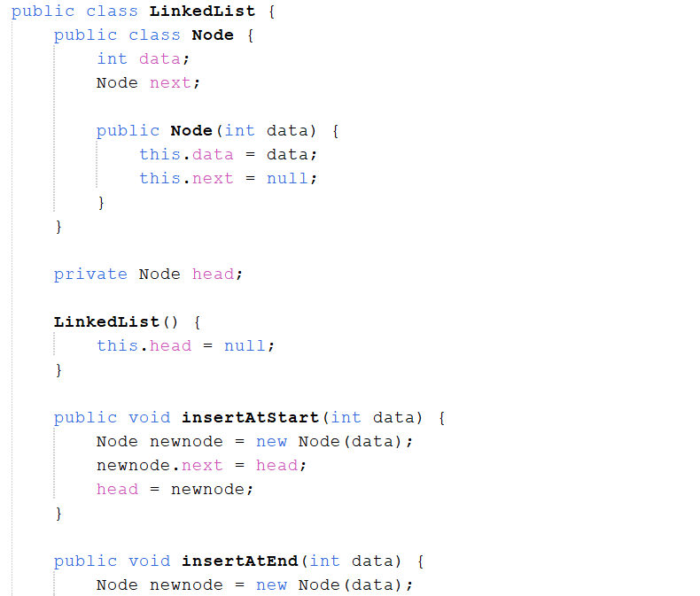

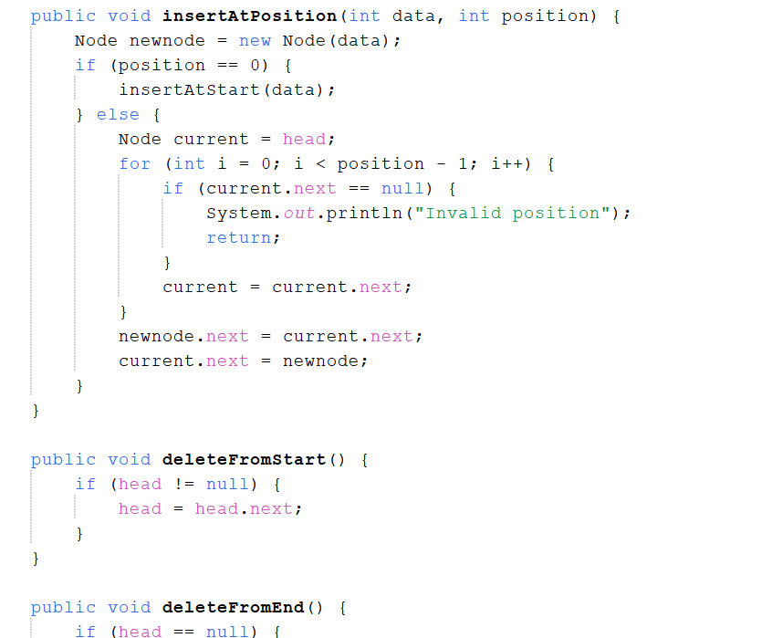

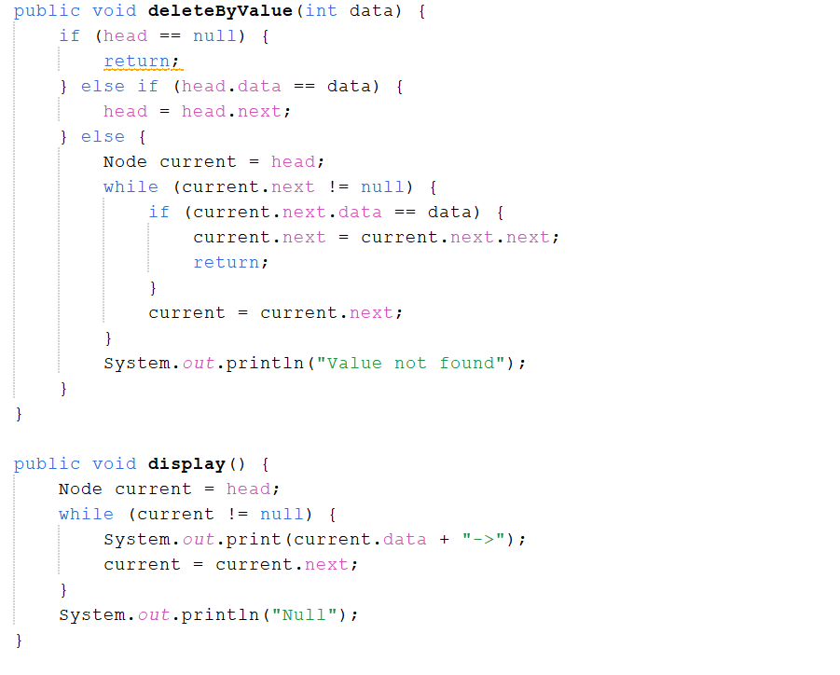

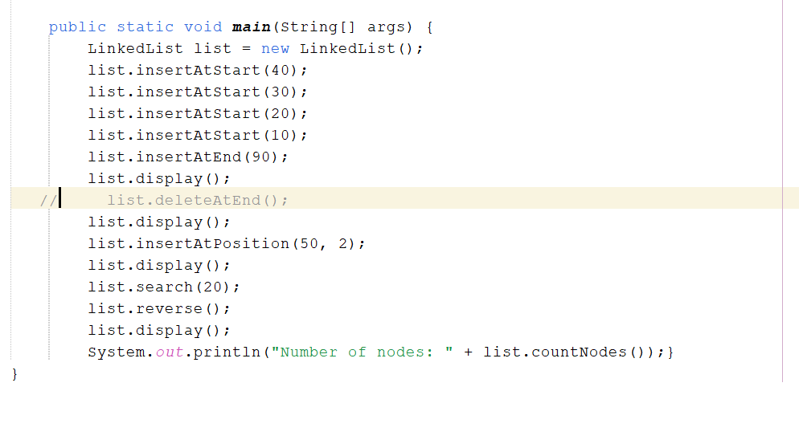

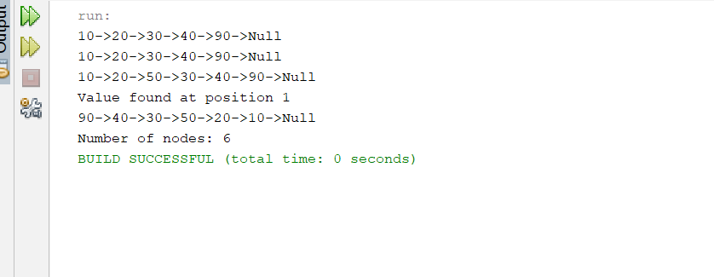

Lab Part 02: LeetCode

Task 01:

[https://leetcode.com/problems/intersection-of-two-linked-lists/description/?envType=problem-](https://leetcode.com/problems/intersection-of-two-linked-lists/description/?envType=problem-list-v2&envId=linked-list) [list-v2&envId=linked-list](https://leetcode.com/problems/intersection-of-two-linked-lists/description/?envType=problem-list-v2&envId=linked-list)

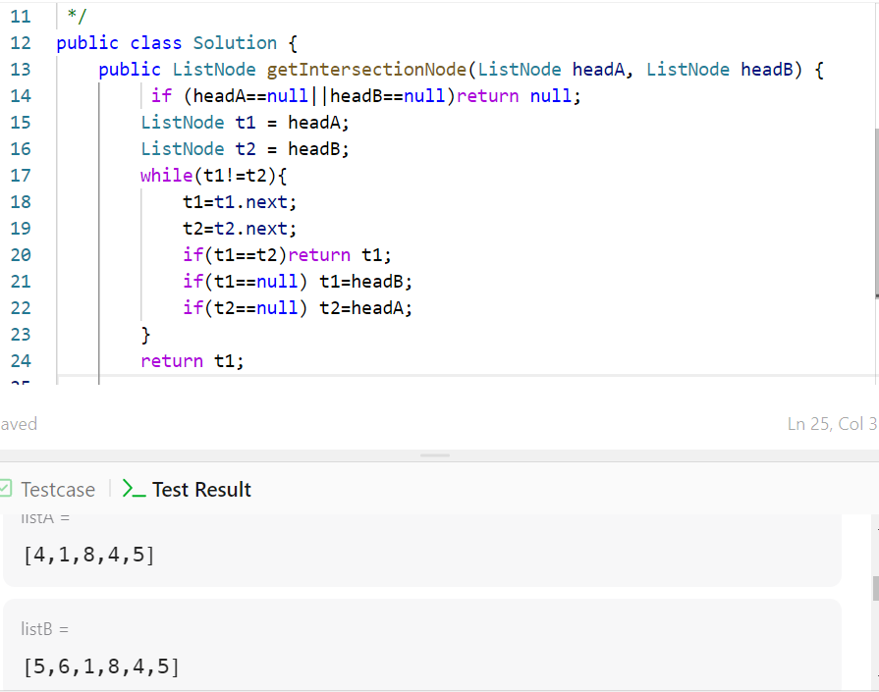

Task 02:

[https://leetcode.com/problems/remove-duplicates-from-sorted-](https://leetcode.com/problems/remove-duplicates-from-sorted-list/description/?envType=problem-list-v2&envId=linked-list) [list/description/?envType=problem-list-v2&envId=linked-list](https://leetcode.com/problems/remove-duplicates-from-sorted-list/description/?envType=problem-list-v2&envId=linked-list)

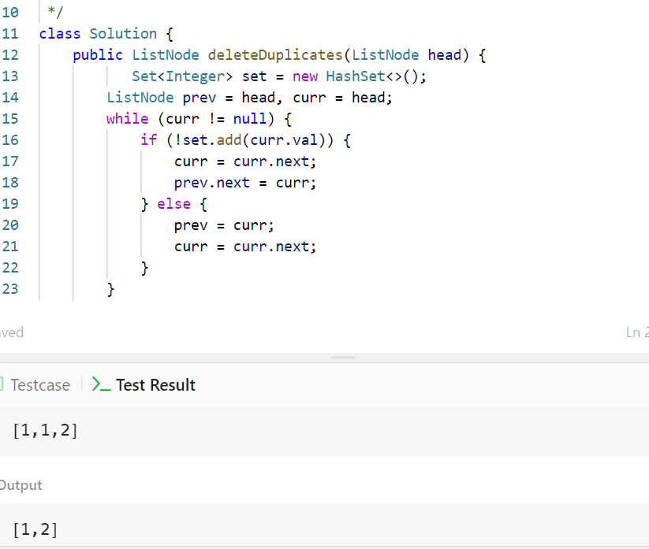

Task 04:

[https://leetcode.com/problems/add-two-numbers/description/?envType=problem-list-](https://leetcode.com/problems/add-two-numbers/description/?envType=problem-list-v2&envId=linked-list) [v2&envId=linked-list](https://leetcode.com/problems/add-two-numbers/description/?envType=problem-list-v2&envId=linked-list)

