Software Requirements Specification

for

Online PCR Tests Booking

at The Department of Electrical and Computer Engineering,

The University of the West Indies

St Augustine Campus

Trinidad

Version 0.1 (Draft)

Prepared by:

Adrian Gookool

Fahad Hosein

Tahj Ramudith

Akshay Seedath

Team Gryffindor

13/09/2021

# Document Control

Title:

Version:

Date:

Author(s):

## Document Signoff

|  |  |  |  |
| --- | --- | --- | --- |
| Nature of Signoff | Person | Signature with Date | Role |
| Author  Reviewees |  |  | Project Manager, Requirements Analyst and Consultant  QA Officer |

## Document Change Record

|  |  |  |  |
| --- | --- | --- | --- |
| Date | Version | Author | Change Details |
| 13 Sept 2021 | 0.0 | Akshay Seedath  Tahj Ramudith  Fahad Hosein  Adrian Gookool | Initial template commit, drafted requirements and project introductions. |
| 22 Sept 2021 | 0.1 | Akshay Seedath  Tahj Ramudith  Adrian Gookool | Added new requirements, changed requirements numbering, revised existing requirements.  Reviewed purpose and product scope sections. Added Product Perspective information. Started Product Functions sections |

# 1. Introduction

## 1.1 Purpose

As of 2020, the world was forced into a pandemic situation due to the rise of COVID-19. As quarantine protocols such as travel and business restrictions are lifted, many persons need to submit a PCR test to engage in these restricted activities. Within Trinidad and Tobago, public health centers operate on a “walk in” basis. This type of operation can cause breaches in COVID-19 health regulations due to the influx of persons entering the health facility at a particular time.

A scheduling type appointment-based web application can aid in managing the number of persons entering the facility for a PCR test. The proposed application not only implements fast and simple scheduling of PCR appointments but also limits the number of persons entering the facility which helps the facility adhere to National health regulations and protocols.

## 1.2 Product Scope

The software system is a web application for online registration and scheduling of a COVID-19 PCR test at a public health center. This software application changes the operation of the health facility to better adhere to health regulations such as social distancing and building personnel limits. It also reduces the number of visits a person makes to the facility as well as optimize its operation. This system is beneficial to a governing body of a country since the PCR test process and data are digitally optimized. This also provides governments with data they can use to perform statistical analyses that can help determine the future state of the country’s economy.

## 1.3 References

# 2. Overall Description

## 2.1 Product Perspective

The software system utilizes a web server that hosts the web-application and relevant database for its operation. The system will be used by the following user classes:

|  |  |
| --- | --- |
| User Class | Description |
| General user | Refers to a regular user of an online application. These users are the ones requesting an appointment. |
| Staff User | Refers to the staff of the facility. Examples are nurses and attending physicians. |
| Admin User | Refers to managerial positions of the facility. Examples are facility directors and health ministers. |

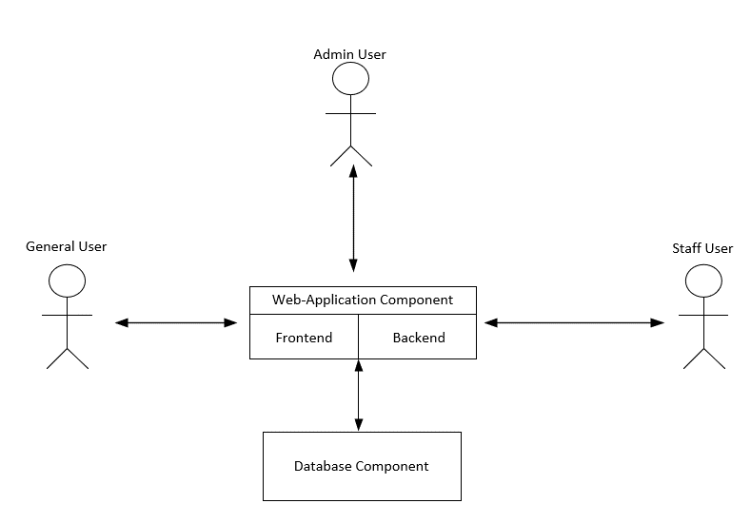

Each user class will have specific functions to mimic the PCR test application process to a health facility. A description of these functions is defined in Section 2.2 of this document.

## 2.2 Product Functions

The system mainly supports these functions for the following user classes:

|  |  |
| --- | --- |
| User Class | Function Description |
| Admin User | These types of users will have total control of the system. These users should:   * View, edit and delete all data pertaining to the system * Can create, delete and change the properties and functionality of the data in the other two user classes |
| Staff User | These users should:   * Only view the data created by the general user class * Update specific data entries related to the general user class |
| General User | These users should: |

# 3. External Interface Requirements

# 4. Specific Requirements

Requirements are given priority flags in the order of highest to lowest from: Necessary, Highly Desirable then Desirable. Priority labelled ‘Removed’ means the requirement was removed from the current implementation of the project because it was unverifiable due to constraints or cannot be implemented in the initial version of the product.

4.1

<about>  
  
4.1.1 Functional Requirements

|  |  |  |
| --- | --- | --- |
| Label | Requirement | Priority |
| Sys.classes | The system will have three user classes: ‘admin user’, ‘staff user’ and ‘general user’. | Necessary |
| Sys.forms | All submitted PCR test forms will be added to a database. | Necessary |
| Sys.queue | System will add newly submitted forms to the end of a queue for admin and staff user approval. | Highly Desirable |
| Sys.app | The system will have a log of all appointments for admin and staff viewing. | Necessary |
| Sys.instruct | The system will have a dynamically changing web-page dedicated to instructions of usage for a specific user class. | Desirable |
| Gu.account | General users will be able to make an account or log in to a pre-existing one. | Necessary |
| Gu.submit | General users will be able to complete and submit PCR test forms prior to booking. | Necessary |
| Gu.app | General users will be able to view available dates for appointment dates | Desirable |
| Gu.booking | General users will be able to request appointments for PCR tests | Necessary |
| Gu.log | General users will have access to a log that contains all their appointments, upcoming and previous. | Highly Desirable |
| Gu.reminder | General users will be sent notifications their upcoming appointments via email. | Desirable |
| Gu.results | General users will be sent email notification to indicate available results. | Desirable |
| Au.app | Admin users will be able to make and change upcoming appointment dates | Necessary |
| Su.forms | Staff user will be able to retrieve submitted PCR test forms. | Necessary |

4.1.2 Non-functional requirements

|  |  |  |
| --- | --- | --- |
| Label | Requirement | Priority |
| Au.info | User information will be secure and only accessible and modifiable by system admins. | Necessary |
| Au.training | System admins will be able to use all system functions after four hours of training. | Removed |
| Su.app | The ‘staff’ user class will only be able to view the appointments but cannot alter the data in it. | Highly  Desirable |
| Sys.centers | General users will be able to make appointments at all centers which provide PCR tests. | Desirable |
| Sys.mobile | The web application will have a mobile format for use on mobile browsers. | Desirable |