Software Requirements Specification

for

Online PCR Tests Booking Platform

at The Department of Electrical and Computer Engineering,

The University of the West Indies

St Augustine Campus

Trinidad

Version 1.1

Prepared by:

Adrian Gookool

Fahad Hosein

Tahj Ramudith

Akshay Seedath

Raefer Gopaul

Team Gryffindor

13/09/2021

# Document Control

Title: Online PCR tests Booking Platform

Version: 1.1

Date: 12/11/2021

Author(s): Adrian Gookool, Tahj Ramudith, Akshay Seedath, Fahad Hosein, Raefer Gopaul

## Document Signoff

|  |  |  |  |
| --- | --- | --- | --- |
| Nature of Signoff | Person | Signature with Date | Role |
| Author  Reviewees | Adrian Gookool, Tahj Ramudith, Fahad Hosein, Akshay Seedath, Raefer Gopaul |  | Project Manager, Product Manager, Configuration Manager,  Risk Officer, Human Resource Officer |

## Document Change Record

|  |  |  |  |
| --- | --- | --- | --- |
| Date | Version | Author | Change Details |
| 13 Sept 2021 | 0.0 | Akshay Seedath  Tahj Ramudith  Fahad Hosein  Adrian Gookool | * Initial template commit * Drafted requirements and project introductions. |
| 22 Sept 2021 | 0.1 | Akshay Seedath  Tahj Ramudith  Adrian Gookool | * Added new requirements * Changed requirements numbering * Revised existing requirements. * Reviewed purpose and product scope sections. Added Product Perspective information * Started Product Functions section |
| 30 Sept 2021 | 1.0 | Adrian Gookool  Fahad Hosein  Akshay Seedath  Tahj Ramudith | * Moved Use-case diagram to section 1.2 * Created the context diagram and top-level dataflow diagram. * Added content for external interface requirements * Refined requirements for handling of submissions and admin functionality. |
| 12 Nov 2021 | 1.1 | Adrian Gookool | * Removed and modified requirements for Scope Reduction of staff requirements |

# 1. Introduction

## Purpose

As of 2020, the world was forced into a pandemic situation due to the rise of COVID-19. As quarantine protocols such as travel and business restrictions are lifted, many persons need to submit a PCR test to engage in these restricted activities. Within Trinidad and Tobago, public health centers operate on a “walk in” basis. This type of operation can cause breaches in COVID-19 health regulations due to the influx of persons entering the health facility at a particular time.

A scheduling type appointment-based web application can aid in managing the number of persons entering the facility for a PCR test. The proposed application not only implements fast and simple scheduling of PCR appointments but also limits the number of persons entering the facility which helps the facility adhere to National health regulations and protocols.

## Product Scope

Figure 1: Use-Case Diagram

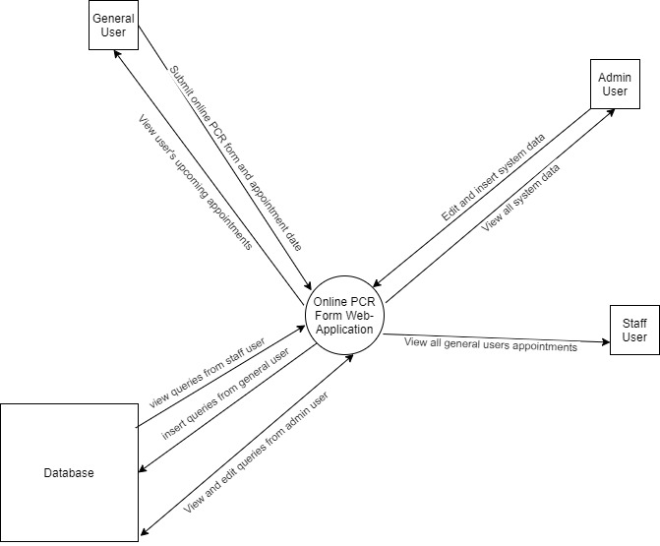

Figure 2: Context Diagram of System

The software system is a web application for online registration and scheduling of a COVID-19 PCR test at a public health center. Figures one and two outlines they key components and users of the system. This software application changes the operation of the health facility to better adhere to health regulations such as social distancing and building personnel limits. It also reduces the number of visits a person makes to the facility as well as optimize its operation. This system is beneficial to a governing body of a country since the PCR test process and data are digitally optimized. This also provides governments with data they can use to perform statistical analyses that can help determine the future state of the country’s economy.

## References

Government of the Republic of Trinidad and Tobago. 2021. *Test for Take-Off! Book and pay for COVID-19 tests with Caribbean Airlines.* March 26. http://www.news.gov.tt/content/test-take-book-and-pay-covid-19-tests-caribbean-airlines#.YVX7AZrMJjU.

M. Hamel-Smith & Co. 2021. "COVID-19 VACCINES IN THE WORKPLACE: A SECOND JAB." *trinidadlaw.* August 1. Accessed September 30, 2021. http://trinidadlaw.com/covid-19-vaccines-in-the-workplace-a-second-jab/.

# Overall Description

## Product Perspective

The software system utilizes a web server that hosts the web-application and relevant database for its operation. The system will be used by the following user classes:

|  |  |
| --- | --- |
| User Class | Description |
| General user | Refers to a regular user of an online application. These users are the ones requesting an appointment. |
| Admin User | Refers to managerial positions of the facility. Examples are hospital network administrators, facility directors and health ministers. |

Each user class will have specific functions to mimic the PCR test application process to a health facility. A description of these functions is defined in Section 2.2 of this document.

## Product Functions

The system mainly supports these functions for the following user classes:

|  |  |
| --- | --- |
| User Class | Function Description |
| Admin User | These types of users will have total control of the system. These users should:   * View, edit and delete all data pertaining to the system * Can create, delete, and change the properties and functionality of the data in the other two user classes |
| General User | These types of users are regular citizens of a country. These users should:   * Sign up for an account if not registered on the system. * Login into the system if account is valid user of the system. * Schedule an appointment date for PCR test at a particular health facility * Fill out a web-based form that mimics the hardcopy PCR test application form. * Be notified of upcoming appointments. |

An overview of these key functions is presented in the Top-level dataflow Diagram shown below.

Figure 3: Top-level Dataflow Diagram

# External Interface Requirements

## User Interfaces

The system will interface through a Graphical User Interface (GUI) within a web browser application. This interface is utilized by all three user classes for interaction between the user and the software. The GUI will be designed using Hypertext Markup Language (HTML) and Cascading Style Sheets (CSS). The system will display content depending on the user class currently logged in, i.e., admin and staff users will be able to view all submitted forms, whereas general users will be able to submit a form and view their responses to that form.

## Hardware Interfaces

An internet connection will be required to allow the software interface to access the application through the worldwide web.

## Software Interfaces

Any web browser capable of remotely accessing the website will be required (e.g., Google Chrome, Microsoft Edge, Mozilla Firefox, Apple Safari, Opera, etc.)

## Communications Interfaces

The system will utilize the e-mails using the Simple Mail Transfer Protocol (SMTP) or text messages using the Short Messages Services (SMS) Protocol. These will serve to notify the general user of any changes regarding their appointments, and results of those appointments, and will notify the admin and staff users of any new appointments submitted.

# Specific Requirements

Requirements are given priority flags in the order of highest to lowest from: Necessary, Highly Desirable then Desirable. Priority labelled ‘Removed’ means the requirement was removed from the current implementation of the project because it was unverifiable due to current constraints or cannot be implemented in the initial version of the product.

## Requirements

### Functional Requirements

|  |  |  |
| --- | --- | --- |
| Label | Requirement | Priority |
| Sys.classes | The system will have two user classes: ‘admin user’ and ‘general user’ | Necessary |
| Sys.forms | All submitted PCR test forms will be added to a database | Necessary |
| Sys.queue | System will add newly submitted forms to the end of a queue | Highly Desirable |
| Sys.app | The system will have a log of all appointments for admin viewing | Necessary |
| Sys.instruct | The system will have a dynamically changing webpage dedicated to instructions of usage for a specific user class. | Highly Desirable |
| Gu.account | General users will be able to make an account or log in to a pre-existing one | Necessary |
| Gu.submit | General users will be able to complete and submit PCR test forms prior to booking | Necessary |
| Gu.app | General users will be able to view available dates for appointment dates | Desirable |
| Gu.booking | General users will be able to request appointments for PCR tests | Necessary |
| Gu.log | General users will have access to a log that contains all their appointments, upcoming and previous | Highly Desirable |
| Gu.reminder | General users will be sent notifications of their upcoming appointments via email | Desirable |
| Gu.results | General users will be sent email notification to indicate available results | Desirable |
| Au.app | Admin users will be able to change and cancel appointments | Necessary |
| Au.dates | Admin users will be able to make and change available dates. | Necessary |
| Au.approve | Admin users will have access to the queue and will be able to approve submissions and appointments | Necessary |
| Au.admin | Admin users will be able to create the general class users | Highly Desirable |
| Su.forms | Admin user will be able to retrieve submitted PCR test forms | Necessary |
| Su.approve | Admin users will have access to the queue and will be able to approve submissions and appointments | Necessary |

### Non-functional requirements

|  |  |  |
| --- | --- | --- |
| Label | Requirement | Priority |
| Au.info | User information will be secure and only accessible and modifiable by system admins | Necessary |
| Au.training | System admins will be able to use all system functions after four hours of training | Removed |
| Sys.centers | General users will be able to make appointments at all centers which provide PCR tests | Desirable |
| Sys.mobile | The web application will have a mobile format for use on mobile browsers | Desirable |
| Sys.classes | The system will have three user classes: ‘admin user’, ‘staff user’ and ‘general user’ | Modified (Scope Reduction) |
| Sys.app | The system will have a log of all appointments for admin and staff viewing | Modified (Scope Reduction) |
| Su.forms | Staff user will be able to retrieve submitted PCR test forms | Modified (Scope Reduction) |
| Su.approve | Staff users will have access to the queue and will be able to approve submissions and appointments | Modified (Scope Reduction) |