User Requirements Specification

for

Online PCR Tests Booking

at The Department of Electrical and Computer Engineering,

The University of the West Indies

St Augustine Campus

Trinidad

Version 1.0

Prepared by:

Tahj Ramudith

Gryffindor

18/09/21

# Document Control

Title: User Requirements Specification

Version: 1.0

Date: 30 Sept 2021

Author(s): Tahj Ramudith

## Document Signoff

|  |  |  |  |
| --- | --- | --- | --- |
| Nature of Signoff | Person | Signature with Date | Role |
| Author  Reviewees | Tahj Ramudith  Akshay Seedath  Adrian Gookool |  | Product Manager  Risk Officer  Project Manager |

## Document Change Record

|  |  |  |  |
| --- | --- | --- | --- |
| Date | Version | Author | Change Details |
| 18 Sept 2021  29 Sept 2021  30 Sept 2021 | Draft  0.0  1.0 | Tahj Ramudith  Tahj Ramudith  Tahj Ramudith | Initial template commit, Defined Users  Defined User Requirements  Added Use case diagrams for each user and updated requirements |

# User Classes

USR1. General User – Person completing and submitting PCR test form.

USR2. Staff User – Regular staff personnel to view appointments and retrieve submitted forms

USR3. Admin User – To monitor and maintain the system and database.

# Specific Use Cases Identified

## USR1. General User (GU)

Gu.account General users will be able to make an account or log in to a pre-existing one.

Gu.submit General users will be able to complete and submit PCR test forms prior to booking.

Gu.app General users will be able to view available dates for appointment dates.

Gu.booking General users will be able to request appointments for PCR tests.

Gu.log General users will have access to a log that contains all their appointments, upcoming and previous.

Gu.reminder General users will be sent notifications their upcoming appointments via email.

Gu.results General users will be sent email notification to indicate available results.

## USR2. Staff User (SU)

Su.forms Staff user will be able to retrieve submitted PCR test forms.

Su.app The ‘staff’ user class will only be able to view the appointments but cannot alter the data in it.

Su.approve Staff users will have access to the queue and will be able to approve submissions and appointments.

## USR3. Admin User (AU)

Au.app Admin users will be able to change and cancel appointments.

Au.dates Admin users will be able to make and change available dates.

Au.admin Admin Users will be able to create staff user accounts.

Au.info User information will be secure and only accessible and modifiable by system admins.

Au.approve Admin users will have access to the queue and will be able to approve submissions and appointments.

# Appendix - Models created

## General User - Use Case Diagram

Model author: Tahj Ramudith

Persons present/reviewed by: Akshay Seedath, Adrian Gookool

Date drawn: 30/09/21

## Staff User - Use Case Diagram

Model author: Tahj Ramudith

Persons present/reviewed by: Akshay Seedath, Adrian Gookool

Date drawn: 30/09/21

## Admin User - Use Case Diagram

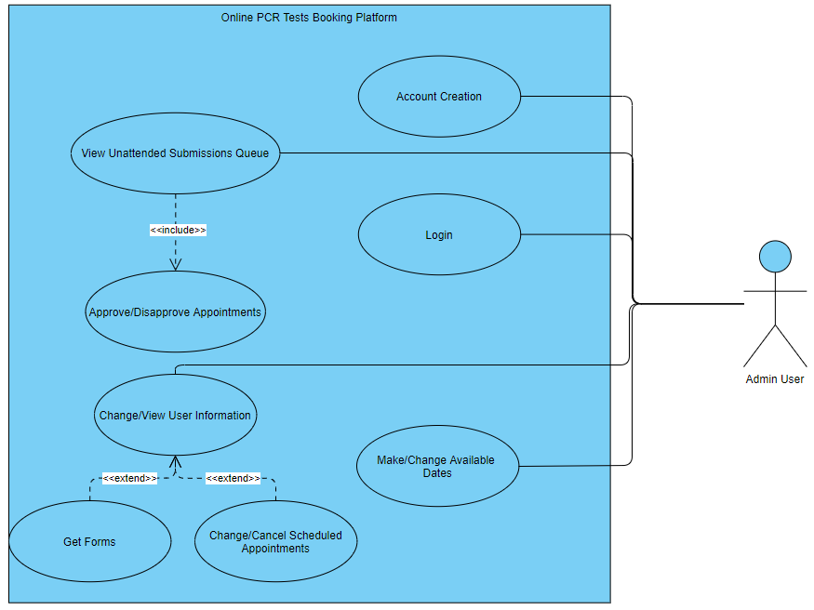

Model author: Tahj Ramudith

Persons present/reviewed by: Akshay Seedath, Adrian Gookool

Date drawn: 30/09/21