User Requirements Specification

for

Online PCR Tests Booking

at The Department of Electrical and Computer Engineering,

The University of the West Indies

St Augustine Campus

Trinidad

Version 1.1

Prepared by:

Tahj Ramudith

Gryffindor

18/09/21

# Document Control

Title: User Requirements Specification

Version: 1.1

Date: 10 Oct 2021

Author(s): Tahj Ramudith

## Document Signoff

|  |  |  |  |
| --- | --- | --- | --- |
| Nature of Signoff | Person | Signature with Date | Role |
| Author  Reviewees | Tahj Ramudith  Akshay Seedath  Adrian Gookool |  | Product Manager  Risk Officer  Project Manager |

## Document Change Record

|  |  |  |  |
| --- | --- | --- | --- |
| Date | Version | Author | Change Details |
| 18 Sept 2021  29 Sept 2021  30 Sept 2021  10 Oct 2021 | Draft  0.0  1.0  1.1 | Tahj Ramudith  Tahj Ramudith  Tahj Ramudith  Tahj Ramudith | Initial template commit, Defined Users  Defined User Requirements  Added Use case diagrams for each user and updated requirements  Removed Staff user to align with changes in requirements |

# User Classes

USR1. General User – Person completing and submitting PCR test form.

USR2. Admin User – To monitor and maintain the system and database.

# Specific Use Cases Identified

## USR1. General User (GU)

Gu-UC1 General users will be able to make an account or log in to a pre-existing one.

Gu-UC2 General users will be able to complete and submit PCR test forms prior to booking.

Gu-UC3 General users will be able to view available dates for appointment dates.

Gu-UC4 General users will be able to request appointments for PCR tests.

Gu-UC5 General users will have access to a log that contains all their appointments, upcoming and previous.

## USR2. Admin User (AU)

Au-UC1 Admin users will be able to change and cancel appointments.

Au-UC2 Admin users will be able to make and change available dates.

Au-UC3 Admin Users will be able to create staff user accounts.

Au-UC4 User information will be secure and only accessible and modifiable by system admins.

Au-UC5 Admin users will have access to the queue and will be able to approve submissions and appointments.

# Appendix - Models created

## General User - Use Case Diagram

Model author: Tahj Ramudith

Persons present/reviewed by: Akshay Seedath, Adrian Gookool

Date drawn: 30/09/21

## Admin User - Use Case Diagram

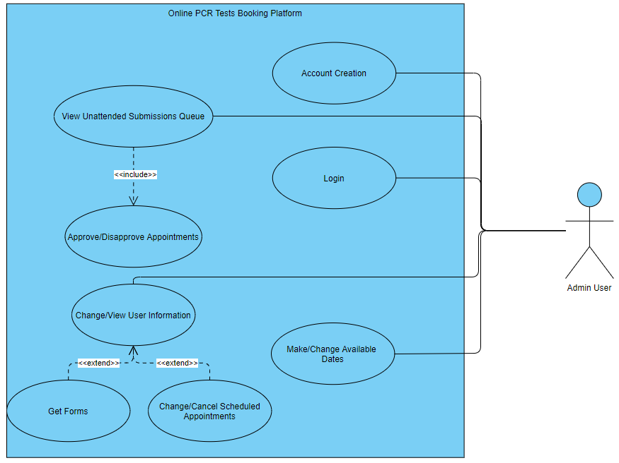

Model author: Tahj Ramudith

Persons present/reviewed by: Akshay Seedath, Adrian Gookool

Date drawn: 30/09/21