Module 4

IDS Lab


Instructor
Dr. Khawaja Qasim

Submitted by
03-134221-057 |  | Khawaja Fahad Zia

Bachelor of Science in Computer Science
Department of Computer Sciences

Bahria University Lahore Campus
September 2025
Activity 1- Defining Tables
Data model is a conceptual view of data elements and include tables, columns and relationships between tables
Import manufacturing_data.csv and make sure to select “Transform Data” instead of “Load”
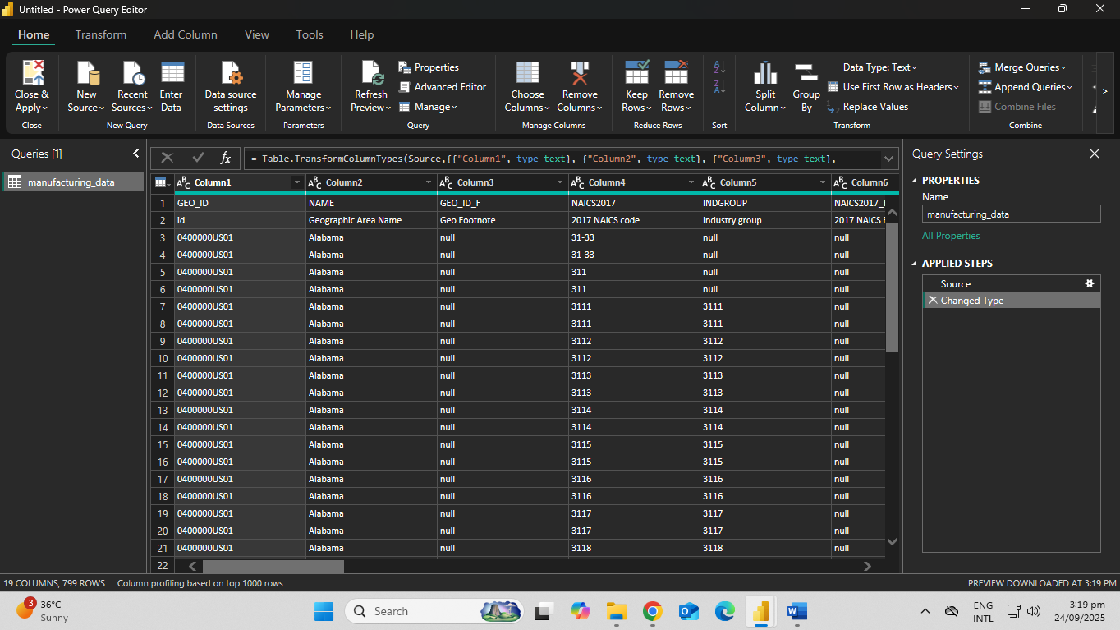
Remove the first row, promote the new first row to become headers
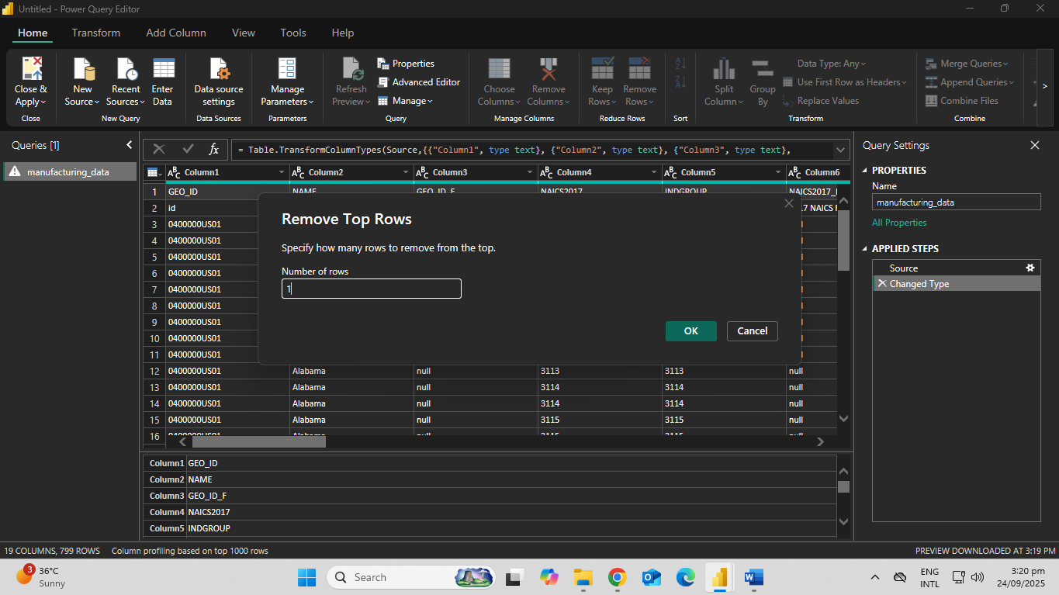
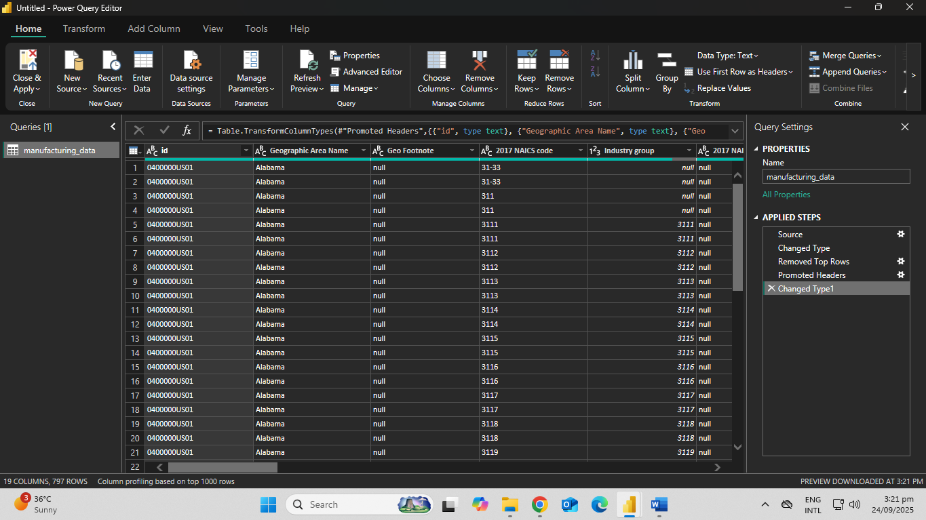
Change the data type of the Year column to become a Date
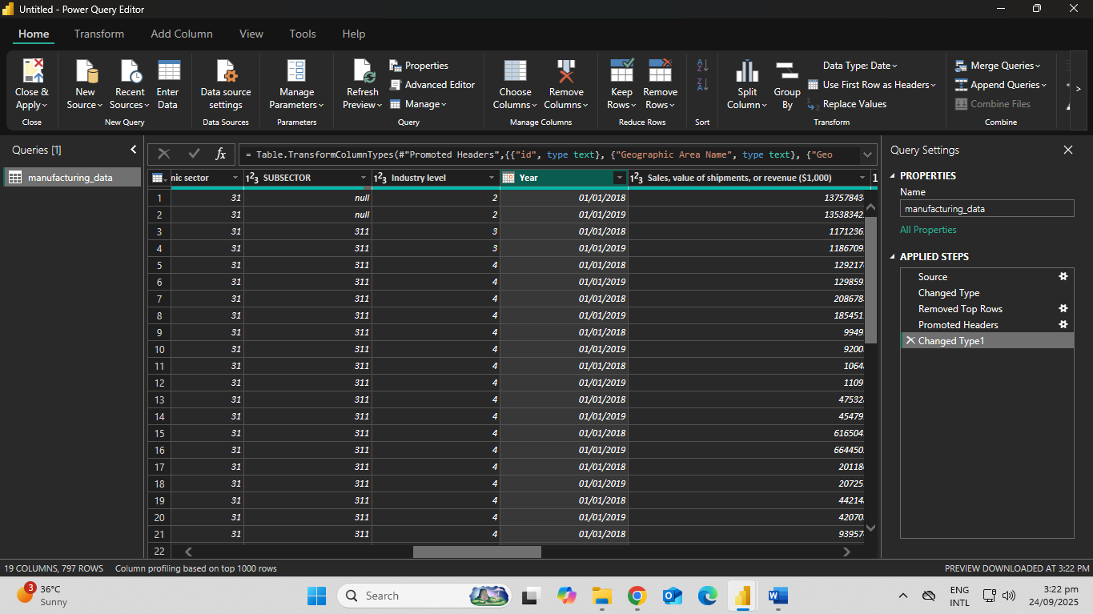
What is the value for the first row of the Year column?
01/01/2018
Navigate to the Sales, value of shipments, or revenue ($1,000) column and use the Transform menu take the square root of this value
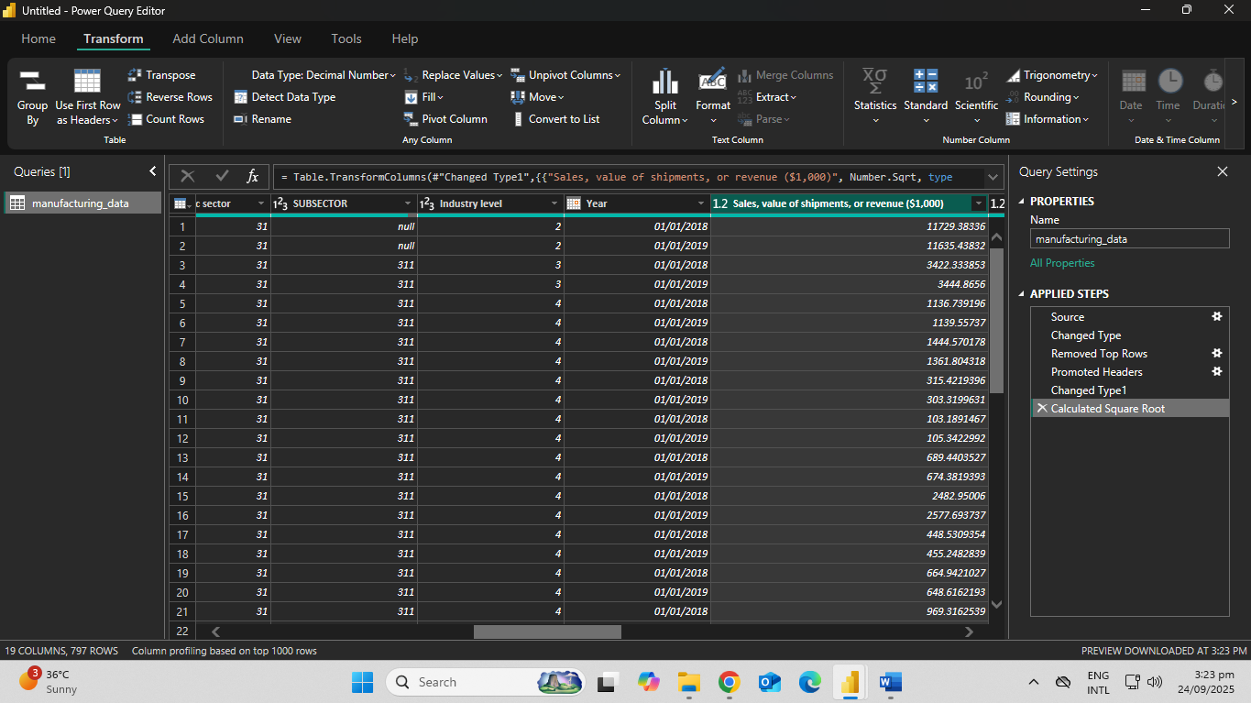
US Census Bureau informed us that a data loading error occurred in Annual payroll ($1,000). It seems that the value “13356360” needs to be “1335636” instead. Replace the appropriate values.
Confirm and save your data modeling changes and return to Power BI
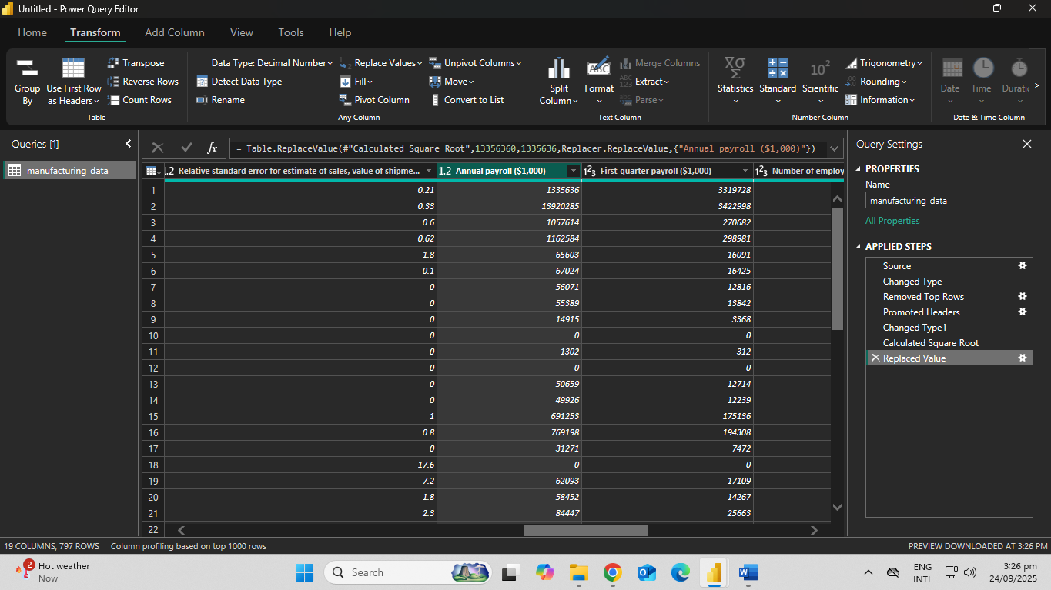

Go to the Table view. You are asked to investigate “Aerospace product and parts manufacturing”, which can be found in the Meaning of NAICS code column.
Sort the 2017 NAICS Code column by Meaning of NAICS code and then sort it in ascending order.
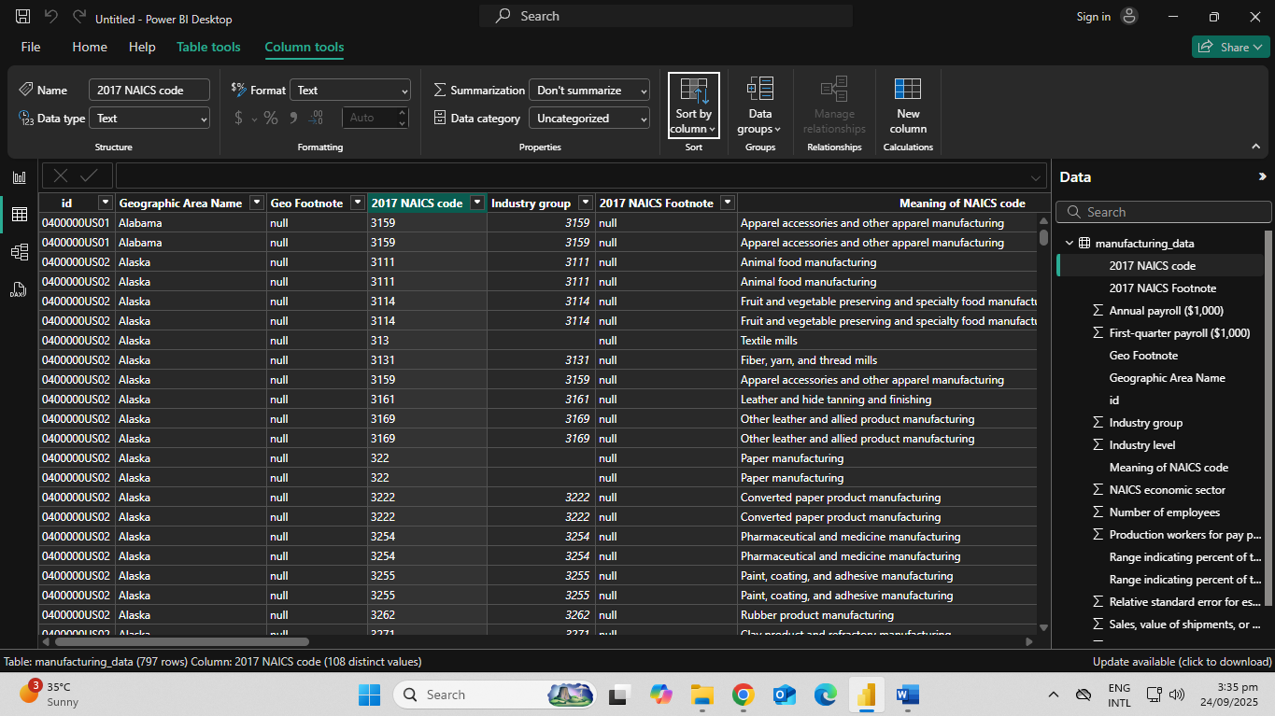
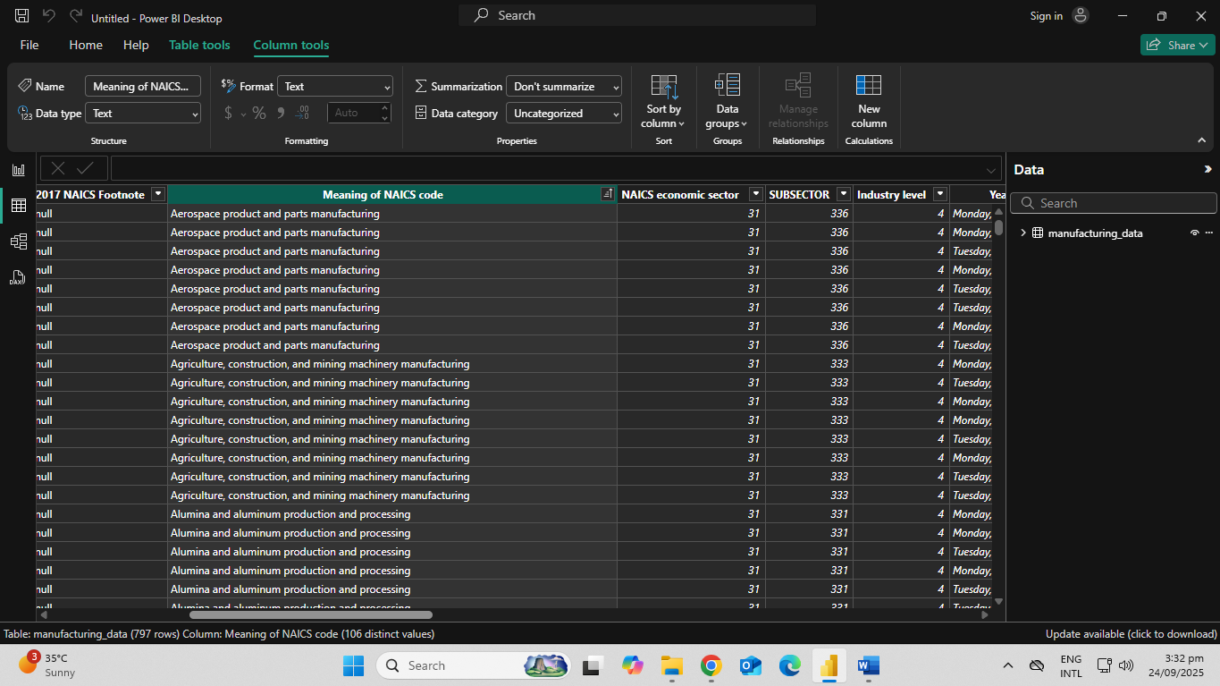

Change the number of decimal places of the Sales, value of shipments, or revenue ($1,000) column to one decimal place
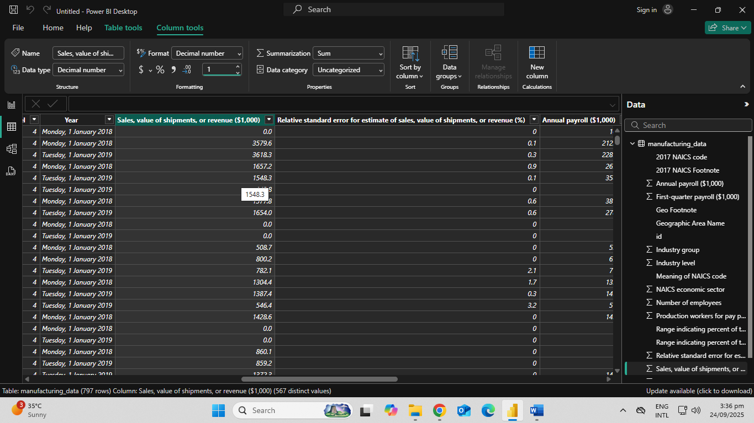
What is the first value of the “Sales, value of shipments, or revenue” column for “Aerospace product and parts manufacturing”?
0.0
Overview of the average number of employees working in manufacturing per state, and you decide to show this on a map
Open 1_3_additional_properties.pbix
Go the Table view, go there and change the data category for the Geographic Area Name to “State or Province”
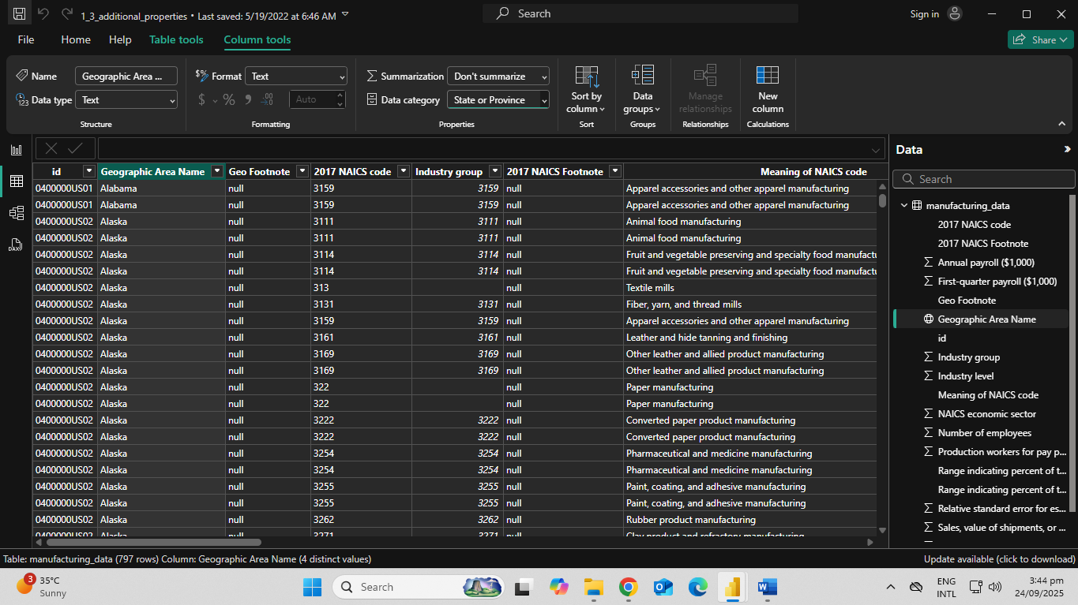
Select the empty 2017 NAICS Footnote column and hide it from the report view
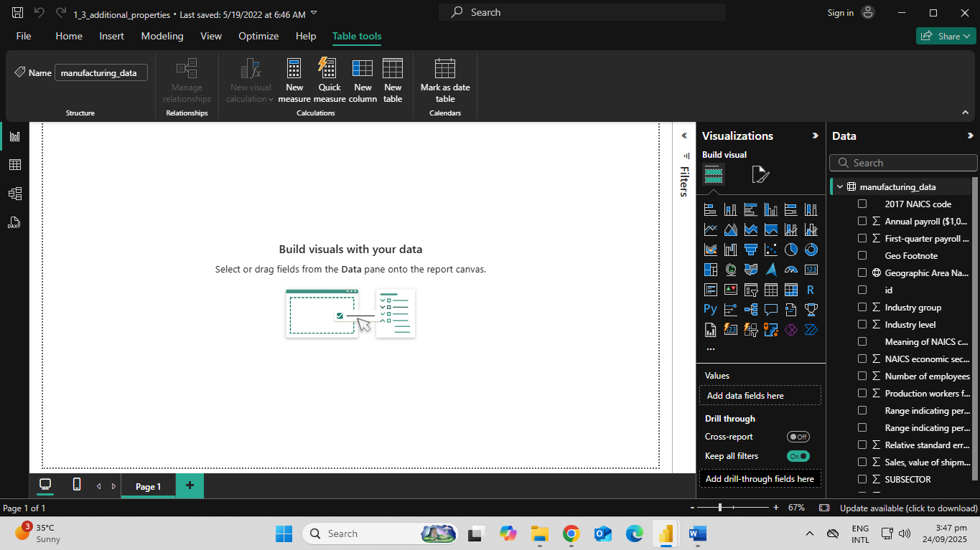
Navigate to the Report view and add a Map visual to the current page. Add Geographic Area Name as the Location and Number of employees as the size.
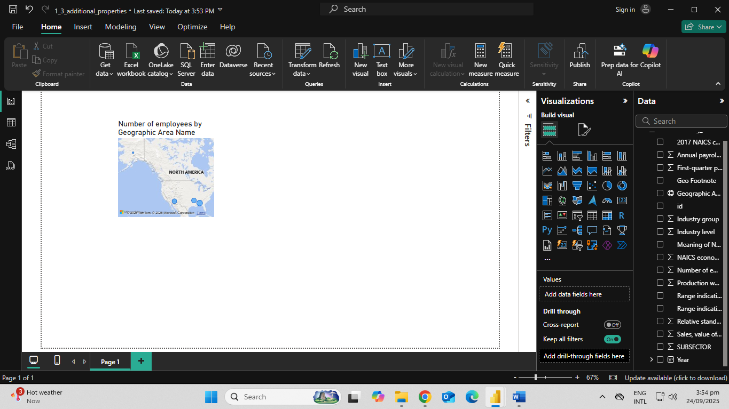
Change the aggregation of Number of employees to “Average”
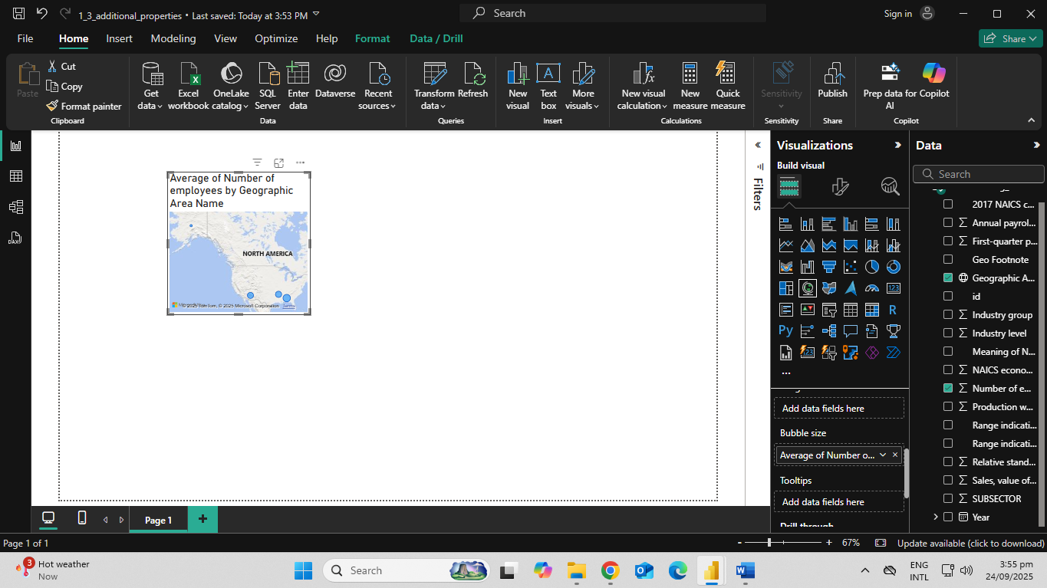
How many employees were there on average over all NAICS codes for the state of Alabama?
7074.56
Add a filter for NAICS code, to easily drill down per industry
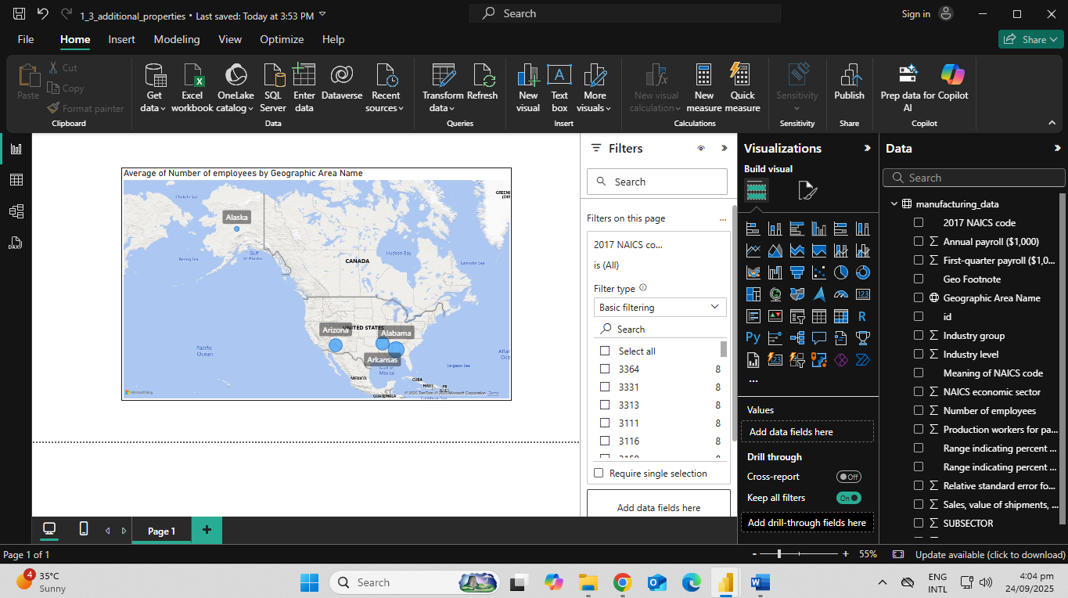
Open 1_4_formatting.pbix
Return to Power Query and change the casing of the Meaning of NAICS Code column to “Capitalize Each Word”. Then change the casing of the Geographic Area Name column to “UPPERCASE”
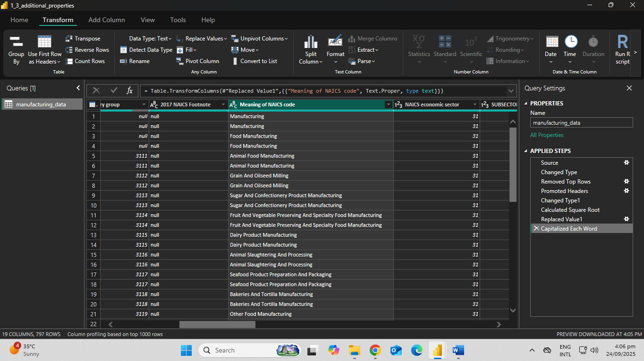
On the 2017 NAICS code column add a prefix of “MANU-“ before each value
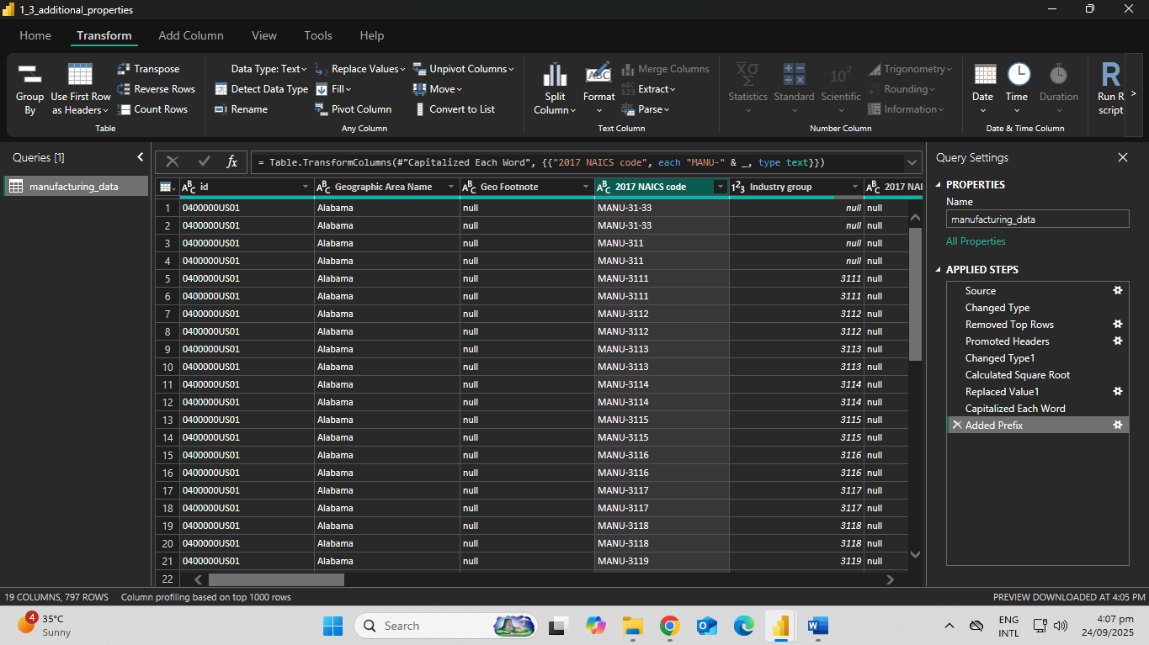
Apply the changes and return to the Report view
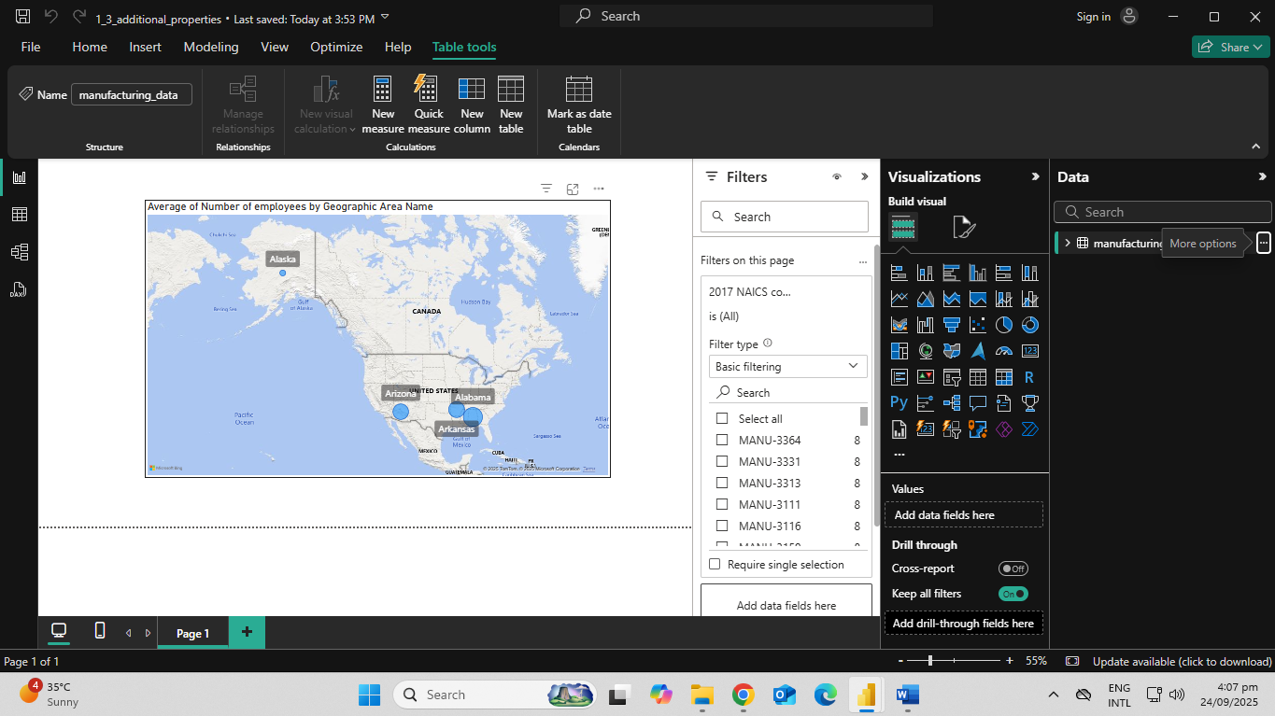
Add a slicer and use 2017 NAICS code as the Field
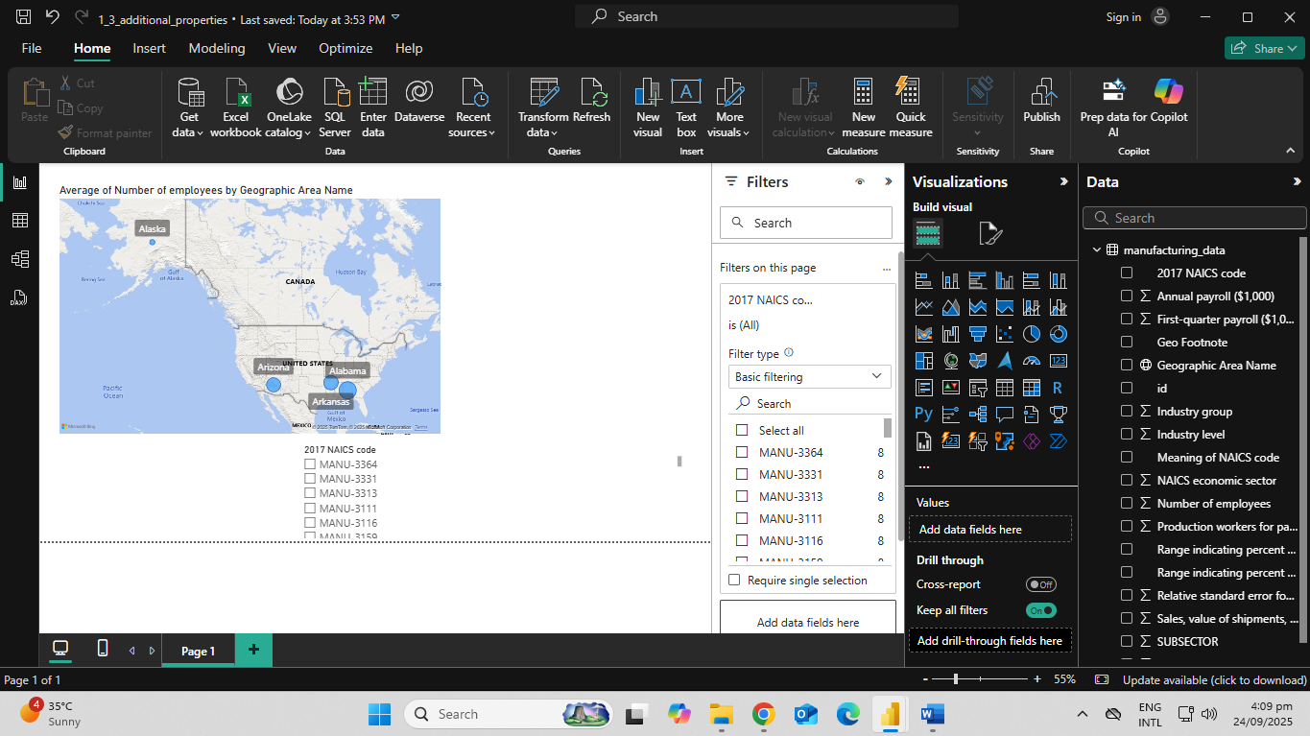
On average, how many employees worked in the manufacturing industry code MANU-3121 in Alaska?
463.50
Activity 2 - Shaping Tables
Database normalization
A set of logical rules and processes to follow for data modeling
Organizing a database
Goals of normalization to remove redundant data
Achieve a design which is a good representation of the real world
Tables are connected through relationships in Power BI
Data Shaping in Power Query
Power Query includes several data shaping operations to get closer to a normalized data model.
Key techniques:
Column splitting
Column extraction
Query merging
Query appending
Open 2_1_split_table.pbix
In power query editor, duplicate the Manufacturing Data table and rename it to NAICS
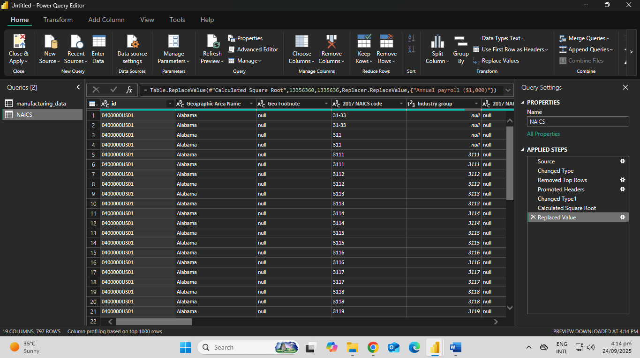
In this new NAICS table, keep only 2017 NAICS code and Meaning of NAICS code.
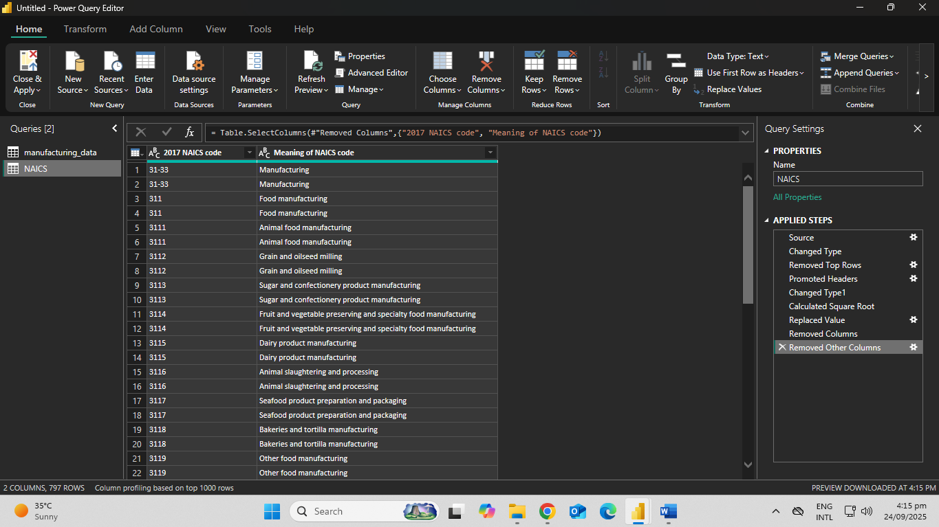
Remove the duplicate codes from 2017 NAICS code
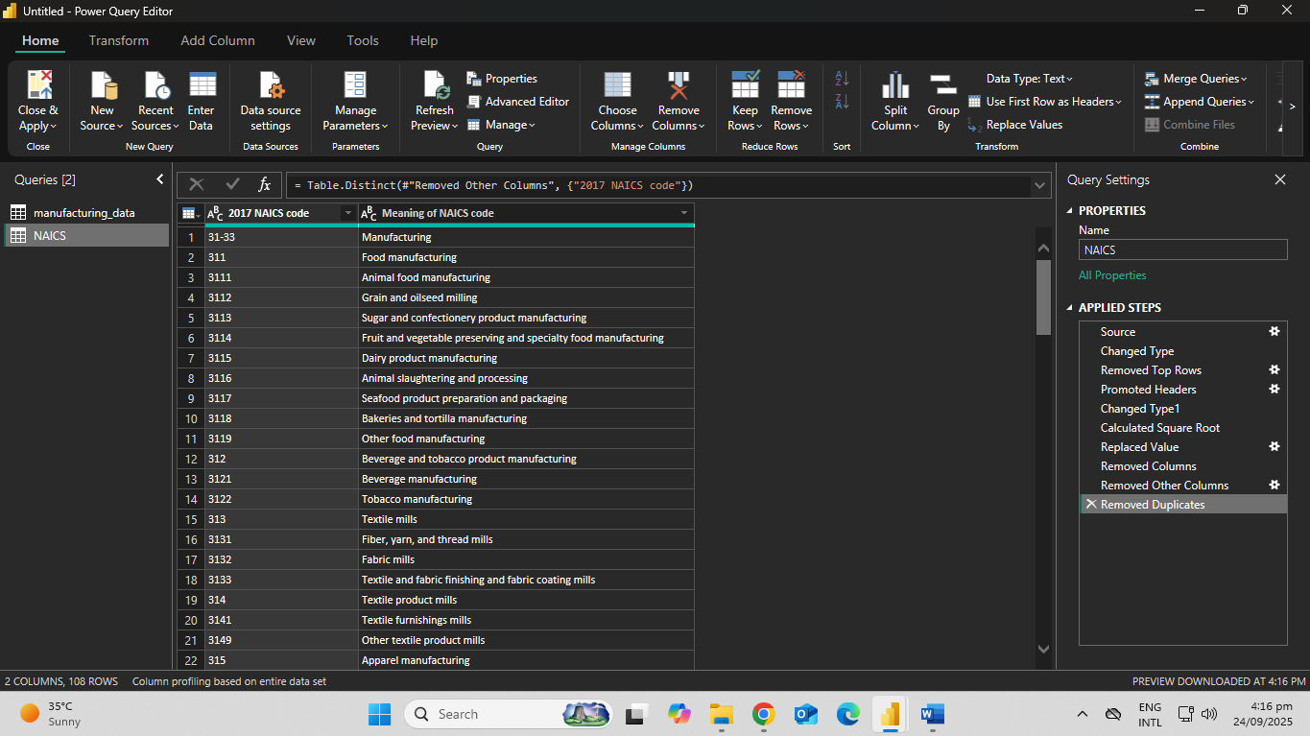
Which “Meaning of NAICS code” is shown on the 4th row of the NAICS table
3112
Within Power Query, load
Timeseries_1979.csv, Timeseries_1980.csv, Timeseries_1981.csv
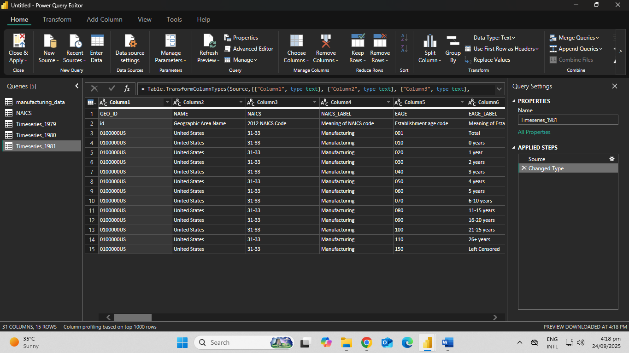
For each of the tables you just loaded, remove the first row and use the new first row as headers
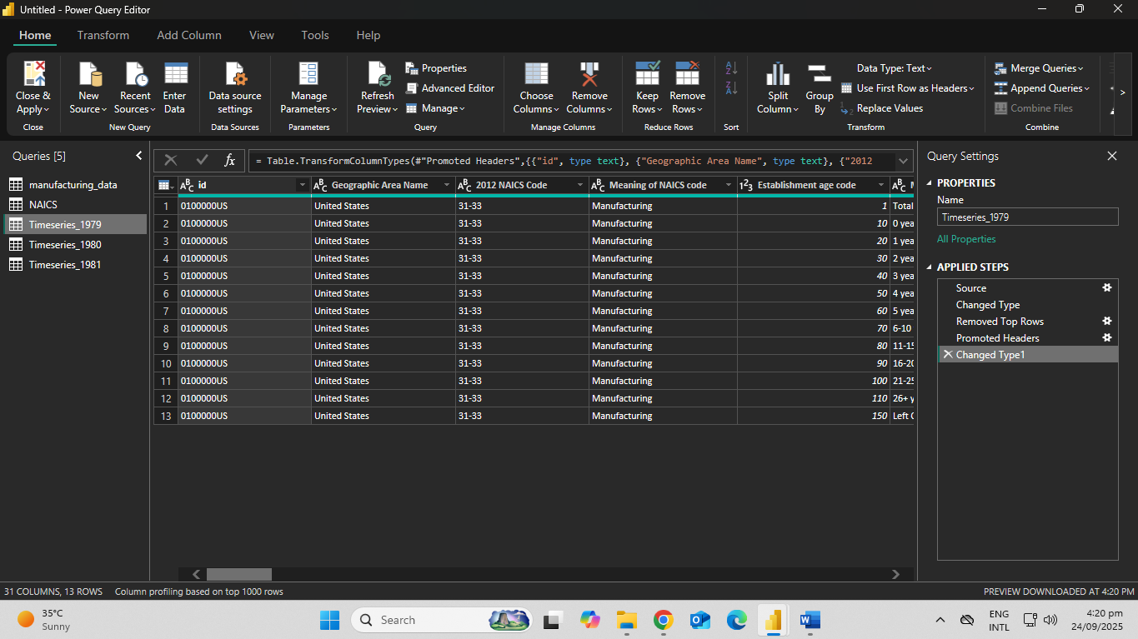
Create a new table, called Establishments by Age with all of the Timeseries_19XX tables appended
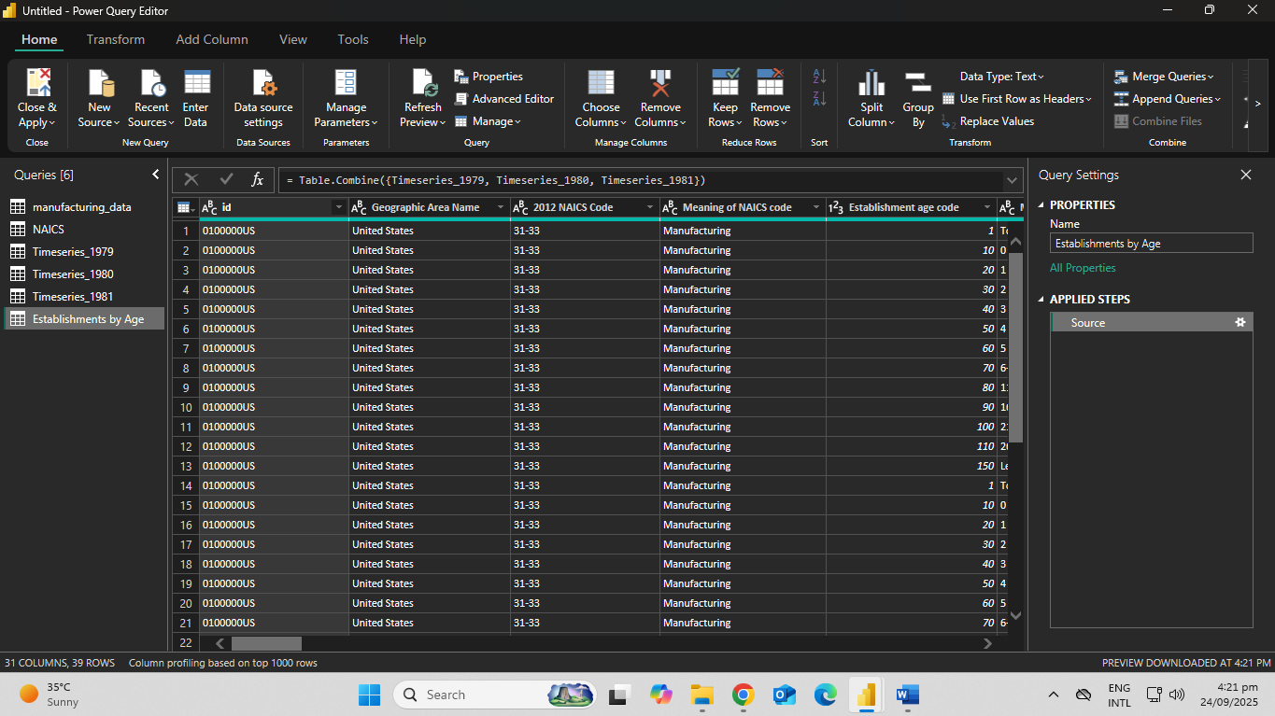
Apply the Power Query changes and return to the Report view in Power BI. Hide all separate Timeseries_19XX tables
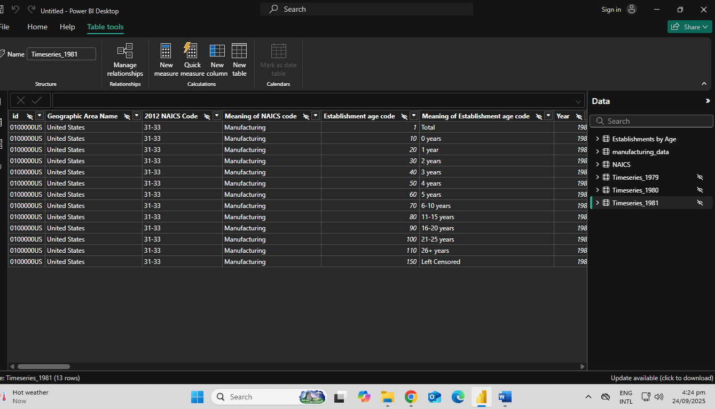
Create a Clustered bar chart visual. From the Establishments by Age table use the Number of employees as X Axis and Meaning of Establishment age code for Y Axis
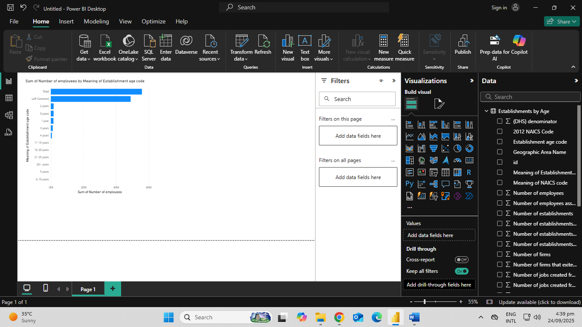
How many employees were hired at firms which had existed for two years?
1731337
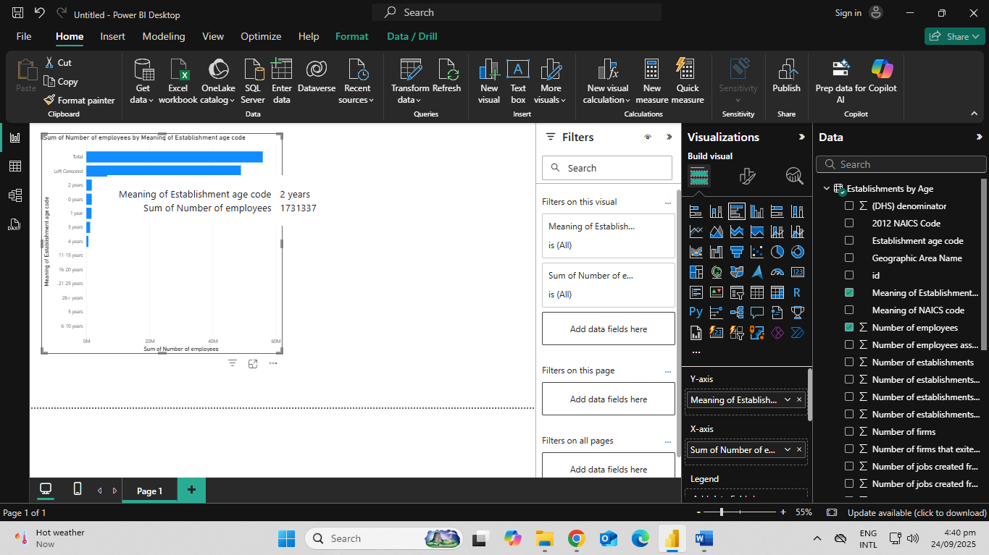
Duplicate the Range indicating percent of total employees imputed column twice
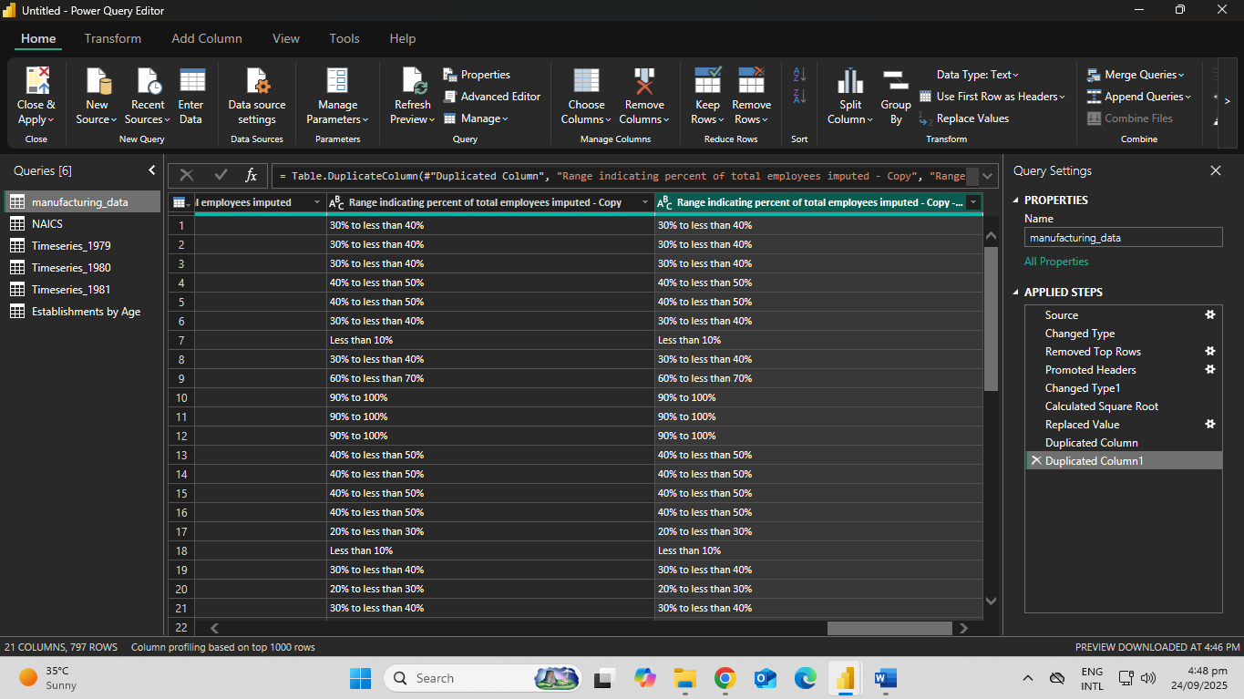
From the first duplicated column, only keep the numbers before the first percent sign (%). You can use “%” as a delimiter
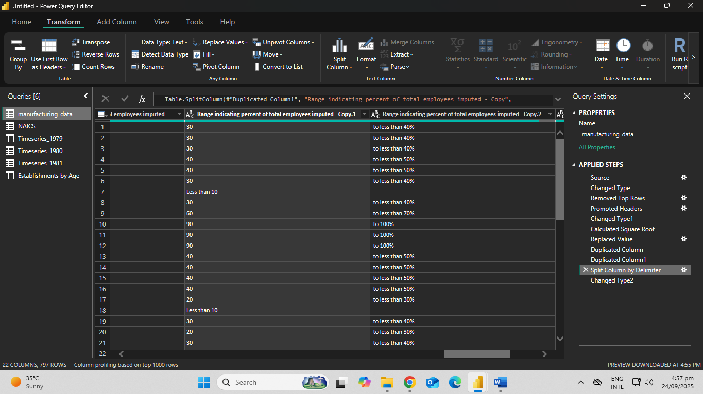
Change the resulting column’s data type to “Whole Number” and rename the column to Low Range Total Employees.
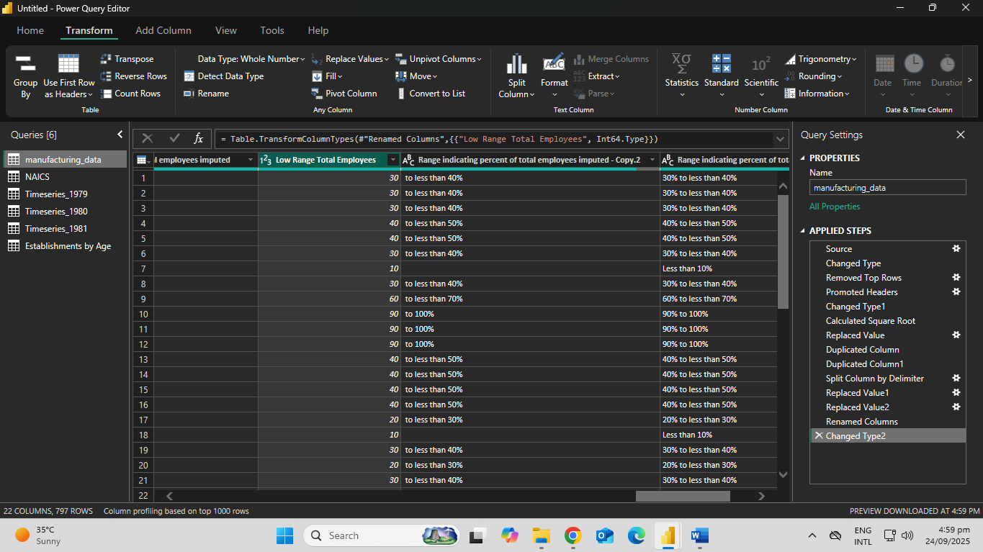
From the second duplicated column, only keep the numbers before the second percent sign(%). First extract the last four characters, then extract again using “%” as a delimiter.
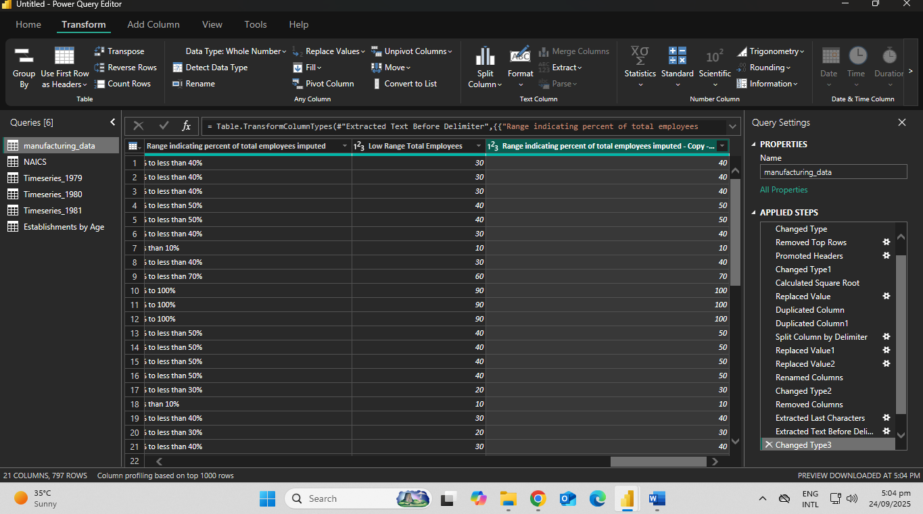
Change the resulting column’s data type to “Whole Number” and rename the column to High Range Total Employees
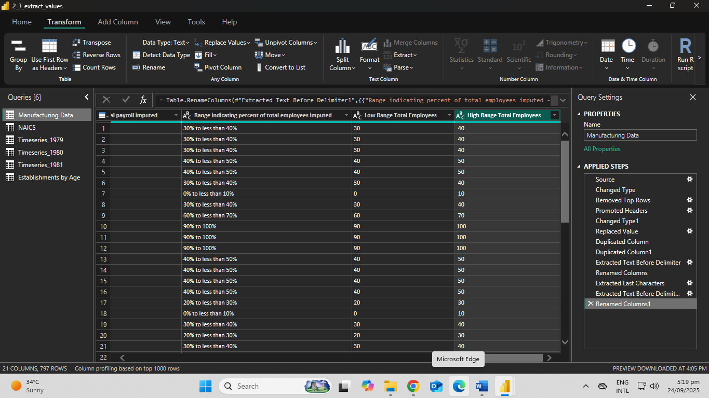
Close and apply your steps and create new page with a clustered column chart visual. From Manufacturing Data use the High Range Total Employees column as the Axis and First-quarter payroll ($1,000) for the values
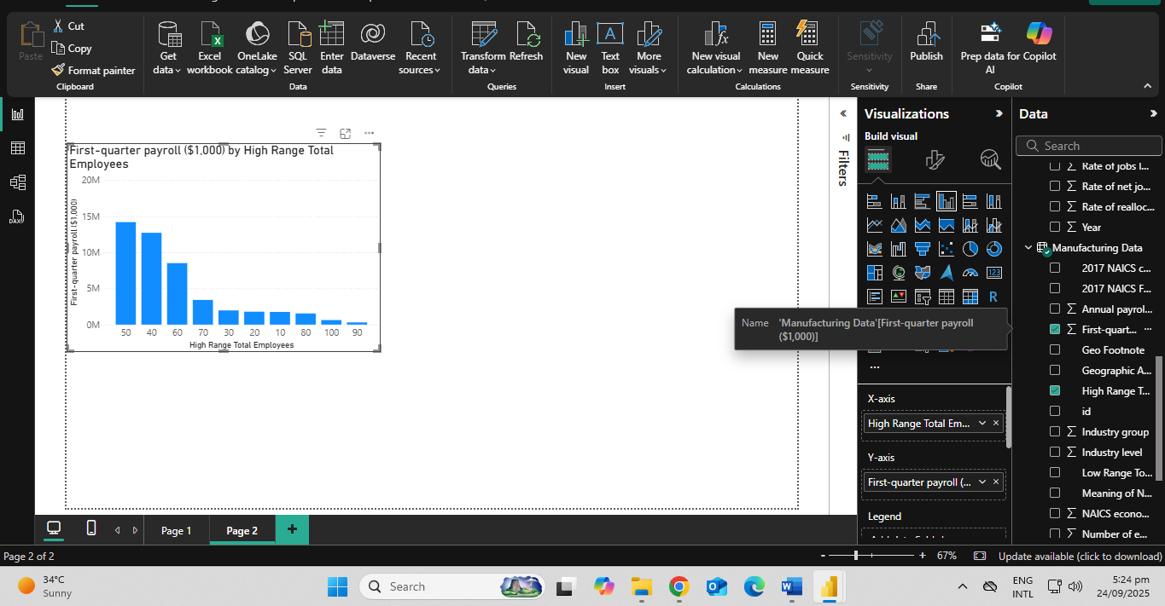

Which is the second-largest “High Range Total Employees” category in terms of payroll?
40
Activity 3- Dimensional Modeling
The Kimball model is known as dimensional model
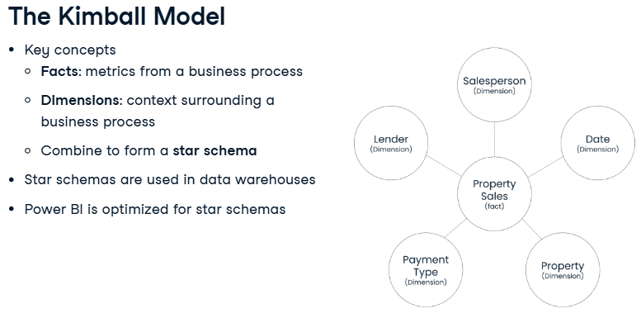
Open 3_1_split_dataset.pbix
Duplicate the Business “Establishment Survey” query and rename it to “Industry”
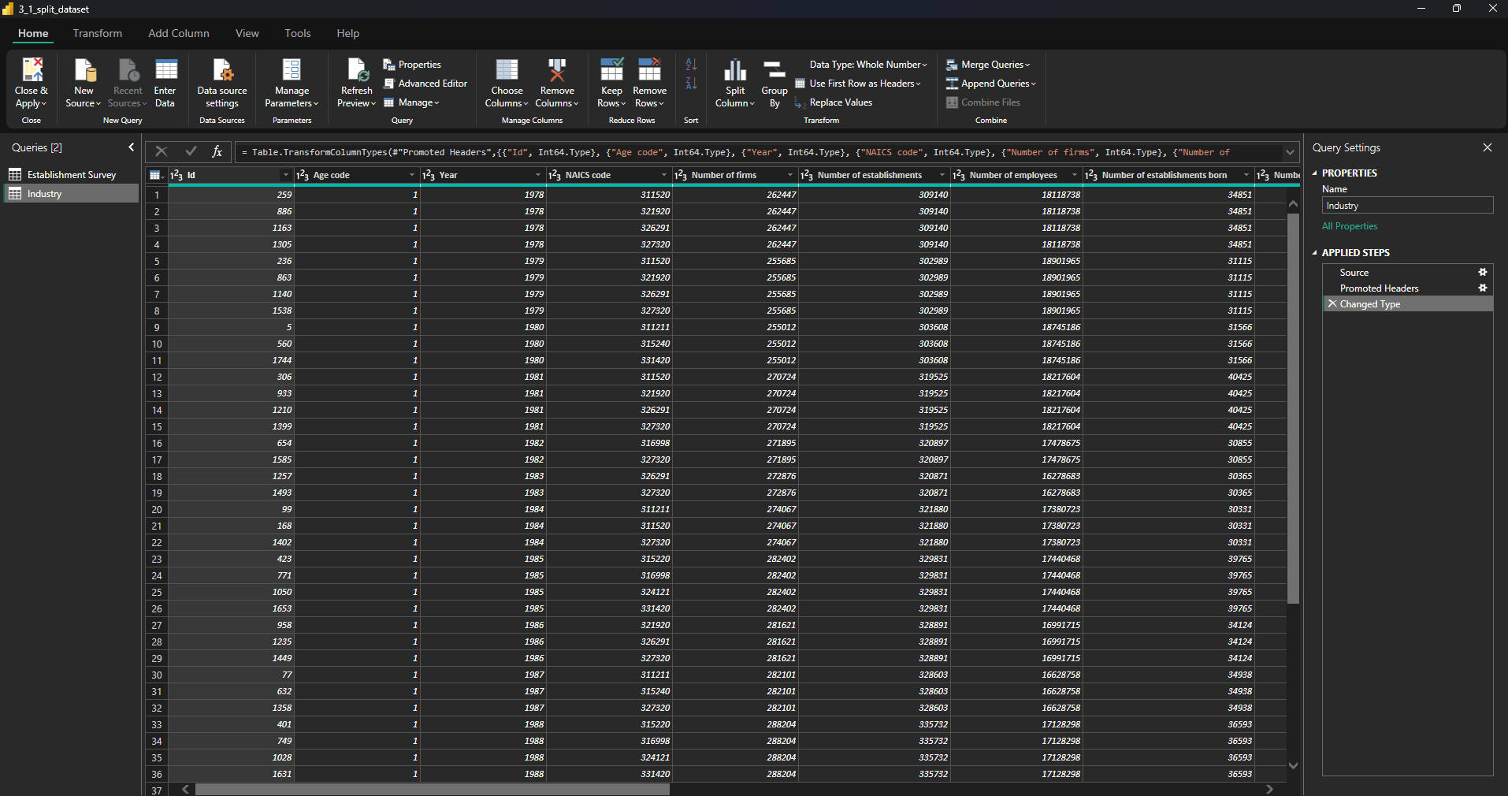
Keep only following columns in the “Industry” table: NAICS code, NAICS Code Description, Industry group code, Industry group, Subsector Code, Subsector, Sector Code and Sector.
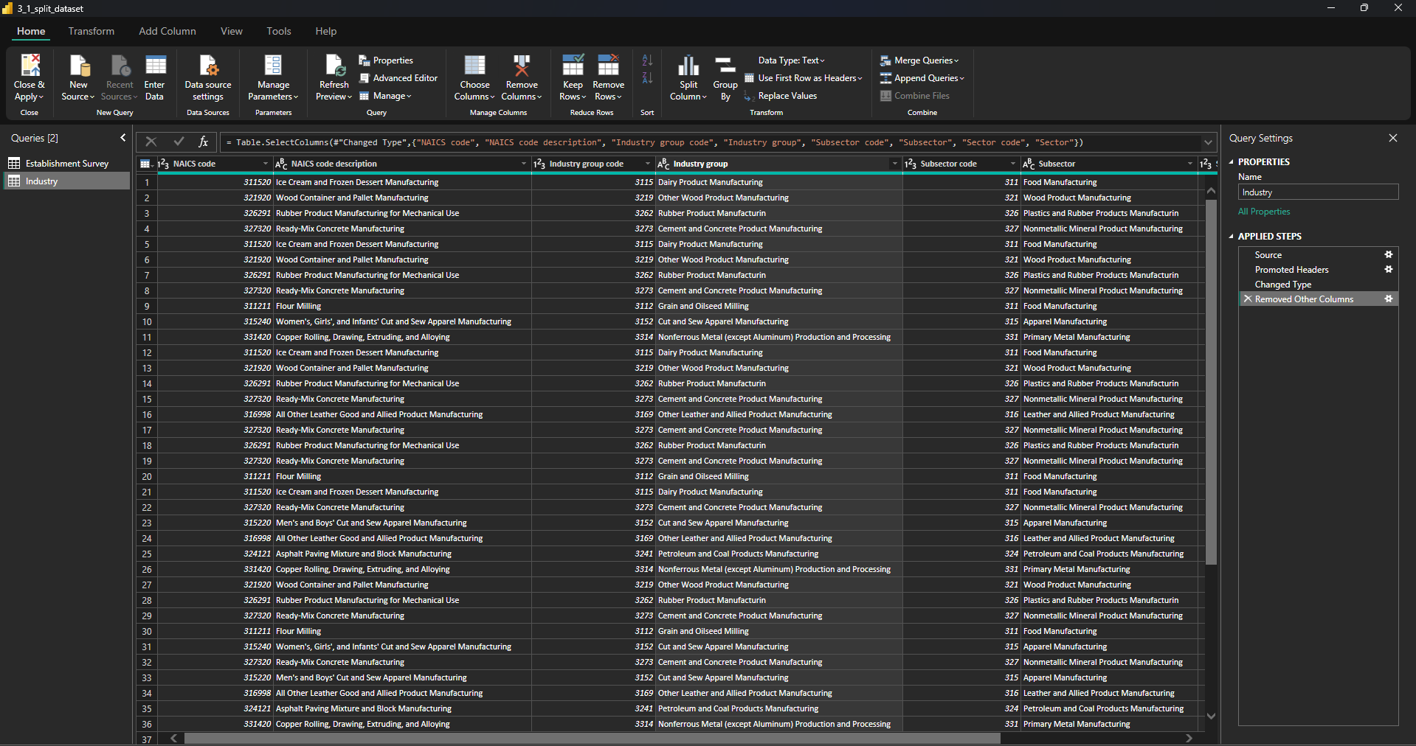
Remove duplicate values from the dataset
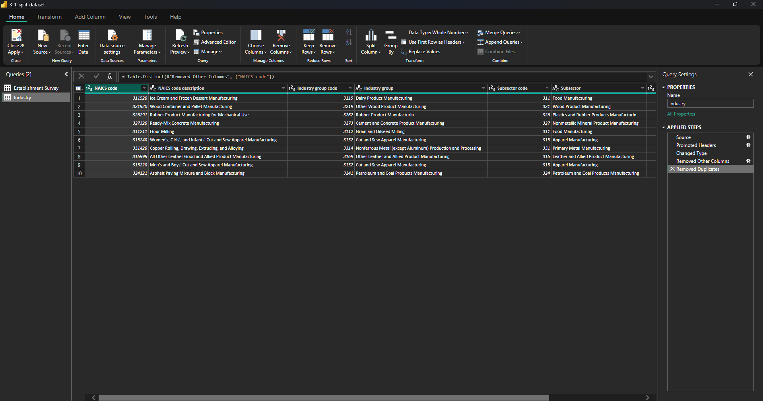
Return to the ”Establishment Survey” query and remove the columns you just added to “Industry”: NAICS Code Description, Industry group code, Industry group, Subsector Code, Subsector, Sector Code and Sector.
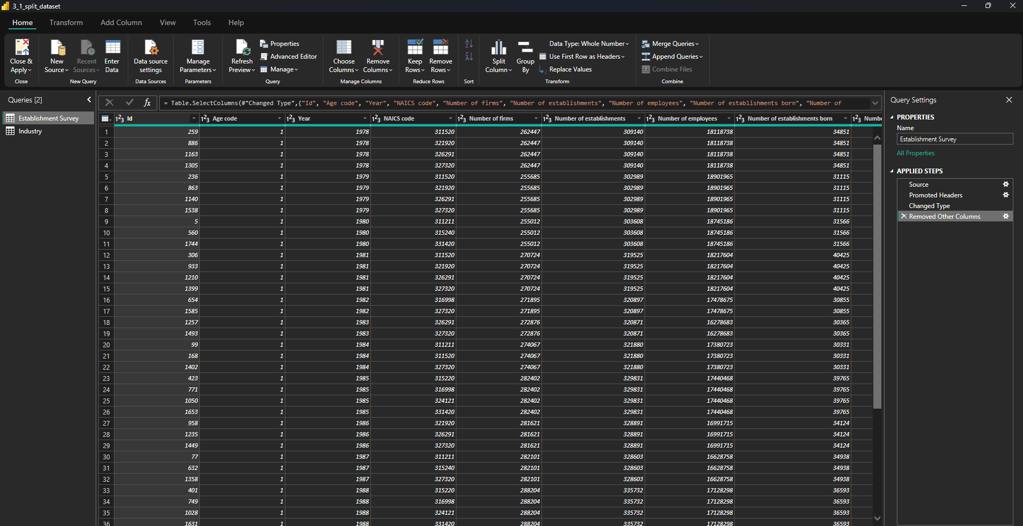
Make sure to keep NAICS code! This column is the key we’ll use to connect the dimension to the fact table. Exist Power Query
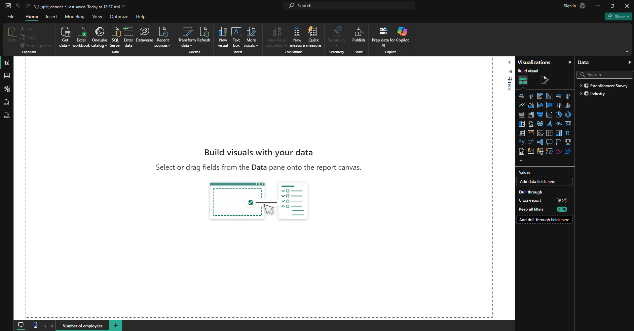
Go to the Model view to verify that there is a relationship between “Industry” and “Establishment Survey”
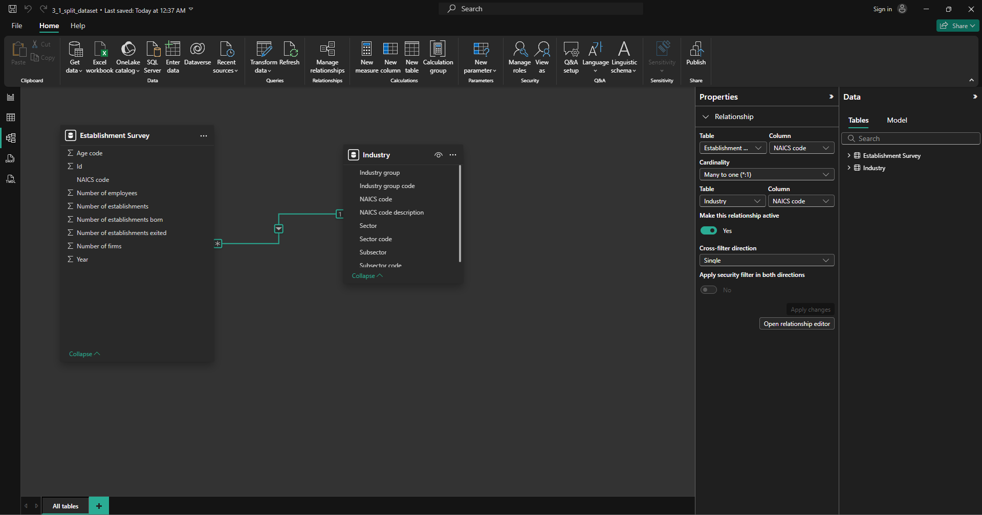
Go to the Report view and create a new clustered bar chart visual with the Subsector column from the dimension table as the Y-Axis and Average Number of employees from the fact table as the Values (X-axis)
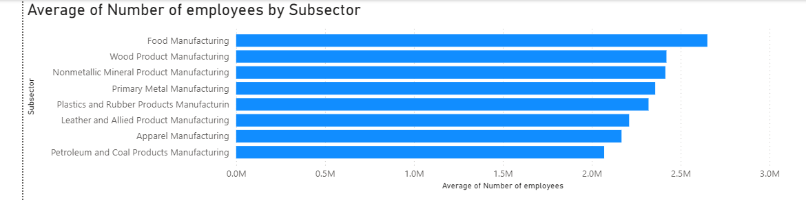
Which subsector counted the highest average number of employees?
Food Manufacturing
Import the file name Time.txt
Go to the Model view and verify that there is a relationship between “Time” & “Establishment Survey” tables defined by the Year column
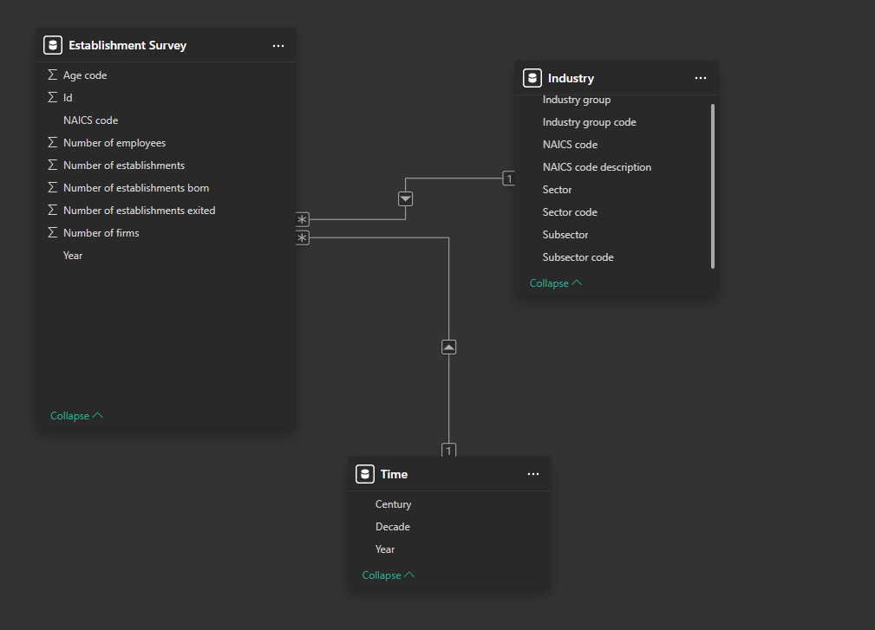
Return to the Report view and add a new slicer visual, slicing on Decade from the Time dimension
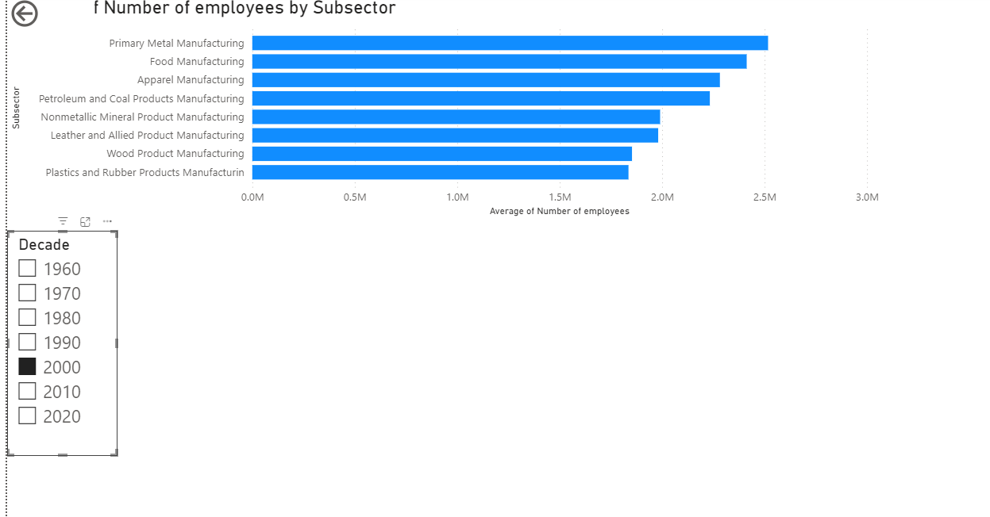
Adjust the size of the slicer in the page until you see the options and change the slicer to be a list of values rather than a range.
How many employees did the Food Manufacturing subsector count on average during the 90s?
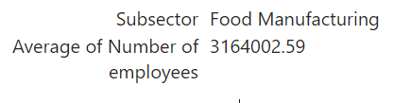
Import the file named EstablishmentAge.csv from the Datasets folder
Go to Power Query and name the table “Age”
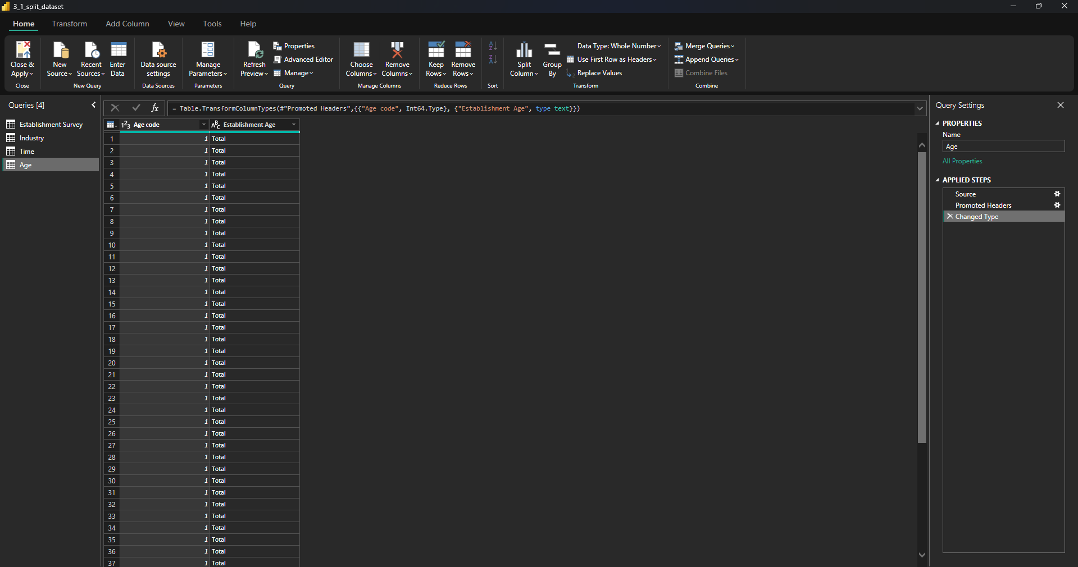
Navigate to the Model view and connect the Age dimension to the Establishment Survey fact by Age code if this is not the case yet.
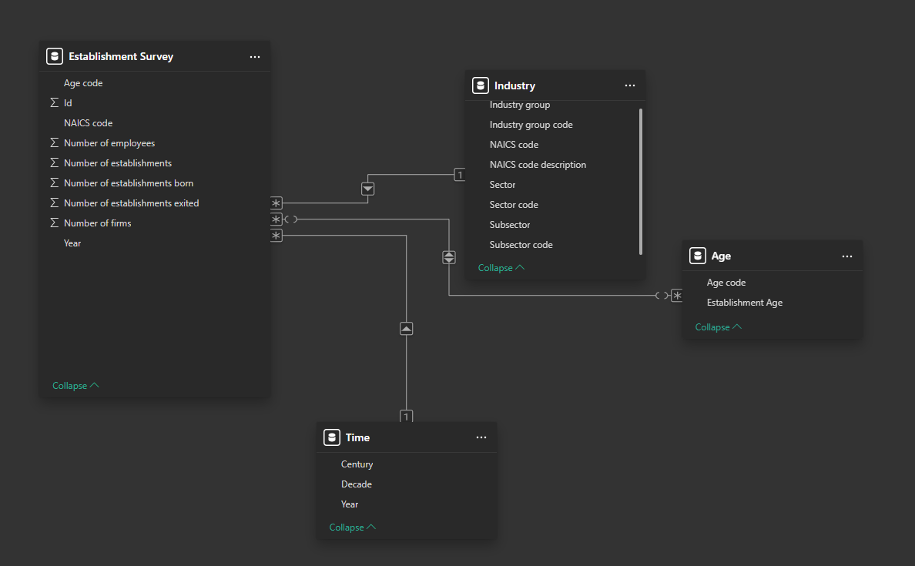
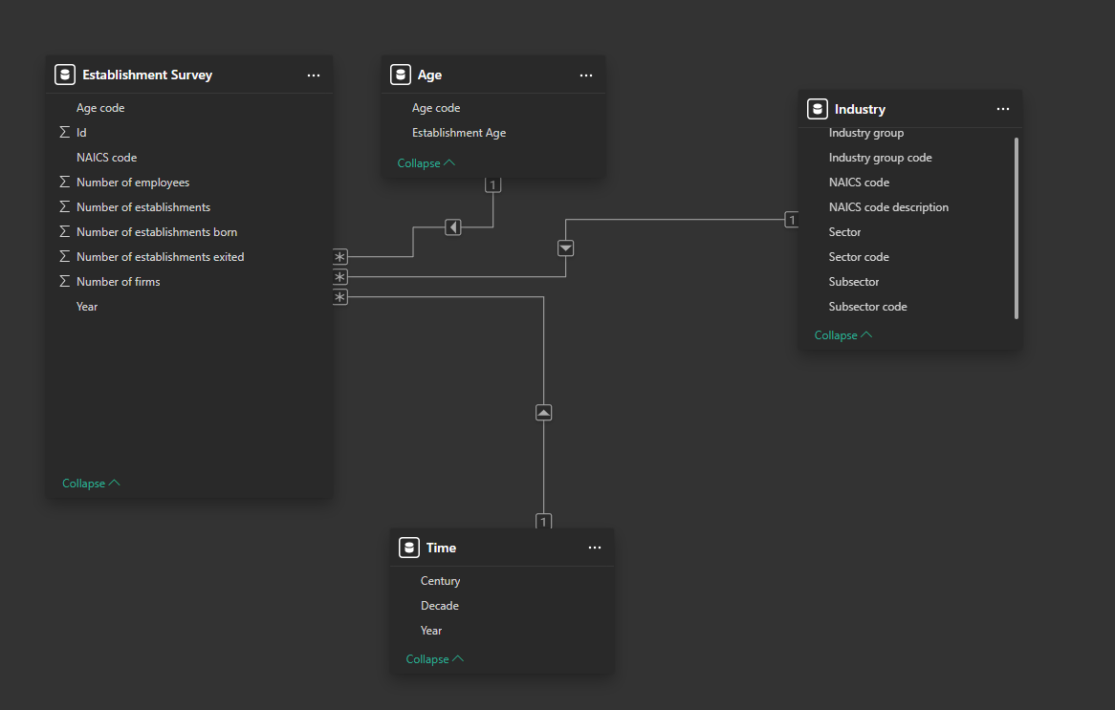
Return to Report view and add a second slicer using Establishment Age from the new Age dimension
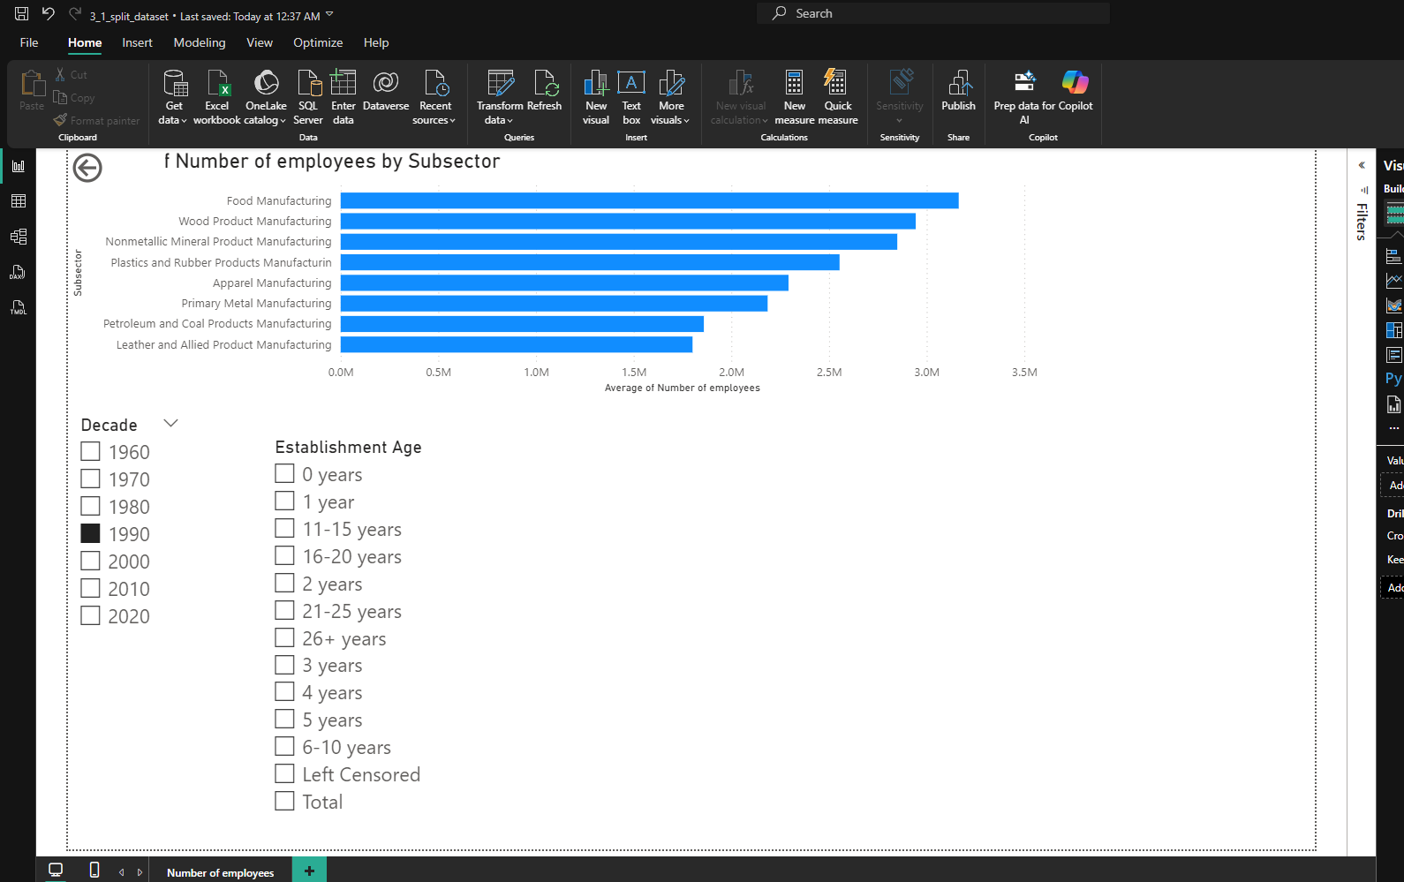
How many average employees did 3-year old firms in the Food Manufacturing subsector have during the 90s?
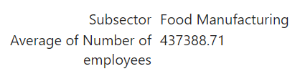
Activity 4- Star and Snowflake Schemas
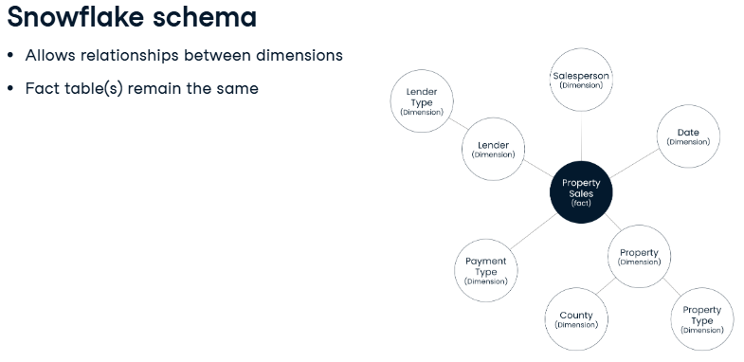
Open 4_1_star_schema
Create a new page and name it “Industry insights” and navigate to the Data view to get familiar with the columns in the “Industry” dimension
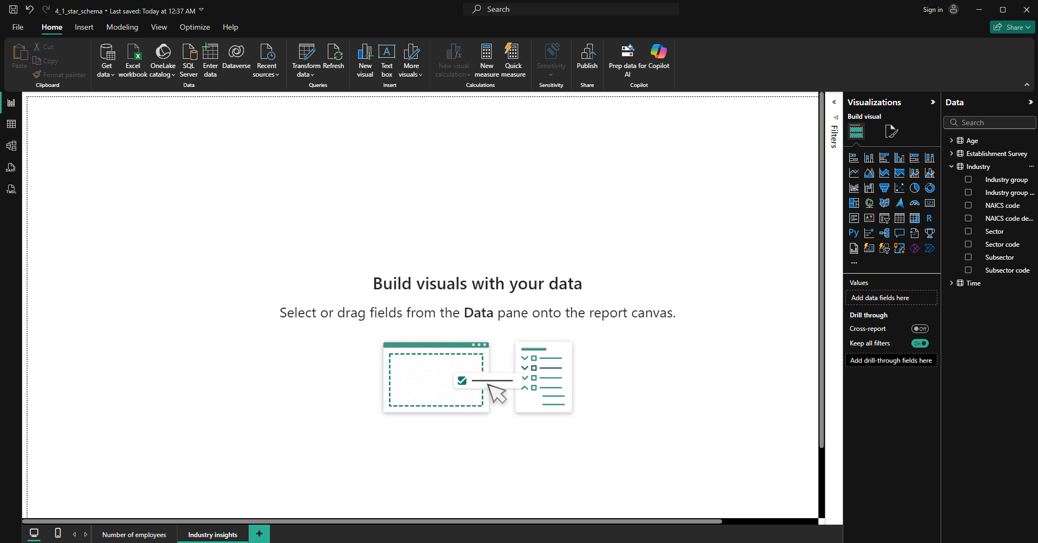
In the Report view, add a table visualization with the following columns from the “Industry” dimension: Industry group, NAICS Code description, Sector and Subsector
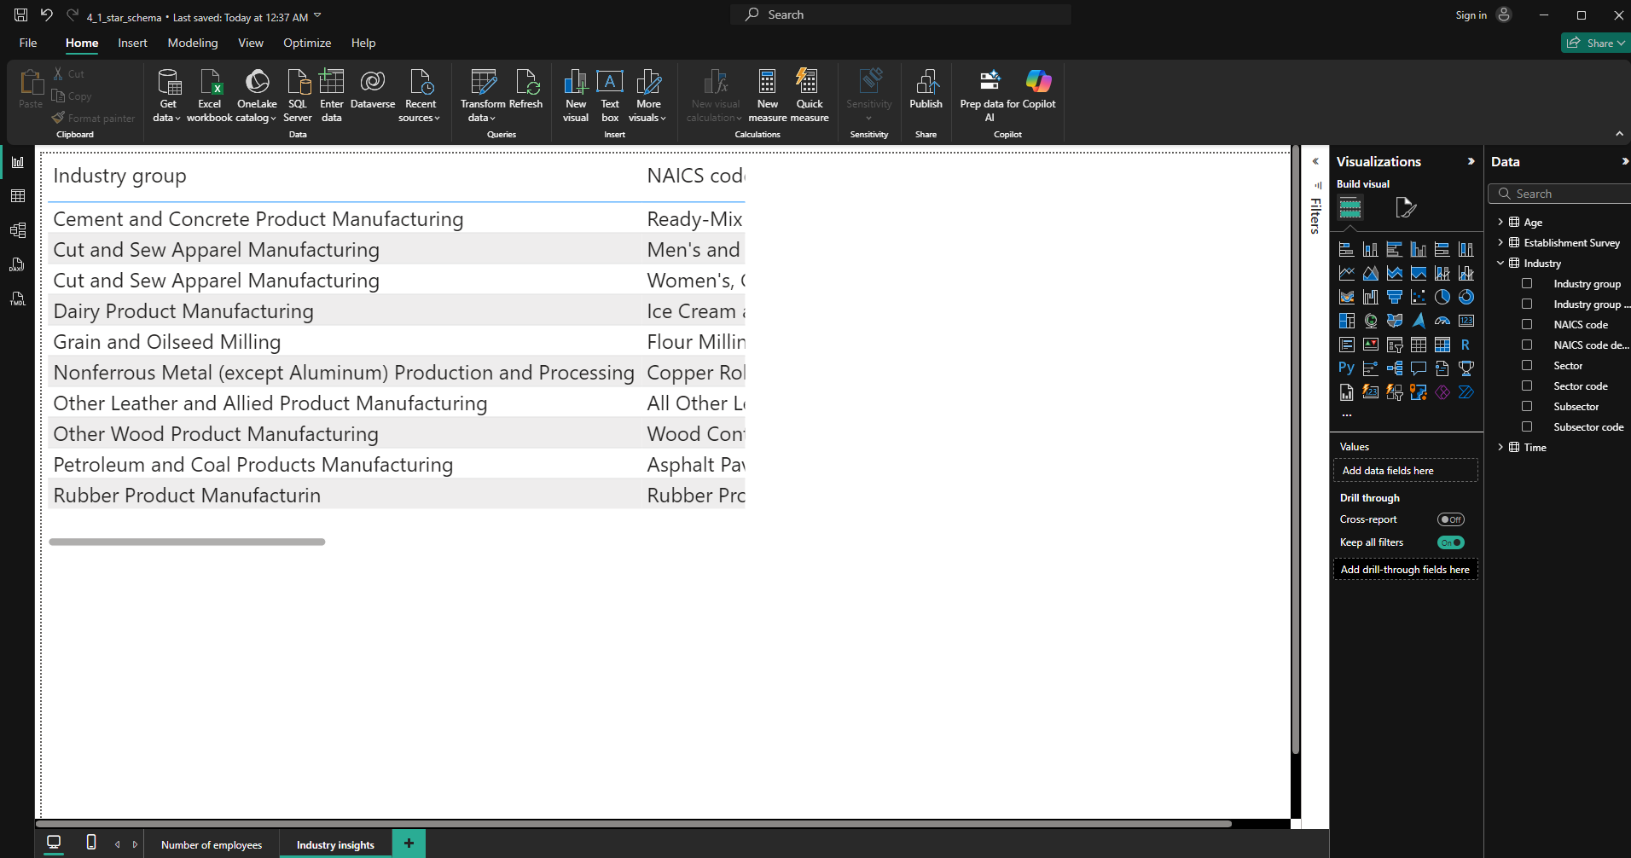
Note that the columns in the Industry table make up a hierarchy. Starting from the highest level, each category gives a more granular view of what industry the establishments operate in.
Put the columns in the right order, going from less to more detail.
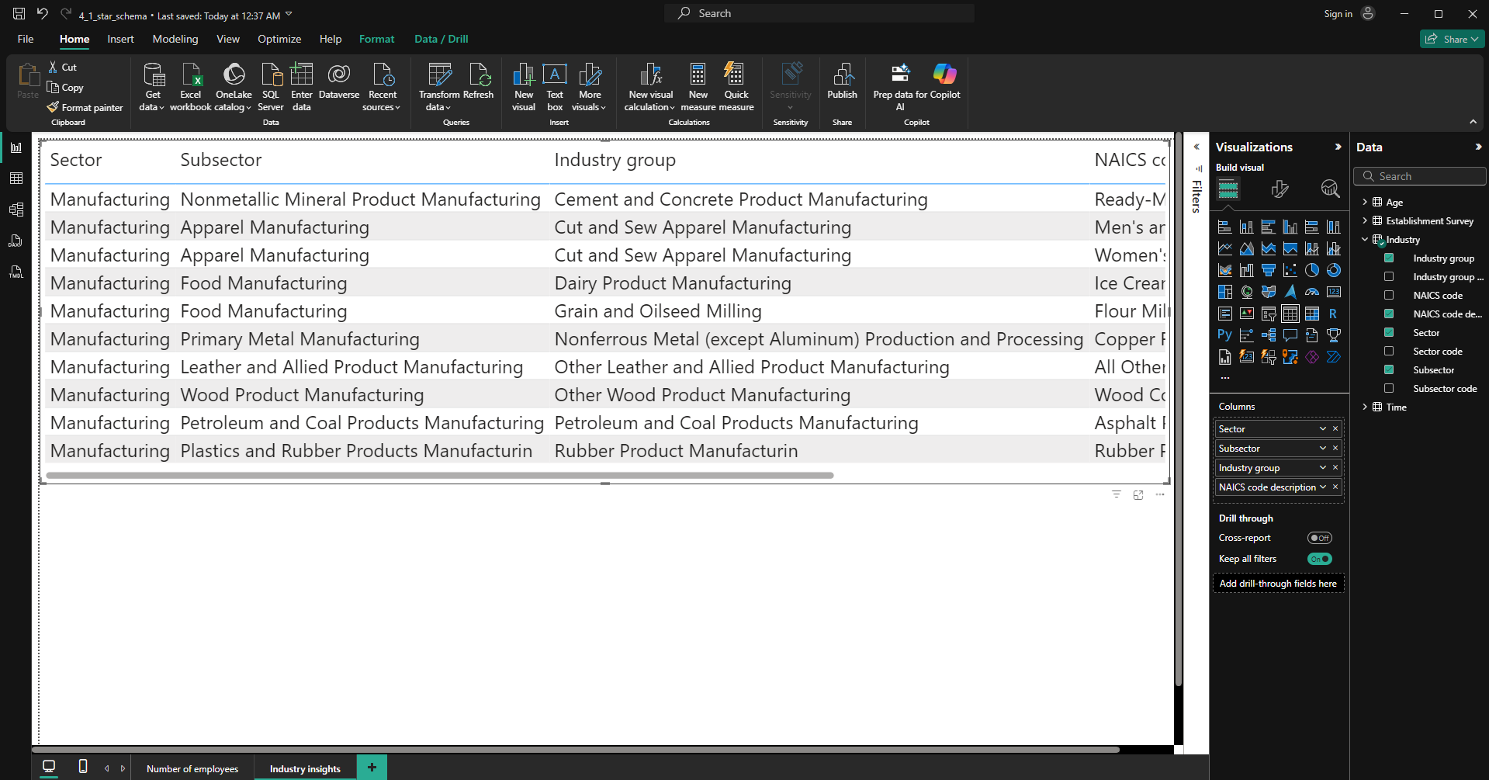
Go to Power Query and duplicate the Industry queries four times.
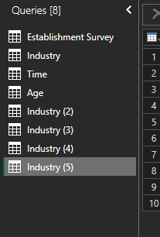
Rename the duplicated queries to “NAICS code”, “Industry group”, “Subsector”, and “Sector”
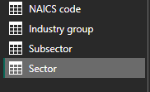
Knowing the hierarchy as: Sector > Subsector > Industry group > NAICS Code description
For each table, keep only the code and text description columns corresponding to that level of the hierarchy, and also keep the code of the next level in the hierarchy, if there is one
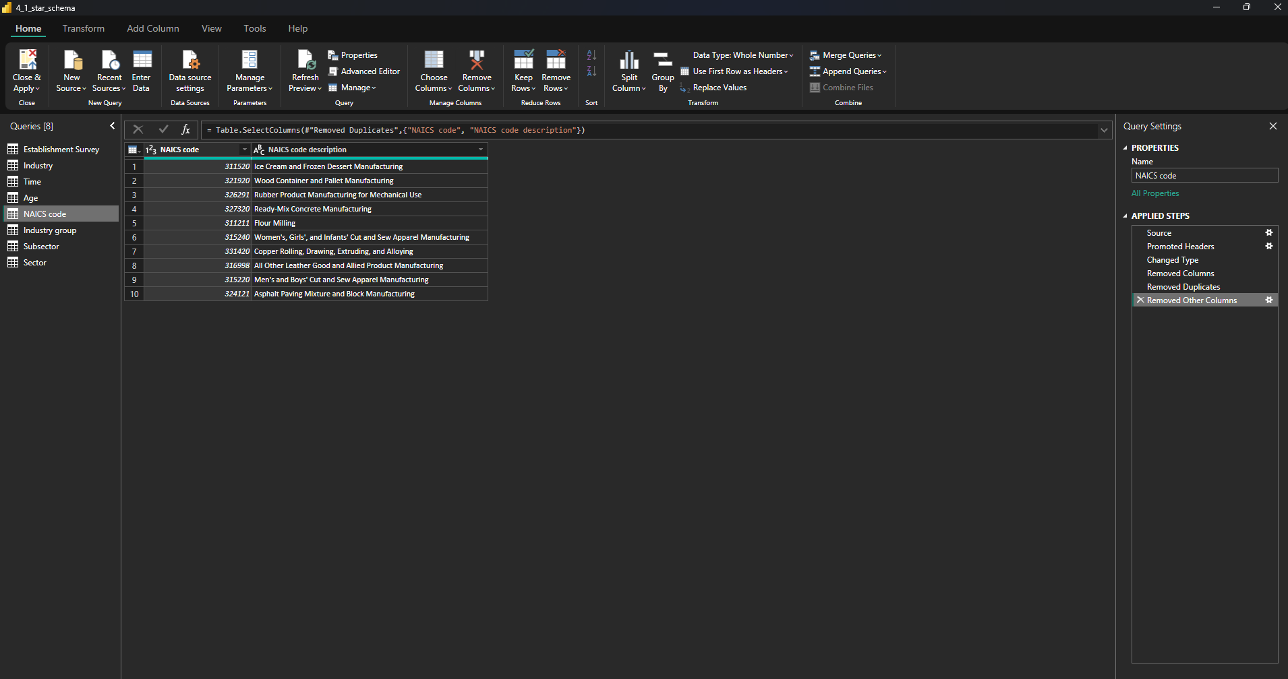
Make sure to remove duplicate values
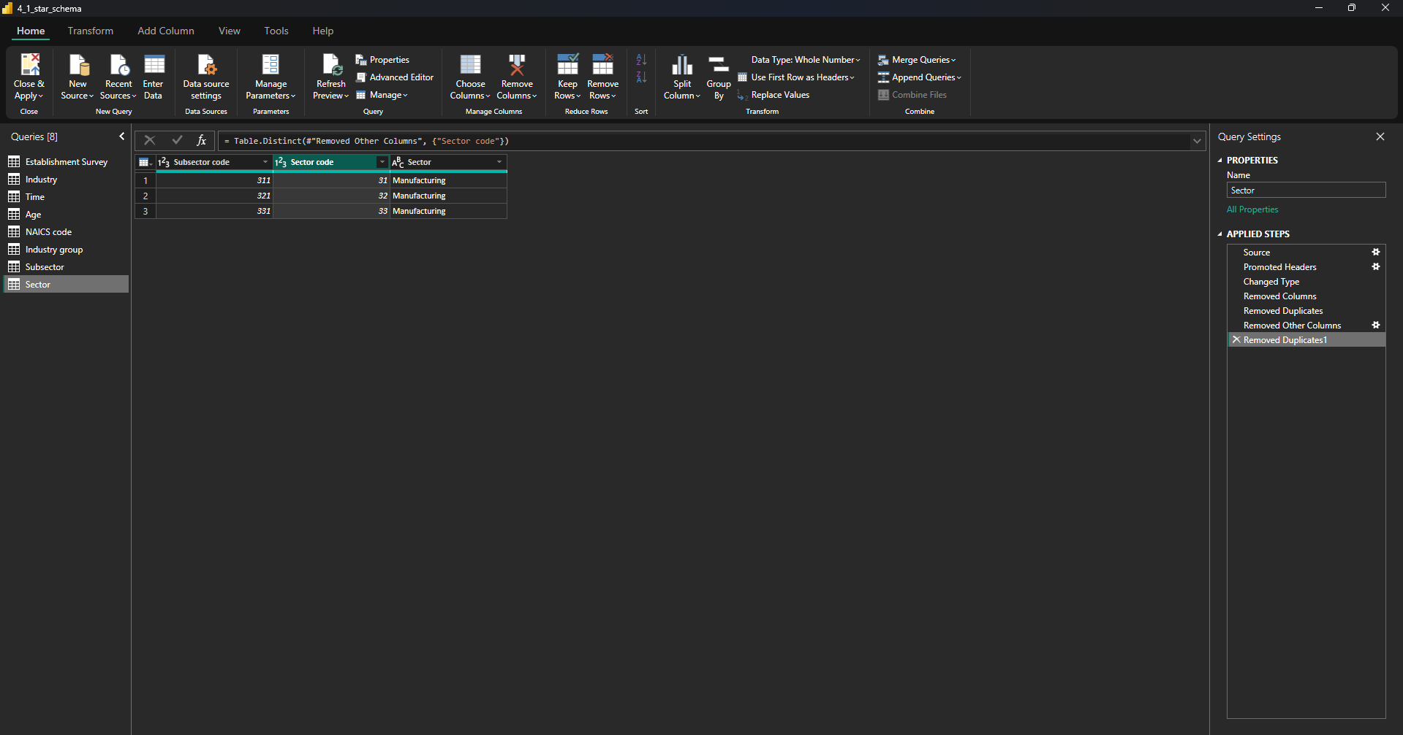
Close Power Query and go to the Model view
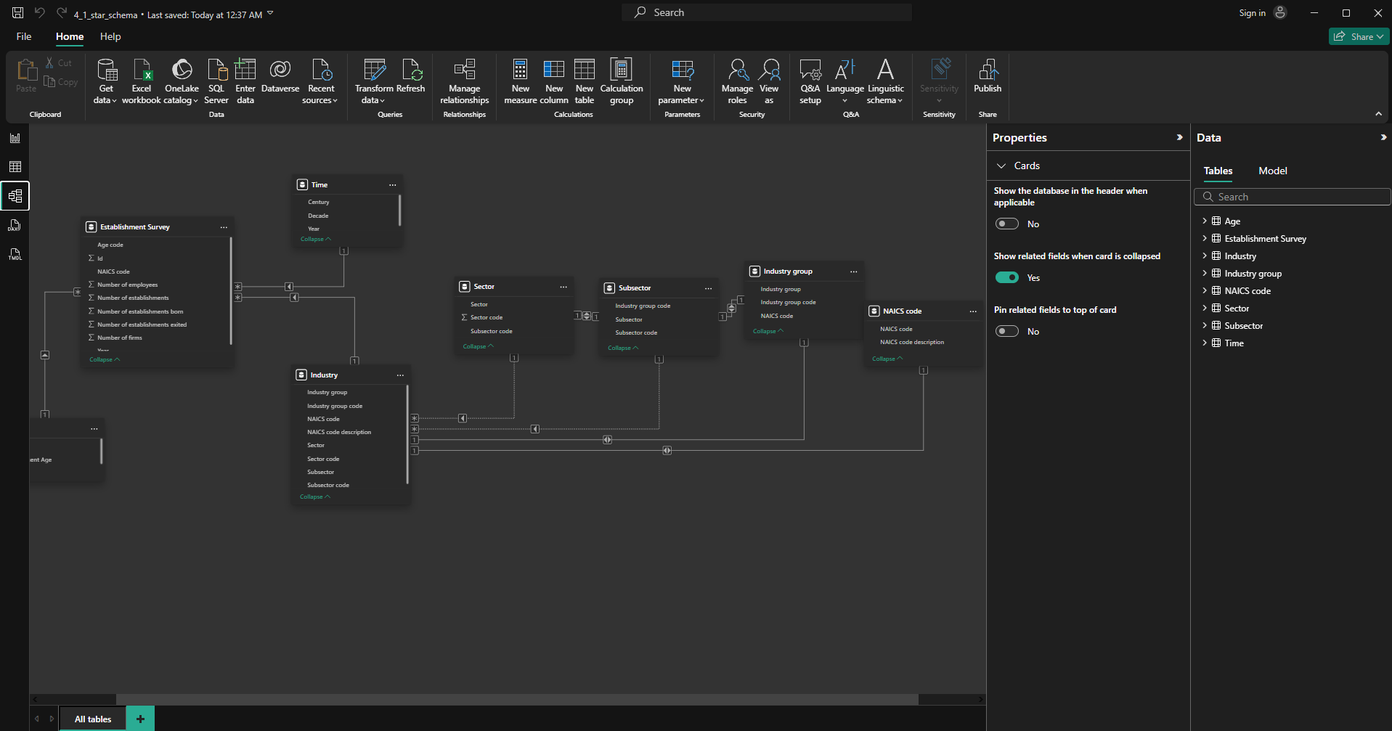
Delete the automatically created relationships between the “Industry” star dimension and the four tables you just created
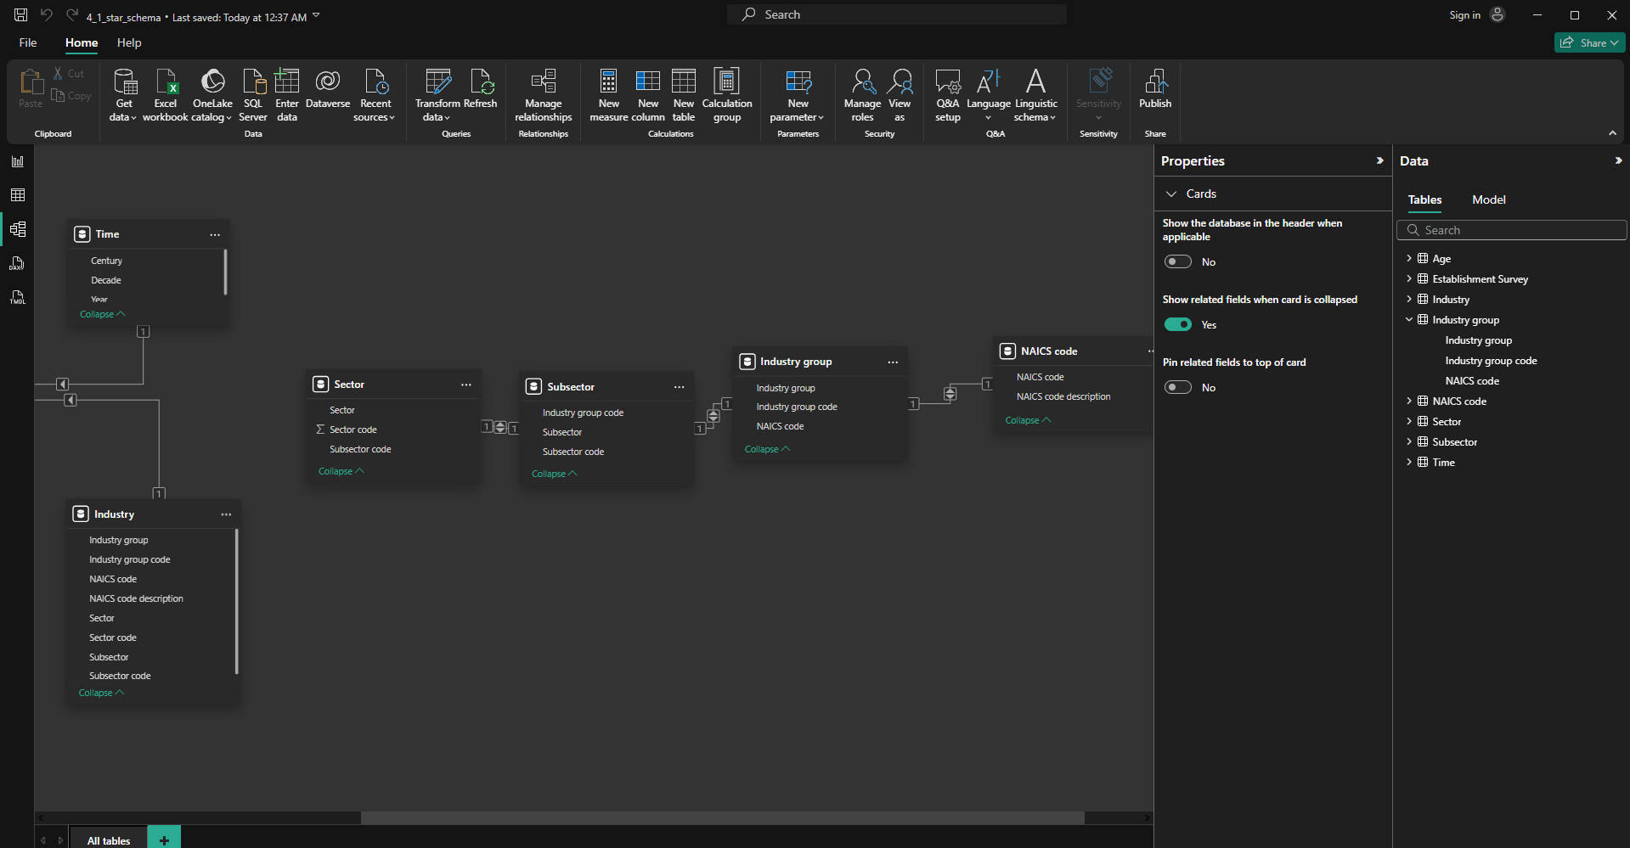
Create a relationship between “NAICS code” and “Establishment Survey” tables, using NAICS code
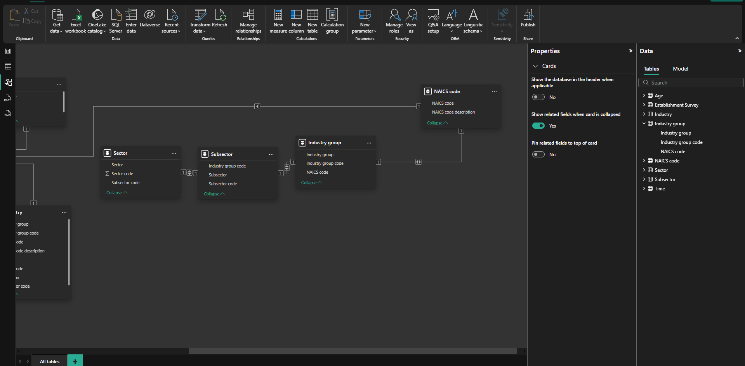
Find the Hierarchical level table that contains “Food Manufacturing” and tell how many rows would you have to change if the name of the subsector changes.
1
Go to the Report view and create a new page named “Comparison”
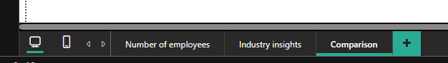
Create a line chart with the decade on the x-axis, the average number of employees on the y-axis, and the subsector (from the star dimension “Industry”) on the legend
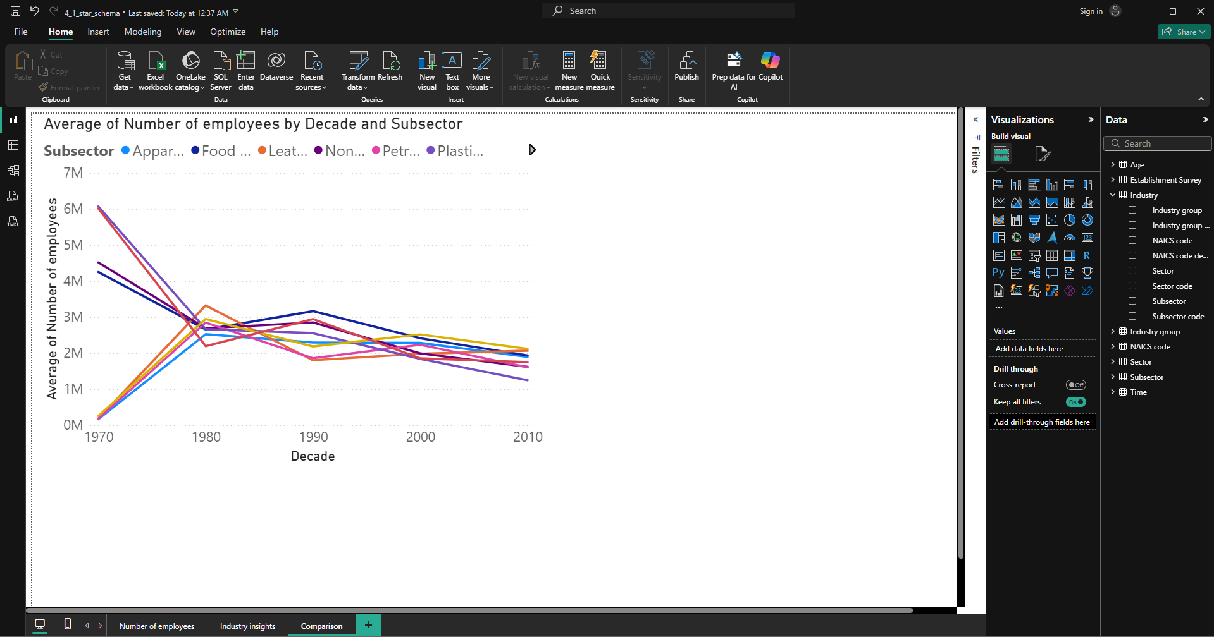
Create another line chart with the decade on the x-axis, the average number of employees on the y-axis, and the subsector (from the snowflake dimension “Subsector”) on the legend
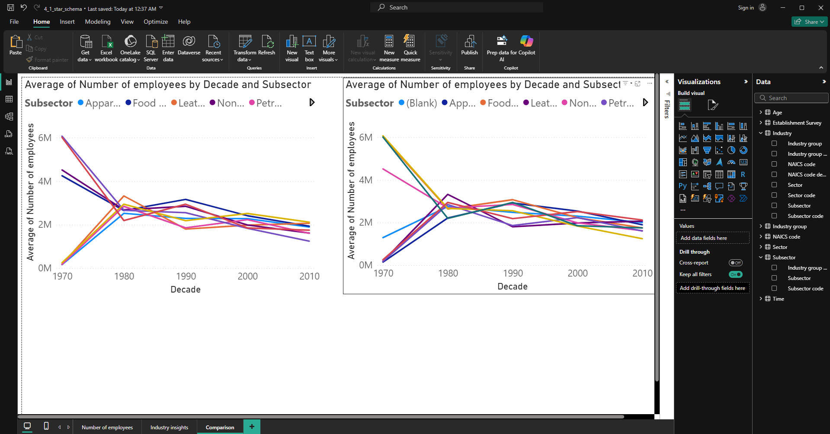
Change the title of the first line chart to “Star schema”
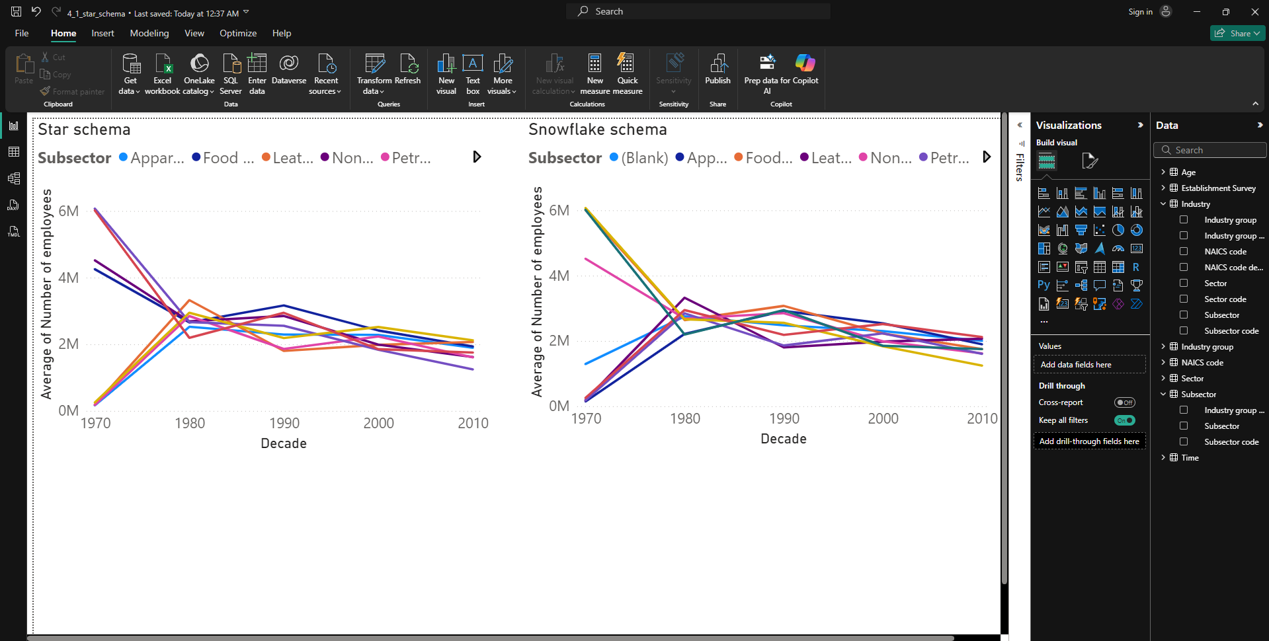
Change the title of the second line chart to “Snowflake schema”
Open the Performance analyzer and start recording to begin performance analysis
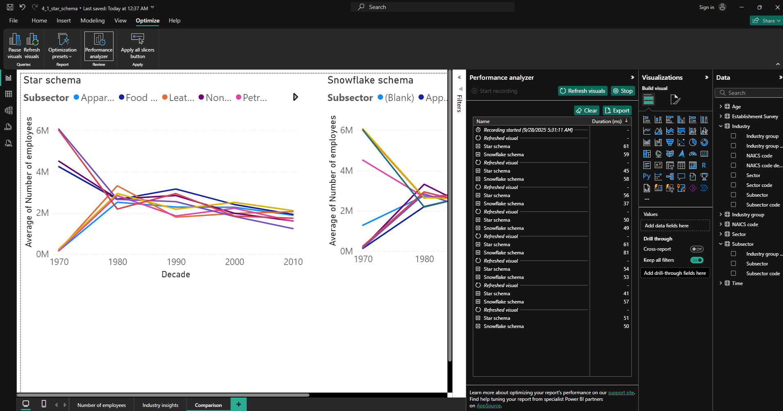
Refresh all visuals on the page. Do this several times to see if there is a consensus on whether the star or snowflake schema is faster in this case
What takes the most amount of time for both visuals?
Star Schema = Other
Snowflake Schema = Other

