**Programming Fundamentals Lab-3**

Insertion operator , setw & setprecision functions

## Exercise 1: A Simple First Program

You need to perform the following to complete the task.

1. Open the Terminal (Ctrl + Alt + t)
2. Installation g++

lab@lab-OptiPlex-330:~$ **sudo apt install g++**

Note: g++ is already install on lab PCs

1. Create file of .cpp file extension using touch command

#### ~$ touch helloworld.cpp

1. Now open the text editor using gedit command

#### ~$ gedit helloworld.cpp

1. Write the following code in helloworld.cpp file.

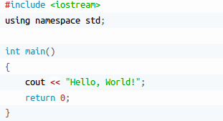

1. Save and close the file.
2. compile and execute it

~$ g++ -o hello helloworld.cpp

~$./hello

**Standard output (cout)**

cout is a C++ stream object, used for standard output by default is the screen. For formatted output operations, cout is used together with the *insertion operator*, which is written as << (i.e., two "less than" signs).



#### Escape Sequences

Character combinations consisting of a backslash (**\**) followed by a letter or by a combination of digits are called "escape sequences." To represent a newline character, single quotation mark, or certain other characters in a character constant, you must use escape sequences. An escape sequence is regarded as a single character and is therefore valid as a character constant. Escape sequences are used to format our output. The following escape sequences can be used to print out special characters.

|  |  |
| --- | --- |
| **Escape Sequence** | **Description** |
| **\n** | Newline |
| **\t** | Horizontal tab |
| **\\** | Backslash |
| **\'** | Single quote |
| **\"** | Double quote |

To insert a line break, a new-line character shall be inserted at the exact position the line should be broken. In C++, a new-line character can be specified as \n (i.e., a backslash character followed by a lowercase n). For example:

This produces the following output:



Alternatively, the endl manipulator can also be used to break lines. For example:

Output



Example 2.1

Following program shows the use of Newline Escape Sequence (\n)

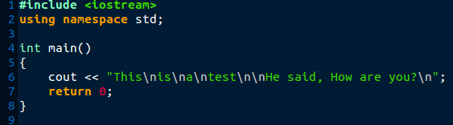

Output

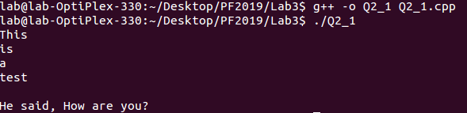

Your turn: Edit above given code and use endl manipulator.

Example 2.2

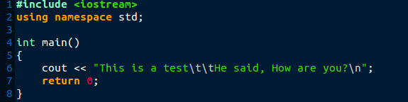This program shows the use of Horizontal tab Escape Sequence (\t)

Output

Now try escape sequences **\\ , \' , \"** yourself. Example 2.3

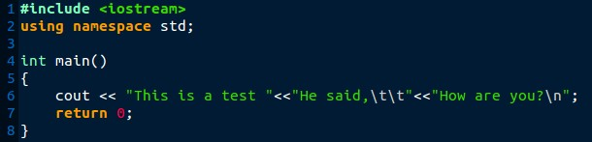Program using multiple insertion operations (<<)

## Output

**iomanip**

iomanip is a library that is used to manipulate the output of C++ program. Below are some Parametric manipulators

#### setw

It is used to sets the field width to be used on output operations.

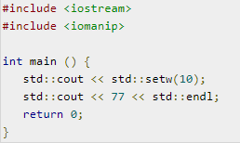Example

Now compile your code and see what the output is.

#### setprecision

It is used to sets the decimal precision to be used to format floating-point values on output operations.

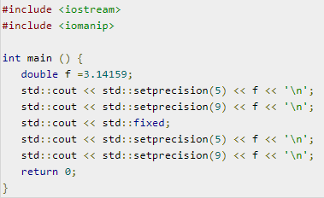Example

Output

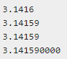

# Exercise:

## Problem 01

### Write your first program saying, “Hello World”. Now change the program to print your name and roll number instead.

**Problem 02**

Write a program that prints the following using COUT statement.



**Problem 03**

Write a program that prints the following using COUT & setw statement.

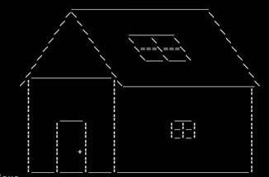

**Note:** Use **setw** function instead of space character

## Problem 04

### Write a program to print the following using just ONE COUT statement & setw function

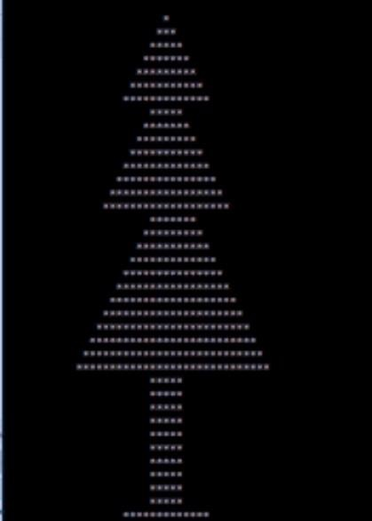

**Note:** Use **setw** function instead of space character

**Submission Instructions:**

1. Save all .cpp files with your roll no and task number

e.g. i20XXXX_Task01.cpp

1. Now create a new folder with name ROLLNO_LAB01 e.g. i20XXXX_LAB03
2. Move all your .cpp files to this newly created directory and compress it into .zip file.
3. Now you must submit this zipped file on LMS.