
COMSATS University Islamabad
Sahiwal Campus
(Department of Computer Science)

INFORMATION SECURITY
Lab Assignment # 4

SUBMITTED TO: Sir MUBASHAR RAZA
SUBMITTED BY: MUHAMMAD HAMZA
Reg No: FA23-BCS-149

Q #1:
What are the vulnerabilities of the ElGamal encryption algorithm? Discuss them in detail. Which of these is the most critical? Develop a python program to simulate the most critical vulnerability to break the ElGamal encryption.

ANSWER:
The ElGamal encryption algorithm, while secure under ideal conditions, has several known vulnerabilities if implemented improperly. Here's a breakdown of the vulnerabilities, followed by a Python simulation of the most critical one.

Vulnerabilities of ElGamal Encryption:

- Chosen Ciphertext Attack (CCA):
If the ElGamal encryption scheme is not used with padding (like OAEP), it can be vulnerable to chosen ciphertext attacks. An attacker can manipulate ciphertexts and observe the decrypted outputs to gather information about the plaintext.
- Deterministic Plaintext Attack:
If the same plaintext is encrypted with the same public key and the same randomness k is reused, it results in the same ciphertext. This predictability can be exploited.
- Poor Randomness (Reuse of k) – Most Critical:
ElGamal relies on a random number k during encryption. If k is reused or poorly chosen, private key extraction becomes possible, making it the most critical vulnerability. If two ciphertexts use the same k, one can recover the private key using simple number theory.
- Message Integrity:
ElGamal does not provide message integrity/authentication on its own. This can allow message tampering if not used with MAC or digital signatures.
- Large Ciphertext Size:
The ciphertext in ElGamal is double the size of the plaintext, which can make it inefficient for large-scale applications.
Most Critical Vulnerability: Reuse of Random k:
When the same random k is used for two different messages, the private key x can be recovered.
Given two ciphertexts:
- C1=(r,s1)C_1 = (r, s_1)C1​=(r,s1​) for message m1m_1m1​
- C2=(r,s2)C_2 = (r, s_2)C2​=(r,s2​) for message m2m_2m2​
With r = g^k mod p, and:
- s1=m1⋅ykmod ps_1 = m_1 \cdot y^k \mod ps1​=m1​⋅ykmodp
- s2=m2⋅ykmod ps_2 = m_2 \cdot y^k \mod ps2​=m2​⋅ykmodp
Since both share the same r, the same k was used. Then:
s1s2=m1m2mod p⇒m1=m2⋅s1s2mod p\frac{s_1}{s_2} = \frac{m_1}{m_2} \mod p \Rightarrow m_1 = m_2 \cdot \frac{s_1}{s_2} \mod ps2​s1​​=m2​m1​​modp⇒m1​=m2​⋅s2​s1​​modp
This leak allows attackers to recover one message if the other is known, and potentially extract k and then x (the private key) using logarithmic calculations.

Python Simulation: Breaking ElGamal with Reused k:

def modinv(a, m):
for x in range(1, m):
if (a * x) % m == 1:
return x
return None

def generate_keys():
p = 467
g = 2
x = 127 # Private key
y = pow(g, x, p)
return (p, g, y), x

def encrypt(m, pub_key, k):
p, g, y = pub_key
r = pow(g, k, p)
s = (m * pow(y, k, p)) % p
return (r, s)

def decrypt(ciphertext, x, p):
r, s = ciphertext
r_inv = modinv(pow(r, x, p), p)
m = (s * r_inv) % p
return m

def recover_k(g, r, p):
for k in range(1, p):
if pow(g, k, p) == r:
return k
return None

def recover_x(g, y, p):
for x in range(1, p):
if pow(g, x, p) == y:
return x
return None

def main():
pub_key, priv_key = generate_keys()
p, g, y = pub_key

print("Public Key (p, g, y):", pub_key)
print("Private Key x:", priv_key)

k = 43 # BAD: same k reused

m1 = 65 # Plaintext 1
m2 = 66 # Plaintext 2

c1 = encrypt(m1, pub_key, k)
c2 = encrypt(m2, pub_key, k)

print("\nCiphertext 1:", c1)
print("Ciphertext 2:", c2)

if c1[0] == c2[0]:
print("\nReused k detected!")

recovered_k = recover_k(g, c1[0], p)
print("Recovered k:", recovered_k)

recovered_x = recover_x(g, y, p)
print("Recovered private key x:", recovered_x)

dec1 = decrypt(c1, recovered_x, p)
dec2 = decrypt(c2, recovered_x, p)

print("\nDecrypted Message 1:", dec1)
print("Decrypted Message 2:", dec2)
else:
print("Different r values, no reused k.")

main()

OUTPUT:
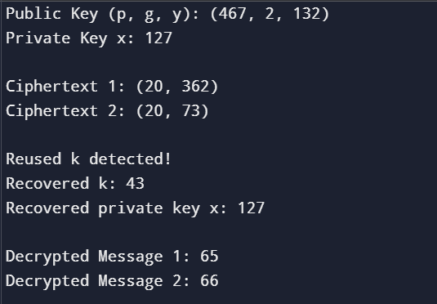

Conclusion:
- Most Critical Vulnerability: Reuse of k, which allows full compromise of private keys.
- Mitigation: Always use a unique random k for each message. Use secure random generators and padding mechanisms.
- Secure Practice: Combine ElGamal with digital signatures or hybrid encryption schemes.

