
1. Overview
This proposal outlines the engineering plan for a secure, internal, single-page telemetry health dashboard designed for Daikibo. The platform serves as a centralized operational hub, aggregating and standardizing live performance metrics from across Daikibo’s global manufacturing footprint. Specifically, the application monitors 36 distinct assets—covering the 9 critical machinery components deployed across each of Daikibo’s 4 physical production plants (Daikibo Factory Meiyo, Daikibo Factory Seiko, Daikibo Berlin, and Daikibo Shenzhen).
By providing instantaneous, real-time status visibility alongside interactive historical logs, this dashboard equips operations managers and on-site engineering crews with the data necessary to preemptively spot operational failures, isolate anomalies, and significantly reduce unplanned factory downtime. To adhere strictly to internal data governance policies, the application is designed from the ground up to operate exclusively within Daikibo’s internal corporate network infrastructure.

2. Scope
The scope of this project encompasses the complete engineering life cycle—including pipeline architecture design, user interface development, corporate security provisioning, and localized intranet deployment. The platform will deliver the following features and technical capabilities:
- Intranet Confinement: The application deployment architecture is restricted to running entirely within the client’s private intranet network. It features no public internet endpoints, ensuring corporate machine telemetry remains entirely secure.
- Synchronized Corporate Authentication: The platform interfaces natively with Daikibo’s existing central identity systems (LDAP / Active Directory). This permits employees to leverage their existing company-wide accounts for access, bypassing the need for an independent credential database and streamlining role-based security permissions.
- Unified Telemetry Aggregation Pipeline: Under the hood, a data abstraction layer processes differing multi-format JSON telemetry packets, automatically normalizing inconsistent values (such as ISO 8601 strings and raw Unix epoch formats) into a uniform, streamlined schema.
- Hierarchical, Single-Page Interface: A clean, single-page reactive dashboard mapping out all 4 corporate factories. As displayed in the provided wireframe design, the user interface features two levels of interactive, collapsible accordion components:
  - Factory Level: Users can see high-level statuses (e.g., Factory Meiyi, Seiko, Berlin, and Shenzhen) along with their respective "Last update" timestamps. Each row expands downward or collapses cleanly using trailing directional arrow toggles.
  - Device Level: Expanding a factory row reveals a nested roster of its 9 integrated machines (CNC, Laser Cutter, Heavy Duty Drill, Spot-welder, Laser Welder, Metal Press, Furnace, Conveyor Belt, and Air Wrench).
  - Status History Tree: Activating a specific device row exposes an inline historical chronology showing past state shifts (e.g., alternating between Status: Unhealthy and Status: Healthy over time) alongside a "Load More" interface action item for deeper investigative access.

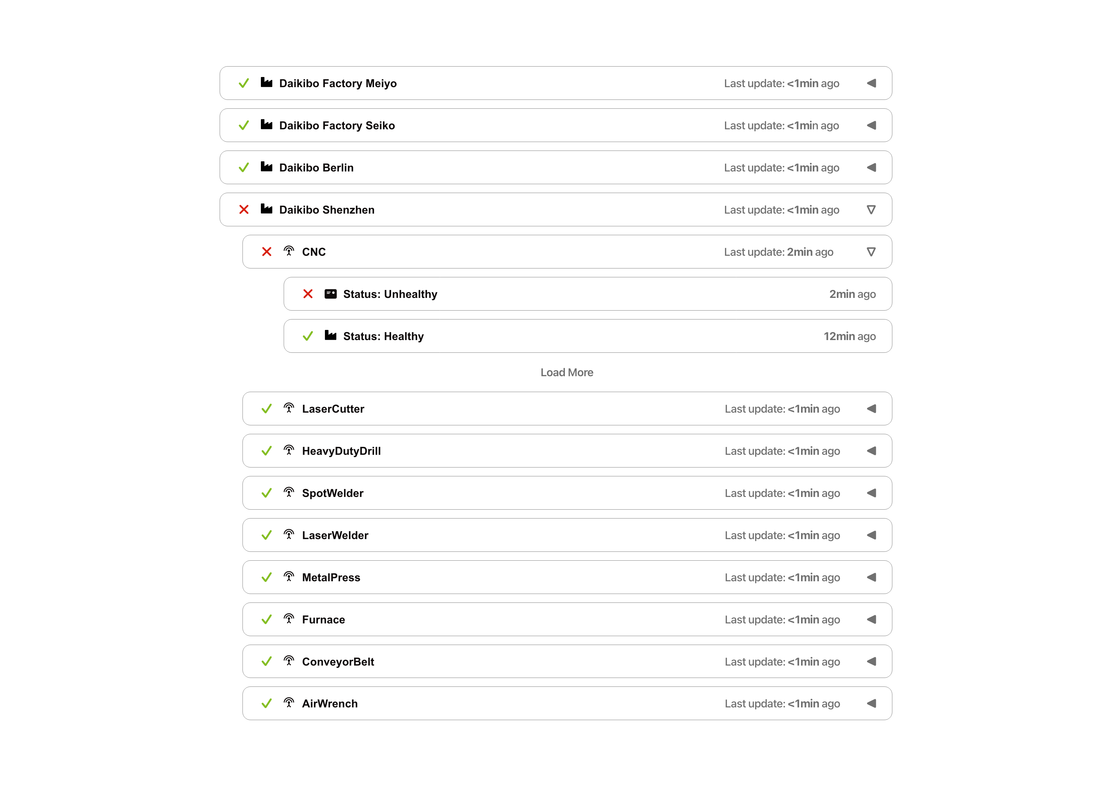
3. Estimate
The total estimated engineering effort required to complete the design, implementation, and deployment of the telemetry dashboard is 128 man-hours. The technical breakdown of these hours across specialized project tasks is structured as follows:
Development Phase | Task Breakdown & Deliverables | Estimated Effort
Data & Architecture Pipeline | Developing incoming telemetry translation adapters; standardizing multi-format JSON schemas; setting up data parsing scripts. | 24 Hours
Frontend Component Engineering | Building the single-page responsive UI; implementing the dual-level nested accordion components; styling status flags matching the wireframe hierarchy. | 40 Hours
Intranet Security & Auth Sync | Interfacing backend middleware with Daikibo's internal authentication server; ensuring session security and localized credential validation. | 32 Hours
Quality Assurance & Testing | Writing automated data pipeline tests; verifying validation rules across anomalous telemetry variants; cross-browser interface testing. | 20 Hours
On-Site Intranet Integration | Local deployment of code assets to internal staging/production environments; provisioning local servers; final handoff documentation. | 12 Hours
Total Project Effort | Comprehensive End-to-End Delivery | 128 Man-Hours

4. Timeline
The project milestones follow an agile development lifecycle, beginning in autumn 2024 to systematically transition from initial concepts to a verified, locally deployed production environment:
- September 1, 2024: Core Application Design Starts
- September 15, 2024: Architecture Sign-Off & Data Aggregation Pipeline Finalized
- October 1, 2024: Single-Page UI Component Prototypes Delivered (Factory & Device Accordions Functional)
- October 15, 2024: Active Directory / LDAP Corporate Authentication Sync Fully Operational
- November 1, 2024: Code Freeze & Complete System Testing / QA Cycles Concluded
- November 10, 2024: Production Launch and Secure On-Site Intranet Handover Complete
5. Support

Following successful deployment, Daikibo can rely on our dedicated team for continuous engineering support to guarantee optimal system availability and long-term utility:
- Direct Support Channels: Access to an assigned engineering team via an internal support ticket system for swift diagnosis and troubleshooting of data synchronization or access anomalies.
- Continuous Patching & Bug Fixes: Ongoing monitoring for localized dashboard runtime issues, delivering continuous patches to remedy layout edge cases or browser incompatibilities.
- Scalable Feature Extensions: The architecture remains adaptable and modular. If Daikibo integrates new manufacturing machinery, expands an existing facility, or opens a 5th production plant in the future, the platform is structured to ingest these new elements into the unified view without necessitating fundamental schema modifications.

