Cambridge O-Level / IGCSE Physics
Complete Revision Guide
Covers every topic in the Cambridge Physics syllabus — definitions, formulas, worked relationships, labelled diagrams, and common exam traps.

How to use this guide
- Every quantity is given with its symbol, unit, and formula — Cambridge examiners award marks for correct units and formula recall, not just the final number.
- Tables marked "Learn this" are commonly tested recall content (definitions, properties, comparisons).
- Diagrams are simplified exam-style sketches — practise reproducing and labelling them from memory, as many mark schemes give marks purely for correctly labelled diagrams.
- Sections follow the syllabus order: Motion, Forces & Energy → Thermal Physics → Waves → Electricity & Magnetism → Nuclear Physics → Space Physics.
- g = 10 m/s² (or 9.8 m/s² if the paper states so) unless told otherwise — always check the front page of the exam paper.

Command words (Cambridge)
Command word | What the examiner wants
State | A brief, concise answer with no explanation needed
Describe | Give the main points/features; for graphs, describe the trend with values
Explain | Give reasons, using physics principles (e.g. particle theory, laws of motion)
Suggest | Apply your knowledge to an unfamiliar situation — reasonable answer required
Calculate | Show full working with correct formula, substitution, and units — method marks are awarded even if the final answer is wrong
Determine | Find a numerical value using data given (often from a graph or experiment)
Sketch | Draw an approximate diagram/graph showing the general shape and key features, labelled
Compare | Refer to both/all items — must include similarities and/or differences explicitly

1. Motion, Forces and Energy

1.1 Physical Quantities and Measurement
Scalar quantities have magnitude only: distance, speed, time, mass, energy, temperature, volume, density.
Vector quantities have magnitude AND direction: displacement, velocity, acceleration, force, weight, momentum.
Instrument | Measures | Typical precision
Metre rule | Length (mm–m) | ±1 mm
Vernier calipers | Length (internal/external/depth) | ±0.1 mm
Micrometer screw gauge | Very small lengths (e.g. wire diameter) | ±0.01 mm
Measuring cylinder | Volume of liquid / irregular solid (displacement) | depends on scale
Stopwatch | Time interval | ±0.01–0.1 s (human reaction time ~0.2–0.3 s limits accuracy)
Ticker-timer / light gates | Short time intervals, speed, acceleration | very accurate — removes reaction time error
To reduce error in a small measurement (e.g. thickness of one sheet of paper, period of a pendulum), measure a MULTIPLE (e.g. 20 sheets, 20 oscillations) and divide.

Resultant of two perpendicular vectors
Use Pythagoras' theorem: resultant R = √(x² + y²). Direction: tan θ = opposite ÷ adjacent.

1.2 Motion
Quantity | Formula | Unit
Average speed | speed = distance ÷ time | m/s
Velocity | velocity = displacement ÷ time (vector) | m/s
Acceleration | a = (v − u) ÷ t | m/s²
Equations of motion (uniform a) | v = u + at s = ut + ½at² v² = u² + 2as | —
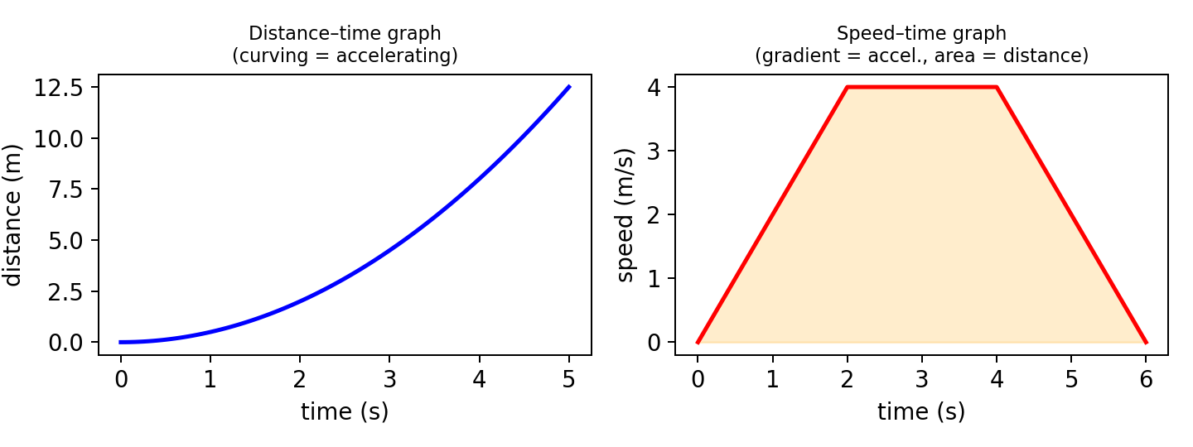
Figure 1.1 — Distance–time and speed–time graphs
- Distance–time graph: gradient = speed. A curve means changing speed (acceleration); a horizontal line means stationary.
- Speed–time graph: gradient = acceleration; area under the graph = distance travelled. A horizontal line = constant speed.
- Free fall: acceleration = g (constant, ignoring air resistance). Falling objects reach terminal velocity when air resistance (drag) equals weight, so resultant force = 0 and acceleration = 0.

1.3 Mass and Weight
 | Mass | Weight
Definition | Amount of matter (measure of inertia) in an object | The gravitational force acting on a mass
Type | Scalar | Vector
Unit | kilogram (kg) | newton (N)
Formula | — | W = mg
Does it change with location? | No — constant everywhere | Yes — depends on gravitational field strength g
g on the Moon (~1.6 N/kg) is about 1/6 of g on Earth (~9.8–10 N/kg), so weight changes but mass does not.

1.4 Density
ρ = m ÷ V (density = mass ÷ volume), unit kg/m³ or g/cm³.
- Regular solid: measure mass on a balance; calculate volume from dimensions.
- Irregular solid: find volume by displacement — lower the object into a partly-filled measuring cylinder and record the rise in liquid level.
- Floating: an object floats if its density is less than the density of the fluid it's placed in.

1.5 Forces
- A resultant (unbalanced) force can change an object's speed, direction, or shape.
- Hooke's Law: extension is directly proportional to applied force, F = kx, up to the limit of proportionality. k = spring constant (N/m).

Newton's Laws of Motion (Learn this)
Law | Statement
First | An object stays at rest or moves at constant velocity unless acted on by a resultant force (inertia)
Second | Resultant force = mass × acceleration ( F = ma )
Third | For every action force, there is an equal and opposite reaction force (acting on a different object)

Moments and equilibrium
Moment = Force × perpendicular distance from the pivot (unit: N·m).
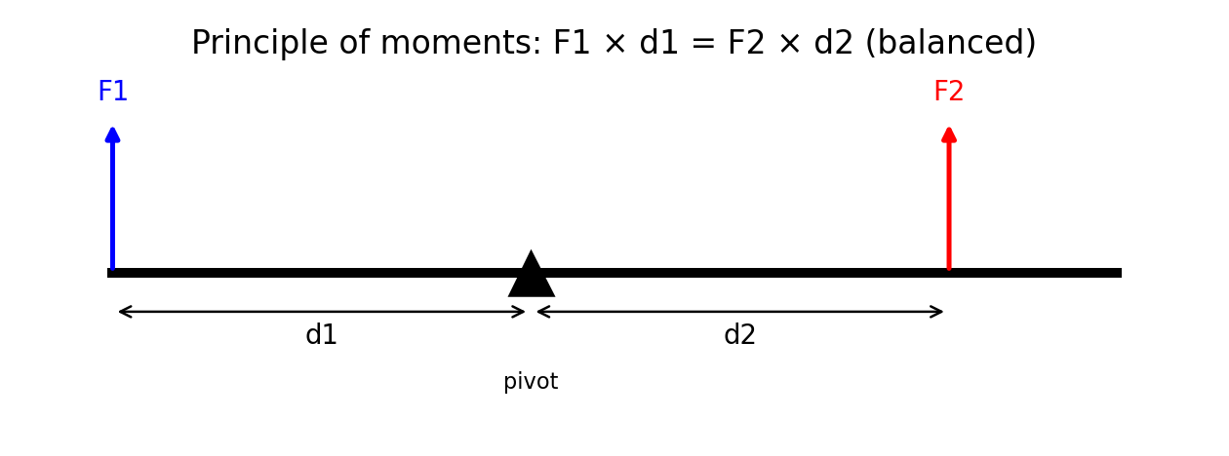
Figure 1.2 — Principle of moments
- Principle of moments: for a body in equilibrium, the sum of clockwise moments = sum of anticlockwise moments about any pivot.
- Centre of gravity: the single point where the whole weight of an object appears to act. Lower centre of gravity + wider base = more stable.

1.6 Momentum
Momentum p = mass × velocity (p = mv), unit kg·m/s. Vector quantity — direction matters.
- Conservation of momentum: in a closed system with no external forces, total momentum before a collision = total momentum after.
- Impulse / Newton's 2nd law form: Force = change in momentum ÷ time, F = (mv − mu) ÷ t.

1.7 Energy, Work and Power
Quantity | Formula | Unit
Kinetic energy | KE = ½mv² | J
Gravitational potential energy | GPE = mgh | J
Work done | W = F × d (d measured in direction of force) | J
Power | P = work done ÷ time = energy transferred ÷ time | W (J/s)
Efficiency | % efficiency = (useful energy output ÷ total energy input) × 100 | %
- Principle of conservation of energy: energy cannot be created or destroyed, only converted from one form to another / transferred from one place to another; total energy remains constant.

Energy resources
Renewable | Non-renewable
Solar, wind, hydroelectric, geothermal, tidal, wave, biofuel | Fossil fuels (coal, oil, natural gas), nuclear fuel
Renewable = replenished naturally / will not run out; non-renewable = finite, being used up faster than replaced, and (fossil fuels) release CO2 contributing to global warming.

1.8 Pressure
Pressure P = Force ÷ Area (P = F/A), unit pascal (Pa = N/m²). For a given force, smaller area → greater pressure.
Pressure in a liquid: P = ρgh (ρ = density, g = gravitational field strength, h = depth).
- Liquid pressure acts equally in all directions and increases with depth (independent of the shape/area of the container).
- Atmospheric pressure decreases with altitude (fewer air molecules above, less weight of air).

2. Thermal Physics

2.1 Kinetic Particle Model of Matter
 | Solid | Liquid | Gas
Arrangement | Regular, tightly packed | Random, close together | Random, far apart
Motion | Vibrate about fixed positions | Move/slide past each other | Move rapidly in random straight lines
Forces of attraction | Strong | Weaker than solid | Very weak / negligible
Relative energy | Lowest | Intermediate | Highest
- Brownian motion (smoke particles seen jostling randomly under a microscope) is evidence that gas molecules are moving randomly and colliding with larger particles.
- Gas pressure is caused by gas molecules colliding with, and exerting a force on, the walls of the container.

Gas laws (Learn this)
Law | Relationship (constant T unless stated) | Explanation
Pressure–volume (Boyle's Law) | P1V1 = P2V2 (constant temperature) | Smaller volume → molecules hit walls more often → higher pressure
Pressure–temperature (Gay-Lussac’s Law) | Pressure increases with temperature at constant volume | Higher temp → molecules move faster → collide harder/more often
Volume–temperature (Charles’s Law) | Volume increases with temperature at constant pressure | Higher temp → molecules move faster → push container walls outward

2.2 Thermal Properties and Temperature
- Thermal expansion: gases expand most, then liquids, then solids, when heated (particles move faster/further apart).
- Temperature scales: Kelvin (K) = Celsius (°C) + 273. 0 K = absolute zero (particles have minimum kinetic energy).
Quantity | Formula | Definition
Specific heat capacity, c | E = mcΔθ | Energy needed to raise the temperature of 1 kg of a substance by 1 °C (J/kg°C)
Specific latent heat, L | E = mL | Energy needed to change the state of 1 kg of a substance with no change in temperature (J/kg)
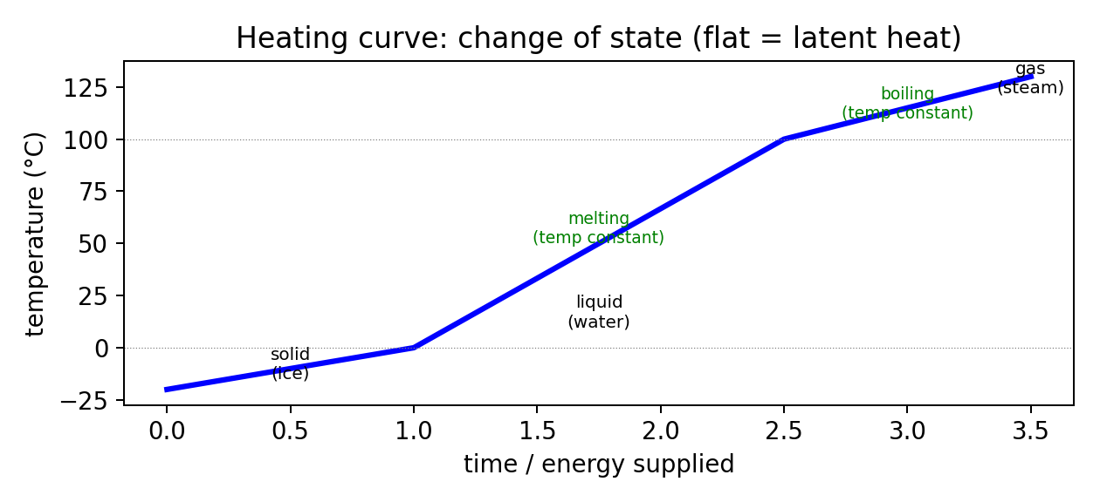
Figure 2.1 — Heating curve showing changes of state
During melting/boiling, temperature stays CONSTANT even though energy is still being supplied — this energy is being used to break intermolecular bonds (latent heat), not to increase kinetic energy/temperature.

2.3 Transfer of Thermal Energy
Method | Medium needed? | Mechanism
Conduction | Solids (needs particles in contact) | Particles vibrate and pass energy to neighbours; in metals, free (delocalised) electrons also carry energy quickly — metals are good conductors
Convection | Liquids and gases only (fluids) | Heated fluid expands, becomes less dense, rises; cooler, denser fluid sinks — sets up a convection current
Radiation | No medium needed — works in a vacuum (infrared/EM waves) | All objects emit infrared radiation; matt black surfaces are the best absorbers/emitters; shiny/white surfaces are the best reflectors and worst absorbers/emitters

3. Waves

3.1 General Properties of Waves
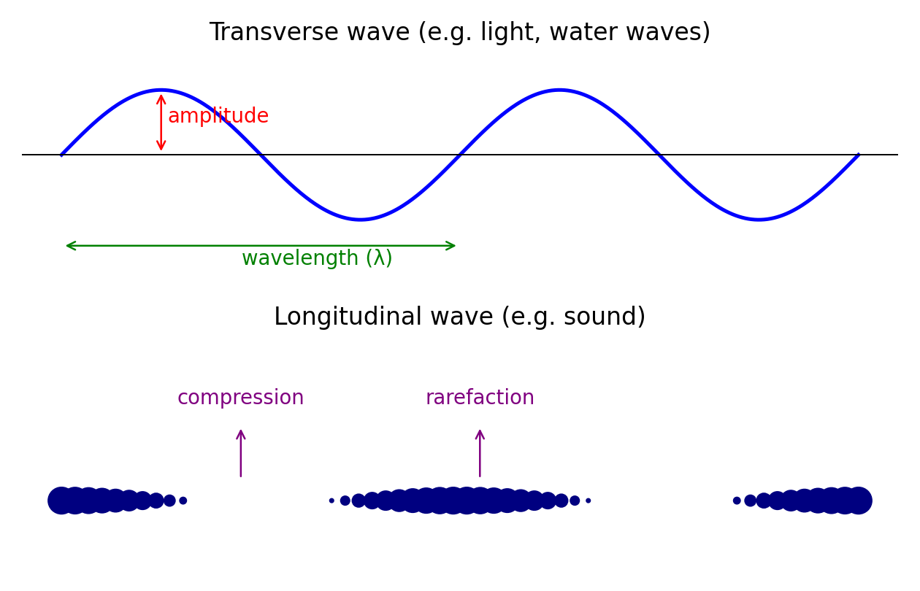
Figure 3.1 — Transverse wave (top) vs longitudinal wave (bottom)
Transverse waves |  | Longitudinal waves
Vibrations are perpendicular (at right angles) to the direction of energy transfer |  | Vibrations are parallel to (along) the direction of energy transfer
Show peaks (crests) and troughs |  | Show compressions (particles close together) and rarefactions (particles spread apart)
e.g. light, all EM waves, water waves, S-waves (seismic) |  | e.g. sound waves, P-waves (seismic)
Term | Meaning |  | Unit
Amplitude | Maximum displacement from the rest (undisturbed) position |  | m
Wavelength, λ | Distance between two adjacent identical points on a wave (e.g. crest to crest) |  | m
Frequency, f | Number of complete waves passing a point per second |  | Hz
Period, T | Time for one complete oscillation/wave, T = 1/f |  | s
Wave speed, v | Distance travelled by the wave per second |  | m/s
Wave equation: v = f λ (speed = frequency × wavelength)
- Waves transfer energy (and information), not matter, from one place to another.
- Reflection: angle of incidence = angle of reflection. Refraction: waves change speed (and direction, if entering at an angle) when passing into a different medium.

3.2 Light
Law of reflection: angle of incidence (i) = angle of reflection (r), both measured from the normal.
Refraction: occurs when light changes speed crossing a boundary between media of different density; it bends towards the normal when entering a denser medium, away from the normal when leaving it.
Refractive index: n = sin i ÷ sin r (also n = speed of light in vacuum ÷ speed of light in medium)
- Total internal reflection (TIR) occurs when light travels from a denser to a less dense medium at an angle greater than the critical angle, c, where sin c = 1/n. Used in optical fibres (e.g. endoscopes, telecommunications).
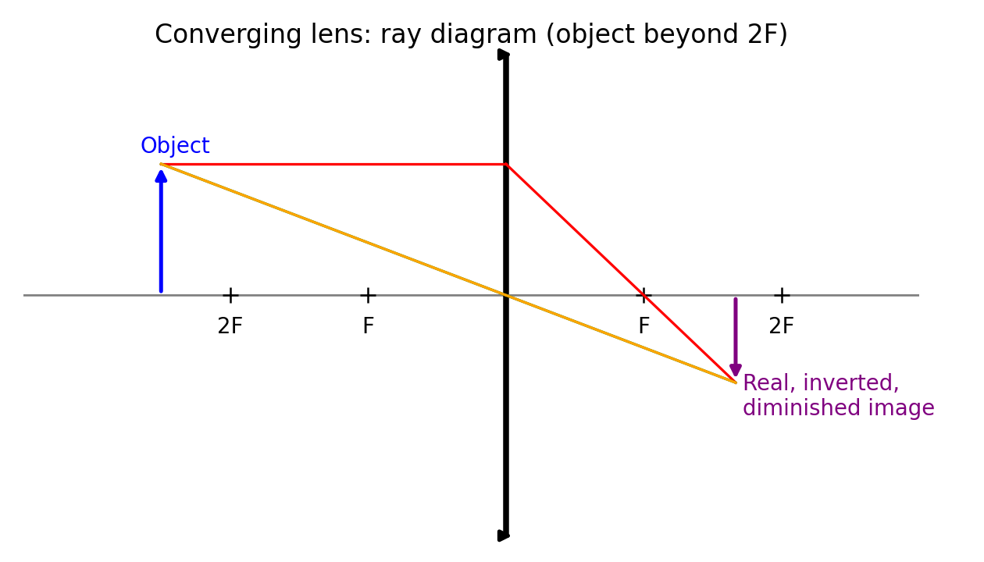
Figure 3.2 — Ray diagram for a converging (convex) lens

Ray diagram rules for a converging lens (Learn this)
- A ray parallel to the principal axis refracts through the principal focus (F) on the far side.
- A ray through the centre of the lens passes straight through, undeviated.
- A ray through the focal point on the near side emerges parallel to the axis.
Object position | Image characteristics
Beyond 2F | Real, inverted, diminished, between F and 2F on other side
At 2F | Real, inverted, same size, at 2F on other side
Between F and 2F | Real, inverted, magnified, beyond 2F
At F | No image forms (rays emerge parallel)
Between F and lens | Virtual, upright, magnified, same side as object (magnifying glass)

3.3 Electromagnetic Spectrum
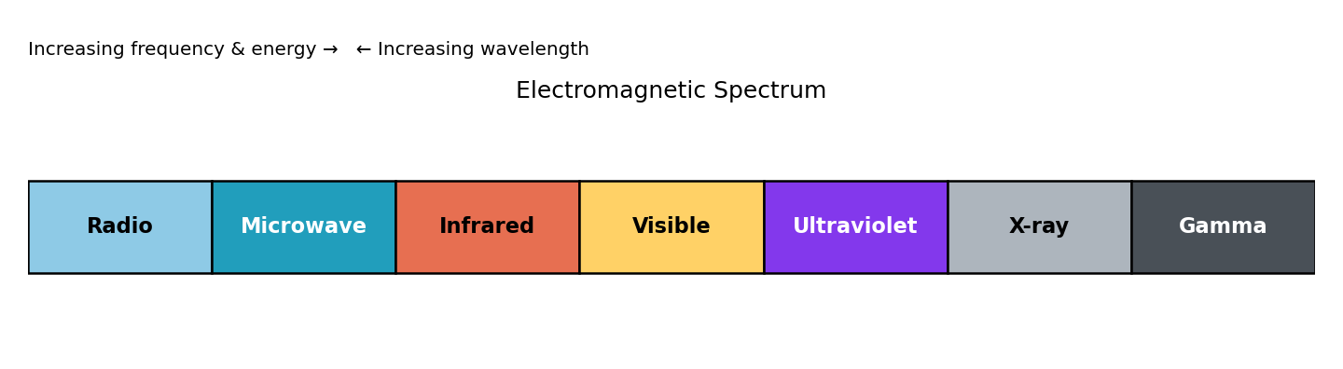
Figure 3.3 — The electromagnetic spectrum
- All electromagnetic waves travel at the same speed in a vacuum: 3 × 10⁸ m/s, and are transverse waves.
- Order of increasing frequency (decreasing wavelength): Radio → Microwave → Infrared → Visible light → Ultraviolet → X-ray → Gamma.
Wave | Common use | Danger
Radio | Broadcasting (TV, radio), communications | —
Microwave | Cooking food, satellite communication, mobile phones | Internal heating of body tissue
Infrared | Remote controls, thermal imaging, cooking (grills), fibre-optic communication | Skin burns
Visible light | Human vision, photography, optical fibres | —
Ultraviolet | Sunbeds, security marking (fluorescence), sterilisation | Skin cancer, eye damage, premature skin ageing
X-ray | Medical imaging, airport security, industrial (crack detection) | Cell/tissue damage, mutation, cancer (ionising)
Gamma | Sterilising medical equipment, cancer treatment/radiotherapy, tracers | Cell damage, cancer (most ionising/penetrating)

3.4 Sound
- Sound is a longitudinal wave and needs a medium (solid, liquid, or gas) to travel — it cannot travel through a vacuum.
- Speed of sound in air ≈ 330–340 m/s; faster in liquids, faster still in solids (particles closer together transmit vibrations more quickly).
- Pitch depends on frequency (higher frequency = higher pitch); loudness depends on amplitude (greater amplitude = louder).
- Human hearing range: approximately 20 Hz to 20 000 Hz (20 kHz).
- Echo: reflection of sound off a hard surface; used to measure distance/depth (e.g. echo sounding): distance = (speed × time) ÷ 2.

4. Electricity and Magnetism

4.1 Simple Phenomena of Magnetism
- Like poles repel; unlike poles attract.
- Magnetic materials (attracted to a magnet, can be magnetised): iron, steel, nickel, cobalt. Most other materials are non-magnetic.
- Magnetic field lines point from the North pole to the South pole outside the magnet; closer lines = stronger field.
- A plotting compass or iron filings can be used to show the shape of a magnetic field around a magnet or current-carrying wire.
- An electromagnet is a coil of wire (solenoid) around a soft iron core; magnetism appears only when current flows, and its strength increases with more turns, higher current, and a soft iron core.

4.2 Electrical Quantities
Quantity | Formula | Unit | Definition
Charge, Q | Q = It | coulomb (C) | Current × time
Current, I | I = Q/t | ampere (A) | Rate of flow of (positive) charge; conventional current flows from + to − outside the source
Potential difference (voltage), V | V = W/Q | volt (V) | Work done (energy transferred) per unit charge passing between two points
Resistance, R | R = V/I (Ohm's Law) | ohm (Ω) | Opposition to current flow
Electrical power, P | P = VI = I²R = V²/R | watt (W) | Rate of transfer of electrical energy
Electrical energy, E | E = Pt = VIt | joule (J) | Energy transferred
Ohm's Law: current through a resistor at constant temperature is directly proportional to the p.d. across it. Resistance increases with temperature for a filament lamp/resistor (curve on I-V graph).

Factors affecting resistance of a wire
- Length: longer wire → greater resistance (directly proportional).
- Cross-sectional area: thicker wire → smaller resistance (inversely proportional).
- Material: different materials have different resistivities (e.g. copper is a much better conductor than nichrome).
- Temperature: resistance of a metal wire increases as temperature increases.

4.3 Electric Circuits
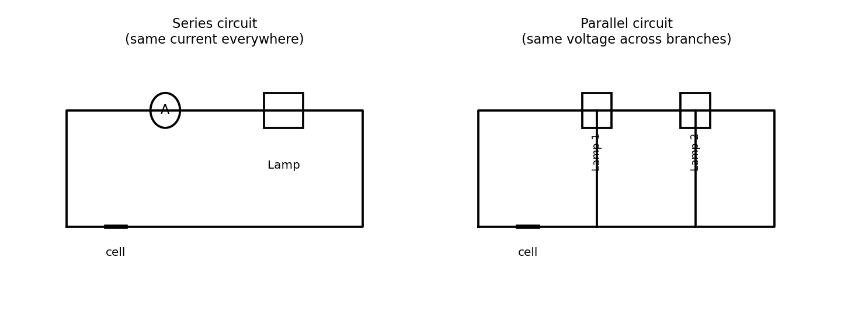
Figure 4.1 — Series circuit vs parallel circuit
 | Series circuit | Parallel circuit
Current | Same at every point: I = I1 = I2 | Splits between branches: I = I1 + I2
Voltage | Shares/splits across components: V = V1 + V2 | Same across each parallel branch: V = V1 = V2
Total resistance | Rtotal = R1 + R2 + … | 1/Rtotal = 1/R1 + 1/R2 + … (always less than the smallest individual resistor)
If one component fails (breaks) | Whole circuit stops (open circuit) | Other branches keep working
- Ammeter: connected in SERIES, has (near) zero resistance, measures current.
- Voltmeter: connected in PARALLEL (across a component), has (near) infinite resistance, measures potential difference.
- Other components: variable resistor/rheostat (adjustable resistance), thermistor (resistance decreases as temperature increases), LDR/light-dependent resistor (resistance decreases as light intensity increases), diode (allows current in one direction only).

4.4 Electrical Safety
- Fuse: thin wire that melts and breaks the circuit if current exceeds its rating, protecting the circuit/wiring from overheating and fire. Choose a fuse rated just above the normal operating current.
- Circuit breaker: an electromagnetic switch that trips (opens) when current is too high — can be reset, unlike a fuse.
- Earthing: connects the metal casing of an appliance to earth (0 V), providing a low-resistance path so a fault current flows to earth (blowing the fuse) rather than through a person touching the casing.
Wire | Colour | Function
Live | Brown | Carries alternating current/voltage from the supply (dangerous even when switch is off, at UK mains ~230 V)
Neutral | Blue | Completes the circuit, at ~0 V
Earth | Green and yellow stripes | Safety wire — carries fault current to earth if the live touches the casing

4.5 Electromagnetic Effects
- Electromagnetic induction: an e.m.f. (and current, if circuit is closed) is induced in a conductor when the magnetic field through/linking it changes (e.g. wire moving through a field, or a changing current in a nearby coil).
- Factors increasing the size of the induced e.m.f.: stronger magnet/field, faster relative motion, more turns on the coil.
- Fleming's left-hand rule (motor effect): predicts the direction of the FORCE on a current-carrying conductor in a magnetic field — thuMb = Motion/force, First finger = Field, seCond finger = Current.
- Fleming's right-hand rule (generator effect): predicts the direction of INDUCED CURRENT — thuMb = Motion, First finger = Field, seCond finger = induced Current.

Transformers
Vp/Vs = Np/Ns (primary voltage ÷ secondary voltage = primary turns ÷ secondary turns)
For an ideal (100% efficient) transformer: Vp × Ip = Vs × Is (input power = output power)
Type | Turns ratio | Effect
Step-up | More turns on secondary (Ns > Np) | Increases voltage, decreases current
Step-down | Fewer turns on secondary (Ns < Np) | Decreases voltage, increases current
Transformers only work with ALTERNATING current (a.c.) — a changing current is needed to produce a changing magnetic field, which induces an e.m.f. in the secondary coil.

5. Nuclear Physics

5.1 The Nuclear Model of the Atom
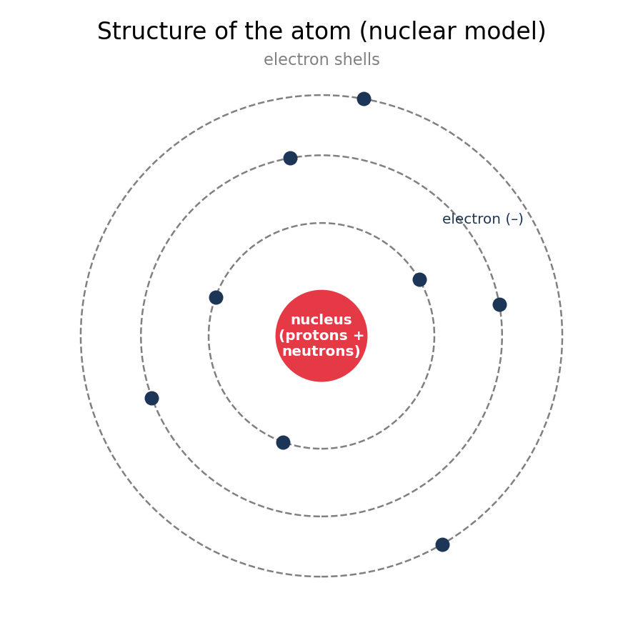
Figure 5.1 — Structure of the atom
Particle | Relative mass | Relative charge | Location
Proton | 1 | +1 | Nucleus
Neutron | 1 | 0 | Nucleus
Electron | 1/1840 (negligible) | −1 | Orbiting shells around the nucleus
- Proton (atomic) number, Z: number of protons in the nucleus; defines the element.
- Nucleon (mass) number, A: total number of protons + neutrons.
- Isotopes: atoms of the same element (same proton number) with a different number of neutrons (different nucleon number).
- Nuclide notation: A above, Z below, e.g. ¹⁴₆C has 6 protons and 14 − 6 = 8 neutrons.
- The atom is mostly empty space; almost all the mass is concentrated in the tiny, dense, positively charged nucleus (evidence from the alpha-particle scattering experiment — most alpha particles pass straight through a thin gold foil, a few deflect, very few bounce straight back).

5.2 Radioactivity
Radiation | Nature | Penetrating power | Ionising ability | Deflection by fields
Alpha (α) | Helium nucleus (2p + 2n) | Stopped by paper / a few cm of air | Strongly ionising | Deflected (heavy, +2 charge — deflects less than beta)
Beta (β) | Fast-moving electron | Stopped by ~3 mm aluminium | Weakly ionising | Deflected strongly, opposite direction to alpha (−1 charge, light)
Gamma (γ) | Electromagnetic wave (no mass/charge) | Needs several cm of lead / thick concrete to significantly reduce | Very weakly ionising | Not deflected (no charge)
- Background radiation comes from natural sources (radon gas from rocks/soil, cosmic rays, food, rocks/soil) and artificial sources (medical X-rays, nuclear industry).
Half-life: the time taken for half the nuclei in a sample of a radioactive isotope to decay (or for the count rate/activity to fall to half its original value). Half-life is constant for a given isotope and unaffected by temperature, pressure, or chemical state.
- In a nuclear equation, the sum of proton numbers must balance on both sides, and the sum of nucleon numbers must balance on both sides.
- Alpha decay: nucleon number decreases by 4, proton number decreases by 2. Beta decay: a neutron changes into a proton + electron (emitted); nucleon number unchanged, proton number increases by 1.
- Uses: medical tracers/diagnosis and radiotherapy (gamma), smoke detectors (alpha), sterilisation of equipment (gamma), thickness control in manufacturing (beta), carbon dating (radioactive carbon-14, half-life ~5700 years) and dating rocks (uranium).
- Safety precautions: minimise time of exposure, maximise distance from source, use shielding (lead/concrete), and store sources in lead-lined containers when not in use.

6. Space Physics

6.1 Earth and the Solar System
- The Solar System consists of the Sun (a star), 8 planets orbiting it, their moons, and smaller bodies (asteroids, comets, dwarf planets).
- Planet order from the Sun: Mercury, Venus, Earth, Mars, Jupiter, Saturn, Uranus, Neptune.
- A planet's orbit is kept roughly circular/elliptical by the Sun's gravitational force, which provides the centripetal force needed for orbital motion.
- The Moon orbits the Earth; Earth's rotation on its axis (24 hours) causes day and night; Earth's orbit around the Sun (365¼ days) combined with the tilt of its axis causes the seasons.
- Gravitational field strength decreases with distance from the mass causing it — planets further from the Sun orbit more slowly and take longer to complete one orbit.

6.2 Stars and the Universe
- The Sun is a star — a hot ball of gas (mainly hydrogen and helium) that releases energy by nuclear fusion (hydrogen fusing into helium) in its core.
Stage | Description
Nebula | Cloud of dust and gas contracts under gravity
Main sequence star | Stable star fusing hydrogen into helium (Sun is here now)
Red giant / red super giant | Star expands and cools as hydrogen fuel runs low
White dwarf (smaller stars) | Outer layers are lost; a small, dense, hot core remains and slowly cools
Supernova (larger stars) | Massive star explodes violently after core collapse
Neutron star / black hole | Remnant left after a supernova, depending on original star's mass
- Redshift: light from distant galaxies is shifted towards the red (longer wavelength) end of the spectrum — evidence that galaxies are moving away from us.
- The further away a galaxy, the greater its redshift and the faster it is moving away — this supports the theory that the Universe is expanding, and points back to a single origin: the Big Bang.
- Light-year: the distance travelled by light in one year — a unit of distance (not time), used for astronomical distances because they are so large.

Appendix A — Quick-Reference Formula Sheet
Quantity | Formula
Speed / velocity | speed = distance ÷ time
Acceleration | a = (v − u) ÷ t
Equations of motion | v = u + at ; s = ut + ½at² ; v² = u² + 2as
Weight | W = mg
Density | ρ = m ÷ V
Hooke's Law | F = kx
Force (Newton's 2nd law) | F = ma
Moment | moment = F × perpendicular distance from pivot
Momentum | p = mv
Kinetic energy | KE = ½mv²
Gravitational potential energy | GPE = mgh
Work done | W = F × d
Power | P = work ÷ time = energy ÷ time
Efficiency | % efficiency = (useful energy output ÷ total energy input) × 100
Pressure | P = F ÷ A
Pressure in a liquid | P = ρgh
Specific heat capacity | E = mcΔθ
Specific latent heat | E = mL
Temperature conversion | K = °C + 273
Wave equation | v = fλ
Period | T = 1 ÷ f
Refractive index | n = sin i ÷ sin r
Critical angle | sin c = 1 ÷ n
Charge | Q = It
Potential difference | V = W ÷ Q
Resistance (Ohm's Law) | R = V ÷ I
Electrical power | P = VI = I²R = V² ÷ R
Electrical energy | E = Pt = VIt
Series resistance | Rtotal = R1 + R2 + …
Parallel resistance | 1/Rtotal = 1/R1 + 1/R2 + …
Transformer voltage ratio | Vp/Vs = Np/Ns
Transformer power (ideal) | Vp × Ip = Vs × Is

Appendix B — Symbols and Units for Physical Quantities
Quantity | Symbol | SI Unit (symbol)
Length | l, d, s, x | metre (m)
Mass | m | kilogram (kg)
Time | t | second (s)
Speed / velocity | v, u | metre/second (m/s)
Acceleration | a | metre/second² (m/s²)
Force / weight | F, W | newton (N)
Density | ρ | kilogram/metre³ (kg/m³)
Momentum | p | kilogram metre/second (kg m/s)
Energy / work | E, W | joule (J)
Power | P | watt (W)
Pressure | P | pascal (Pa)
Temperature | θ, T | degree Celsius (°C) / kelvin (K)
Frequency | f | hertz (Hz)
Current | I | ampere (A)
Potential difference | V | volt (V)
Resistance | R | ohm (Ω)
Charge | Q | coulomb (C)

Appendix C — Last-Minute Exam Checklist
- Always show your working and units in calculations — method marks are awarded even if the final answer is wrong.
- For 'describe the trend' graph questions, mention direction (increase/decrease), rate of change, and any turning points/plateaus — with values where possible.
- For 'explain' questions, relate the answer to the underlying physics (particles, forces, fields) — do not just restate the observation.
- Double-check units before substituting into formulas (e.g. convert cm to m, g to kg, °C to K where needed).
- Remember the sign/direction convention for vectors — velocity, displacement, acceleration and force can be positive or negative depending on direction.
- Practise drawing and labelling standard diagrams from memory: ray diagrams (lenses, reflection), circuit diagrams and symbols, wave diagrams, the atom, moments, and the electromagnetic spectrum.
- For circuit questions, check whether components are in series or parallel BEFORE applying current/voltage rules.
- For radioactivity questions, check whether the question wants proton number, nucleon number, or number of neutrons — and balance both numbers in nuclear equations.
- Learn definitions precisely, word-for-word where possible (e.g. moment, momentum, density, efficiency) — many are worth a mark on their own.

