NAME – Fahad Shahab

REG NO. - 220962370

ROLL – 59

AIML – B

1) Write a JavaScript program to perform an online quiz

<!DOCTYPE html>

<html lang="en">

<head>

<meta charset="UTF-8">

<meta name="viewport" content="width=device-width, initial-scale=1.0">

<title>Online Quiz</title>

</head>

<body>

<h1>Pop Quiz</h1>

<div>

<p>1. What is the capital of India?</p>

<label><input type="radio" name="q1" value="a"> Berlin</label><br>

<label><input type="radio" name="q1" value="b"> Delhi</label><br>

<label><input type="radio" name="q1" value="c"> Sydney</label>

</div>

<div>

<p>2. Which planet is known as the Red Planet?</p>

<label><input type="radio" name="q2" value="a"> Earth</label><br>

<label><input type="radio" name="q2" value="b"> Mars</label><br>

<label><input type="radio" name="q2" value="c"> Venus</label>

</div>

<div>

<p>3. What is 2 + 2?</p>

<label><input type="radio" name="q3" value="a"> 4</label><br>

<label><input type="radio" name="q3" value="b"> Option a</label><br>

<label><input type="radio" name="q3" value="c"> Both a and b</label>

</div>

<div>

<p>4. What is the smallest prime number?</p>

<label><input type="radio" name="q4" value="a"> 1</label><br>

<label><input type="radio" name="q4" value="b"> 2</label><br>

<label><input type="radio" name="q4" value="c"> 3</label>

</div>

<div>

<p>5. What is the largest ocean on Earth?</p>

<label><input type="radio" name="q5" value="a"> Atlantic</label><br>

<label><input type="radio" name="q5" value="b"> Indian</label><br>

<label><input type="radio" name="q5" value="c"> Pacific</label>

</div>

<br>

<button onclick="submitQuiz()">Submit</button>

<div id="result"></div>

<script>

function submitQuiz() {

let score = 0;

const answers = {

q1: 'b',

q2: 'b',

q3: 'a',

q4: 'b',

q5: 'c'

};

for (let i = 1; i <= 5; i++) {

const selectedOption = document.querySelector(`input[name="q${i}"]:checked`);

if (selectedOption && selectedOption.value === answers[`q${i}`]) {

score++;

}

}

const result = document.getElementById('result');

result.innerHTML = `Your score is: ${score} out of 5`;

}

</script>

</body>

</html>

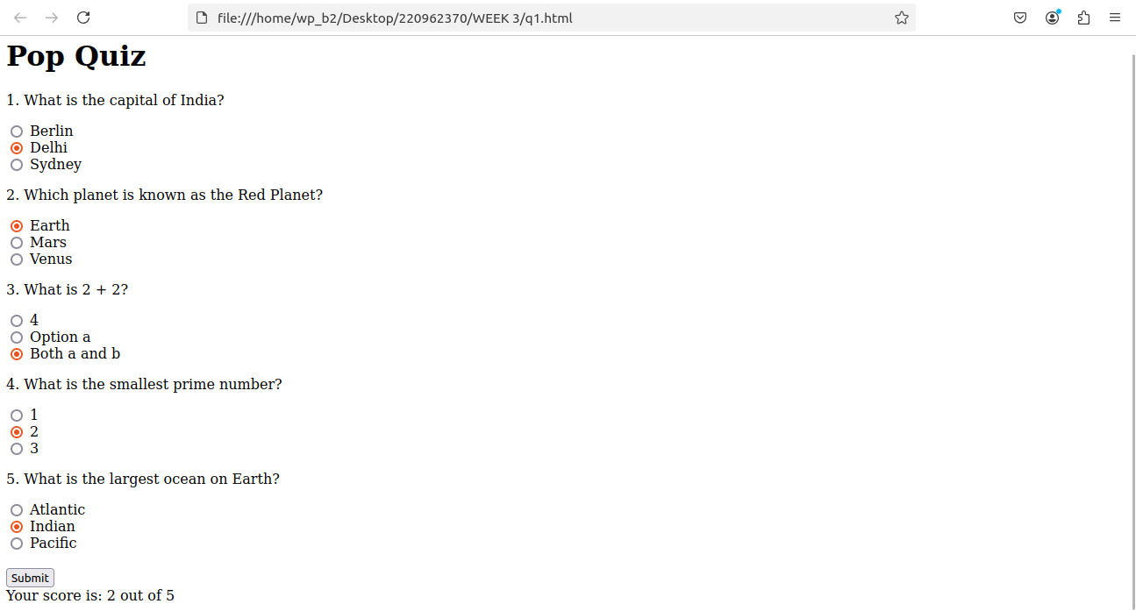

2) Write a JavaScript program to Wish a user at different hours of a day. Use

appropriate dialog boxes for wishing the user. Display the dynamic clock on the

web page. Make use of CSS and HTML5 elements for creative and attractive

design.

<!DOCTYPE html>

<html lang="en">

<head>

<meta charset="UTF-8">

<meta name="viewport" content="width=device-width, initial-scale=1.0">

<title>Dynamic Clock and Greetings</title>

<style>

body {

font-family: Arial, sans-serif;

display: flex;

justify-content: center;

align-items: center;

height: 100vh;

margin: 0;

background-color: #f0f0f0;

flex-direction: column;

}

#clock {

font-size: 48px;

font-weight: bold;

margin-bottom: 20px;

padding: 20px;

background-color: #2c3e50;

color: white;

border-radius: 10px;

}

</style>

</head>

<body>

<div id="clock"></div>

<script>

function greetUser() {

const currentHour = new Date().getHours();

let greetingMessage = "";

if (currentHour >= 5 && currentHour < 12) {

greetingMessage = "Good Morning!";

} else if (currentHour >= 12 && currentHour < 17) {

greetingMessage = "Good Afternoon!";

} else if (currentHour >= 17 && currentHour < 21) {

greetingMessage = "Good Evening!";

} else {

greetingMessage = "Good Night!";

}

alert(greetingMessage);

}

function updateClock() {

const now = new Date();

const hours = now.getHours().toString().padStart(2, "0");

const minutes = now.getMinutes().toString().padStart(2, "0");

const seconds = now.getSeconds().toString().padStart(2, "0");

const timeString = `${hours}:${minutes}:${seconds}`;

document.getElementById("clock").textContent = timeString;

}

greetUser();

setInterval(updateClock, 1000);

</script>

</body>

</html>

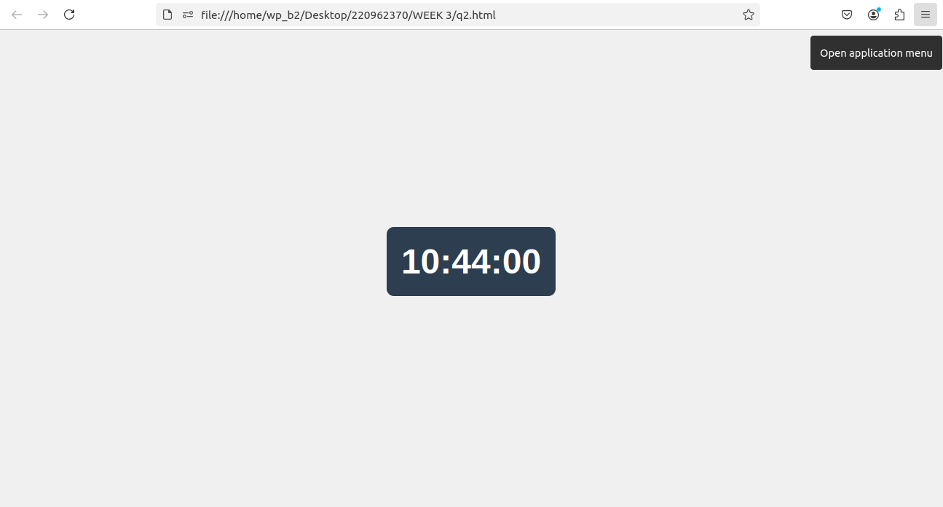

3) Write the java script program to display the grade [A, B,C,D] based on the marks

entered by student(take the input into text boxes). Enter the marks of 4 subjects and

calculate the average( using button). If the avg>90 then A, avg>80 then B, if avg>70

then C, if avg>60 then D.

<!DOCTYPE html>

<html lang="en">

<head>

<meta charset="UTF-8">

<meta name="viewport" content="width=device-width, initial-scale=1.0">

<title>Grade Calculator</title>

<style>

body {

font-family: Arial, sans-serif;

padding: 20px;

background-color: #f4f4f4;

}

.container {

max-width: 400px;

margin: 0 auto;

background-color: #fff;

padding: 20px;

border-radius: 10px;

box-shadow: 0 0 10px rgba(0, 0, 0, 0.1);

}

input[type="number"] {

width: 100%;

padding: 10px;

margin: 10px 0;

border: 1px solid #ccc;

border-radius: 5px;

}

button {

width: 100%;

padding: 10px;

background-color: #4CAF50;

color: white;

border: none;

border-radius: 5px;

cursor: pointer;

}

button:hover {

background-color: #45a049;

}

.result {

margin-top: 20px;

font-size: 18px;

font-weight: bold;

}

</style>

</head>

<body>

<div class="container">

<h2>Grade Calculator</h2>

<label for="subject1">Enter Marks for Subject 1:</label>

<input type="number" id="subject1" required>

<label for="subject2">Enter Marks for Subject 2:</label>

<input type="number" id="subject2" required>

<label for="subject3">Enter Marks for Subject 3:</label>

<input type="number" id="subject3" required>

<label for="subject4">Enter Marks for Subject 4:</label>

<input type="number" id="subject4" required>

<button onclick="calculateGrade()">Calculate Grade</button>

<div class="result" id="result"></div>

</div>

<script>

function calculateGrade() {

// Get the values entered in the textboxes

const subject1 = parseFloat(document.getElementById('subject1').value);

const subject2 = parseFloat(document.getElementById('subject2').value);

const subject3 = parseFloat(document.getElementById('subject3').value);

const subject4 = parseFloat(document.getElementById('subject4').value);

// Check if all subjects have marks entered

if (isNaN(subject1) || isNaN(subject2) || isNaN(subject3) || isNaN(subject4)) {

alert("Please enter valid marks for all subjects.");

return;

}

// Calculate average marks

const average = (subject1 + subject2 + subject3 + subject4) / 4;

// Determine grade based on average marks

let grade = '';

if (average > 90) {

grade = 'A';

} else if (average > 80) {

grade = 'B';

} else if (average > 70) {

grade = 'C';

} else if (average > 60) {

grade = 'D';

} else {

grade = 'F'; // F for failing grade if average <= 60

}

// Display the result

document.getElementById('result').innerHTML = `Average Marks: ${average.toFixed(2)}<br>Grade: ${grade}`;

}

</script>

</body>

</html>

