**PROJECT NAME: JOB PORTAL**

**Languages/Technologies used: C#, ASP.NET, MS SQL SERVER, JavaScript for Validation.**

Lecture 33&34.

project name -- Job portal

1. default master
2. jobseeker master
3. job recruiter master
4. Admin master

header/footer same in all master. only change in navigation bar

two registration form

job seeker reg form

job recrter form

seeker pe details.

self mind.

for ex. textbox

name txt

gender radio

qual dropdw

job profile dropdm java,c#

resume upload

photo upload

email id txt

passowrd. txt

CRUD : Reg,dislay,edit,update,delete.

Job recruiter Form

Company details

Fields--

Comp name txtbx

comp URL www.hcl.com

addres txtbx

HR name

HR COntact

HR EMail

HR Passwrd

CRUD : Reg,dislay,edit,update,delete.

Default master in both REG Form.

Only one LogIn Page.

dropdown top pe -- job seeker/job recruiter static value 1,2

EMail id

password

login button

label

Login.cs

btnclick_insert()

if(dropdownlist.selected value==1){

job recruiter login code

}

else if(dropdownlist.selected value==2){

job seekerlogin code

}

Home page 2

Jobseeker

jobrecruiter

wlecome "Name"

welcome "Company"

1 logout

---------------------------Lecture 33 end.

Lecture 34.

Loginpage:

User Type - dropdwn-- Admin,User/Seeker/recruiter

User Email :txt

User Password : txt

button save -- side me Signup for User/Seekre SignUp for recruiter

Admin section

Admin ka table.. Owner of Site.

adminhome- welcome admin.

1.NavBar- Manage MAster data---

1.a - Manage Country

2.b - Mnage State

3.c - Manage city

4.d - Mnage job profile

5.e - Manage skills

6.f - Mnage qualification

1.a - Manage Country.aspx open--

fields...

Country name -- txtbox

save button.

Gridview show same page.

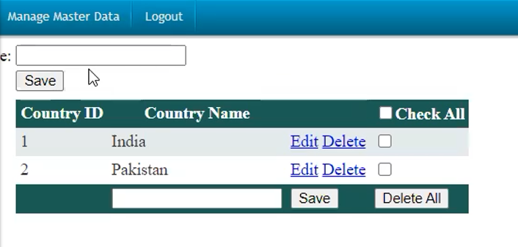

ManageState.aspx

Country Name – dropdown.

State Name – txtbox

Gridview – Delete/Edit

ManageCity.aspx

CountryName -- dropdwn

StateName – dropdwn

CityName – txtbox

Save button

Grid – Del/Edit

Mnage job profile.aspx

Job profile Title : Txtbox

Save button

Gridviw- Profile Naame, Edit,Delete, checkbox

ManageQualification.aspx