**Data Structures and Algorithms**

**Data Types:**

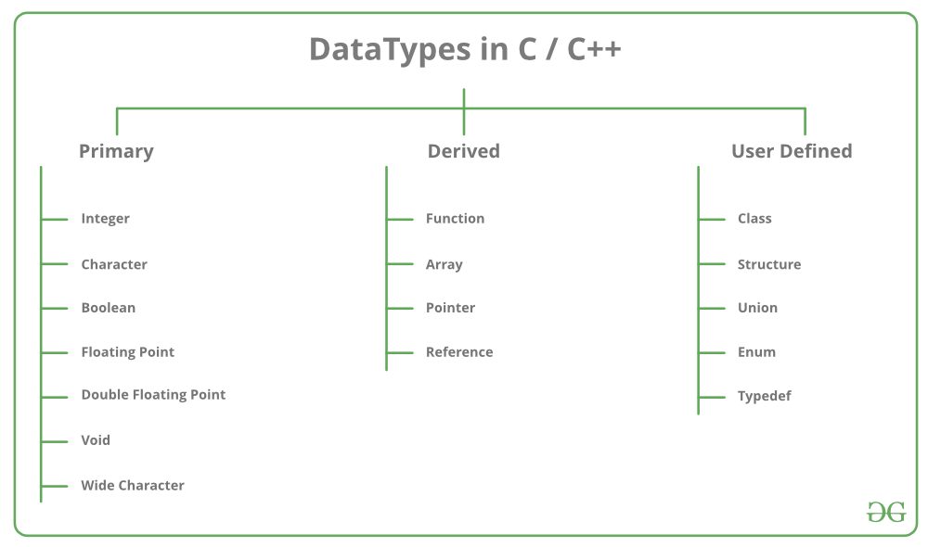

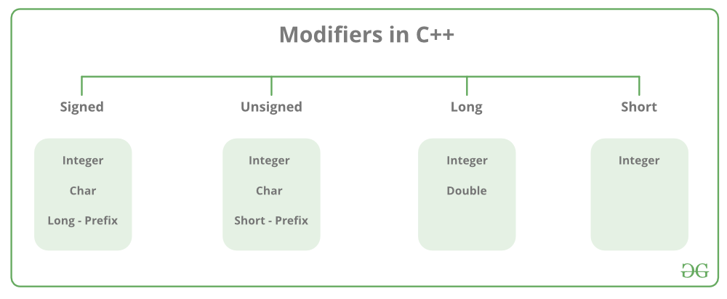

**Conversion of Bytes to Bits:**

* 1 Byte is equal to 8 Bits
* N Byte is equal to (N x 8) Bits

**Bool Value Representation:**

* 0 represents False
* Non-Zero Values represent True [Usually 1 is used to represent True]

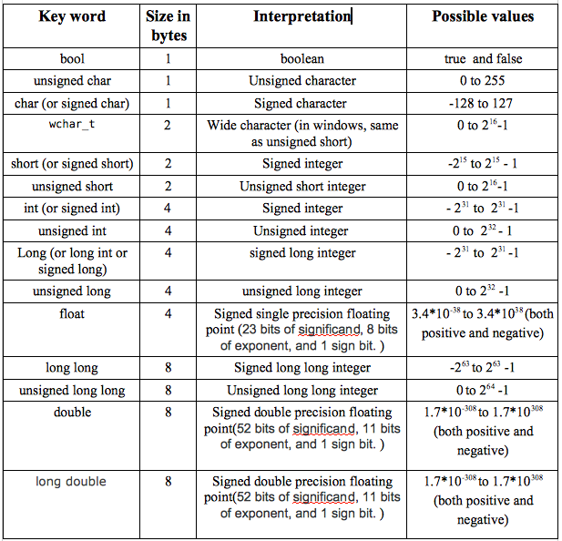

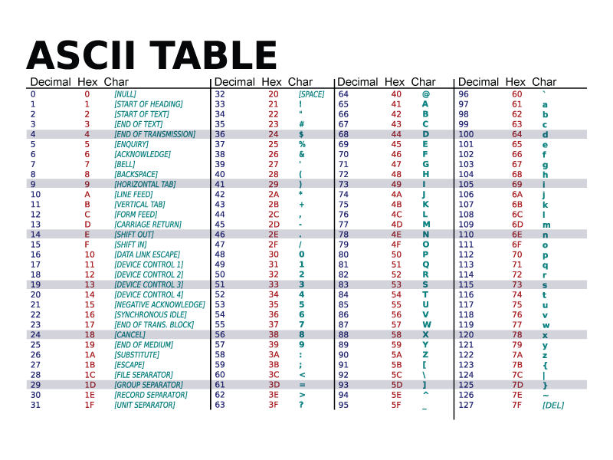

**Operators:**

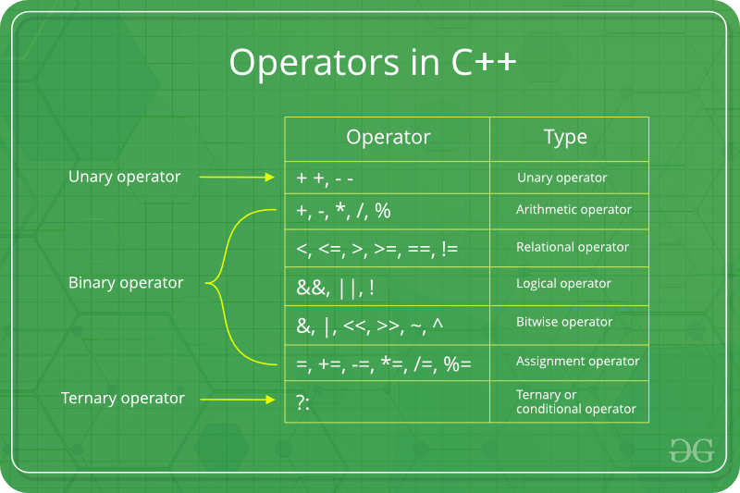

**Bitwise Operator**

